Home Assignment 1

1. a) Two game engines which are used to develop video games are Unity and Unigine. For this assignment, Unity was chosen since it is more suitable and has more advantages than Unigine.

* Unity supports 2D graphics unlike Unigine.
* It uses C# and JavaScript as programming languages unlike Unigine which uses C++.
* Unity is easy to use but also very powerful.
* Unity has a simpler UI then Unigine.

b) Two programming languages used in game development are C# and JavaScript.

* C# is typed statically while JavaScript is typed dynamically.
* C# has automatic completion.
* C# has conversion overloading and operator while JavaScript does not.
* C# gives the programming explicit control over threading while JavaScript hide this with its response function structure.

1. a)

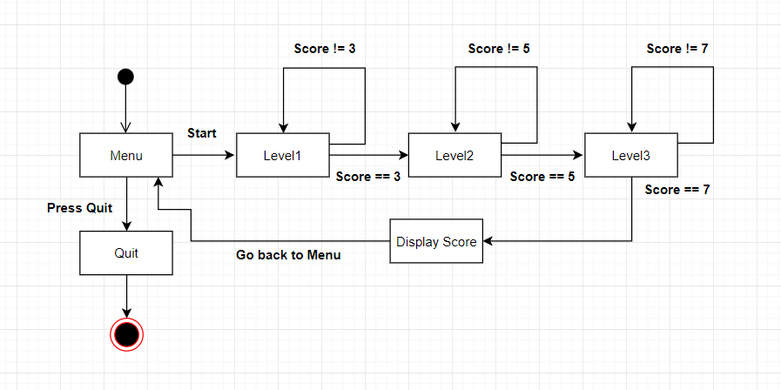

b) 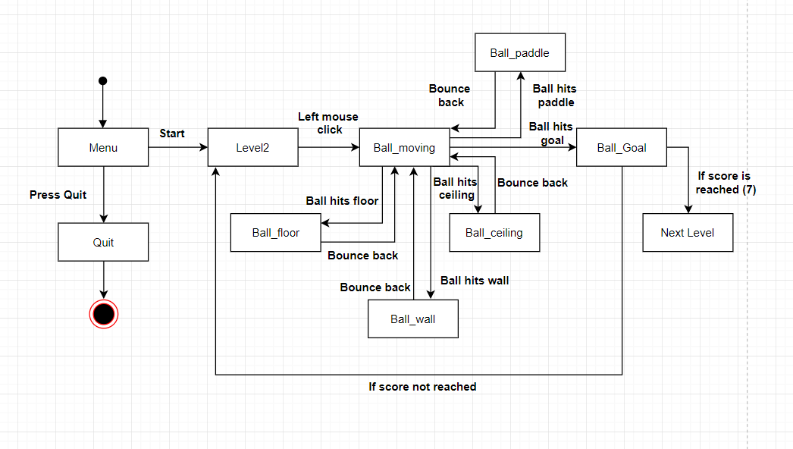

1. 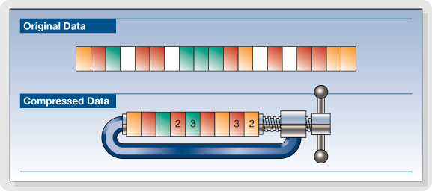Compression in data is needed to have less space so one can store more files on a hard disk, faster reading and writing and faster file transfer. An uncompressed image can be many megabytes in size. Image compression is to find ways of how to describe a complex image in detail using less space. Compression works by removing repetitive and redundant information. It makes the files smaller and more practical to store and share data. Compression leads to a faster performance and also helps in transferring large files from one location to another in a faster manner.

Compression

# References

*Data compression*. (2017, November 29). Retrieved from Wikipedia: https://en.wikipedia.org/wiki/Data_compression

*Unigine*. (2017, September 6). Retrieved from Wikipedia: https://en.wikipedia.org/wiki/Unigine

*Unity (game engine)*. (2017, December 9). Retrieved from Wikipedia: https://en.wikipedia.org/wiki/Unity_(game_engine)