Lab Report No: 02

Name of the lab report: Basic Linux command.
Name: Most. Aysa Aktar
ID: IT-17004

Objectives: On Linux OS command line ‘Terminal Shell’ is helpful to declare a command.
On this lab we see some basic commands of Linux OS. 15 commands are down below & I also take screen shot of this commands.

Qusetion No1. What is Linux command?
Ans:
Commands are normally handling by typing in the command line & pressing ENTER which pass them to ‘shell’. The default shell on most Linux system is bash. Command is an instruction given by a user operating the computer to do something like running a program or multiprogramming .On Linus the command line is known as ‘Terminal’. We can open it either by pressing “ ctrl+alt+t ” or find from application drawer.
Manually , First go to app drawer . Then select all application. Then we found the Terminal app . After clicking this , the terminal command line will arrive in our monitor.

Question No.2 Write 15 commands of Linux operating system.
Ans:
- hostname commands.
- locate commands.
- commands.
- cat commands.
- du commands.
- pwd command.
- ls command.
- cd command.
- uptime command.
- ps commands.
- mv commands.
- rm commands.
- mkdir commands.
- sudu commands.
- history commands.
Q.3. Describe the basic operation of Linux commands.
Ans:

hostname:
See the hostname

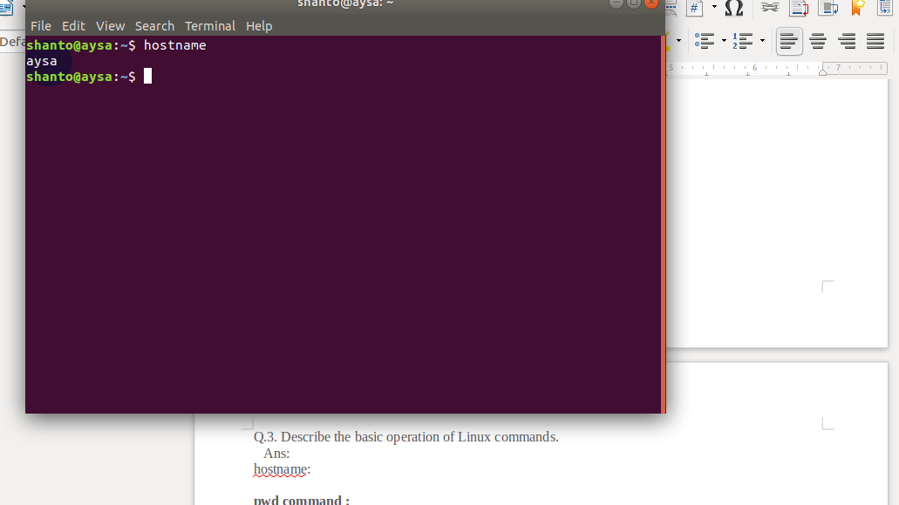

pwd command :
This command showss the location of my current working directory. It's important to know actually where i’m before going to a parent or sub directories.

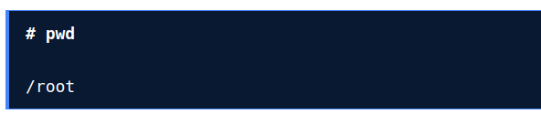

ls command:
Use the ‘ls’ command to know what files are in the directory I am staying. Besides i can see all the hidden files by using this command.

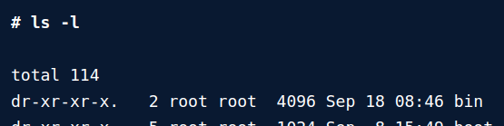

cd

command:
This command is used to go to a directory. For example, if you are in the home folder, and you want to go to the pictures folder, then you can type in“cd Pictures”. Remember, this command is case sensitive, and you have to type in the name of the folder exactly as it is.



Uptime:
This command can be very interesting. Shows the time when we open our pc, how many times we use it , hour,seconds, minutes.



cp command:
This command to copy files through the command line. It takes two arguments: The first is the location of the file to be copied, the second is where to copy.

mv commands:
The mv command is used to move or rename directories files.



rm command:
rm is used to delete file directory.



mkdir command:
Use to create new file.


Sudu command:
This command provide permission authorization everything.
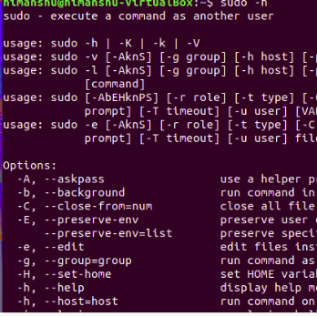

locate command:
Locate the file directory.



sort command:
It will sort some text file.



cat command:
Adding text in file or text add in the previous text file



ps command:
Number of documents file stored in the hard disk.

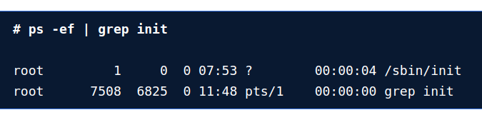

history command:
After doing something in the terminal shell , if we are pressing ctrl+R then we have our previous working history.

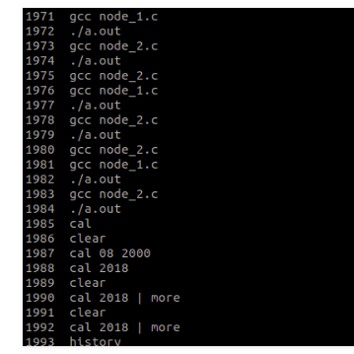

Conclusion: I take the help from the internet to become more specific. So this said that the earlier this commands shows many interesting scenario of my current Operating System, such as cat,uptime,locate,history is feel ease to me. Those commands are very much helpful. I feel some different challenge to do it.

