Assignment 3 (7%)

Total : 60 marks.

Please work in **groups** of max 3 and min 2 to complete this Assignment. This Assignment is worth 7% of the total course grade and will be evaluated through your written submission, as well as the Assignment demo in the class worth 3%. During the Assignment demo, group members are randomly selected to present the answers to each of the lab questions. Group members not present during the Assignment demo will lose the demo mark. Individual submission will have penalty of 10%.

1. Display department number, department name, and the number of employees working in each department that has the highest number of employees. Use subquery only. (5 marks)

select department_id, d.department_name, count(employee_id)

from employees e join departments d

using(department_id)

group by department_id, d.department_name

having count(employee_id) = all (select max(count(employee_id)) from employees group by department_id);

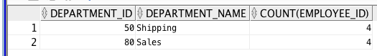

1. Display all the employees who were hired on the day of the week on which the highest number of employees were hired. List the first name and last name columns together with a space in between. Label the column as Full Name and label day as day of the week. Use subquery only. (5 marks)

select first_name || ' ' || last_name "Full Name", to_char(hire_date, 'Day') "Day"

from employees

where to_char(hire_date, 'day') in (select to_char(hire_date, 'day') "Day"

from employees

group by to_char(hire_date, 'day')

having count(*) = (select max(count(*))

from employees

group by to_char(hire_date, 'day')));

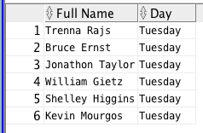

1. Department 50 needs access to its employee data. Create a view named DEPT50 that contains the employee numbers, employee last names, and department numbers for all employees in department 50. They have requested that you label the view columns EMPNO, EMPLOYEE, and DEPTNO. For security purposes, do not allow an employee to be reassigned to another department through the view. (5 marks)

Create view dept50 as

select employee_id empno, last_name employee,department_id deptno

from employees

where department_id = 50

with check option constraint emp_dept50_ck;

*The "with check option", it is used to prevent changes to a view that would produce rows that are not included in a sub-query.

../Desktop/Screen%20Shot%202018-11-27%20at%2011.54.31%20AM.p

1. Create a view named emp_hired that has the names and hire dates for all employees who were hired before their managers, along with their manager’s names and hire dates. Label the columns Employee, Emp Hired, Manager, and Mgr Hired, respectively. (5 marks)

select w.last_name “Employee”, w.hire_date “Emp Hired”, m.last_name ”Manager”, m.hire_date “Mgr Hired”

from employees w join employees m

on (w.manager_id = m.employee_id)

where w.hire_date < m.hire_date;

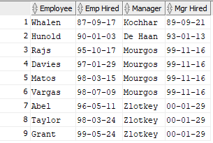

1. The Date base Administrator needs you to create a table, which has a primary key constraint, but she wants to name the index to have a different name than the constraint. Create the Locations_Index table based on the following table instance chart. Name the index for the PRIMARY KEY column as LOCATIONS_PK_IDX. (5 marks)

|  |  |  |
| --- | --- | --- |
| Column Name | Deptno | Dname |
| Primary key | Yes |  |
| Data Type | Number | VARCHAR2 |
| Length | 4 | 30 |

create table locations_index

(locno number(4) primary key using index

(create index locations_pk_idx on locations_index(locno)),

locationname varchar2 (30));

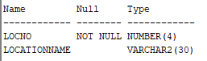

1. Create a report of a list of employees who are up for review in March; so you are requested to do the following: (5 marks)

Write a query to display the last names, month of the date of hire, and hire date of those employees who have been hired in the month of March, irrespective of the year of hire.

For MAC date format (YY-MM-DD)

select last_name, to_char(hire_date, 'month') as "month", hire_date

from employees

where hire_date like '%03%';

For WINDOWS date format (DD-MON-YY)

select last_name, to_char(hire_date, 'month') as "month", hire_date

from employees

where hire_date like '%MAR%';

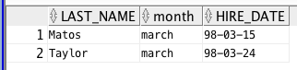

1. The Accounting department requires an analysis on maximum and minimum salaries by job, manager, and department. They have asked you to do the following: (5 marks)

Write a query to display the following groupings:

Department_id, job_id:

select department_id, job_id, min(salary), max(salary)

from employees

group by department_id, job_id;

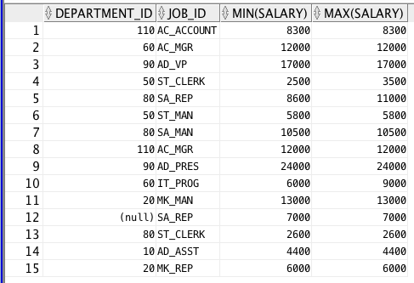

Job_id, manager_id:

select manager_id, job_id, min(salary), max(salary)

from employees

group by manager_id, job_id;

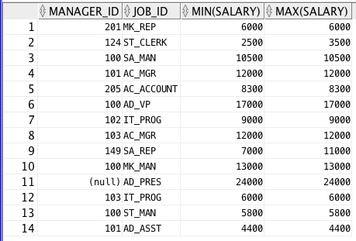

1. Create the EMP table based on the structure of the EMPLOYEES table. Include only the EMPLOYEE_ID, FIRST_NAME, LAST_NAME, SALARY, and JOB_ID columns for departments 90,80,60, and 50. Name the columns in your new table NO, FIRST_NAME, LAST_NAME, SALARY, and JOB_TITLE, respectively. (5 marks)

create table emp (no, first_name, last_name, salary, job_title) as

select employee_id, first_name, last_name, salary, job_id

from employees

where department_id in (90, 80, 60, 50);

output: Table EMP created.

1. (15 marks)

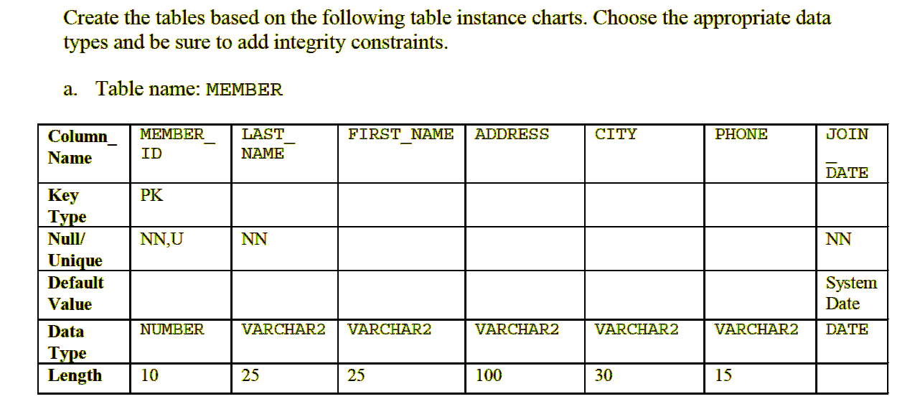

create table member(

member_id number(10) primary key not null,

last_name varchar2(25) not null,

first_name varchar2(25),

address varchar2(100),

city varchar2(30),

phone varchar2(15),

join_date date default sysdate not null

);

output: Table member created.

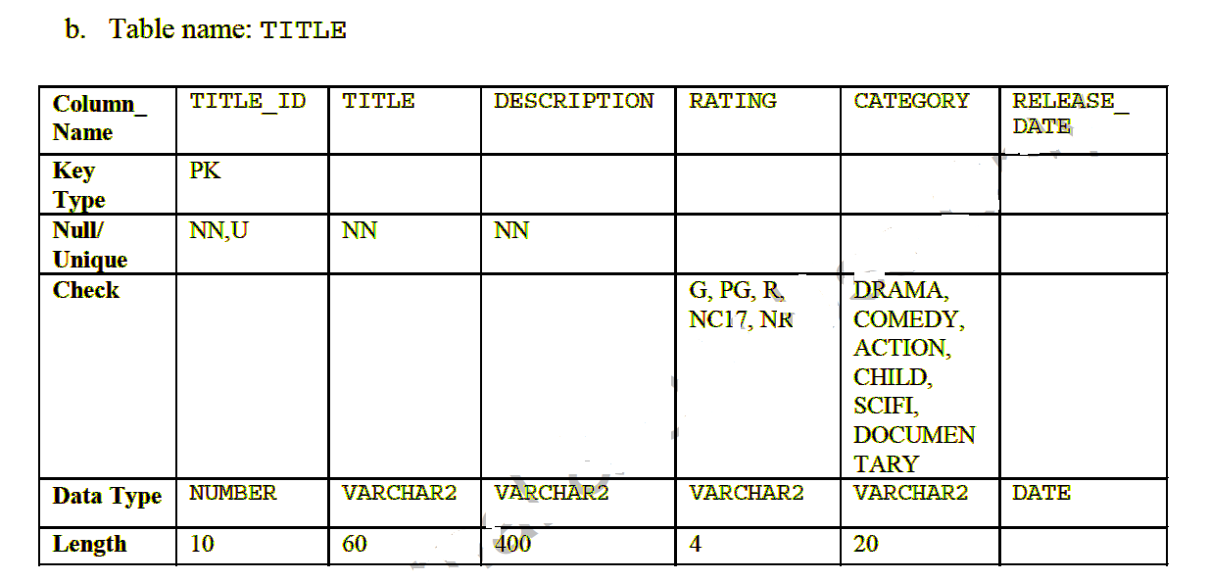

create table title(

title_id number(10) primary key not null,

title varchar2(60) not null,

description varchar2(400) not null,

rating varchar2(4) constraint title_rating_ck check(rating in ('G','PG','R','NC17','NR')),

category varchar2(20) constraint title_category_ck check(category in ('drama', 'comedy', 'action', 'child', 'scifi', 'documentary')),

release_date date

);

output: Table TITLE created.

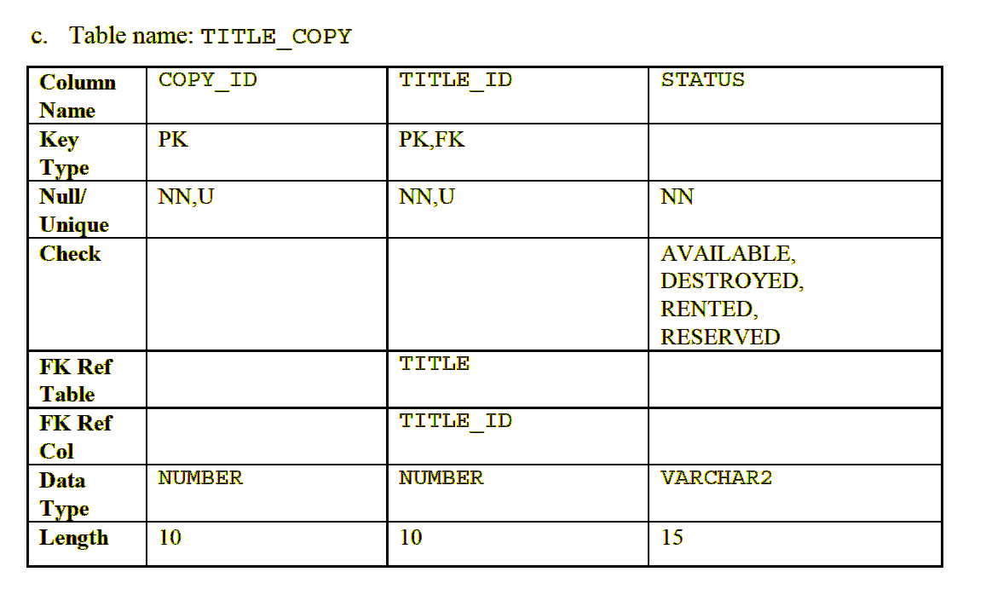

create table title_copy(

copy_id number(10),

title_id number(10) references title(title_id) not null,

status varchar2(15) constraint status_ck check(status in ('available', 'destroyed', 'rented', 'reserved')),

constraint copy_title_pk primary key (copy_id, title_id)

);

output: Table TITLE_COPY created.

1. (5 marks)

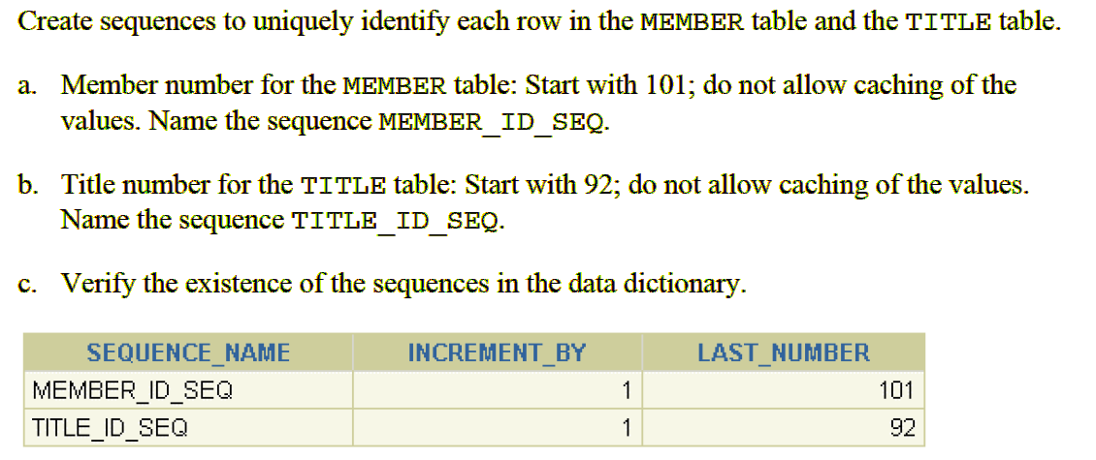

create sequence member_id_seq

start with 101

nocache;

output: Sequence MEMBER_ID_SEQ created.

create sequence title_id_seq

start with 92

nocache;

output: Sequence TITLE_ID_SEQ created.

select sequence_name, increment_by, last_number

from user_sequences

where sequence_name in (’MEMBER_ID_SEQ’, ’TITLE_ID_SEQ’);

