L1-DBS301-intro-select DBS301 Lab 1

– late means no grade

SUBMISSION: When you have finished, submit on Blackboard.

Hopefully, you downloaded demobld10 file and ran the script that will build the tables.

1 Start by ENTERING

SELECT * FROM EMPLOYEES;

SELECT * FROM DEPARTMENTS;

SELECT * FROM JOB_HISTORY;

Ask yourself, which one of these tables appeared to be the widest? 🡺 or longest?

(no answer required)

SELECT * FROM EMPLOYEES;

The table Employees is the widest or longest one.

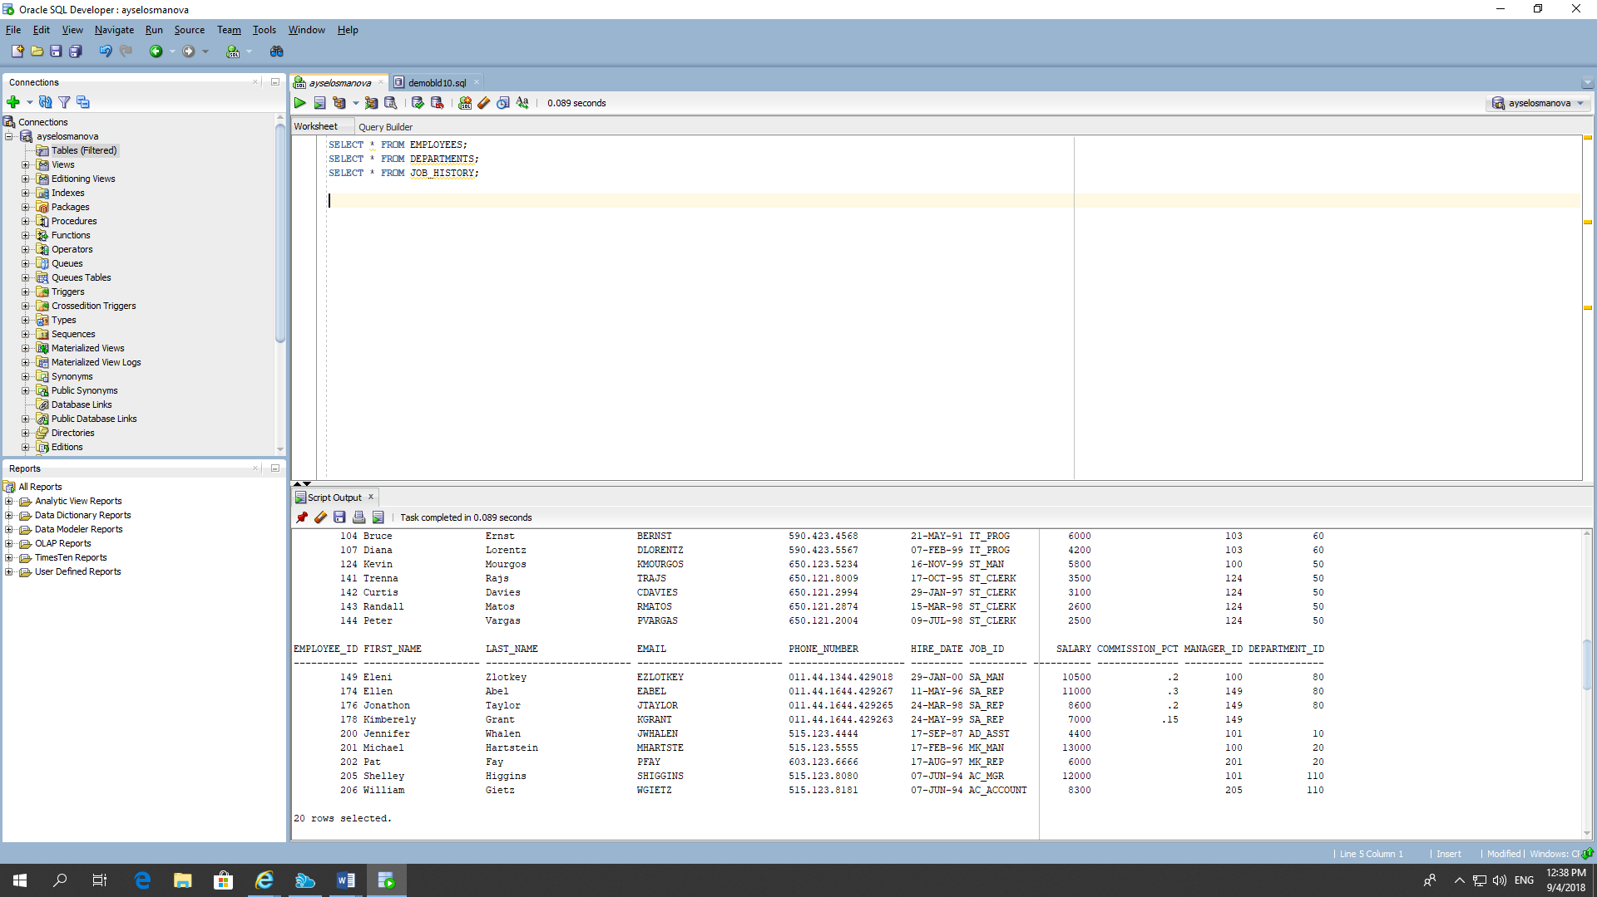

2. If the following SELECT statement does NOT execute successfully, how would you fix it.

SELECT last_name “LName”, job_id “Job Title”, Hire Date “Job Start”

FROM employees;

SELECT last_name "LName", job_id "Job Title", Hire_Date "Job Start"

FROM employees;

3 There are THREE coding errors in this statement. Can you identify them?

SELECT employee_id, last_name, commission_pct as “Emp Comm”

FROM employees;

4. What command would show the structure of the LOCATIONS table.

Desc LOCATIONS;

5 Create a query to display the output shown below.

City# City Province with Country Code

---------------------------------------------------------------------------------

1000 Roma IN THE IT

1100 Venice IN THE IT

1200 Tokyo Tokyo Prefecture IN THE JP

1300 Hiroshima IN THE JP

1400 Southlake Texas IN THE US

1500 South San Francisco California IN THE US

SELECT LOCATION_ID as "City#" , City "City" , State_province || 'IN THE' || country_id "Province with Country Code"

from locations

where location_id between 1000 and 1500;

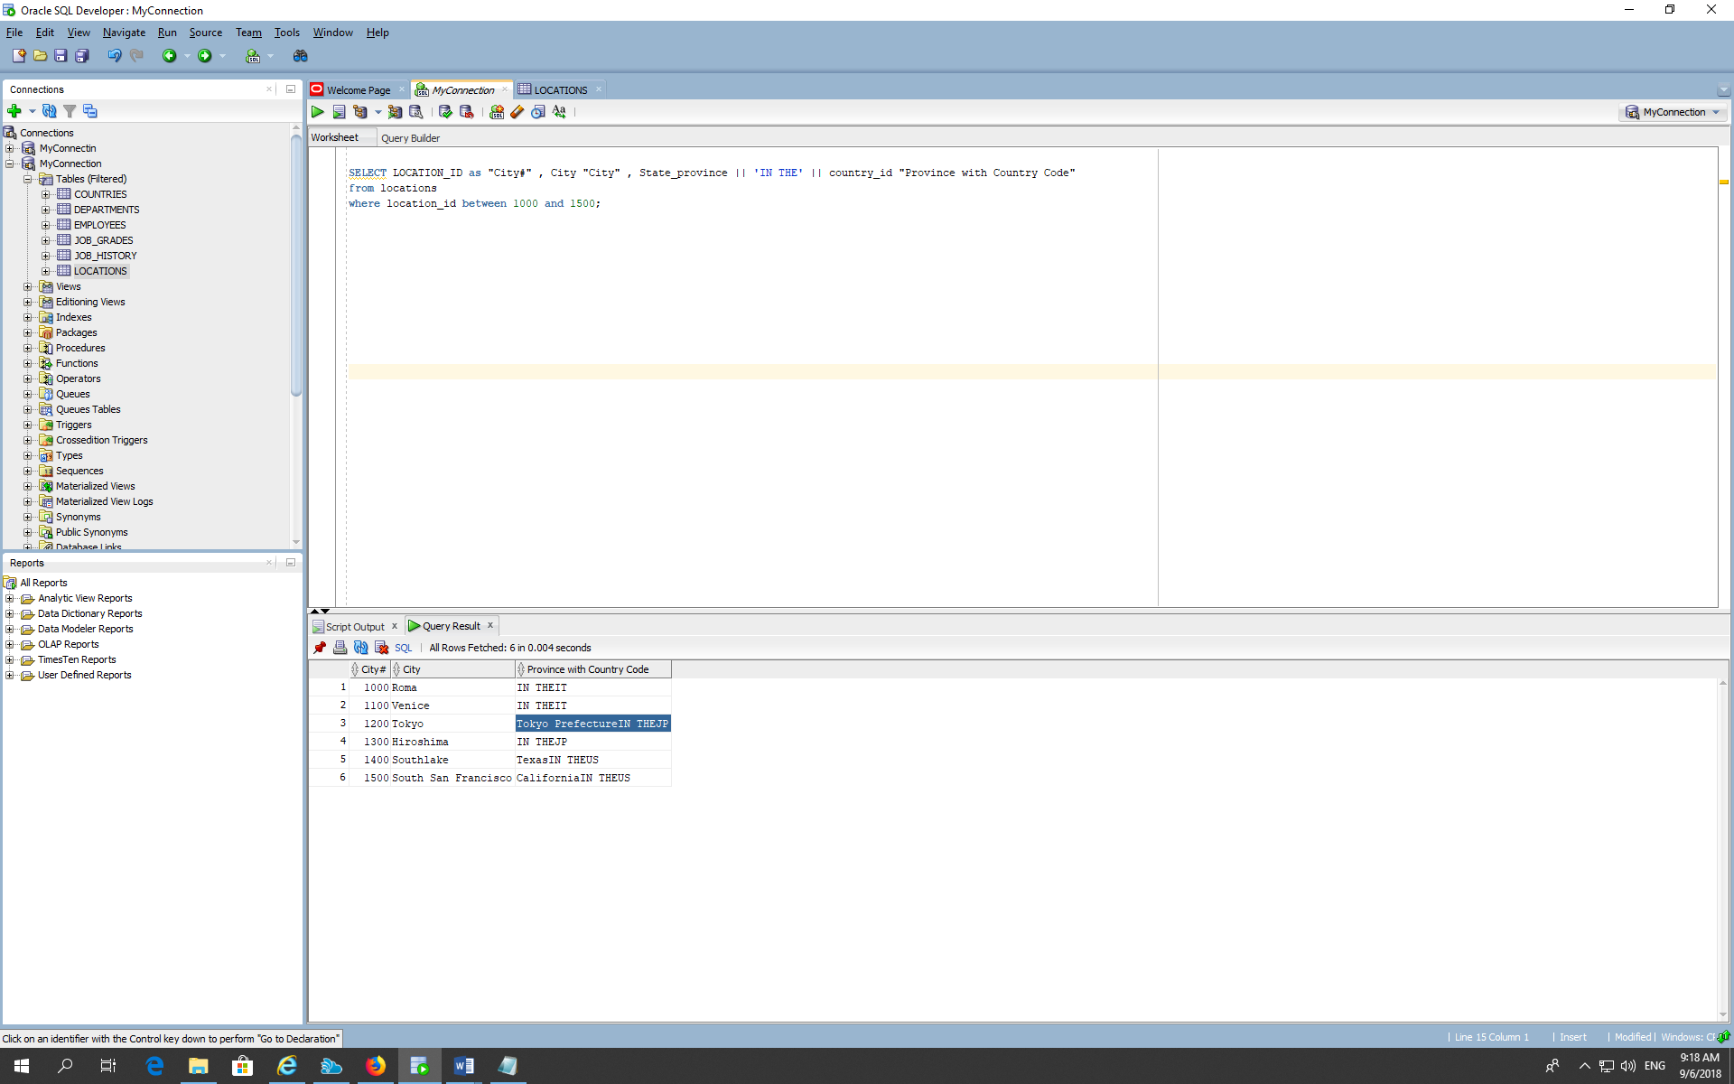

6. Create a query to display unique (department codes and job titles) from the EMPLOYEES table.

How many rows were returned

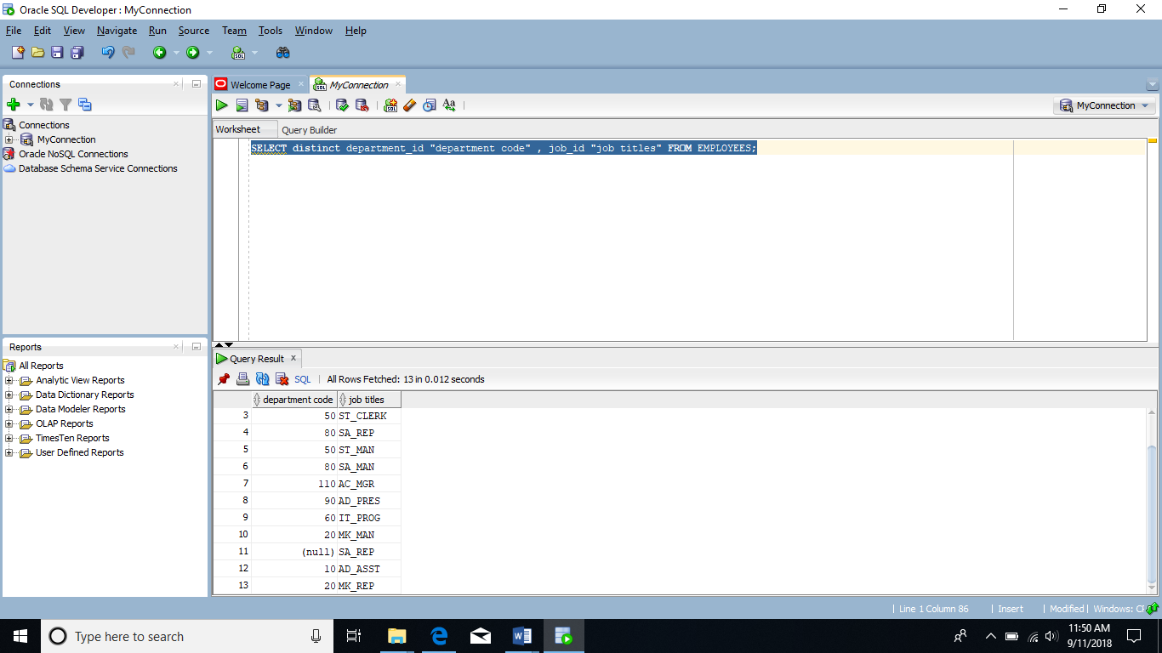

SELECT distinct department_id "department code" , job_id "job titles" FROM EMPLOYEES;

13 rows