L2-W2-DBS301-select-range-order

*STEP 1: rename the file to L2-your id name*

*STEP 2: Put the SQL and the results after each question below*

*STEP 3: Submit on Blackboard.*

1 Display the employee_id, last name and salary of employees earning in the range of $8000 to $15,000. Sort the output by top salaries first and then by last name.

select employee_id,last_name,salary

from employees

where salary >8000 and salary<15000

order by salary desc, last_name asc;

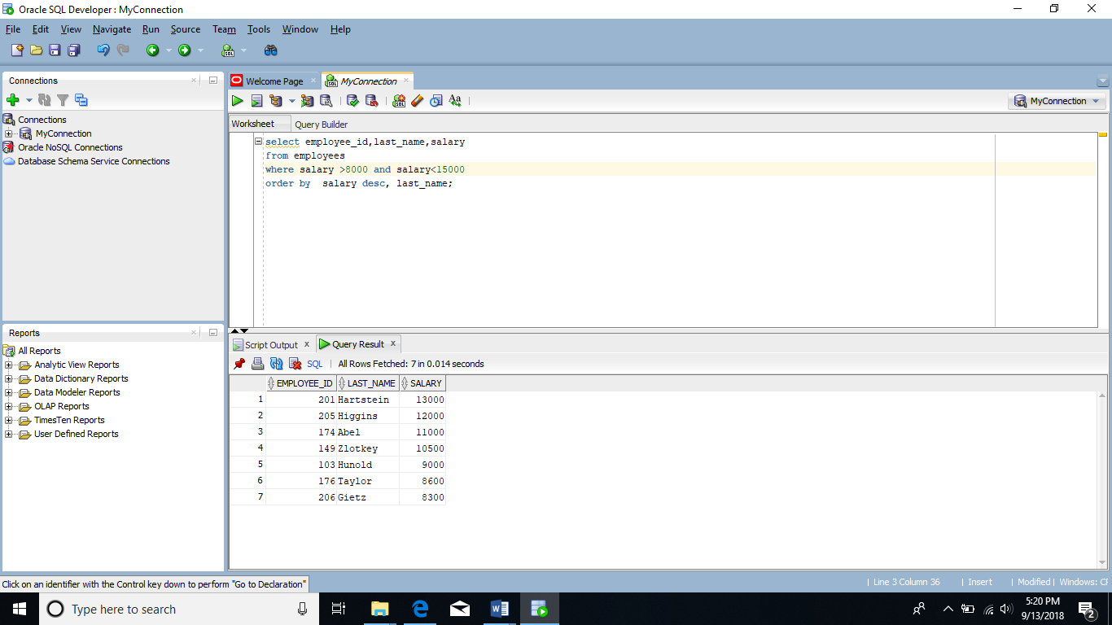

2 Modify previous query (#1) so that additional condition is to display only if they work as Programmers or Sales Representatives. Use same sorting as before.

select employee_id,last_name,salary

from employees

where salary >8000 and salary<15000

and job_id in ('IT_PROG','SA_REP')

order by salary desc, last_name asc;

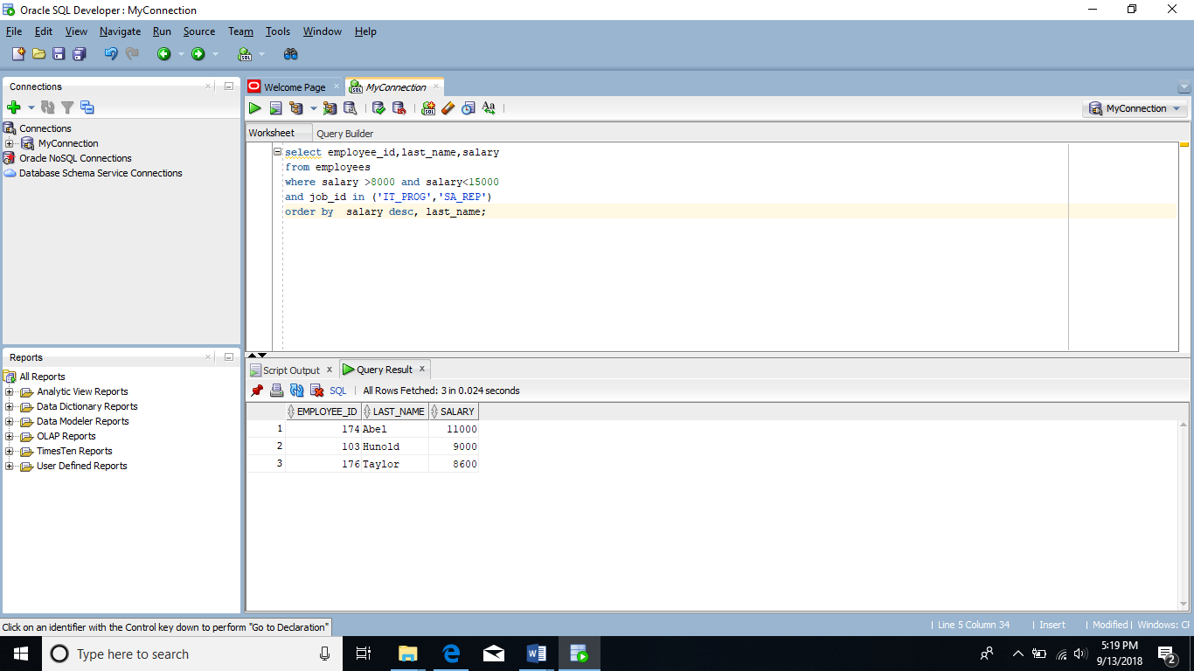

3 The Human Resources department wants to find high salary and low salary employees. Modify previous query (#2) so that it displays the same job titles but for people who earn outside the given salary range from question 1. Use same sorting as before.

select employee_id,last_name,job_id,salary

from employees

where job_id in('IT_PROG' , 'SA_REP')

and salary not between 8000 and 15000

order by salary desc, last_name asc;

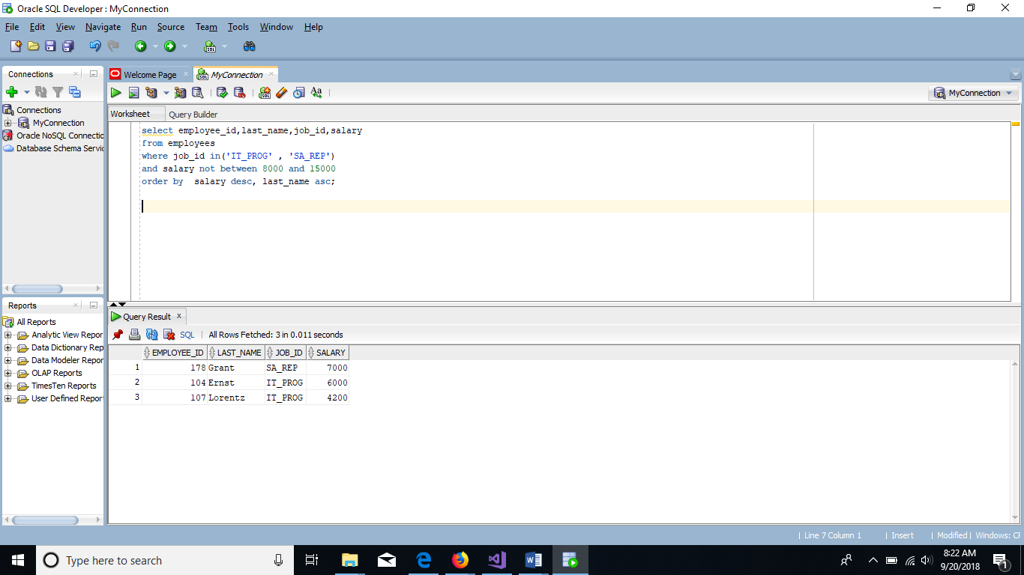

4 The company needs a list of long term employees, in order to give them a thankyou dinner. Display the last name, job_id and salary of employees hired before 1998. List the most recently hired employees first.

select last_name,job_id,salary

from employees

where hire_date<'01-JAN-98'

order by hire_date desc;

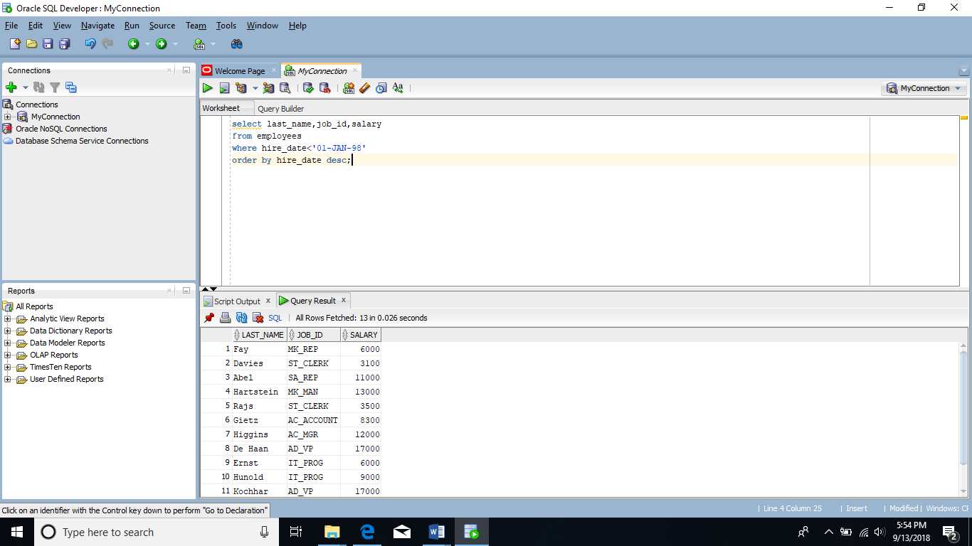

5 Modify previous query (#4) so that it displays only employees earning more than $10,000. List the output by job title alphabetically and then by highest paid employees.

select job_id "Job Title" ,salary

from employees

where salary>10000

order by job_id, salary desc;

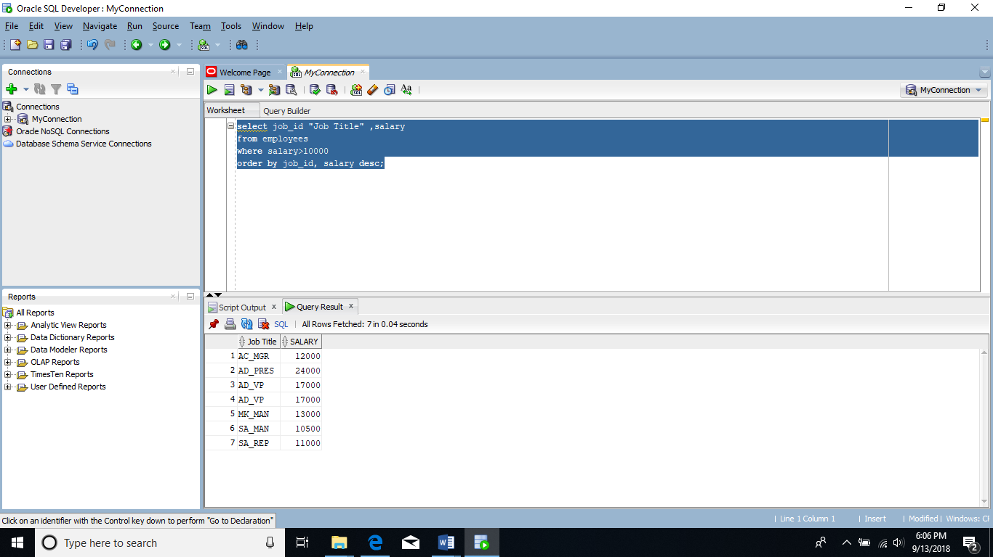

6 Display the job titles and full names of employees whose first name contains an ‘e’ or ‘E’ anywhere. The output should look like:

Job Title Full name

--------------------------------------

AD_VP Neena Kochhar

… more rows

select job_id "Job Title" ,first_name || ' ' ||last_name

as "Full name"

from employees

where first_name Like '%e%';

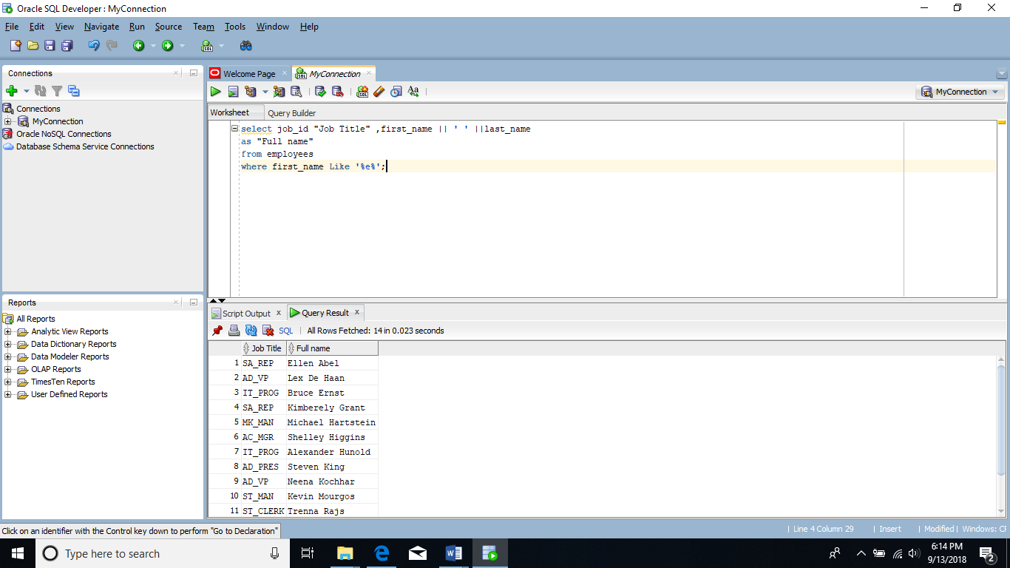

7 Create a report to display last name, salary, and commission percentage for all employees that earn a commission.

select last_name, salary,commission_pct

from employees

where commission_pct is not null;

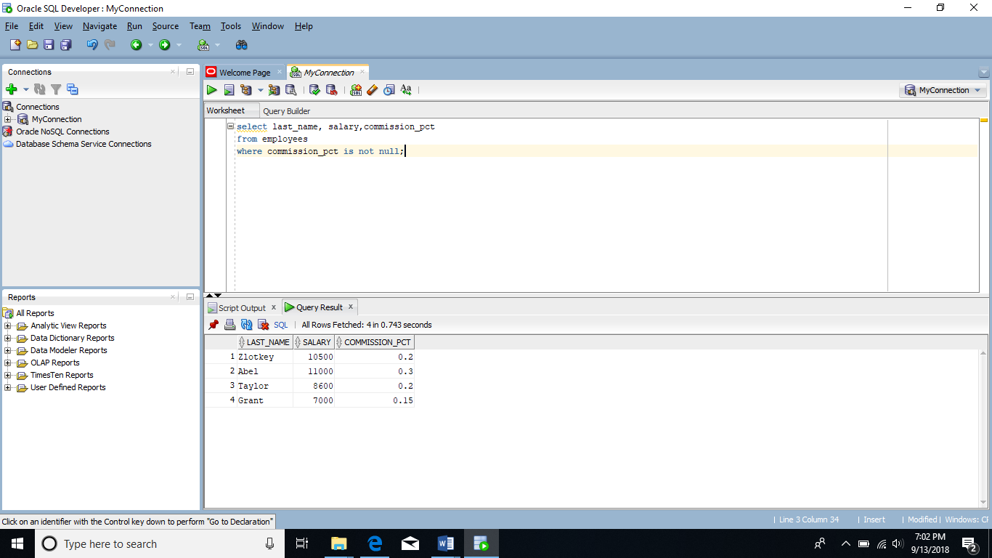

8 Do the same as question 7, but put the report in order of descending salaries.

select last_name, salary,commission_pct

from employees

where commission_pct is not null

order by salary desc;

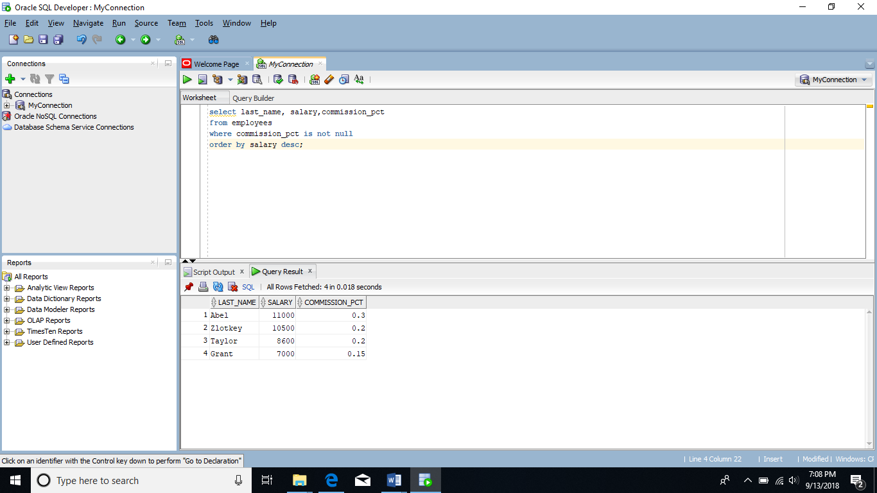

9 Do the same as 8, but use a numeric value instead of a column name to do the sorting.

select last_name, salary,commission_pct

from employees

where commission_pct is not null

order by 2 desc;