L4-W5-DBS301-Group functions

*STEP 1: Put the SQL and the results after each question below*

*STEP 2: Submit on Blackboard.*

1 Display the difference between the Average pay and Lowest pay in the company.

Name this result *Real Amount*.

select round(avg(salary))-min(salary) "Real Amount"

from employees;

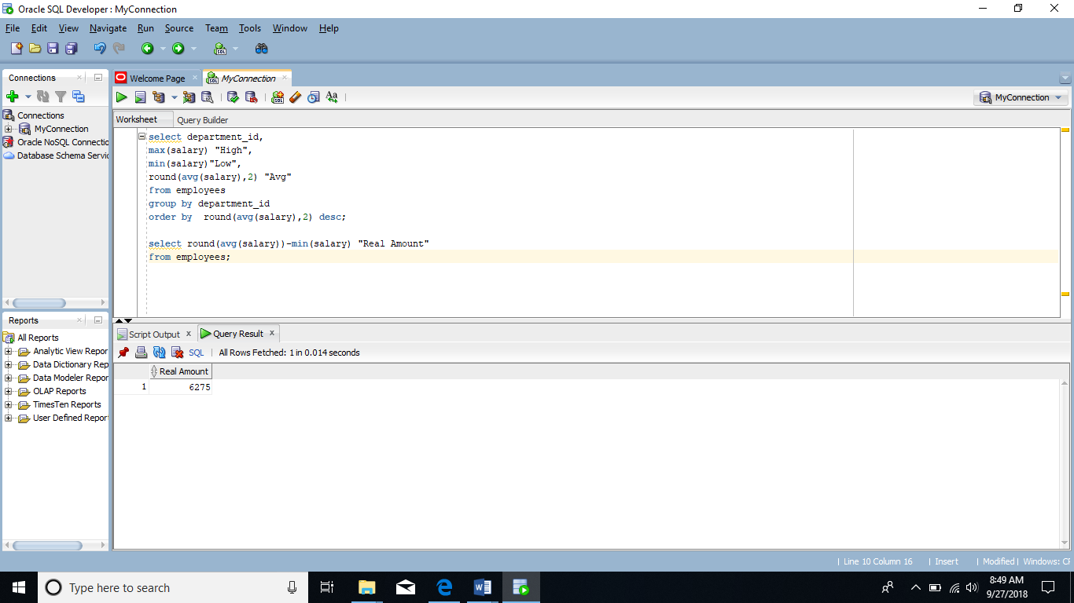

2 Display the department number and Highest, Lowest and Average pay per each department. Name these results *High, Low* and *Avg.*

Sort the output so that the department with highest average salary is shown first.

select department_id,

max(salary) "High",

min(salary)"Low",

round(avg(salary),2) "Avg"

from employees

group by department_id

order by round(avg(salary),2) desc;

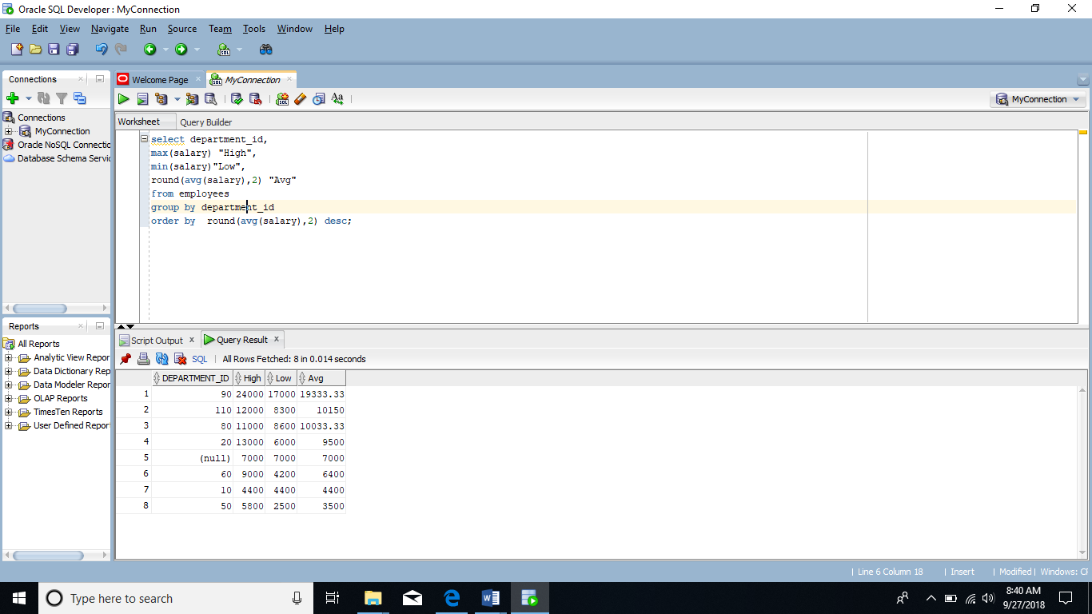

3 Display how many people work the same job in the same department.

Name these results *Dept#, Job* and *How Many.*

Include only jobs that involve more than one person.

Sort the output so that jobs with the most people involved are shown first.

select department_id "Dept#", job_id "Job",count (job_id) "How Many"

from employees

group by department_id, job_id

having count(job_id)>1

order by count (job_id)desc;

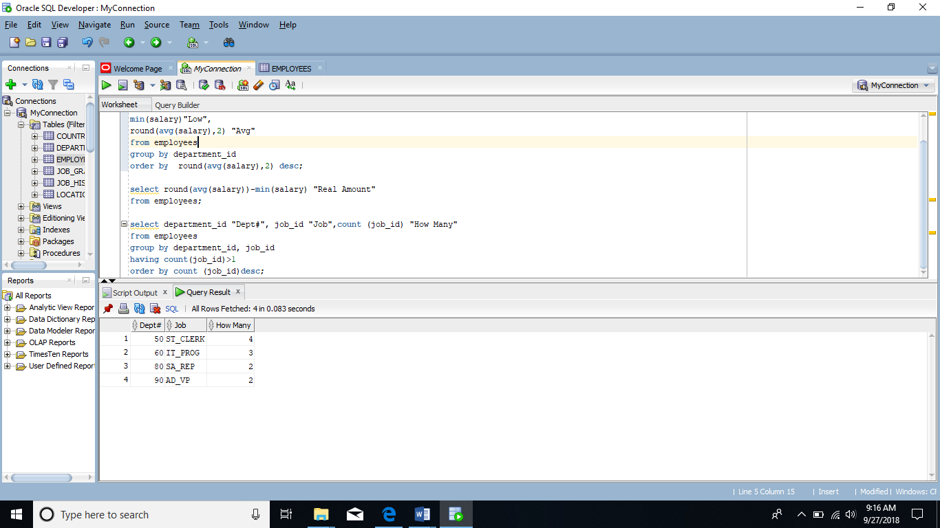

4 For each job title display the job title and total amount paid each month for this type of the job. Exclude titles *AD_PRES* and *AD_VP* and also include only jobs that require more than $15,000.

Sort the output so that top paid jobs are shown first.

select job_id, sum(salary)

from employees

where job_id not in ('AD_PRES','AD_VP')

group by job_id

having sum(salary)>15000

order by sum(salary) desc;

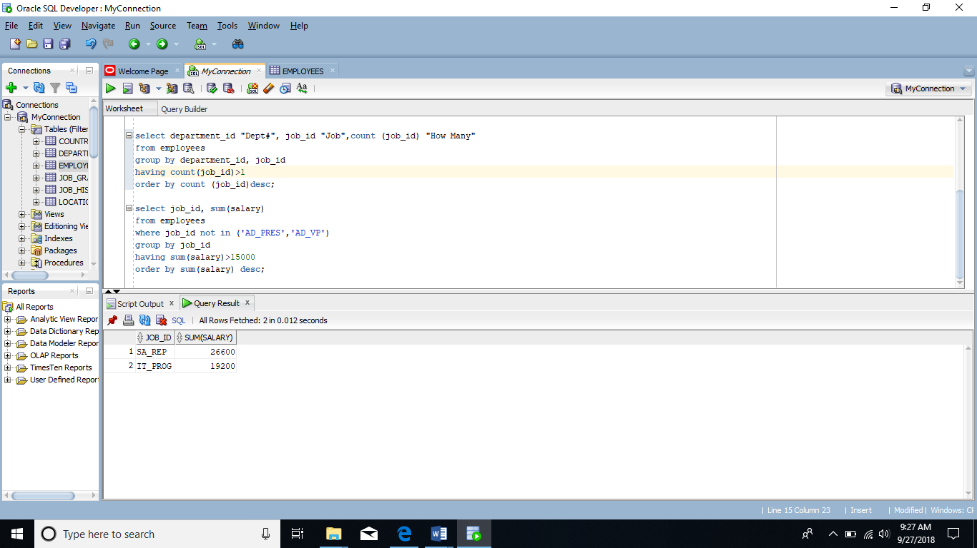

5 For each manager number display how many persons he / she supervises. Exclude managers with numbers 100, 101 and 102 and also include only those managers that supervise more than 2 persons.

Sort the output so that manager numbers with the most supervised persons are shown first.

select manager_id, count(employee_id) "How Many"

from employees

where manager_id not in (100,101,102)

group by manager_id

having count(employee_id)>2

order by count(employee_id) desc;

6 For each department show the latest and earliest hire date, BUT

- exclude departments 10 and 20

- also exclude those departments where the last person was hired in this century.

- Sort the output so that the most recent, meaning latest hire dates, are shown first.

select department_id,

max(hire_date) "Latest Hire Date",

min(hire_date) "Earliest Hire Date"

from employees

where department_id not in (10,20)

group by department_id

having max(hire_date)<'01-Jan-00'

order by max(hire_date) desc;

