L5a-DBS301-Simple Joins

**NOTE 1: This is about simple joins, so no LEFT or RIGHT joins etc. Required.**

**NOTE 2: There is a 5b on joins that also needs to be done**

**NOTE 3: If you are not finishing this in week 5, then you are actually running behind. Please catch up.**

1)      Display the department name, city, street address and postal code for departments sorted by city and department name.

select d.department_name, l.city, l.street_address, l.postal_code

from departments d, locations l

where d.location_id=l.location_id

order by l.city, d.department_name;

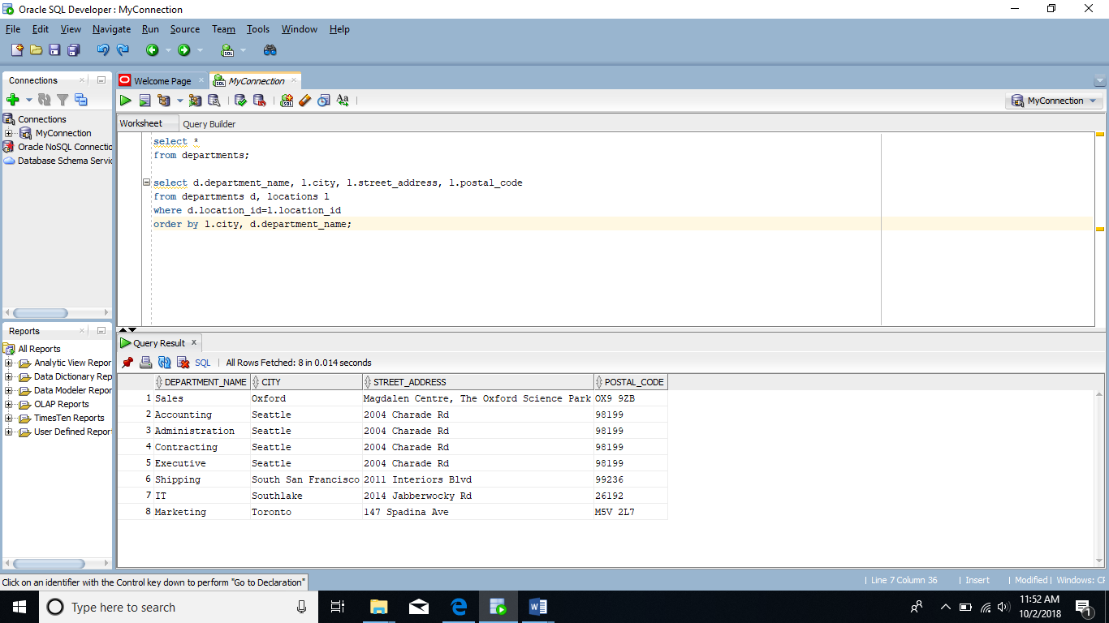

2)      Display full name of employees as a single field using format of **Last,** **First**, their hire date, salary, department name and city, but only for departments with names starting with an **A** or **S** sorted by department name and employee name.

select e.last_name || ' ' || e.first_name "Full Name", e.hire_date,e.salary,

d.department_name,l.city

from employees e

inner join departments d on e.department_id= d.department_id

inner join locations l on d.location_id = l.location_id

where d.department_name like 'A%' or d.department_name like 'S%'

order by d.department_name, e.last_name || ' ' || e.first_name ;

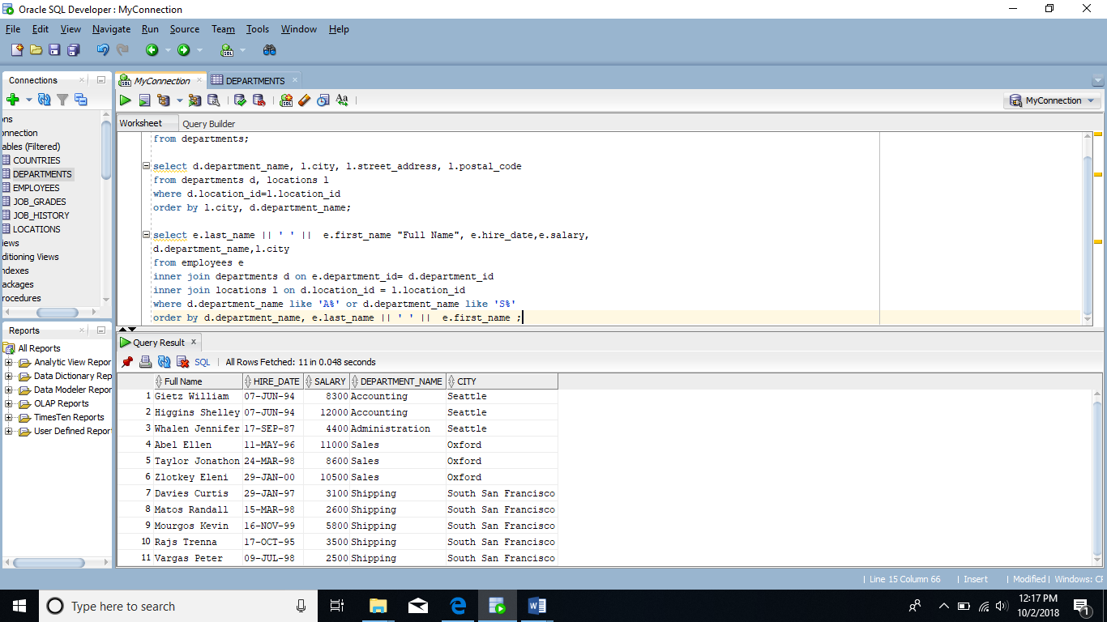

3)      Display the full name of the manager of each department in states/provinces of Ontario, California and Washington along with the department name, city, postal code and province name. Sort the output by city and then by department name.

select e.last_name || ' ' || e.first_name "Manager's name" ,d.manager_id

,d.department_name,l.city,l.postal_code,l.state_province

from employees e

inner join departments d on e.employee_id=d.manager_id

inner join locations l on d.location_id=l.location_id

where l.state_province in ('Ontario','California','Washington')

order by l.city,d.department_name ;

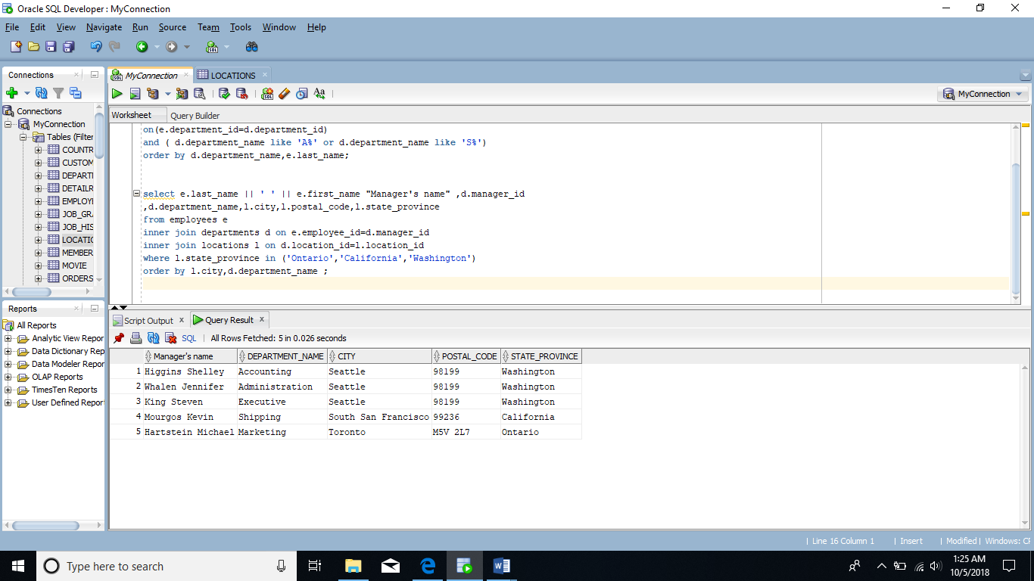

4)      Display employee’s last name and employee number along with their manager’s last name and manager number. Label the columns Employee, Emp#, Manager, and Mgr# respectively.

select e.last_name "Employee",e.employee_id "Emp#",m.last_name "Manager",

m.employee_id "Mgr#"

from employees e

inner join employees m on e.manager_id=m.employee_id;

