L05b-DBS301-non-simple joins

1. Display the department name, city, street address and postal contry name for all Departments. Use the JOIN and USING form of syntax.

Sort the output by department name descending.

select d.department_name,l.city,l.street_address,l.postal_code,c.country_name

from departments d

join locations l using (location_id)

join countries c using (country_id)

order by d.department_name desc;

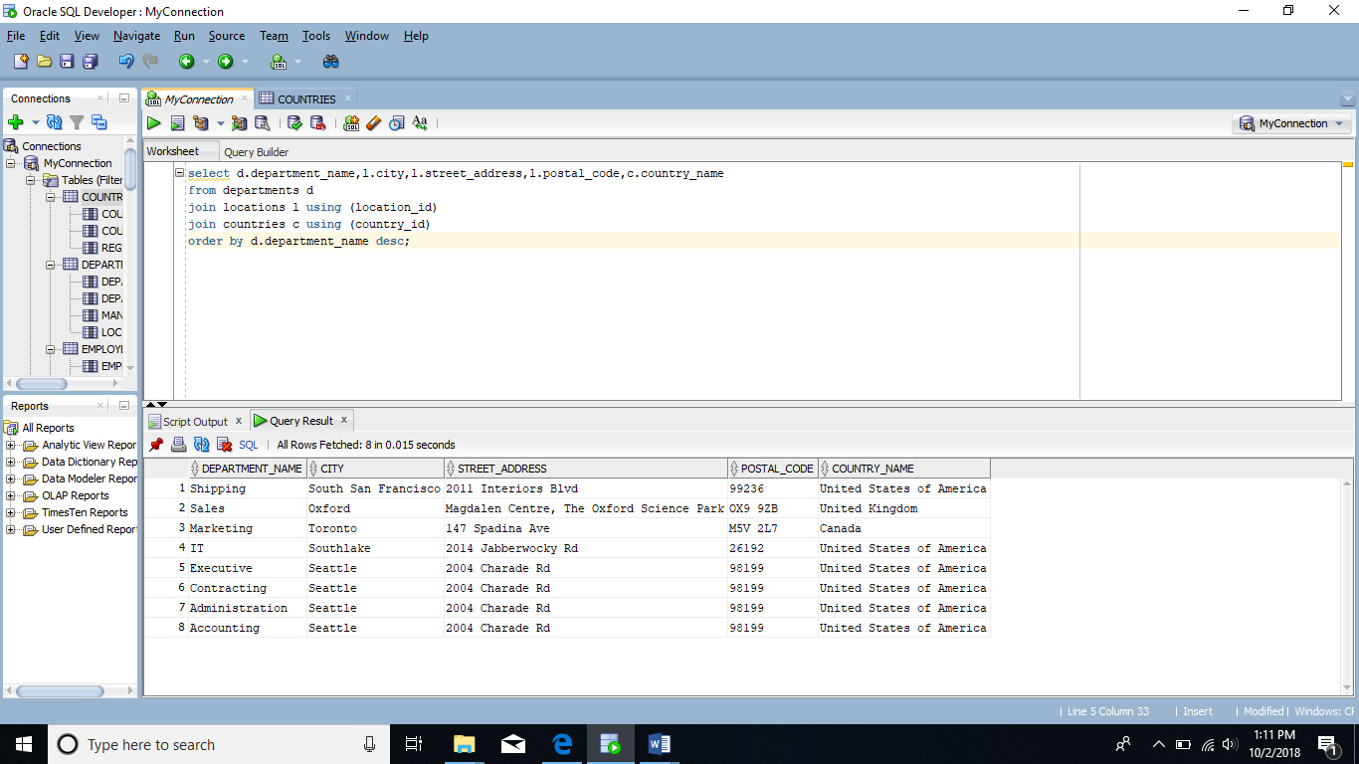

2. Display full name of the employees, their hire date and salary together with their department name, but only for departments which names start with **A** or **S**. Full name should be in format of :

**First / Last.** Use the JOIN and ON form of syntax.

Sort the output by department name and then by last name.

select e.first_name|| ' ' || e.last_name "Full Name", e.hire_date ,e.salary ,

d.department_name

from employees e join departments d

on(e.department_id=d.department_id)

and ( d.department_name like 'A%' or d.department_name like 'S%')

order by d.department_name,e.last_name;

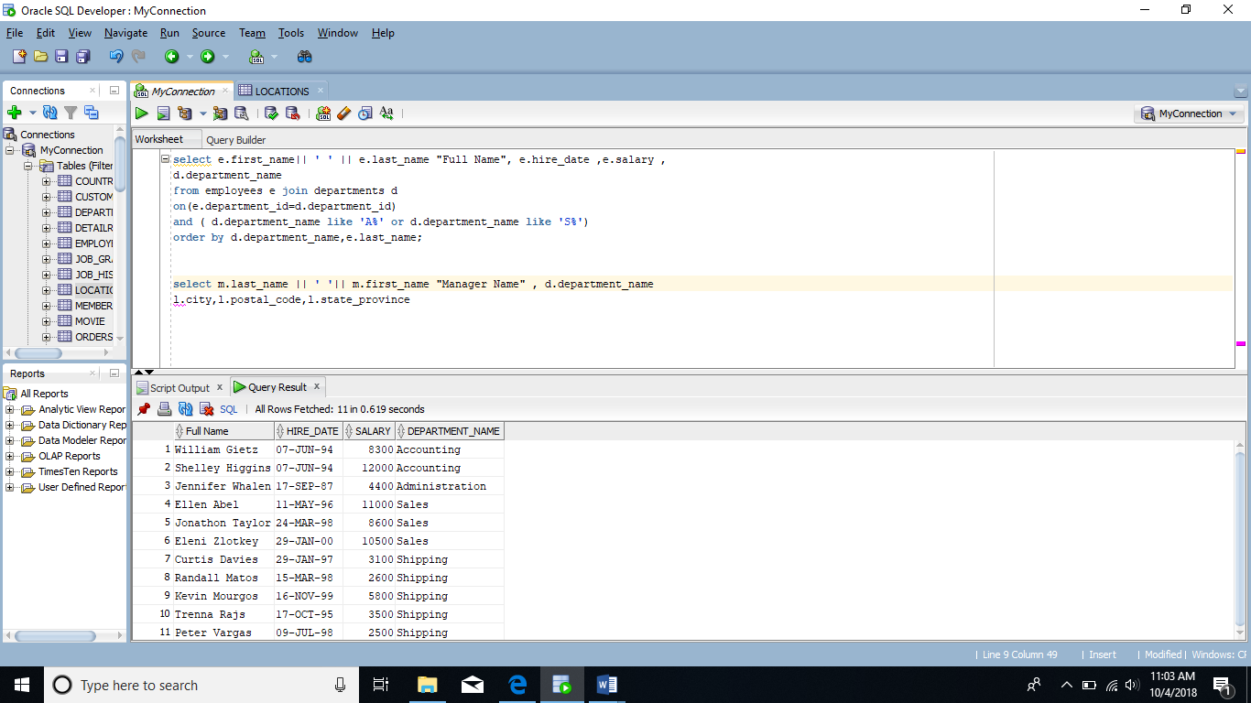

3. Rewrite the previous question by using Standard (Old -- prior to Oracle9i) Join

method.

select e.first_name|| ' ' || e.last_name "Full Name", e.hire_date ,e.salary ,

d.department_name

from employees e, departments d

where (e.department_id=d.department_id)

and (d.department_name like 'A%' or d.department_name like 'S%')

order by d.department_name,e.last_name;

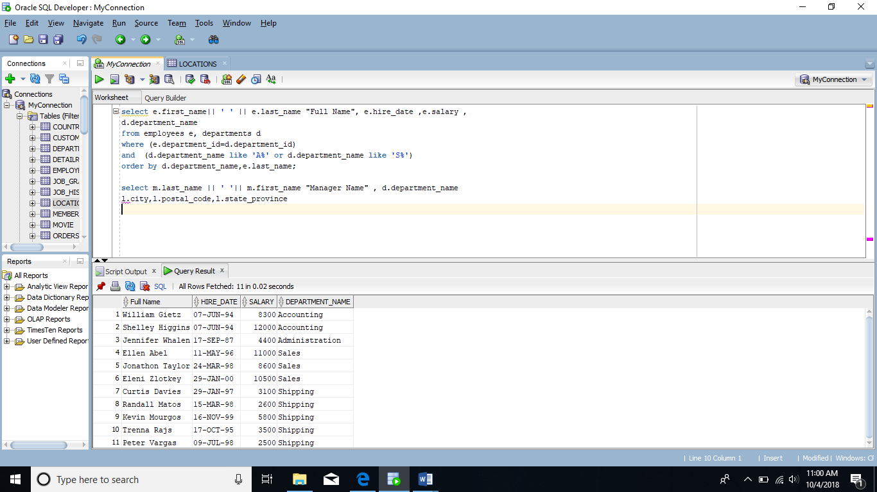

4. Display full name of the manager of each department in provinces Ontario,

California and Washington plus department name, city, postal code and province name. Full name should be in format as follows:

**Last, First.** Use the JOIN and ON form of syntax.

Sort the output by city and then by department name. 7

select e.last_name || ' ' || e.first_name "Full name" ,d.department_name,l.city,l.postal_code,l.state_province

from employees e

inner join departments d on e.employee_id=d.manager_id

inner join locations l on d.location_id=l.location_id

where l.state_province in ('Ontario','California','Washington')

order by l.city,d.department_name ;

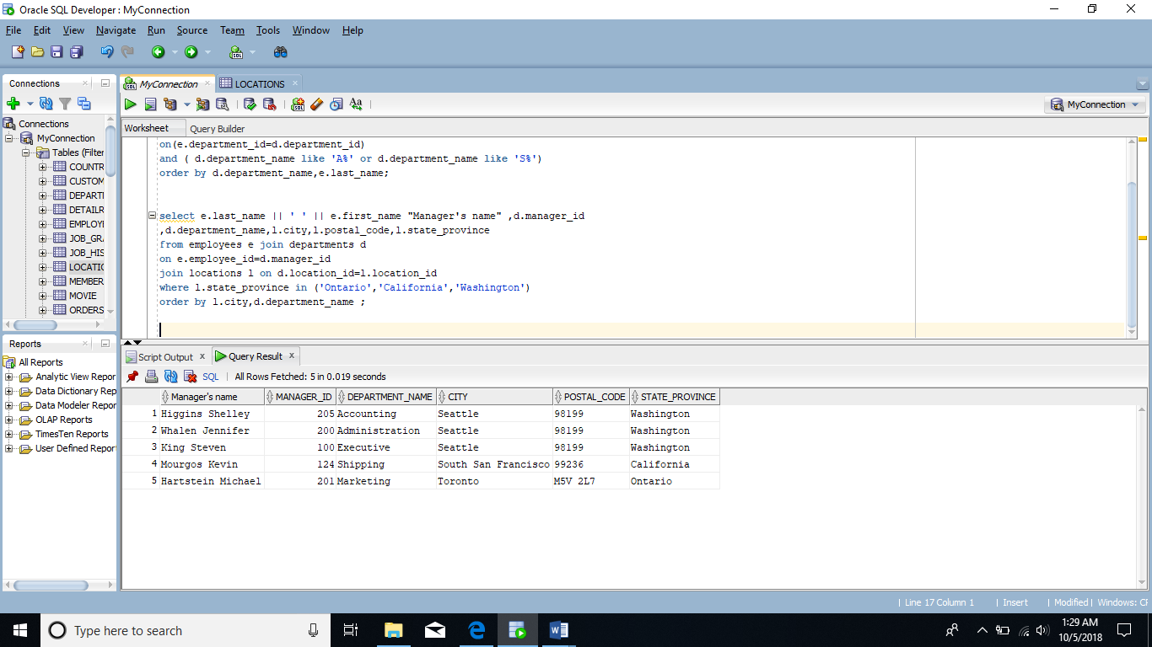

5. Rewrite the previous question by using Standard (Old -- prior to Oracle9i) Join method.

select e.last_name || ' ' || e.first_name "Full name"

,d.department_name,l.city,l.postal_code,l.state_province

from employees e , departments d ,locations l

where (e.employee_id=d.manager_id )

and (d.location_id=l.location_id) and

l.state_province in ('Ontario','California','Washington')

order by l.city,d.department_name ;

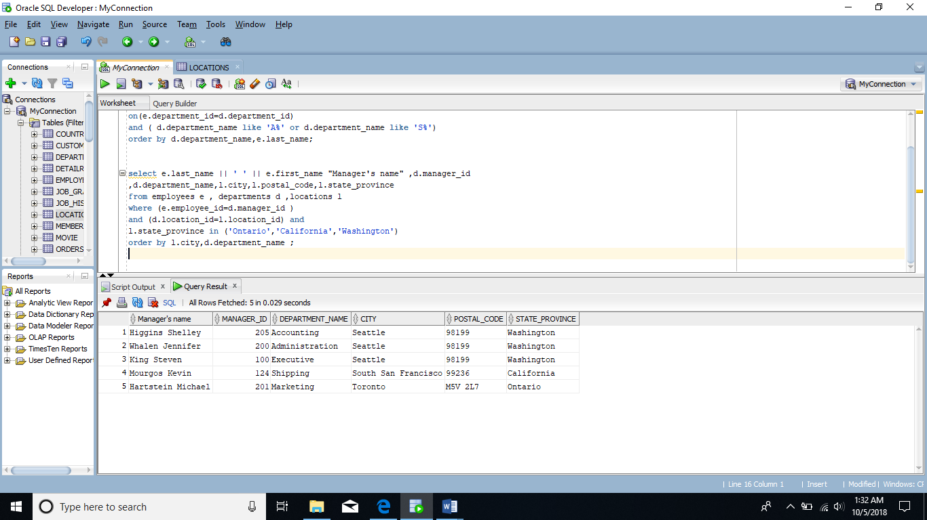

6. Display the department name and Highest, Lowest and Average pay per each department. Name these results *High, Low* and *Avg.*

Use JOIN and ON form of the syntax.

Sort the output so that department with highest average salary are shown first.

select department_name,max(salary) "High"

,min(salary) "Low",

round(avg(employees.salary),2) "Avg"

from departments join employees

on departments.department_id=employees.department_id

group by department_name

order by round(avg(employees.salary),2) desc;

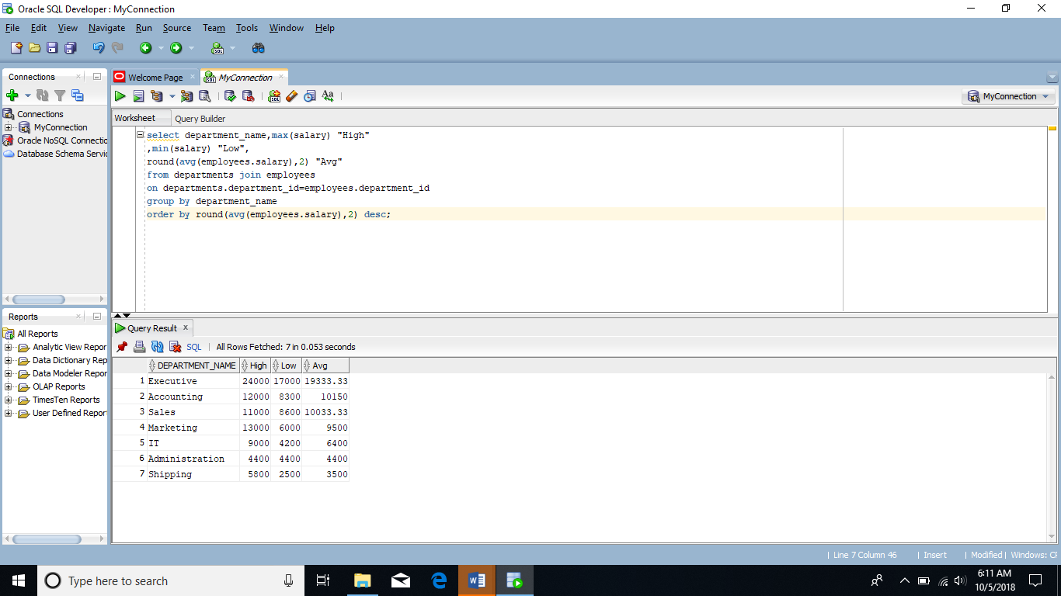

7. Display the employee last name and employee number along with their manager’s last name and manager number. Label the columns Employee,

Emp#, Manager, and Mgr#, respectively. Include also employees who do

NOT have a manager and also employees who do NOT supervise anyone (or

you could say managers without employees to supervise).

select e.last_name "Employee",e.employee_id "Emp#",m.last_name "Manager",

m.employee_id "Mgr#"

from employees e

full join employees m on (e.manager_id=m.employee_id);

