**ADNAN MENDERES UNIVERSITY**

**2020 – 2021**

**SOFTWARE ENGINEERING**

**PROJECT TEAM INFORMATIONS**

**UNITATIS**

**Ayşe Akışık**

**Ayşen Alpaslan**

**Betül Berna Soylu**

**Saliha Apak**

**Team Informations for Midterm Project**

Deliverer Team Member Name: Ayşen ALPASLAN

Team Members: Ayşe AKIŞIK, Ayşen ALPASLAN, Betül Berna SOYLU, Saliha APAK

Team Name: Unitatis

Project Name: Book Examination Website

Team Lead: Ayşen ALPASLAN

Strong features of our team: Our perspectives as team members are very similar. Our team communication and harmony is strong.

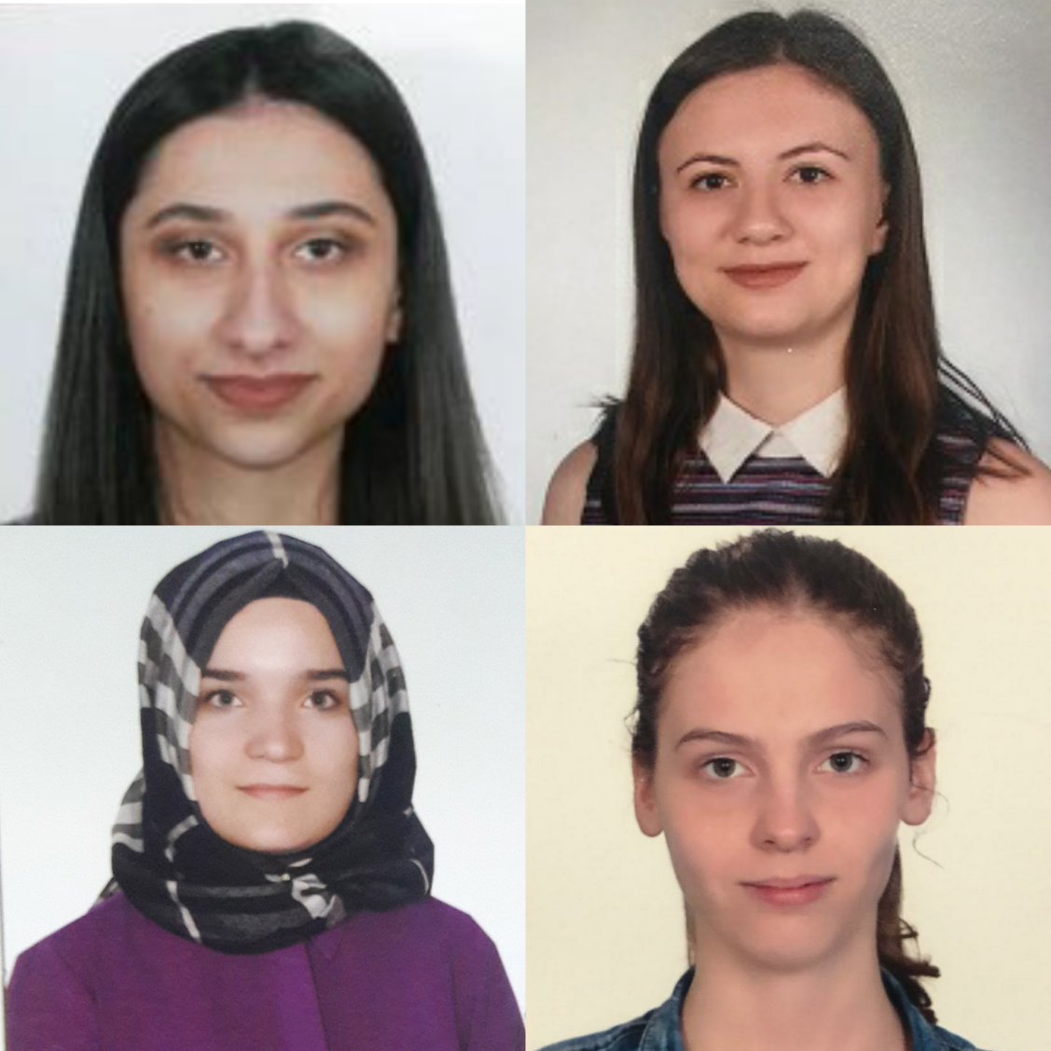

Team Biographies:

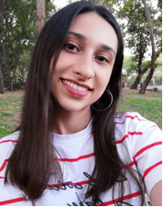My name is Ayşe Akışık, I am 21 years old and I live in Bursa. I am studying computer engineering at Adnan Menderes University. I want to contribute to the corporate development of the company I work for and improve myself in the meantime. I aim to improve myself and to benefit both myself and my environment. I am open to innovations, I love software development and technology. I am patient and I don't give up easily. I try to do my best when I need to do a project. I want to specialize in a field in my working life and move forward.

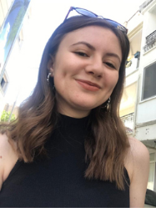I am Ayşen Alpaslan. I am a third year computer engineering student at Adnan Menderes University. My interests are web design and web development. I have attended courses, training camps and seminars in this area. My planned career goal is mobile programming and web programming. But because I wanted to know a different field, I did an internship at Masomo for 1 month. During my internship, I worked in the data team. In the gaming industry, the data stored is huge. So I learned how the collected data are made meaningful. I have been working as a Junior Web Developer at VS Digital since September. I prepared Anta Taşımacılık, ETV Manisa and Şeker Oto websites. I'm happy to develop myself in my field of interest.

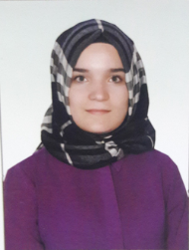Hello my name is Betül Berna Soylu. I was born on January 1, 2000 in Bursa. I completed my primary, secondary school in Bursa and my high school education in Istanbul. I have been a student of Aydın Adnan Menderes University Computer Engineering Faculty since 2017. I think my choice of this field is the right choice in world digitalization. I am familiar with different programming languages such as java, c ++, javascript, html, css and python. My level of English is good in reading, writing and listening. My hobbies are reading and doing research. I am also a member of IEEE Computer Society. My dream and goal is to become an IT / Computer specialist with the necessary skills and to work in government or private organizations.

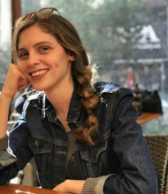I'm Saliha Apak. I am 21 years old and I am a 3rd grade student at Adnan Menderes University Computer Engineering department. My biggest regret about my department is that I wasn't involved in programming at a very early age. Because many factors such as the courses I took during my university education, the communities I am a member of, the seminars and courses I attended made me love my department. I also love and want to create new things, discover and help people. Therefore, it is my biggest dream to take myself to a much higher level in the field of programming and to write programs that can help people.

Github Accounts:

Ayşe Akışık: <https://github.com/ayyse>

Ayşen Alpaslan: <https://github.com/AysenAlpsln>

Betül Berna Soylu: <https://github.com/Berbet16>

Saliha Apak: <https://github.com/saliha99>

Team Agreement:

**Methods of Communication:** We use e-mail, phone, whatsapp correspondence, video speech tools as communication methods.

**Communication Response Times:** Communication via mail or message are answered with in 1 hour at the latest.

**Meeting Attendance**: All group members attend the meeting in order not to miss the project and homework. Participation in meetings is mandatory.

**Running Meeting:** The meeting was held on November 5 , 2020 at 13.00. We held our meeting on google meet application. The meeting took 1 hour. Project ideas and evaluation were made. Task distribution was made.

**Meeting Preparation:** Preparation fort he meeting is required because both to become more familiar with the meeting and not to waste time in the meeting.There may be preparations such as doing the necessary research about the meeting to be held or acquiring equipment such as paper and pen.

**Version Control:** Daily messages are about who does what and can not fo what.

**Division of Work:** In the project, 2 people will work in the design section, 2 people will work in the coding section. A meeting will be held and jointly prepared fort he files to be sent at each step. We have determined our team leader as Ayşen Alpaslan .

**Submitting Assignments:** Assignments will be sent on or before the assignment deadline . The assignment will be assigned by each group member. For general control purposes everyone will check.

**Contingency Planning:** If someone does not attend the meeting, they will have to leave the group. If someone is not academically honest, they must also leave the group.

|  |  |
| --- | --- |
|  | **AYŞE AKIŞIK** |
| Adress: Yıldırım / BURSA  Email: ayseakisik16@gmail.com  GSM: 0542 429 8973 |

|  |  |
| --- | --- |
| **PERSONAL INFORMATION**  **EDUCATION INFORMATION**  2017 - Continue  2013 - 2017  **COMPUTER SKILLS**  **FOREIGN LANGUAGE**  **HOBBIES**  **ASSOCIATION/CLUB MEMBERSHIPS**  **REFERENCES** | **Date of Birth:** 31.05.1999  **Marital Status :** Single  **Nationality:** T.C.  **University** Adnan Menderes University, Aydın  Computer Engineering  **High School** Bursa Anatolian Girl High School    **Microsoft Office**  **Operation Systems**: Windows  **Software Technology:** Python, C#, Java,  **Web Technology:** JavaScript, Html, Css, Asp.Net, .Net Core  **Database:** SQL  English  Painting, walk, sport  IEEE Computer Society  **Dr. Mahmut Sinecen**  ADU Engineering Faculty, 0543-5440923  **Dr. Hüseyin Abacı**  ADU Engineering Faculty, 0256-2137503 / 3762 |

|  |  |
| --- | --- |
| VESIKALIK | **AYŞEN ALPASLAN** |
| Güzelyurt Mah. Göçmen Evleri Açelya Apt. K:1 D:4  Yunusemre / Manisa  aysenalpaslan01@gmail.com  0505 140 8890 |

|  |  |
| --- | --- |
| **PERSONAL INFORMATION**  **EDUCATION INFORMATION**  2017 - Continue  2013 - 2017  **COMPUTER SKILLS**    **EXPERIENCE**  Aug. 2020-Sep. 2020    Sep. 2020-Continue  **FOREIGN LANGUAGE**  **HOBBIES**  **ASSOCIATION/CLUB MEMBERSHIPS**  **REFERENCES** | **Date of Birth:** 07.09.1999  **Marital Status :** Single  **Nationality:** T.C.  **University** Adnan Menderes University, Aydın  Computer Engineering  **High School** Dündar Çiloğlu Anatolian High School    **Software Technology:** C#, Java, Python, R  **Web Technology:** JavaScript, Html, Css, Asp.Net  **Database:** SQL  **Intern** (Masomo Gaming)  **Junior Web Developer** (VS Dijital)  English  Watching documentary, reading book, puzzles  IEEE Computer Society  AHBAP Manisa  **Ecem KARABACAKLAR**  Hesapkurdu.com, Quality Assurance Specialist, 0553 220 7819  **Arif ERSİN**  Kokteyl Bilgi Teknolojileri, Managing Partner, 0532 460 0466  **Veli TÜRE**  VS Dijital, Software Developer, 0507 929 2820 |

|  |  |
| --- | --- |
| CVRESMİ.jpg | **BETÜL BERNA SOYLU** |
| Yıldırım / BURSA  Email: bernasoylu16@gmail.com  GSM: 0534 486 5341 |

|  |  |
| --- | --- |
| **PERSONAL INFORMATION**  **EDUCATION INFORMATION**  2017 - Continue  2013 - 2017  **COMPUTER SKILLS**  **FOREIGN LANGUAGE**  **HOBBIES**  **ASSOCIATION/CLUB MEMBERSHIPS**  **REFERENCES** | **Date of Birth:** 01.01.2000  **Marital Status :** Single  **Nationality:** T.C.  **University** Adnan Menderes University, Aydın  Computer Engineering  **High School** Final High School / İstanbul    **Microsoft Office**  **Operation Systems**: Windows  **Software Technology:** Java, C,Python, Uml, Xml, R statistical programming  **Web Technology:** JavaScript, Html, Css, Php  **Database:** SQL  English  Travelling , Reading , Trekking  IEEE Computer Society  **Dr. Mahmut Sinecen**  ADU Engineering Faculty, 0543-5440923  **Dr. Hüseyin Abacı**  ADU Engineering Faculty, 0256-2137503 / 3762 |

|  |  |
| --- | --- |
|  | **SALİHA APAK** |
| Şehzadeler/MANİSA  Email: salihaapak@gmail.com  GSM:+90-542-3373986 |

|  |  |
| --- | --- |
| **PERSONAL INFORMATION**  **EDUCATION INFORMATION**  2017 - Continue  2013 - 2017  **COMPUTER SKILLS**  **FOREIGN LANGUAGE**  **HOBBIES**  **ASSOCIATION/CLUB MEMBERSHIPS**  **REFERENCES** | **Date of Birth:** 24.05.1999  **Marital Status :** Single  **Nationality:** T.C.  **University** Adnan Menderes University, Aydın  Computer Engineering  **High School** Zafer High School / Manisa    **Operation Systems**: Windows  **Software Technology:** Java, C, Python, R  **Web Technology:** Html, CSS  **Database:** SQL  English  Hiking, Yoga  IEEE Computer Society  **Dr. Mahmut Sinecen**  ADU Engineering Faculty, 0543-5440923  **Dr. Hüseyin Abacı**  ADU Engineering Faculty, 0256-2137503 / 3762 |

Video Conference Images:

