**ADNAN MENDERES UNIVERSITY**

**2020 – 2021**

**SOFTWARE ENGINEERING**

**SYSTEM REQUIREMENTS**

**UNİTATİS**

**Ayşe Akışık**

**Ayşen Alpaslan**

**Betül Berna Soylu**

**Saliha Apak**

***SYSTEM REQUIREMENTS***

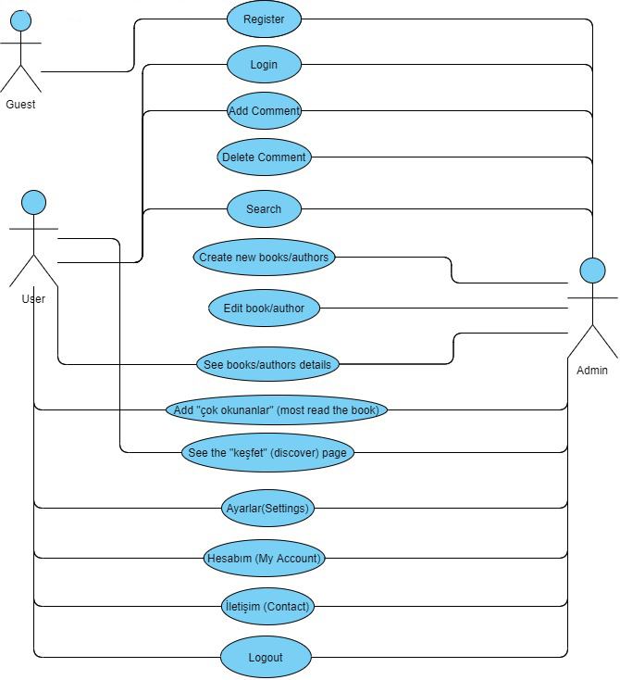

**User Story List**

1. As a “guest”

I want to register

So I will can enter the site as a “user”.

Acceptance Criteria: Given I'm a guest user, when I run the project, then the system shows me the registration page. When I fill in the necessary information and click the register button, the system directs me to the login page.

1. As a “user”

I want to login

So I can login to the site.

Acceptance Criteria: Given I'm a user, when I want to login, then the system shows me the login page. When I fill in the input boxes and click the login button, the system directs me to the main page.

1. As a “user”

I want to add a comment

Because I can help other users to have an idea about the book with the comment I add about the book I have read.

Acceptance Criteria: Given that I'm a user, when I want to add a comment, then I go to comments page. When I write a comment on the comments page and press the add button, the system save to my comment and directs me to the comments page.

1. As a “user”

I want to search

So since too many books or authors are registered in the system, it becomes easier for me to find what I am looking for and I can save time.

Acceptance Criteria: Given that I'm a user, when I want to search, then I go to search bar. When I write anything on the search bar, the system shows me the books or authors related to it.

1. As a “user”

I want to see book/author details

Because the author, translator, summary, page number, category, language, publication date, etc. of the book and the author's life (date of birth, date of death, education, etc.) I want to learn many details like.

Acceptance Criteria: Given I'm a user, when I want to see book/author details, then I click "DETAY(Detail)" button on the book/author page. When I open the detail page, I can examine the detail.

1. As a “user”

I want to add “çok okunanlar”(most read) the book

By voting on the book I'm reading, I can help it get into "the most read" section on the "discover page" at the end of the month.

Acceptance Criteria: Given I'm a user, when I want to add “çok okunanlar” (most read) the book, then I go to books page. When I click "LİSTELERE EKLE", I give the book a score.

1. As a “user”

I want to browse the “keşfet”(discover) page

Because I want to see the most read books of the month and the most liked comments about these books.

Acceptance Criteria: Given I'm a user, when I want to browse the "keşfet(discover)" page, then I click to "Keşfet" tab. When I open the discover page, I see books liked by readers.

1. As a “user”

I want to enter the “ayarlar”(settings) page

So I can update my profile information whenever I want.

Acceptance Criteria: Given I'm a user, when I to enter the settings page, then I click the setting icon. When I open the settings page, I can go to the setting area I want and make changes.

1. As a “user”

I want to enter the “hesabım”(my account) page

So I can read the comments I have made on my own page and view my profile information at any time.

Acceptance Criteria: Given I'm a user, when I want to enter the account page, then I click the user icon. When I open the profile page, I can change the my profile informations.

1. As a “user”

I want to enter the “iletişim”(contact) page

So when I have a problem, suggestion or complaint about the site, I can contact the site officials.

Acceptance Criteria: Given I'm a user, when I want to go contact page, then I click "İletişim(Contact)" tab. When I write a message and click to send button, I crete an contact with website admins.

1. As a “admin”

I want to create new book/author

So I can help our users who love to read and are curious about the lives of authors to learn about more books/authors.

Acceptance Criteria: Given I'm an admin, when I want to create new book/author, then I click the add button. When I write the book informations and click "EKLE" button, the book I added apperad in the list.

1. As a “admin”

I want to edit book/author

Therefore the misinformation about books and authors is noticed by me or the users, I can easily fix the problem.

Acceptance Criteria: Given I'm an admin, when I want to edit book/author, then I click the edit button. When I rewrite the information I want to change and save it, the book / author information changes.

1. As a “admin”

I want to delete comment

So I can remove comments that contain inappropriate content or that might offend other users.

Acceptance Criteria: Given I'm an admin, when I want to delete comment, then I click the delete button. When I see a wrong comment, I delete it by pressing the delete button.

1. As a “user”

I want to logout

Because I'm done on the site for now.

Acceptance Criteria: Given I'm a user, when I want to logout, then I click exit icon. When I'm done the my transactions, I leave the website.

* There are no user stories that are too big or too complex to be epic because it has an understandable and easy story (epic).It is enough to know the functional features of the features on the home page. As long as these features are known, there will be no problems on the site.
* When entering some sections on the home page, it can be divided into small user stories. These sections are divided into sections such as register, login, comment, search, book, authordetails, çok okunanlar(mostread), keşfet(discover), ayarlar (settings), hesabım(myaccount), iletişim (contact), logout.
* Besides the main story there are small user stories. On the ayarlar(settings) page, it is divided into sub-parts as profile information. There is no more splintering is needed.
* Physical Environment: There is a physical integrity but it is divided into sub-parts for the use of the system.
* User and human factor: Users who want to get information about books will use the system. It is very difficult for the user to abuse the system except for the comment part.
* Functionality: The system will enable us to get information about the commented books and to comment on the books we read. Since authors and books are registered in the system, it will be easier to find. By voting for the books, we will make it enter the most read page.
* Security: User data will be kept safe with the login account opened. At the same time, control is provided by logging into the system.
* Resources: C #, SQL, ASP.NET, MVC, HTML, CSS and JS trainings are required to set up a system.

**System Glossary**

**ASP.NET:** ASP.NET is a web application development technology developed by Microsoft.

**MVC:** MVC(Model-View-Controller) is an "architectural pattern" used in software engineering.

**C#:** C # is a modern programming language developed by Microsoft for .NET Technology.

**HTML:** HTML stands for Hyper Text Markup Language. HTML is the standard markup language for creating Web pages.

**CSS:** CSS stands for Cascading Style Sheets. CSS describes how HTML elements are to be displayed on screen, paper, or in other media.

**JavaScript:** JavaScript is the Programming Language for the Web. It can update and change both HTML and CSS. It can calculate, manipulate and validate data.

**SQL Server Managament System:** SSMS is an integrated environment to manage a SQL Server infrastructure. It provides a user interface and a group of tools with rich script editors that interact with SQL Server.

**Bootstrap:** Bootstrap is a free and open-source CSS framework directed at responsive, mobile-first front-end web development.

**Antlr:** (Another Tool for Language Recognition) is a powerful parser generator for reading, processing, executing, or translating structured text or binary files.

**EntityFramework:** EF is an open source object-relational mapping (ORM) framework for ADO.NET.

**jQuery:** The purpose of jQuery is to make it much easier to use JavaScript on your website.

**JQuery.Validation:** This jQuery plugin makes simple client side form validation trivial, while offering lots of option for customization.

**Razor:** Razor is an ASP.NET programming syntax used to create dynamic web pages with the C# or VB.NET programming languages.

**AspNet.WebOptimization:** ASP.NET Optimization introduces a way to bundle and optimize CSS and JavaScript files.

**AspNet.WebPages:** This package contains core runtime assemblies shared between ASP.NET MVC and ASP.NET Web Pages.

**CodeDOM:** Replacement CodeDOM providers that use the new .NET Compiler Platform ("Roslyn") compiler as a service APIs.

**Microsoft.Web.Infrastructure:** This package contains the Microsoft.Web.Infrastructure assembly that lets you dynamically register HTTP modules at run time.

**Modernizr:** Modernizr adds classes to the <html> element which allow you to target specific browser functionality in your stylesheet. You don't actually need to write any Javascript to use it.

**Newtonsoft.Json:** Json.NET is a popular high-performance JSON framework for .NET

**PagedList:** PagedList makes it easier for .Net developers to write paging code.