The Analysis of Wheat Prices, Reasons and Results of Low Wheat Productivity in Turkey

Ayşenaz Gözde Yedekçioğlu-22MIS5001

Musa Şimşek-22COMP5002

Umair Ali Khan-21ITEC5001

Seyhun Altunbay Department of Computer Engineering Işık University seyhun.altunbay@isikun.edu.tr

*Abstract-* In this study we aim to analyze the factors that are affecting the prices and productivity of wheat which has been a significant problem recently. The rise in wheat prices and the decline in wheat productivity have especially affected the price of wheat-based food products. The study seeks to research the average selling price, export-import value and yield productivity of wheat in the last decade. The population growth in Turkey has been increasing to a significant level which is seen as one of the main factors influencing the amount of wheat production per person. As Turkey is not self sufficient in production of wheat, the need of wheat has been met by imports. However, due to low currency exchange rate of Turkish Lira, the cost of importing wheat has increased to a great extent. The main goal of this study is to find the critical factors that cause the decrease in wheat production by exploring the parameters such as inflation rate and cultivation areas. The increase in wheat prices will also be analysed and underlying reasons will be determined. The research will be conducted our research by using data-sets from data repositories, google sites and some research journals. Analysis tools such as PySpark and Python will be used in order to analyse the data-sets.

*Index Terms-* Data Analytics, Data Visualizations, Wheat prices, Wheat production per person, Population growth, Currency rate, Inflation rate

1. **Introduction**

Wheat is one of the most important agricultural products in Turkey. It’s an essential food source, consumed mostly as bread, pasta, flour and other wheat-based products. Turkey is considered very suitable for wheat cultivation with its favourable climate, geographical conditions and rich fertile land. Wheat is generally produced in Thrace and Mediterranean, Aegean, and Marmara seaside places as a spring type and in other places it is produced as a winter type (FAO, 2015). Although wheat could be cultivated in any field of Turkey, its productivity is in sharp decline caused by policies, rising costs, inefficient state support and drought.

Due to the growing population of Turkey, the demand for food products have increased to a significant level in the recent years. In 2002, when Turkey's population was 70 million, the annual wheat production was around 20 million tons. Now, the country's population is over 85 million, and the production is the same. Therefore, Turkey’s wheat import is expected to increase in the following years in order to meet the growing internal wheat requirement and global wheat flour demand.

1. **Parameters**

In this project, we will be examining different sets of parameters, which are:

*1)Focusing Parameter*

* The amount of wheat production per person

*2) Influencing Parameters*

* Inflation rate
* Cultivation areas
* Population growth
* Wheat prices
* Deforestation

*3) Affected Parameters*

* Wheat import rate

1. **Literature Review**

* **Wheat Production and Import in Turkey**

As wheat based food products are consumed highly in Turkey, the wheat production also plays an important role in meeting the internal need of the country.  Although Turkey takes place within the first 10 countries in the world wheat area, the amount of production is low. According to data from the FAO between the years 2005-2018 wheat production areas in the world increased by 6.70%, while wheat production area in Turkey has decreased by 20.98% (FAO, 2020).

Due to parameters such as population growth, high inflation, decline in wheat cultivation areas, and insufficient state support, it has become difficult more than ever for Turkey to be self-sufficient in production of wheat. Therefore, the policy has changed toward importing wheat to meet the needs of the country.

Turkey’s annual need of wheat is 30 million tons however according to the chair of the Board of Directors of the Chamber of Agricultural Engineers (TMMOB) it will be difficult for Turkey to produce 20 million tons of wheat in 2022. Thus, the gap will be covered with imports again.

**As a result of the decline in wheat cultivation areas, wheat import rates of Turkey between the years 2005 and 2022 have increased to a significant level which is shown in the figure below:**

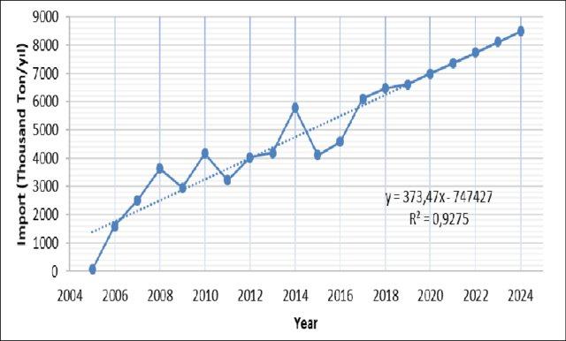

Figure 3: Wheat Import of Turkey between the years 2005-2020

* **Turkey’s Economy**

One of the most significant influencing parameters of the wheat production and import rates is the inflation rate and collapsing currency of Turkey.

Turkey's inflation rate was 85.51 percent in October 2022, the highest inflation rate recorded during the provided time period. Since late 2019, the inflation rate of Turkey has consistently been in double figures, with inflation accelerating fastest in the recent months (Statista, 2022).

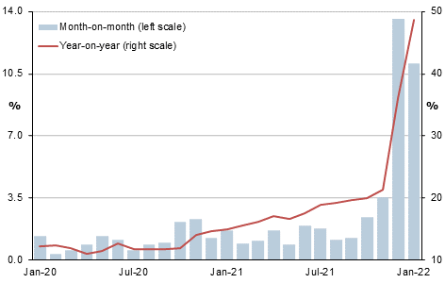

Figure 4: Turkey’s Inflation Rate

Agricultural activities are highly dependent on the imported agricultural products such as pesticides, fertilizer, fuel, etc. Turkish lira has declined 77% against the euro over the past decade. Due to the low currency of Turkey, the cost of importing these essential equipment has become very expensive.

* **Turkey’s Population**

Turkey’s population rose by more than 1 million in 2021. However, the totals only include resident foreigners with a residence/work permit, valid address or international protection identity document, but exclude refugees under temporary protection and those with temporary permits. The rising numbers of foreign workers will be seen as competing for jobs and services which will cause the economic situation of Turkey to get worse.

Turkey received the highest [number of registered refugees of any country or territory](https://en.wikipedia.org/wiki/List_of_countries_by_refugee_population) every year from 2014 to 2019, and had the world's largest refugee population according to the [United Nations High Commissioner for Refugees (UNHCR)](https://en.wikipedia.org/wiki/United_Nations_High_Commissioner_for_Refugees)

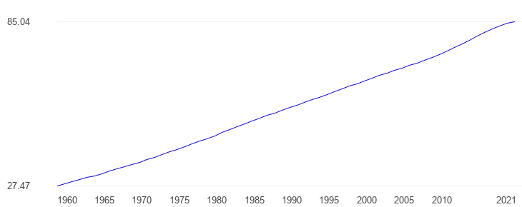

Figure 5: Turkey Population size in millions

* **Deforestation**

Average temperature is the estimate of the weather conditions in a specific area, which affects all parts of the ecosystem. Forests are being cut down and converted into living societies in Turkey as a result of industrialization and urbanization. This change in ecosystem disrupts the ecosystem's balance, from decomposers to producers and consumers. Climate is the average of a region's meteorological conditions, which has an impact on every component of the ecosystem. Forests are being destroyed and replaced into living societies as a result of industrialization and urbanization. The ecosystem's delicate balance between decomposers, producers, and consumers is upset by this transition. Essential component of an ecosystem is made up of plants, which are energy producers. Plant productivity and sustainability are impacted by this change. Wheat is a staple cereal that is significantly impacted by temperature and elevated CO2 levels. It not only has an impact on wheat yield but also makes wheat more susceptible to disease. High temperatures increase transpiration, which raises the risk of drought and lowers productivity.

1. **Datasets and Tools**

We found datasets from Tuik, U.S. Department of Agriculture (ASDA), Trading Economics and Worldometers’s website. We determined below datasets after reviewed literature. Most of the data analysis showed that these parameters affect wheat production per person to a significant level. Below you can see the summary of our data

|  |  |  |  |  |  |
| --- | --- | --- | --- | --- | --- |
| Year | Production (Million Tons) | Price (TL) | Cultivation Area (Million Hectares) | Wheat Import (Million Tons) | Inflation Index |
| 2011 | 21.80 | 0.58 | 8.10 | 3.22 | 202.33 |
| 2012 | 20.10 | 0.60 | 7.53 | 4.03 | 207.29 |
| 2013 | 22.05 | 0.66 | 7.77 | 4.19 | 221.74 |
| 2014 | 19.00 | 0.74 | 7.92 | 5.78 | 235.84 |
| 2015 | 22.60 | 0.77 | 7.87 | 4.11 | 249.31 |
| 2016 | 20.60 | 0.80 | 7.67 | 4.59 | 274.09 |
| 2017 | 21.50 | 0.88 | 7.67 | 6.11 | 316.48 |
| 2018 | 20.00 | 0.96 | 7.30 | 6.47 | 422.94 |
| 2019 | 19.00 | 1.21 | 6.85 | 10.79 | 454.08 |
| 2020 | 20.50 | 1.50 | 6.92 | 8.24 | 568.27 |
| 2021 | 17.65 | 2.04 | 6.74 | 8.10 | 1022.25 |

Table 1. Summary Wheat Production related statistics in Turkey

* 1. **Wheat Production**

According to data from the FAO between the years 2005-2018 wheat production areas in the world increased by 6.70%, while wheat production area in Turkey has decreased by 20.98% (FAO, 2020). Turkey’s annual need of wheat is 30 million tons however Turkey only produced 17 million tons of wheat in 2022. The wheat production dataset shared by Tuik is an excel file(.xlsx) format. We organized the dataset as comma separated documents (.csv). It comprises the wheat production (million tons) data of 10 years (2011-2021). In Fig.1, you can view the wheat production in Turkey between the years 2011 and 2021.

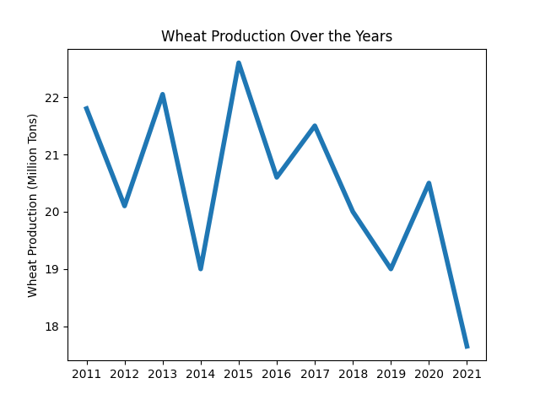

Fig. 1. Wheat Production in Turkey over the years

* 1. **Cultivation Areas**

The cultivation areas dataset shared by Tuik is in an excel file (.xlsx) format. We organized the dataset as comma-separated documents (.csv). It comprises the cultivation area (million hectares) data of 10 years (2011-2021) in Turkey. According to Tuik’s dataset, there’s a continuous decline in the wheat cultivation areas. The total cultivation area was reduced to **6,74** million hectares in 2021 from **8.10** million hectares in 2011. This corresponds to 17% reduction in the total of wheat cultivation areas in just ten years.

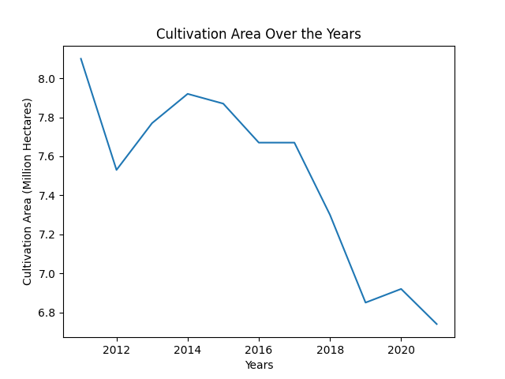

Fig.2. Wheat Cultivation area in Turkey over the years

* 1. **Inflation**

One of the most significant influencing parameters of the wheat production is the inflation rate and collapsing currency of Turkey. Turkey's inflation rate was 85.51% in October 2022, the highest inflation rate recorded during the provided time period. Inflation has risen significantly, particularly in the years 2021 to 2022. Figure 3 displays therising trend of inflation in Turkey. The inflation index rose to 1022 in **2021** from **202** in **2011**. This corresponds to over **400%** rise in the inflation index within ten years.

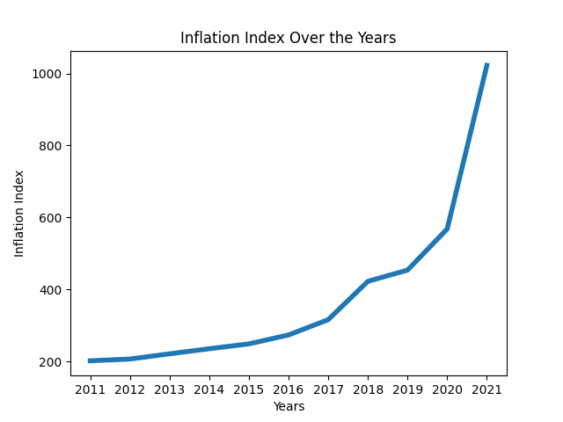

Fig.3. Inflation Index in Turkey over the years

* 1. **Wheat Prices**

Figure 4 shows the rising wheat prices in Turkey over the years. The wheat prices increased to **2.04 TL** in **2021 from 0.58 TL** in **2011**. This corresponds to over **250%** price increase in wheat price in just ten years.

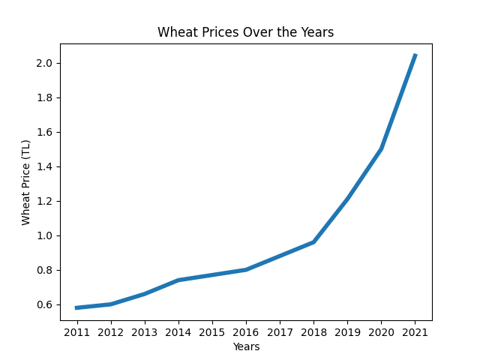

Fig.4. Wheat Prices in Turkey over the years

* 1. **Population Growth**
  2. **Temperature Change**
  3. **Wheat Import**

As a result of the decline in wheat cultivation areas, wheat import rates of Turkey between the years 2005 and 2022 have increased to a significant level. **Fig. 5** displays the rising trend of wheat imports of Turkey over the years. The total wheat imports increased to **8.1** million tons in **2021** from **3.2** million tons in **2011**. This corresponds to over **150%** increase in wheat imports within ten years

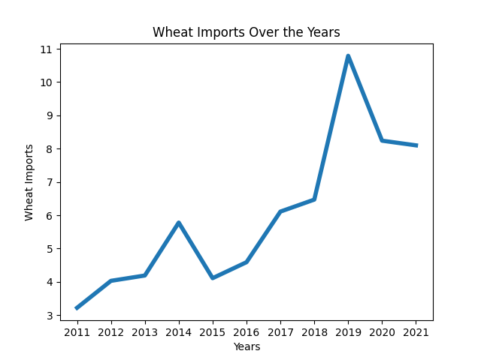

Fig.5. Wheat Import of Turkey over the years

1. **Datasets Analysis and Results**

First, we examined the focusing parameter which is the total wheat production per person decreased by over 19% from 2011 to 2021. The influencing parameters were found out as; inflation, cultivation areas, wheat prices, population growth and temperature change. The affected parameter from the decrease in wheat production was the wheat import.

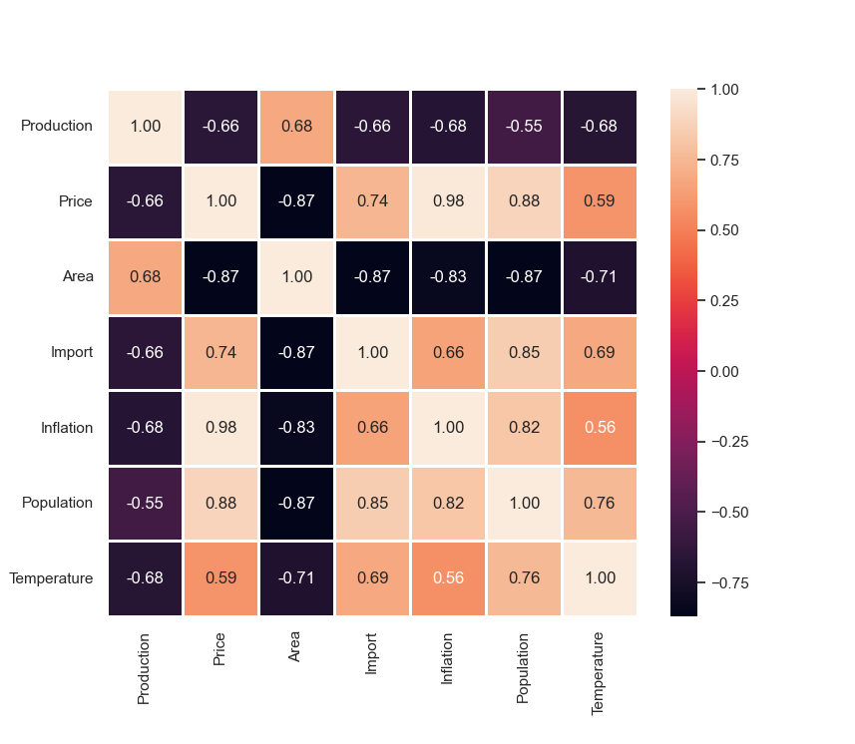

Fig.7. Correlation matrix for all datasets we used in analysis between years 2011 and 2021.

Second, we examined the total of wheat cultivation areas. From 2011 to 2021 wheat cultivation areas decreased by 17% in Turkey. Imports were used to compensate for the shrinkage in wheat production. Calculations showed a very significant correlation between the total of wheat cultivation areas and the total wheat production. We found a significant negative correlation relationship (Correlation is -0.87) between the wheat cultivation area and imports between 2011 and 2021 as showed in the figure below:

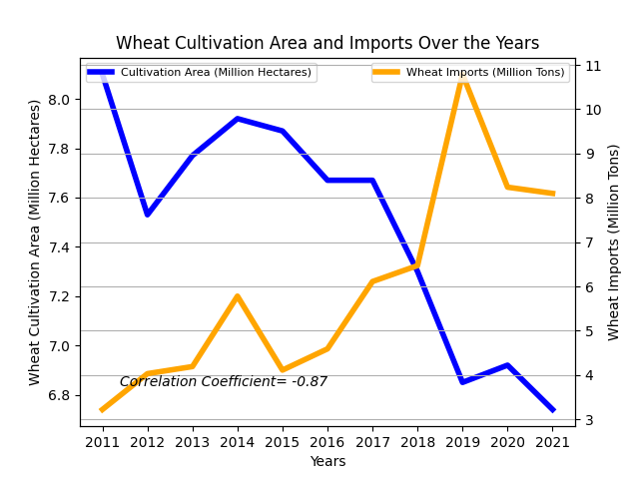

Fig.6. Wheat Cultivation Area and Wheat Imports Over the Years

In addition, further study pointed to a very strong negative correlation between inflation index and the size of the cultivation areas used for wheat production and also a strong negative correlation (-0.68) between inflation index and the amount of wheat production, suggesting that wheat farmers impacted by very high levels of inflation are gradually reducing the area of cultivation resulting in the shrinkage of wheat production. The correlation coefficient between wheat prices and inflation index (0.98) is very close to 1. Unless wheat farmers are protected from detrimental effects of inflationary environment by radically bringing down the rate of inflation and providing state subsidies and incentives, wheat production might further decrease.

We also analyzed the population growth in Turkey. Total population is increasing with immigrants and this leads to new demands of housing and food. On the other hand, total wheat cultivation area per person is decreasing over the years, which is another reason for food scarcity. Wheat import is doubled in last ten years as the result of high demand and low wheat production rate. While wheat import is increasing, wheat cultivation areas are decreasing in the same time interval.

1. **Conclusion**

This study intends to analyze the underlying reasons and results of the wheat production decline in Turkey. It also attempts to determine the relationship between the increase in wheat imports and the influencing parameters which are the population growth, decline in the wheat cultivation areas and drought. Due to these parameters, there has been a rising demand for wheat imports while the cost of importing wheat has been has steadily risen due to the declining exchange rate of Turkish lira. Therefore, the average wheat prices in the market has increased which has made it difficult for many consumers to buy wheat based products such as bread, pasta, flour, etc.

It can be concluded that due to population growth and increase in the livestock, there has been a continuous increase in wheat imports and this trend is expected to continue for the coming years in Turkey. Turkey's current agricultural production system cannot effectively cope with increased water scarcity and climate change. Therefore, an agricultural reform in Turkey is urgently needed. The negative impact of climate change on agriculture could be minimised by adopting sustainable, climate-friendly agriculture practices. The producers should be supported by public policies in order for them to cope with rising costs of imported agricultural inputs, such as fertilizer, fuel, and pesticides.  Otherwise, the cost of production will continue to rise which will cause average wheat prices to go up. Therefore, consumption of wheat based products may decline and mal nutrition/ undernourishment may rise within the population. Furthermore, due to the falling exchange rate of Turkish lira, it is turning out to be very costly to import wheat which may lead to wheat scarcity if the necessary precautions are not taken.

1. **Future Work**

We can expand this study by examining other agricultural products such as barley, corn and rice. We chose to examine wheat as it is the most imported agricultural product in Turkey. However, Turkey’s agricultural production has been decreasing especially recently. It is expected that the employment in agriculture will decrease and imports will rise thus agricultural studies will continue to play a significant role.

References

Cançelik, M., Şahin, Z., Sevinç, M. R., Küçük, N., & Aydoğdu, M. H. (2021). The analysis of the recent periods of wheat market in Turkey. *ITEGAM-JETIA*, *7*(27), 57-62. <https://doi.org/10.5935/jetia.v7i27.734>

Food and Agriculture Organization (FAO), “Wheat production quantity and area harvested,” 2020. http://www.fao.org/faostat/en/#data/QC (accessed Nov. 15, 2020).

TUIK, “Crop production statistics” 2020. <https://biruni.tuik.gov.tr/medas/?kn=92&locale=tr>

The Global Economy, Population, https://www.theglobaleconomy.com/Turkey/population_size/

“Wheat production statistics,” https://biruni.tuik.gov.tr/medas/?kn=92&locale=tr

“Agricultural product balance tables,” <https://biruni.tuik.gov.tr/medas/?kn=104&locale=tr>

“Wheat Prices”, https://biruni.tuik.gov.tr/medas/?kn=92&locale=tr

TCMB, “Purchasing Power Parity” https://tcmb.gov.tr/wps/wcm/connect/TR/TCMB+TR/Main+Menu/Istatistikler/Doviz+Kurlari/Reel+Efektif+Doviz+Kuruu/Veri+%28Tablolar%29+-+Kasim+2022/

“Currency rate”, <https://tradingeconomics.com/eurtry:cur>

World Bank, “Inflation Rate”, <https://www.macrotrends.net/countries/TUR/turkey/inflation-rate-cpi#:~:text=Turkey%20inflation%20rate%20for%202021,a%207.32%25%20increase%20from%202020>.

Worldometers, “Population of Turkey”, [www.Worldometers.info](https://www.worldometers.info/)