Full Stack Development Laboratory
Course Project

PROJECT TITLE
SystemForge: A Web-Based Platform for Visual Design and Simulation of Complex Systems
Course Details
● Programme: TY BTech CSE
● Course Name: Full Stack Development Laboratory
● Academic Year: 2025-26
● Semester: 6th
Group Members:
- Ayush Sairaman
- Sarthak Das
- C.M Sai Krishna

1. Abstract
Modern systems such as supply chains, infrastructure networks, and organizational workflows consist of numerous interconnected components whose interactions often produce complex and unpredictable outcomes. Traditional planning tools typically rely on static diagrams or manual analysis, which makes it difficult to evaluate how such systems behave dynamically under varying conditions. This limitation often results in inefficiencies, bottlenecks, and design flaws that only become apparent after implementation.
The proposed project, SystemForge, is a full-stack web platform designed to enable users to visually design complex systems and simulate their behavior before real-world deployment. The platform provides an interactive interface where users can construct systems using nodes and connections that represent components and relationships. Users can define operational parameters such as capacity, processing rates, and delays, and then run simulations that model system behavior over time.
The system analyzes interactions among components and provides insights into resource flow, bottlenecks, and system performance. Through dynamic visualization and analytics dashboards, users can identify inefficiencies and iteratively improve their designs. The expected outcome of the project is a comprehensive web-based tool that integrates system design, simulation, and performance analysis within a single platform, enabling better planning and decision-making for complex systems.
2. Introduction
2.1 Background and Motivation
Modern systems in areas such as logistics, urban infrastructure, business operations, and software architecture are composed of numerous interconnected components whose interactions determine overall performance. Designing such systems is challenging because small changes in one component can lead to significant effects across the entire network. Traditionally, system planning relies on static diagrams, spreadsheets, or manual analysis. While these tools help visualize system structure, they do not allow users to observe how the system behaves dynamically over time.
Simulation tools do exist, but many of them require specialized knowledge or complex programming environments, making them inaccessible to many users. As systems become increasingly complex, there is a growing need for tools that allow users to easily design systems, test different configurations, and analyze potential outcomes before implementation.
The motivation behind SystemForge is to provide a web-based platform that combines visual system design with dynamic simulation capabilities. By allowing users to model systems interactively and observe their behavior under different conditions, the platform helps users better understand system interactions and improve system efficiency.
2.2 Problem Statement
Existing planning and design tools often fail to provide an integrated environment where users can both visualize system structures and simulate their dynamic behavior. Static diagramming tools only represent relationships between components but do not allow users to analyze performance, resource flow, or potential failures.
On the other hand, advanced simulation software is often complex, expensive, and requires technical expertise that many planners or designers may not possess. As a result, system inefficiencies, bottlenecks, and design flaws are frequently discovered only after real-world implementation, which can lead to increased costs and operational challenges.
Therefore, there is a need for a user-friendly platform that enables individuals to design systems visually, simulate their behavior dynamically, and analyze performance metrics in an integrated environment.
2.3 Objectives
The main objectives of the proposed project are:
- To develop a full-stack web platform that allows users to visually design complex systems using interconnected components.
- To implement a simulation engine capable of modeling interactions between system components over time.
- To provide analytical tools and dashboards that help identify bottlenecks, inefficiencies, and performance issues.
- To enable users to modify system parameters and observe how changes affect overall system behavior.
- To create an interactive and user-friendly interface that simplifies system modeling and simulation.
- To support multiple system design scenarios for experimentation and analysis.
3. Literature Review / Related Work
Several tools and research efforts have been developed to assist in system design, modeling, and simulation. Diagramming platforms such as Lucidchart and Microsoft Visio allow users to create visual representations of system structures, workflows, and network architectures. These tools are widely used for planning and documentation purposes. However, they primarily focus on static visualization and lack the capability to simulate dynamic system behavior or analyze performance metrics.
Simulation platforms such as AnyLogic and Simul8 provide advanced capabilities for modeling and analyzing complex systems. These tools support discrete-event simulation, agent-based modeling, and system dynamics modeling, which are useful for studying supply chains, manufacturing processes, and infrastructure systems. Despite their powerful features, these platforms often require specialized knowledge and may involve complex configuration, making them less accessible for general users or students.
Other platforms such as NetLogo provide environments for modeling complex systems and simulations, particularly in academic research and educational settings. While NetLogo enables users to simulate interactions among agents within a system, it typically requires scripting and programming knowledge, which may limit usability for users who prefer visual design interfaces.
The limitation of many existing systems is the lack of an integrated platform that combines visual system design, real-time simulation, and interactive performance analysis within an accessible web-based environment. The proposed SystemForge platform aims to address this gap by providing a full-stack solution that allows users to design systems visually, define behavioral parameters, and run simulations within a unified and user-friendly interface. This approach improves accessibility while still supporting meaningful system analysis and experimentation.
4. Proposed System
4.1 Proposed Solution
The proposed system, SystemForge, is a full-stack web-based platform designed to enable users to visually design complex systems and simulate their behavior in a controlled environment. The platform allows users to create system models by defining components as nodes and relationships as connections between them. Each component can be configured with parameters such as capacity, processing rate, delay time, and interaction rules that determine how it behaves during simulation.
Once the system structure and parameters are defined, the platform runs simulations that model interactions between components over time. The simulation engine processes events and updates system states dynamically, enabling users to observe how resources, tasks, or information flow through the system.
The system also provides analytical tools that help identify inefficiencies, bottlenecks, and potential failure points within the designed system. Visualization dashboards present simulation results using graphs, metrics, and system maps, allowing users to interpret system performance easily. Users can modify parameters and rerun simulations to test different configurations and improve system efficiency. By combining visual modeling with dynamic simulation and analytics, the platform offers an integrated environment for system experimentation and design optimization.
4.2 System Architecture
The proposed architecture of SystemForge follows a multi-layer full-stack architecture consisting of a frontend layer, backend layer, simulation engine, and database layer.
At the frontend layer, users interact with the system through a graphical interface where they can design system models using drag-and-drop components. The interface allows users to create nodes, define connections, and configure system parameters. It also provides visualization tools for displaying simulation results and analytics dashboards.
The backend layer manages application logic, user management, project storage, and communication between the frontend interface and the simulation engine. It handles API requests, processes system configurations submitted by users, and coordinates simulation execution.
The simulation engine is responsible for running system simulations. It processes the defined system structure and parameters, evaluates interactions between components, and generates simulation outputs over time. The engine calculates metrics such as throughput, delays, and bottlenecks within the system.
The database layer stores system models, user projects, configuration parameters, and simulation results. This ensures that users can save, modify, and revisit their system designs for further experimentation.
Conceptually, the architecture can be represented as:

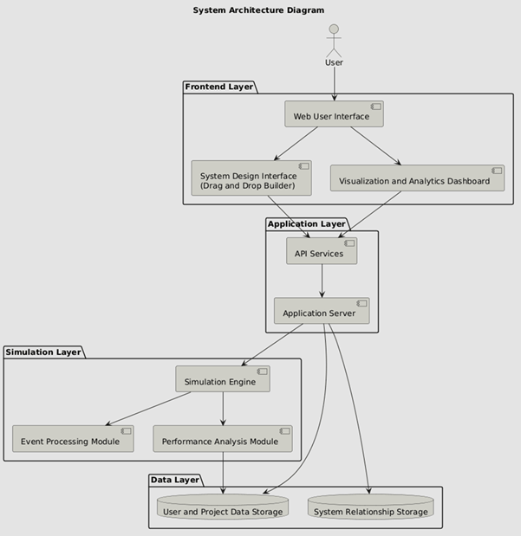

- Functional Requirements
- User Registration and Authentication
The system shall allow users to create accounts and securely log in to access the platform.
- Project Creation and Management
The system shall allow users to create, edit, save, and delete system design projects.
- Visual System Design Interface
The system shall provide a graphical interface that allows users to create system models using nodes and connections.
- Component Configuration
The system shall allow users to define parameters for each system component such as capacity, processing rate, delay, and resource flow.
- Relationship Definition Between Components
The system shall allow users to connect components and define how resources or interactions move between them.
- Simulation Execution
The system shall provide functionality for users to run simulations that analyze how the defined system behaves over time.
- Simulation Control
The system shall allow users to start, pause, stop, and reset simulations.
- Performance Analytics Generation
The system shall analyze simulation data and generate performance metrics such as throughput, bottlenecks, delays, and resource utilization.
- Visualization of Simulation Results
The system shall display results using graphs, charts, and visual system maps to help users interpret system behavior.
- Project Storage and Retrieval
The system shall store user-created system models and simulation results in a database and allow users to retrieve them later.

- Non-Functional Requirements
- Usability
The system interface should be intuitive and user-friendly, allowing users to design systems with minimal training.
- Performance
The system should process simulations efficiently and provide results within an acceptable response time.
- Scalability
The architecture should support an increasing number of users and projects without significant performance degradation.
- Reliability
The system should operate consistently and handle errors without causing system failure or data loss.
- Security
User data and system models should be protected through authentication mechanisms and secure data storage.
- Data Integrity
The system must ensure that stored project data and simulation results remain accurate and consistent.

- Maintainability
The system architecture should allow easy updates, modifications, and maintenance.
- Availability
The platform should be accessible to users whenever needed with minimal downtime.
- Compatibility
The web application should function across modern web browsers and different devices.
- Extensibility
The system should allow future enhancements such as additional simulation modules or advanced analytical tools.
This layered architecture ensures scalability, modular development, and efficient handling of system simulations.
4.3 Proposed Technology Stack
- Frontend:
React.js, Next.js, TypeScript, Tailwind CSS, D3.js for visualization
- Backend:
Node.js with Express.js for REST APIs and application logic
- Database:
PostgreSQL for structured data storage and Neo4j for storing system relationships
- Tools / Frameworks:
Docker for containerization, WebSockets for real-time updates, Git for version control, and Node Package Manager (NPM) for dependency management.
5. Scope of the Project
The scope of the proposed project is to develop a web-based platform that enables users to design and simulate interconnected systems using a visual interface. The project focuses on providing tools for modeling system components, defining relationships between them, and running simulations to analyze how these components interact over time.
The platform will allow users to create system models consisting of nodes and connections that represent entities and their interactions. Users will be able to define parameters such as processing rates, capacity limits, delays, and resource flow rules. The system will simulate these interactions and generate analytical insights related to system performance, including bottlenecks, delays, and efficiency metrics.
The project will include features such as a visual system design interface, simulation engine, result visualization dashboards, and storage of user-created system models. The system will support experimentation by allowing users to modify parameters and rerun simulations to observe changes in system behavior.
However, the project will focus on conceptual simulation and analysis rather than real-world deployment control. Advanced predictive algorithms or real-time integration with external physical systems will remain outside the scope of the current implementation. The primary objective is to provide a flexible and accessible environment for system design and experimentation.

6. Expected Outcomes
The successful completion of the project is expected to produce a functional full-stack web application that allows users to visually model and simulate complex systems. The system will provide an interactive interface where users can construct system structures, define component behavior, and run simulations to observe how different parts of the system interact.
The platform will generate simulation results that help users understand system performance and identify inefficiencies such as delays, bottlenecks, or resource imbalances. Visualization dashboards will present these results through graphs, metrics, and dynamic system maps, enabling users to analyze system behavior more effectively.
Another expected outcome is the ability for users to experiment with different configurations of the same system by modifying parameters and rerunning simulations. This capability will allow users to compare outcomes and determine improved system designs.
The final deliverable will be a complete full-stack system consisting of a frontend interface, backend services, simulation engine, and database integration. The project will demonstrate practical applications of system modeling, simulation, and data visualization within a modern web-based architecture.

