Project Report
TECHCOOK – AI Cooking Assistant
TechCook – AI-Based Cooking Assistant Using FastAPI

Introduction
TechCook is a web-based AI cooking assistant designed to help users generate recipes based on the ingredients they have at home. The system takes user input in the form of available ingredients and suggests suitable recipes using AI logic through a backend API.
The goal of this project is to reduce food waste, simplify cooking decisions, and provide quick recipe ideas for users.
Objective
The main objectives of the TechCook project are:
- To build an AI-based recipe suggestion system
- To accept user input ingredients dynamically
- To generate recipe responses using a backend API
- To design a simple and interactive user interface
- To integrate frontend with FastAPI backend

Technologies Used

Frontend:
- HTML
- CSS
- JavaScript

Backend:
- Python
- FastAPI
- Pydantic

Tools:
- VS Code
- Postman (for API testing)
- Uvicorn (server)

System Architecture
User → Frontend (HTML/JS) → FastAPI Backend → Recipe Generator Logic → Response → Frontend Display
Explanation:
- User enters ingredients in UI
- Request is sent to FastAPI backend
- Backend processes input
- AI logic generates recipe output
- Response is returned to frontend

Project Features
- Ingredient-based recipe generation
- Simple REST API using FastAPI
- JSON response handling
- Interactive frontend UI
- Expandable AI logic for future improvements

API Endpoints

1. Root Endpoint
GET /
{
"message": "Hello World"
}

2. Recipe Generation Endpoint
POST /generate
Request Body:
{
"prompt": "carrot,coconut,coconut oil,mustard,small onion,chilli,turmeric and salt"
}
Response:
{
"generated_text": "carrot,coconut,coconut oil,mustard,small onion,chilli,turmeric and salt"
}

Implementation Steps
- Created project folder in VS Code
- Set up Python virtual environment
- Installed FastAPI and Uvicorn
- Built basic API using FastAPI
- Created /generate endpoint using Pydantic model
- Tested API using Postman
- Planned frontend integration for user input
- Designed recipe output format

Future Enhancements
- Integration with real AI model (LLM like Groq / OpenAI)
- Better UI design with animations
- Recipe step-by-step instructions
- Nutritional value calculation
- Save favorite recipes feature
- Voice input support

Conclusion
TechCook is a beginner-friendly AI-based cooking assistant that demonstrates how FastAPI can be used to build backend APIs and integrate them with a frontend interface. The project can be further enhanced using advanced AI models to generate more accurate and creative recipes.

Screenshots
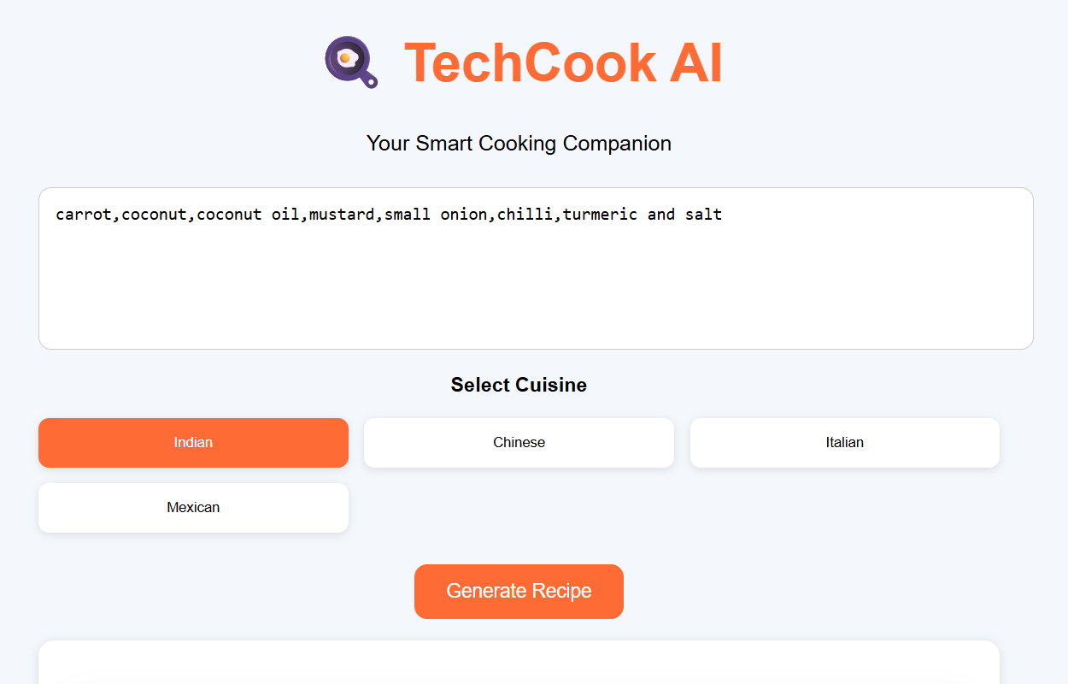

OUTPUT
