PetCare Journal - Project Plan

Course: INFR3120 - Assignment 3
Student Name: Aysha Chowdhury
Date: 11/21/2025

1. Introduction
The PetCare Journal is a web application that helps pet owners track important information about their pets in one place. Instead of relying on memory or scattered notes, users can log care events such as vet visits, grooming appointments, vaccinations, medications and general care notes. The primary goal of the application is to provide a simple, organized directory of pet care history that is easy to view, update, and maintain over time.

2. Project Overview
The application will be built using Node.js, Express.js, MongoDB with Mongoose, and EJS templating. It will implement full CRUD (Create, Read, Update, Delete) functionality on a single main collection of pet care entries stored in a MongoDB Atlas database. The user interface will use Bootstrap and custom CSS to provide a clean, professional online-directory look. The site will be deployed to a cloud provider and the source code will be managed with Git and GitHub, following the security requirement of using .env and .gitignore to protect database credentials.

3. Objectives
The main objectives of the PetCare Journal application are:
- Allow users to record pet care entries including pet information, care type, dates, and notes.
- Provide a public list page that displays all stored entries from the MongoDB collection.
- Support full CRUD functionality: create new entries, view existing entries, edit entries, and delete entries.
- Include a delete confirmation step to prevent accidental removal of data.
- Use a consistent layout with a shared header and footer across all pages.
- Deploy the application to a cloud provider with a working remote MongoDB database.
- Follow best practices for version control and credential security (.env and .gitignore).

4. Data Model
The application will use a single main MongoDB collection named PetCareEntry. Each document in this collection represents one pet care entry. The fields will be:
Field Name | Type | Description
_id | ObjectId | Unique identifier generated by MongoDB.
petName | String | Name of the pet (e.g., Luna, Rocky).
petType | String | Type of pet (e.g., Dog, Cat, Bird).
age | Number/String | Age of the pet (e.g., 3 or "3 years").
entryType | String | Type of care event (Vet Visit, Grooming, Medication, Vaccination, Other).
date | Date | Date of the care event.
vetName | String | Name of the veterinarian (optional).
nextAppointment | Date | Next scheduled appointment (optional).
notes | String | Additional notes or comments about the care event.

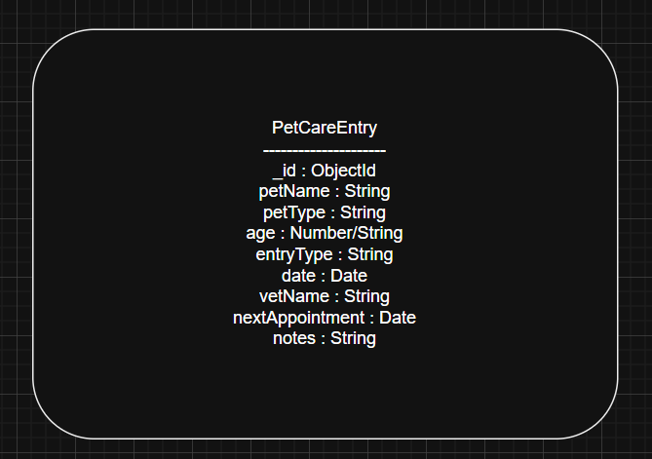

5. Page Descriptions and Wireframes

5.1 Home Page (Splash Page)
The home page serves as the splash page for the application. It includes a navigation bar, a hero section with the application title and short description, and two primary call-to-action buttons: one to view all journal entries and one to add a new entry.
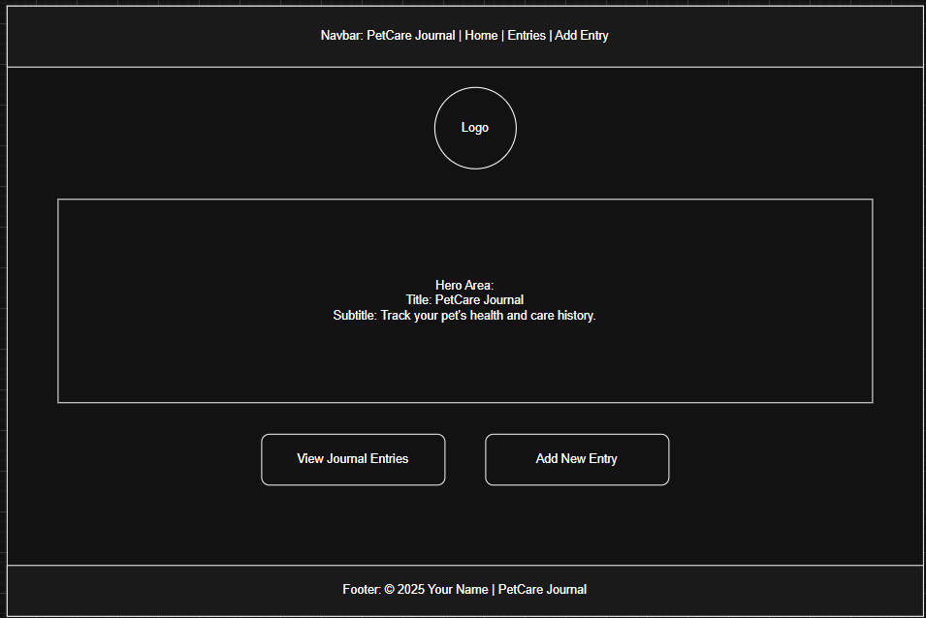

5.2 Entries List Page (/entries)
The Entries List page is a public page that displays a table of all pet care entries from the PetCareEntry collection. Each row in the table shows key information such as pet name, type, entry type, date, next appointment and available actions. The actions typically include View, Edit, and Delete. There is also an "Add New Entry" button that links to the form page.
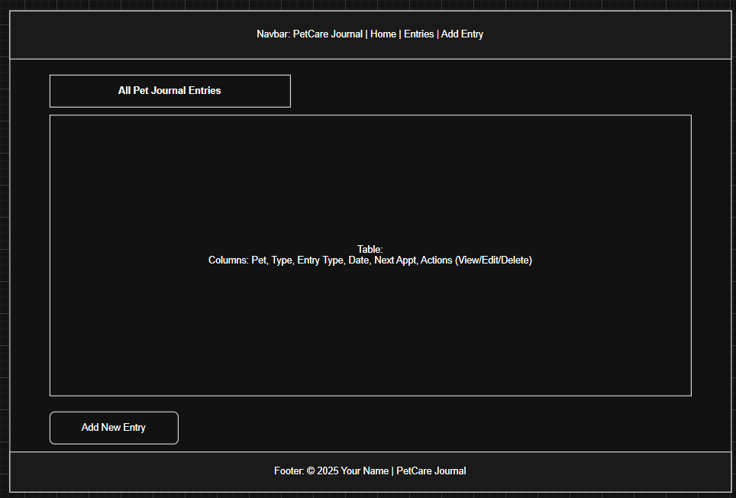

5.3 Add Entry Page (/entries/new)
The Add Entry page contains a form that allows the user to create a new pet care entry. The form includes input fields for pet name, pet type, age, entry type, date, vet name, next appointment date and notes. When the form is submitted, the server creates a new document in the MongoDB collection and redirects the user back to the Entries List page.
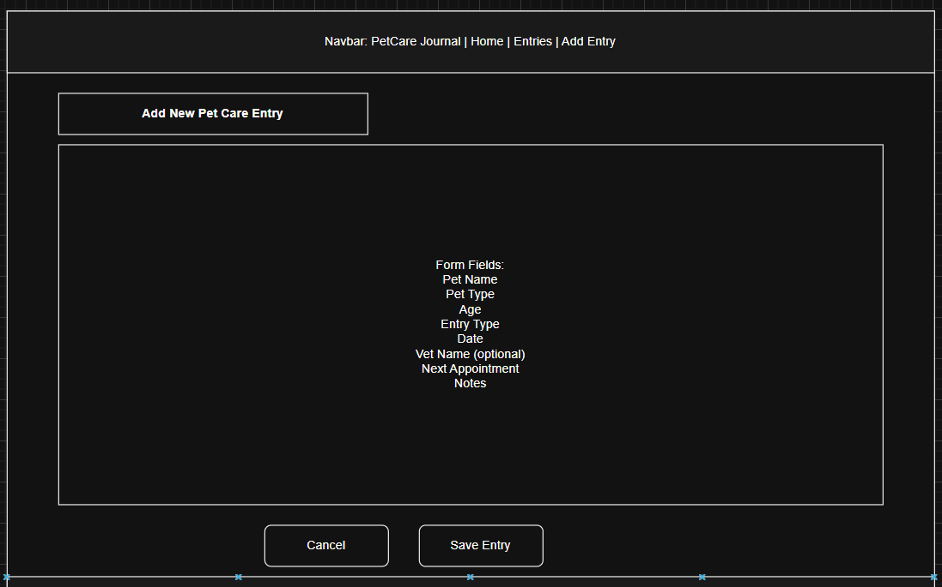

5.4 Edit Entry Page (/entries/:id/edit)
The Edit Entry page is similar to the Add Entry page but is pre-populated with the existing data for the selected entry. Users can update any of the fields and submit the form to save changes. The server updates the corresponding document in MongoDB and then redirects back to the Entries List page.

5.5 Delete Confirmation Page (/entries/:id/delete)
When a user chooses to delete an entry from the Entries List page, they are first taken to a Delete Confirmation page. This page displays key details about the entry (such as pet name and entry type) and asks the user to confirm whether they really want to delete it. The page includes two buttons: Cancel (which returns to the Entries List) and Confirm Delete (which permanently removes the document from MongoDB).
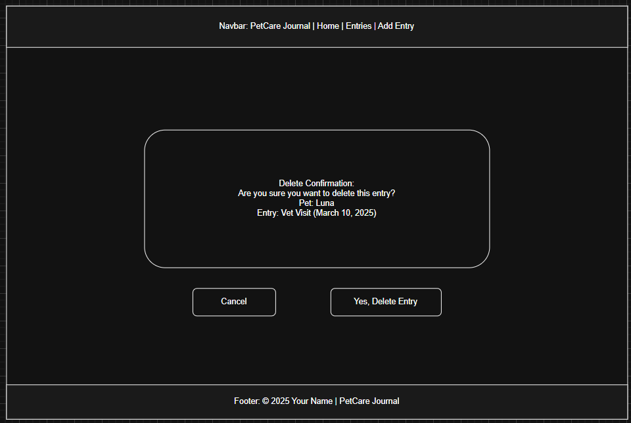

6. Page Flow
