Yenepoya Institue of Arts Science Commerce and Management
Project – High Level Design
on
Personalized Smart City Logistics Recommendation System

Student Name:
Aysha Sabaa
23BSAMD009
BSc AI ML & DS

Industry Mentor: |  | Guided by: | Raheema ma’am
Mr. Sumith Kumar Shukla

Table of Contents

- System Overview

- Architecture Design

- Core Components

- Data Flow Design

- Technology Stack

- Scalability & Performance

- Security & Reliability

- User Interaction Flow

- References

1. System Overview
1.1 Purpose
This document presents the high-level architectural design of an intelligent logistics recommendation system that utilizes public transport networks to optimize parcel delivery routes.

1.2 Vision
To develop a data-driven, AI-assisted smart logistics system that:
- Leverages existing public transport infrastructure
- Reduces delivery cost and inefficiency
- Supports smart city initiatives

1.3 System Description
The system operates as an intelligent recommendation engine that:
- Accepts user input (pickup & drop locations)
- Maps locations to transport nodes
- Suggests optimal parcel delivery routes
Additionally, a lightweight web interface is provided to:
- Enable user interaction through a modern UI
- Demonstrate system functionality visually
- Enhance accessibility beyond command-line usage

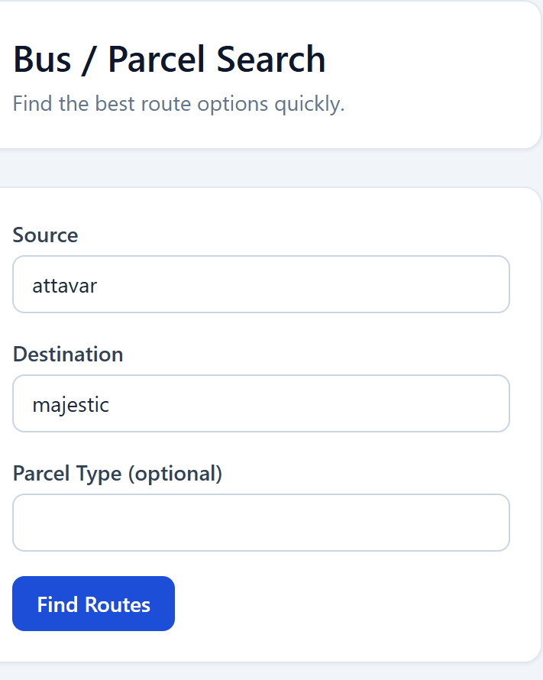

2. Architecture Design
2.1 Architectural Style
- Modular Architecture
- Data-driven System
- Hybrid Intelligent Matching Model

2.2 High-Level Architecture
User (CLI / Website)
↓
Input Processing Layer
↓
Recommendation Engine
↓
Geolocation Services
↓
Output Interface

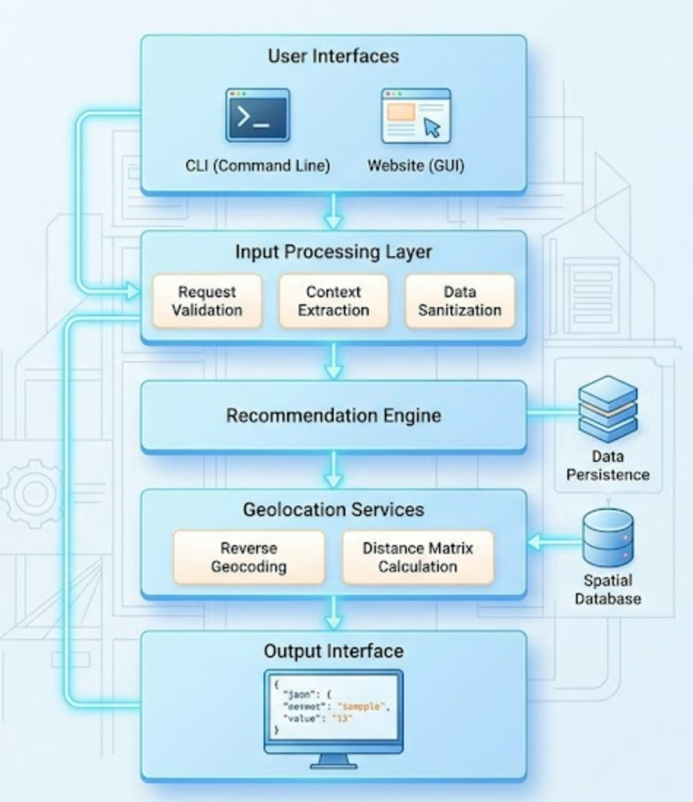

3. Core Components
3.1 Input Processing Module
- Captures user input from CLI or website
- Performs normalization and correction
- Applies fuzzy matching techniques

3.2 Data Management Layer
- Handles structured transport datasets
- Maintains stop-level mapping
- Supports efficient querying

3.3 Recommendation Engine
- Core logic component
- Identifies:
  - Direct routes
  - Nearest stop routes
  - Hub-based fallback routes
- Applies intelligent filtering

3.4 Geolocation Module
- Converts location names to coordinates
- Calculates distances
- Improves recommendation accuracy

3.5 Output Interface
- Displays route recommendations
- Shows bus details, stops, and distance
- Available via CLI and basic web interface

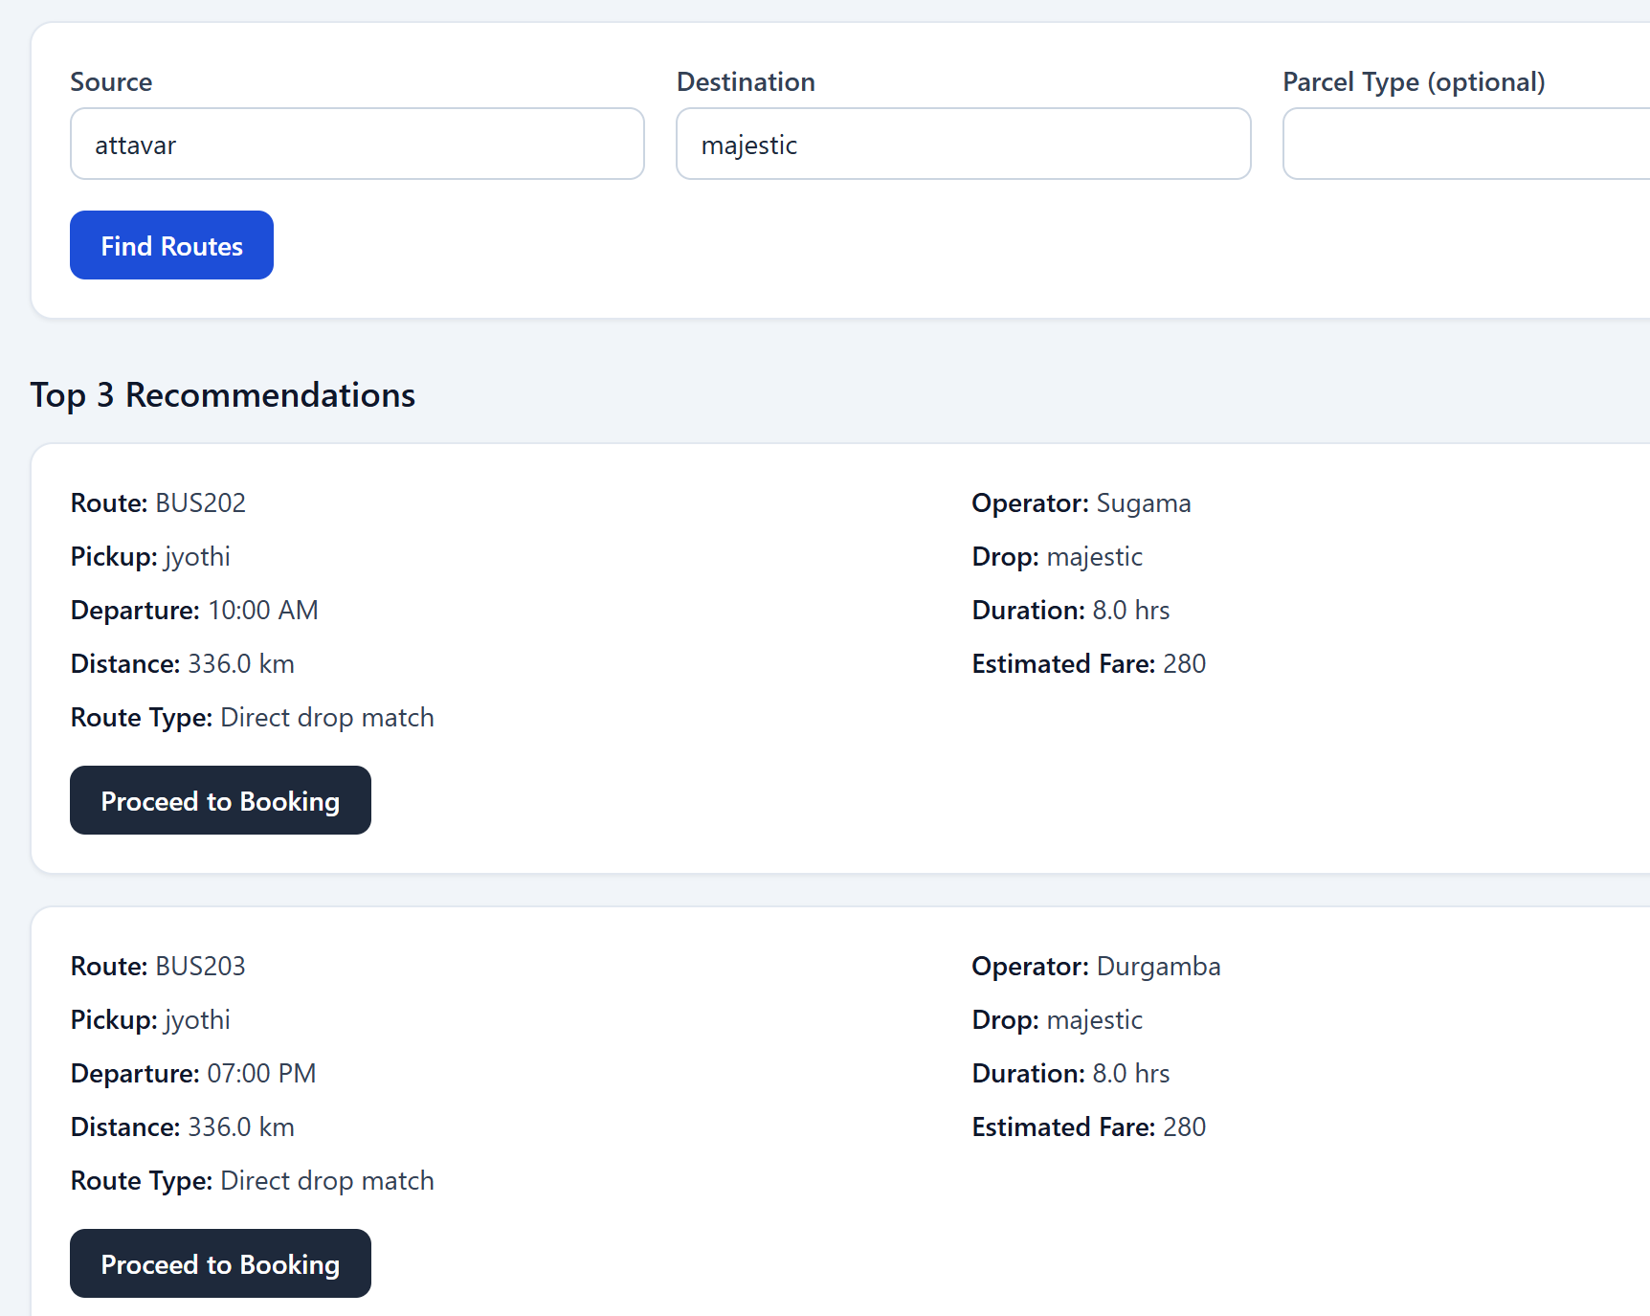

4. Data Flow Design
4.1 Workflow
- User enters source and destination
- Input is processed and corrected
- Dataset is analyzed
- Routes are identified:
  - Direct
  - Nearest
  - Fallback
- Results are displayed

4.2 Data Pipeline
User Input → Processing → Route Matching → Recommendation → Output

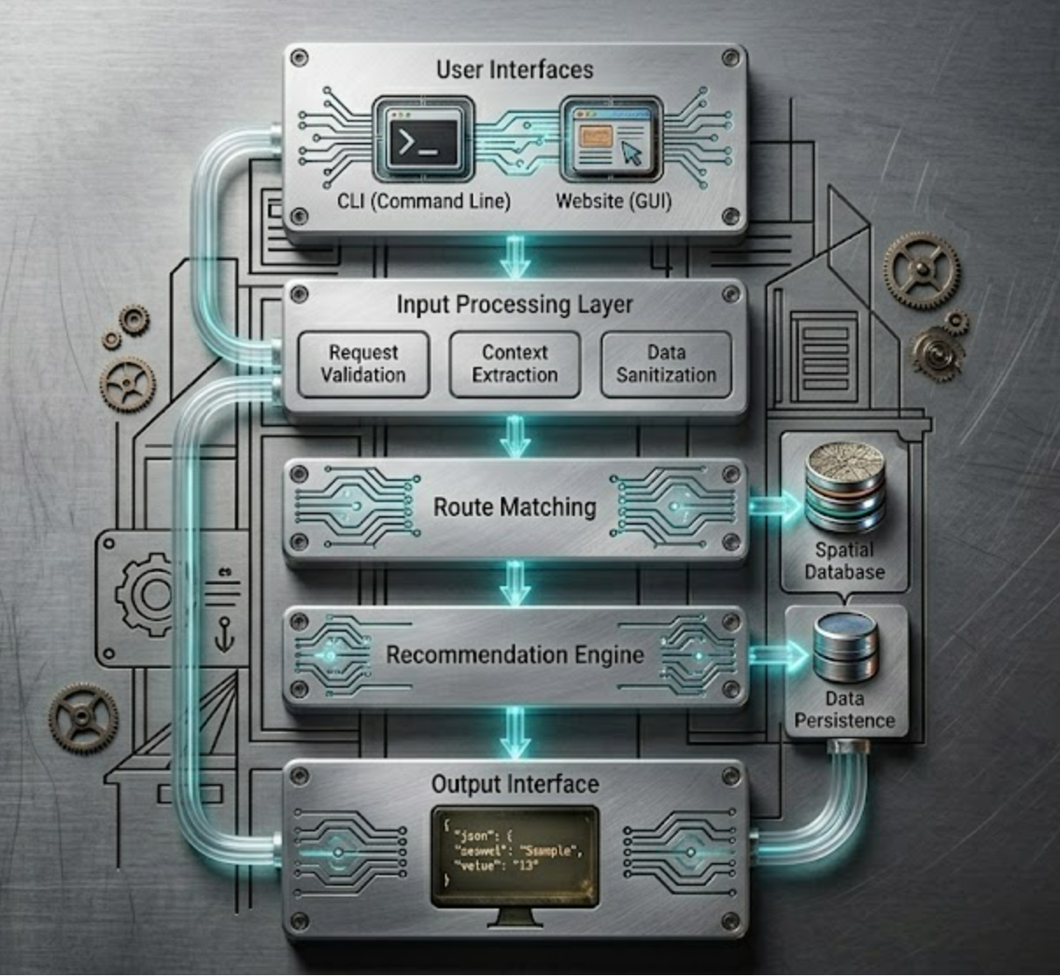

5. Technology Stack
Layer | Technology
Backend Logic | Python
Data Handling | Pandas
Geolocation | GeoPy
Matching | difflib
Interface | CLI + Basic Web Interface

6. Scalability & Performance
- Efficient data processing using Pandas
- Modular design allows future enhancements
- Web interface can be extended to full-stack deployment
- Supports expansion to multi-city datasets

7. Security & Reliability
- Input validation and sanitization
- Error handling for invalid locations
- Graceful fallback mechanisms
- Controlled API usage

8. User Interaction Flow
Process
- User enters pickup and drop location
- System interprets input
- Routes are computed
- Best recommendations are displayed
- User follows suggested delivery path
This interaction can occur via:
- Command-line interface
- Simple web interface

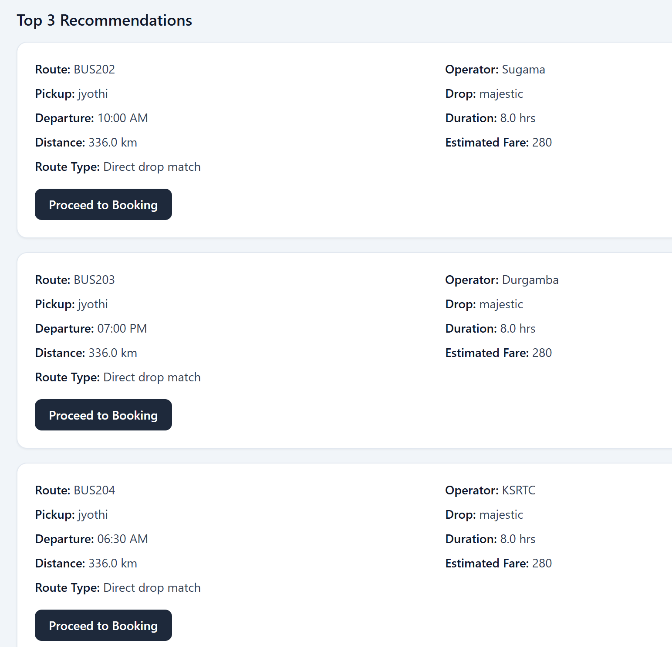

9. References
- GeoPy Documentation
- OpenStreetMap (Nominatim API)
- Python difflib Library
- Smart City Transportation Concepts

