
Yenepoya Institue of Arts Science Commerce and Management

Low Level Design (LLD)
Personalized Smart City Logistics Recommendation System using Public Transport Networks

Student Name: Aysha Sabaa
23BSAMD009
LH08

BSc. Artificial Intelligence,
Machine learning and Data Science(IBM,TCS)

Industry Mentor: Mr. Sumit Kumar Shukla
Guided by: Raheema Ma’am
Table of Contents
- Introduction
- Detailed Module Design
- Algorithm Design
- Data Structures
- Function-Level Design
- Error Handling
- Interface Design
- Performance Considerations
- References

1. Introduction
1.1 Scope of Document
This document provides a detailed internal design of the system including module-level implementation, algorithms, and data handling mechanisms.
1.2 Intended Audience
- Developers
- Evaluators
- Project reviewers
1.3 System Overview
The system is a chatbot-based recommendation engine that suggests optimal parcel delivery routes using public transport buses within a smart city.

2. Detailed Module Design
2.1 Modules
1. Input Module
- Accepts user input (source & destination)
- Handles spelling correction

2. Data Processing Module
- Reads dataset (Excel/CSV)
- Extracts bus routes, stops, timings
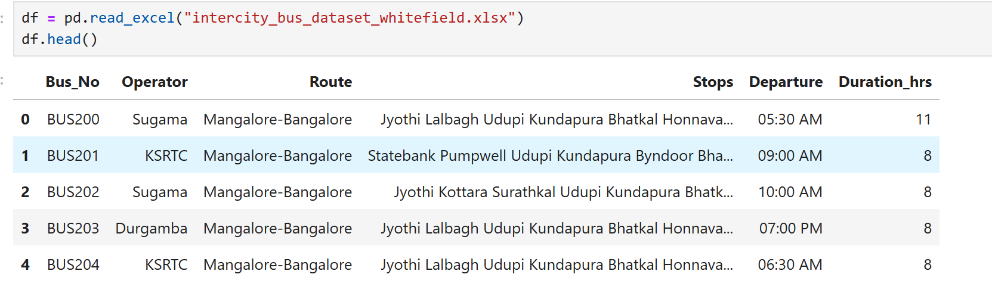
3. Recommendation Engine
- Identifies:
  - Direct routes
  - Nearest drop points
  - Fallback routes (via Majestic)
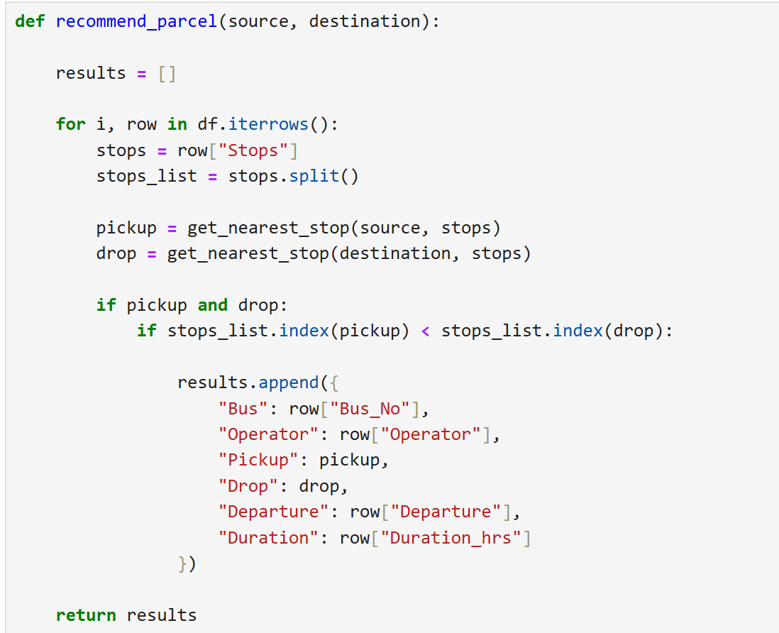

4. Geolocation Module
- Converts location → coordinates
- Calculates distance using GeoPy
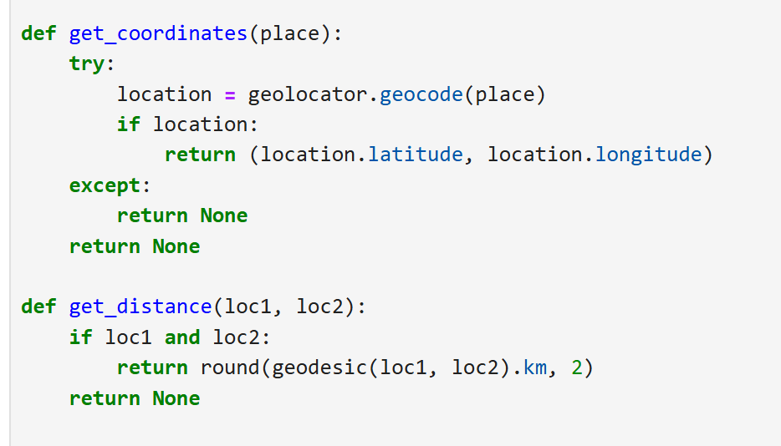

5. Output Module
- Displays:
  - Bus details
  - Route
  - Distance
  - Final suggestions
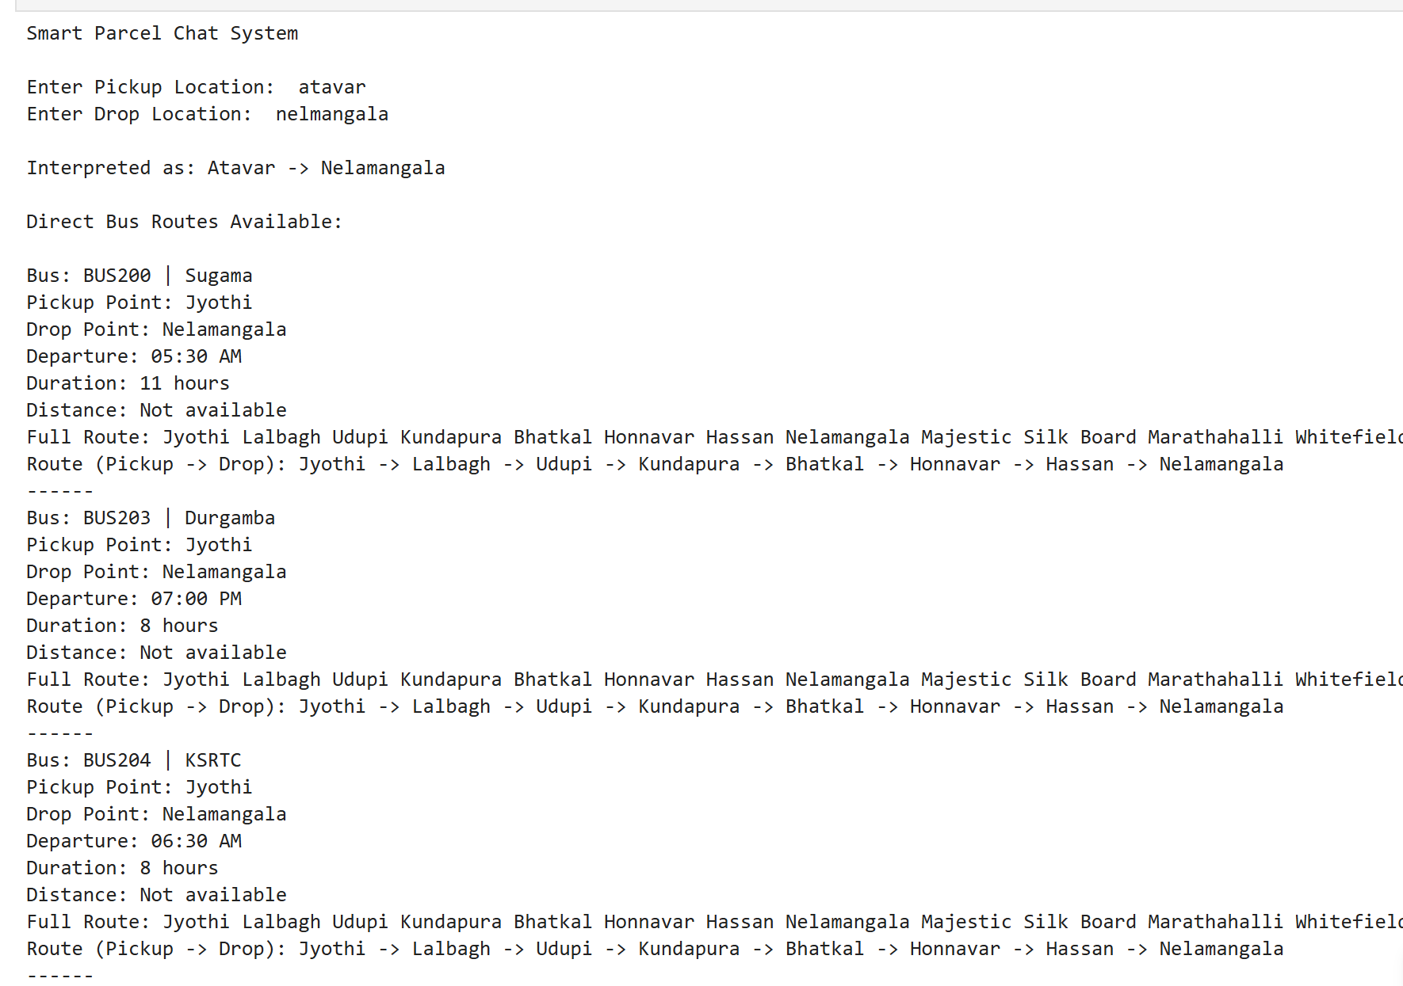

3. Algorithm Design
3.1 Recommendation Algorithm
Steps:
- Take user input (source, destination)
- Apply spelling correction
- For each bus:
  - Check if direct route exists
  - Else find nearest drop
- If no match:
  - Apply fallback via major hub
- Rank and return top results

3.2 Distance Calculation Algorithm
- Convert locations to coordinates
- Apply geodesic formula
- Return distance in km

4. Data Structures
Data | Structure
Bus dataset | Pandas DataFrame
Stops | List
Results | List of Dictionaries
Location mapping | Dictionary

5. Function-Level Design
5.1 get_coordinates(place)
- Input: location name
- Output: latitude, longitude

5.2 get_distance(user_loc, pickup_loc)
- Input: coordinates
- Output: distance in km

5.3 correct_spelling(input)
- Uses fuzzy matching
- Returns closest valid stop

5.4 get_best_drop(destination, stops)
- Finds nearest valid drop point

5.5 recommend_via_major_stop()
- Suggests routes via Majestic

5.6 chat_show_results()
- Main controller function
- Calls all modules
- Displays final output

6. Error Handling
- Invalid location input → corrected using fuzzy logic
- Missing coordinates → handled with fallback message
- No route found → alternative suggestions provided

7. Interface Design
7.1 User Interface
- Command-line chatbot
- Input prompts:
  - Pickup location
  - Drop location

7.2 Output Interface
Displays:
- Bus number
- Operator
- Pickup & drop
- Distance
- Route

8. Performance Considerations
- Limited results (top 3) for speed
- GeoPy calls minimized
- Efficient iteration using Pandas

9. References
- GeoPy Documentation
- OpenStreetMap (Nominatim API)
- Python difflib library
- Smart City transportation dataset

