**Spatial Analysis – Exercise 2.7**

***Hypothesis -*** *If age is an independent variable, then people 65 and above will be experience higher influenza mortality rates compared to younger age groups.*

**Link to tableau workbook -** <https://public.tableau.com/app/profile/aysha.samsudeen/viz/SpatialmapsforinfluenzaDeathsintheUS/CombinationMap>

**Choropleth Map**

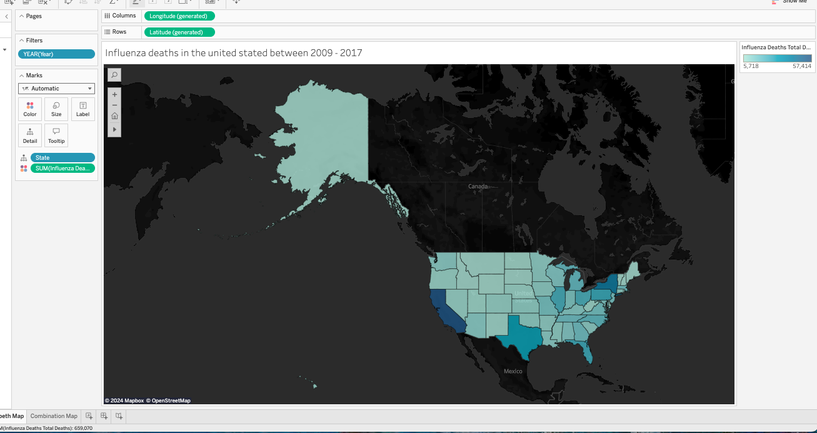

**Combination maps**

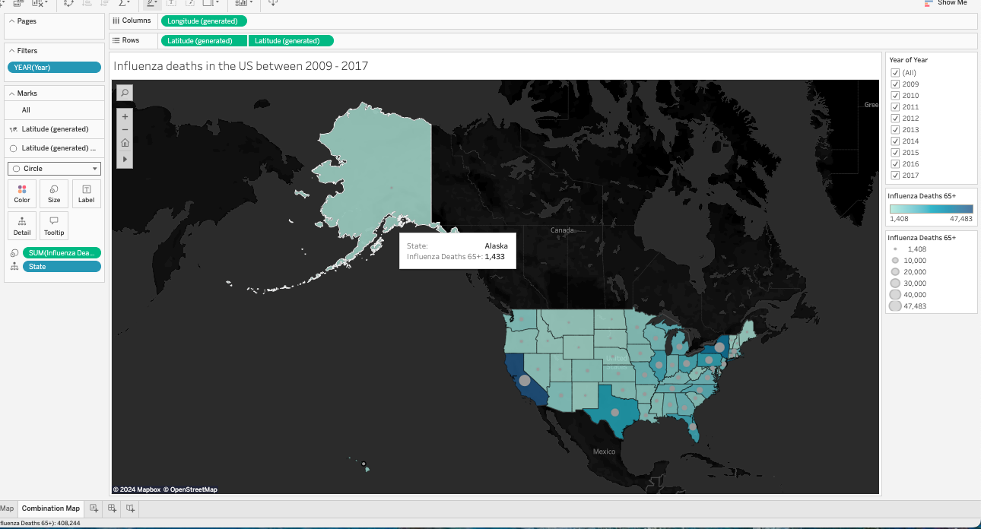

**Insights of spatial analysis of attached maps:**

***Highest and Lowest Deaths:***

* California and New York emerged as the states with the highest number of influenza deaths across all age groups during the specified period. This could be attributed to several factors, including higher population densities, greater healthcare access, and possibly more extensive reporting mechanisms.
* Vermont, on the other hand, recorded the lowest number of influenza deaths. This may reflect its smaller population size, demographic factors, or effective public health interventions.

***Vulnerable Population Correlation:***

* The data suggests a correlation between the total number of deaths among the vulnerable population (ages 65 and older) and the overall influenza deaths in the U.S. This means that states with higher mortality rates among older adults also tended to report higher overall influenza deaths. This trend is represented by gray circles on the map, where the size of the circle correlates to the number of deaths—larger circles indicate more deaths.
* California, having the largest circle, suggests a significant number of deaths in both the vulnerable population and the general population, emphasizing the impact of influenza on older adults.

***Trends Over Time:***

* The overall trend indicates that the number of influenza deaths increased over the years studied. This rise may be influenced by factors such as the emergence of more virulent strains of the virus, increased awareness and reporting, or changes in vaccination rates.
* California’s consistent position at the top of the death toll list throughout the years signals a persistent public health challenge, potentially warranting more targeted interventions and resources to manage influenza outbreaks.