**Exercise 2.8 – Textual analysis**

My textual analysis process started by created a frequency table which showcases question 12 – “What do the letters HPV stand for”?

<https://public.tableau.com/app/profile/aysha.samsudeen/viz/Textualanalysis2_8/PackedBubblechart>

For the ***word cloud,*** I edited the data and included responses for “don’t know”, “not sure”, “ I don’t know” and filtered the responses through. I filtered out all the other responses and words that didn’t have any relation to the “human papilloma virus”.

However, I eventually decided to try showing responses with at least 2 counts to visualize the total responses given.

**Packed Bubble chart**

This bubble chart uses the same factoring/grouping as the word cloud. In the below diagram the frequency element has not been filtered so other responses are clumped together too.

In the below diagram the grouping of values into 2 is taken into consideration which makes the data clearer and easier to understand. It has eliminated other responses and only showcased what’s required.

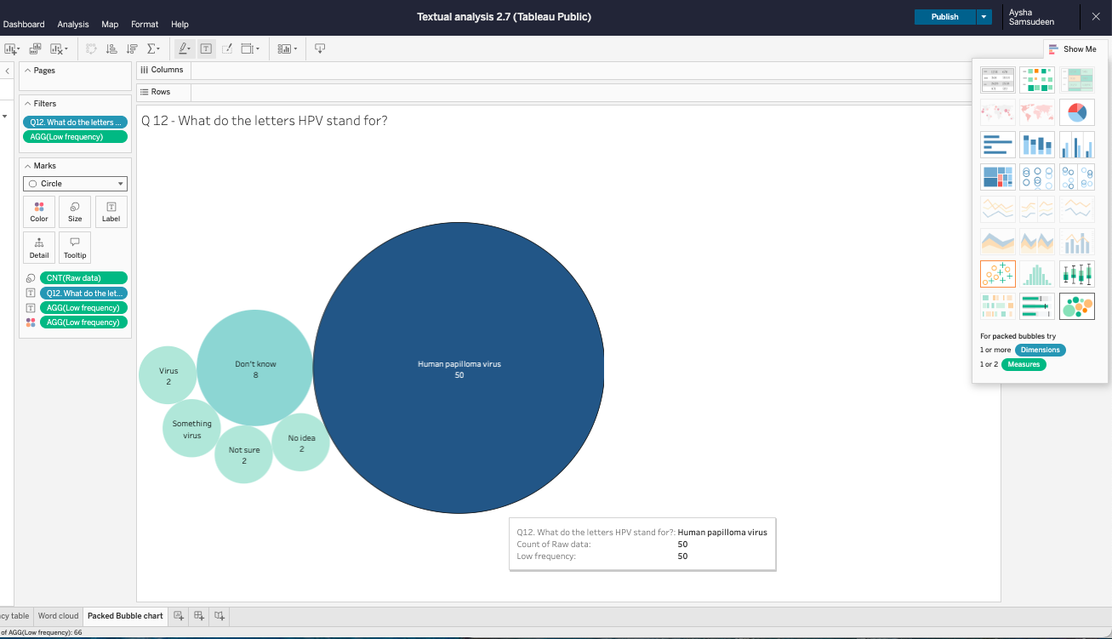

In the above graph responses that appeared twice are displayed to make things more concise and simple to make the visualisation clear and concise. The bubble chart and word cloud display data in similar but different ways, The main difference being bubble charts include frequency of responses to make the graphs more detailed and precise.

**Question 2**

How might unstructured survey data supplement your student project? What sort of data might you receive from unstructured survey questions posed to staff and patients?

This approach to understanding and addressing influenza mortality rates among vulnerable populations is both insightful and practical. Conducting a survey can uncover critical barriers and attitudes that impact health outcomes. Here are some key points to consider for your survey and subsequent actions:

1. **Survey Design**: Ensure the survey includes diverse demographic questions to capture a broad spectrum of experiences. Incorporate both quantitative (e.g., rating scales) and qualitative (e.g., open-ended questions) elements to gather detailed insights.
2. **Barriers to Access**: Identify specific logistical challenges, such as transportation issues, financial constraints, or lack of awareness about available services. Understanding these factors can guide targeted interventions.
3. **Health Literacy**: Assess the level of understanding about influenza, its transmission, and the role of vaccination. This can help tailor educational materials to address misconceptions and build trust.
4. **Community Engagement**: Involve local leaders and organizations in the outreach efforts. Their endorsement can enhance credibility and encourage participation in vaccination programs.
5. **Flexible Service Models**: Based on survey findings, consider mobile clinics or partnerships with local organizations to facilitate access to vaccinations and health services in underserved areas.
6. **Feedback Mechanisms**: After implementing interventions, gather feedback to assess their effectiveness and make necessary adjustments.
7. Conducting a survey of medical staff in areas with high influenza mortality rates can provide crucial insights into systemic issues that may be contributing to the problem.

How could textual analysis be used to produce insights from this data? How might surveys or other forms of unstructured data be useful to analyze as a next step in this project?

**Key Findings:**

**Patient Surveys**:

* Barriers:
  + Fear and Skepticism: Words like “afraid,” “side effects,” and “don’t trust” suggest a need for educational outreach.
  + Time Constraints: Phrases such as “no time” and “busy with work” indicate a need for mobile vaccination centers near workplaces.

**Healthcare Staff Surveys**:

* Challenges:
  + Terms like “overtime,” “rushed,” and “stressed” highlight the need for greater staffing and resources in facilities

**Overview of Textual Analysis Process**

1. **Data Collection**:
   * **Surveys**: Distribute surveys with both quantitative and open-ended questions to gather insights on barriers to vaccination from patients and challenges faced by healthcare staff.
   * **Focus on Qualitative Responses**: Emphasize open-ended questions to capture nuanced opinions and experiences.
2. **Textual Analysis**:
   * **Keyword Extraction**: Analyze responses to identify frequently used words and phrases. This can be done using text analysis software or manual coding.
   * **Sentiment Assessment**: Determine the overall sentiment (positive, negative, or neutral) expressed in the responses. This helps gauge emotional responses to vaccination and healthcare challenges.

**Interpretation of Findings**

* **For Patients**:
  + **Fear and Skepticism**: If responses include terms like "afraid," "side effects," or "don’t trust," this suggests a lack of confidence in vaccines. This highlights the need for educational outreach to clarify misconceptions and build trust.
  + **Logistical Barriers**: Phrases like "no time" or "busy with work" indicate practical challenges in accessing vaccinations. This suggests the potential value of mobile vaccination centers or extended hours at existing facilities.
* **For Healthcare Staff**:
  + **Workload and Stress**: Common terms such as "overtime," "rushed," or "stressed" reveal issues with staffing and resource allocation. This points to a pressing need for increasing personnel and improving working conditions.

**Actionable Strategies**

1. **Educational Outreach**:
   * **Targeted Programs**: Develop informational campaigns aimed at addressing specific fears and misconceptions identified in the analysis. This could include community seminars, online resources, and partnerships with local health organizations.
   * **Personal Testimonials**: Use stories from trusted community members or healthcare providers to help alleviate fears about vaccines.
2. **Resource Allocation**:
   * **Staffing Solutions**: Advocate for increased hiring and improved working conditions based on staff feedback. This may include adjusting shift patterns, providing support staff, or offering mental health resources.
   * **Logistical Improvements**: Implement mobile vaccination units that can visit workplaces or community centers, making it easier for individuals to receive vaccinations without disrupting their schedules.
3. **Feedback and Iteration**:
   * **Ongoing Surveys**: After implementing interventions, conduct follow-up surveys to assess the effectiveness of changes and gather new insights. Use this data to continuously refine strategies and address emerging issues.

**Conclusion**

By employing textual analysis, healthcare organizations can gain a deeper understanding of the barriers and sentiments influencing vaccination rates and staff morale. This approach not only informs targeted educational and resource allocation strategies but also fosters a more responsive and adaptable healthcare system. Ultimately, addressing these concerns can lead to improved vaccination rates and better health outcomes in the community.

With influenza staffing needs determined and plans in place for the next influenza season, how might you use textual analysis to measure the success of the project? How could textual analysis be used to produce insights from this data?

**1. Patient and Staff Surveys**

**Purpose**: To monitor the effectiveness of healthcare services and identify areas needing improvement during flu season.

**Implementation**:

* **Regular Surveys**: Distribute surveys periodically throughout the season to gather feedback on experiences with wait times, access to care, and overall satisfaction.
* **Key Questions**: Include questions about:
  + Wait times for emergency care
  + Perceived adequacy of resources (e.g., staff, medications)
  + Experiences with hospital discharge processes
  + General health service accessibility

**Analysis**:

* **Identify Trends**: Analyze the survey data to detect patterns, such as frequent reports of long wait times or early discharges.
* **Resource Allocation**: If issues are identified, advocate for additional resources (e.g., staffing, supplies) to address these challenges.

**2. Meeting Minutes Analysis**

**Purpose**: To ensure that any operational challenges or resource shortages are addressed promptly.

**Implementation**:

* **Collect Meeting Minutes**: Regularly gather minutes from medical staff meetings that occur during the influenza season.
* **Focus on Key Discussions**: Pay attention to discussions about:
  + Patient care challenges
  + Resource availability (e.g., medications, equipment)
  + Staffing levels and workload concerns

**Analysis**:

* **Keyword Analysis**: Look for phrases indicating shortages or concerns, such as "medication shortage," "staffing issues," or "increased patient load."
* **Actionable Insights**: If phrases indicating medication shortages are prevalent, this suggests a need for increased or more frequent deliveries of flu medications to ensure patient care is not compromised.

**Conclusion**

By conducting regular surveys and analyzing meeting minutes, healthcare facilities can proactively identify and address issues that arise during influenza season. This approach allows for timely adjustments to resource allocation and