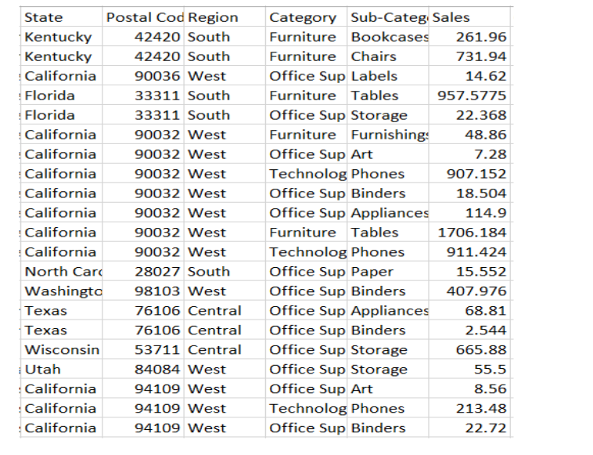
- Display all records from the sales_data table.
- Show only State, Region, and Sales columns.
- Display unique regions available in the table.
- Display unique categories available in the table.
- Find all records where sales are greater than 500.
- Display records belonging to California.
- Show all records from the Technology category.
- Find records where sales are between 50 and 500.
- Display records from West and South regions.
- Show all records where sub category is Binders.
- Display records where sales are less than 100.
- Arrange the records by sales from lowest to highest.
- Arrange the records by sales from highest to lowest.
- Display the top 5 highest sales records.
- Display only the first 3 rows from the table.
- Find the total number of records in the table.
- Find the total sales amount.
- Find the average sales amount.
- Display the highest sales value.
- Display the lowest sales value.
- Find the number of records available in each region.
- Find the total sales for each category.
- Find the average sales for each state.
- Display the highest sales in each region.
- Find the total sales for each sub category.
- Find how many records belong to each category.
- Display categories where total sales is greater than 1000.
- Display regions where average sales is greater than 200.
- Display the top 3 states with highest total sales.
- Find the second highest sales value from the table.
- Display states where total sales are greater than 1500.
- Find the number of unique states available in the table.
- Display categories arranged alphabetically.
- Find the total sales region-wise and arrange them from highest to lowest.
- Display the lowest 5 sales records from the table

