The repo
https://github.com/Ayshah-Ankoush/NextFlow_summer_training_-.git

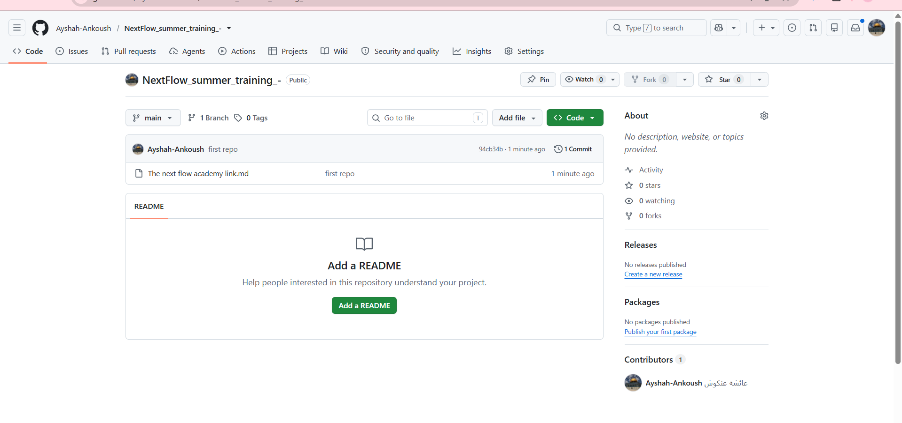
Git commands
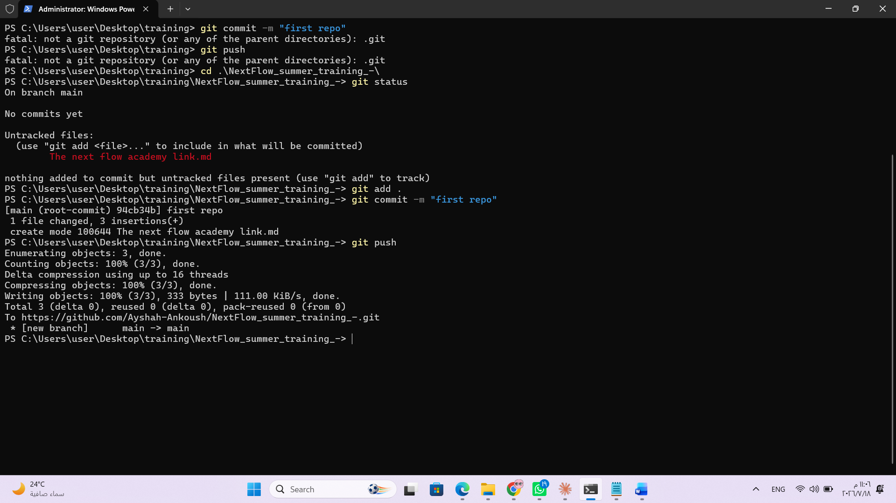

Commit in git_hub
