Cucumber has very clear step definition in future file and also report is very visual that all people can understand.

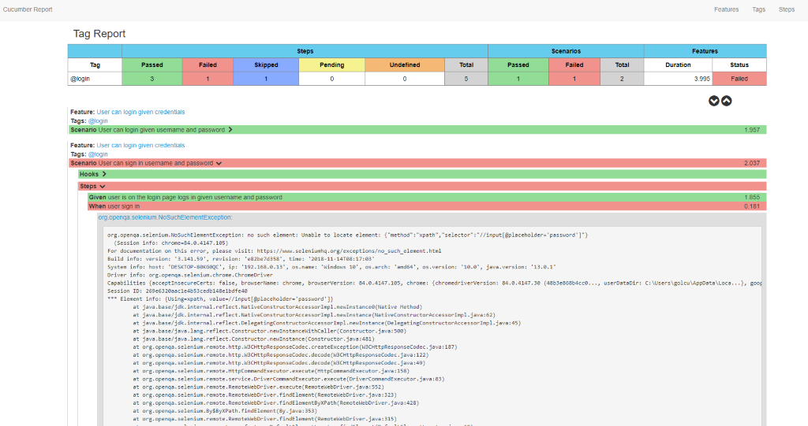
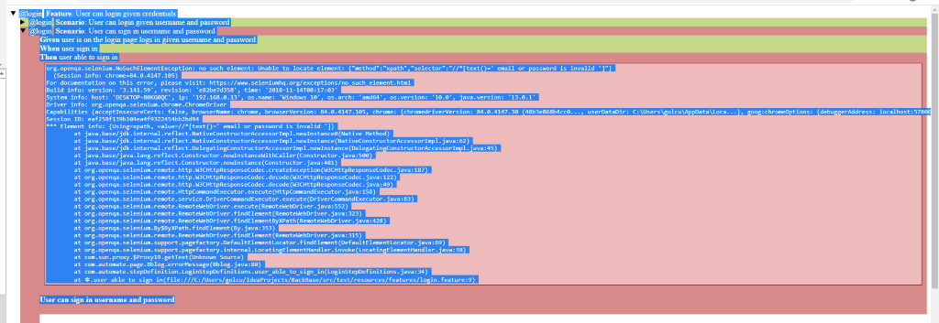
SMOKE TEST
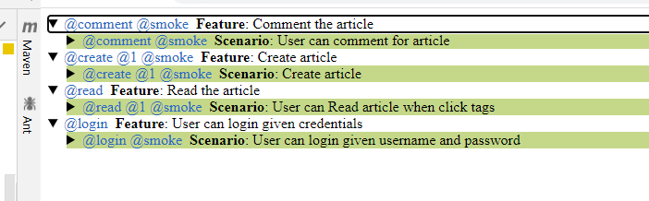
The Webpages has a lot problems but these are important
Bug1 =Username box did not accept username and it is bug
Bug2-Create Article when try to create article it did not override the article
Bug 3- When click user profile the page shows article, when click read more user not able to read the article

