**Exercise 3: Stored Procedures**

**Scenario 1:**

**Code:**

CREATE OR REPLACE PROCEDURE ProcessMonthlyInterest AS

BEGIN

  UPDATE accounts

  SET balance = balance + (balance * 0.01)

  WHERE account_type = 'savings';

  COMMIT;

END;

/

BEGIN

  ProcessMonthlyInterest;

END;

SELECT * FROM accounts;

**OUTPUT:**

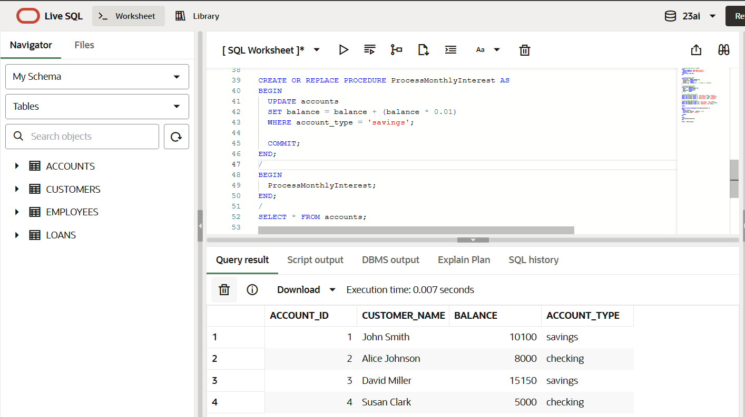

**Scenario 2:**

**Code:**

CREATE OR REPLACE PROCEDURE UpdateEmployeeBonus (

  dept_name IN VARCHAR2,

  bonus_percent IN NUMBER

) AS

BEGIN

  UPDATE employees

  SET salary = salary + (salary * (bonus_percent / 100))

  WHERE department = dept_name;

  COMMIT;

END;

/

SELECT * FROM employees;

**OUTPUT:**

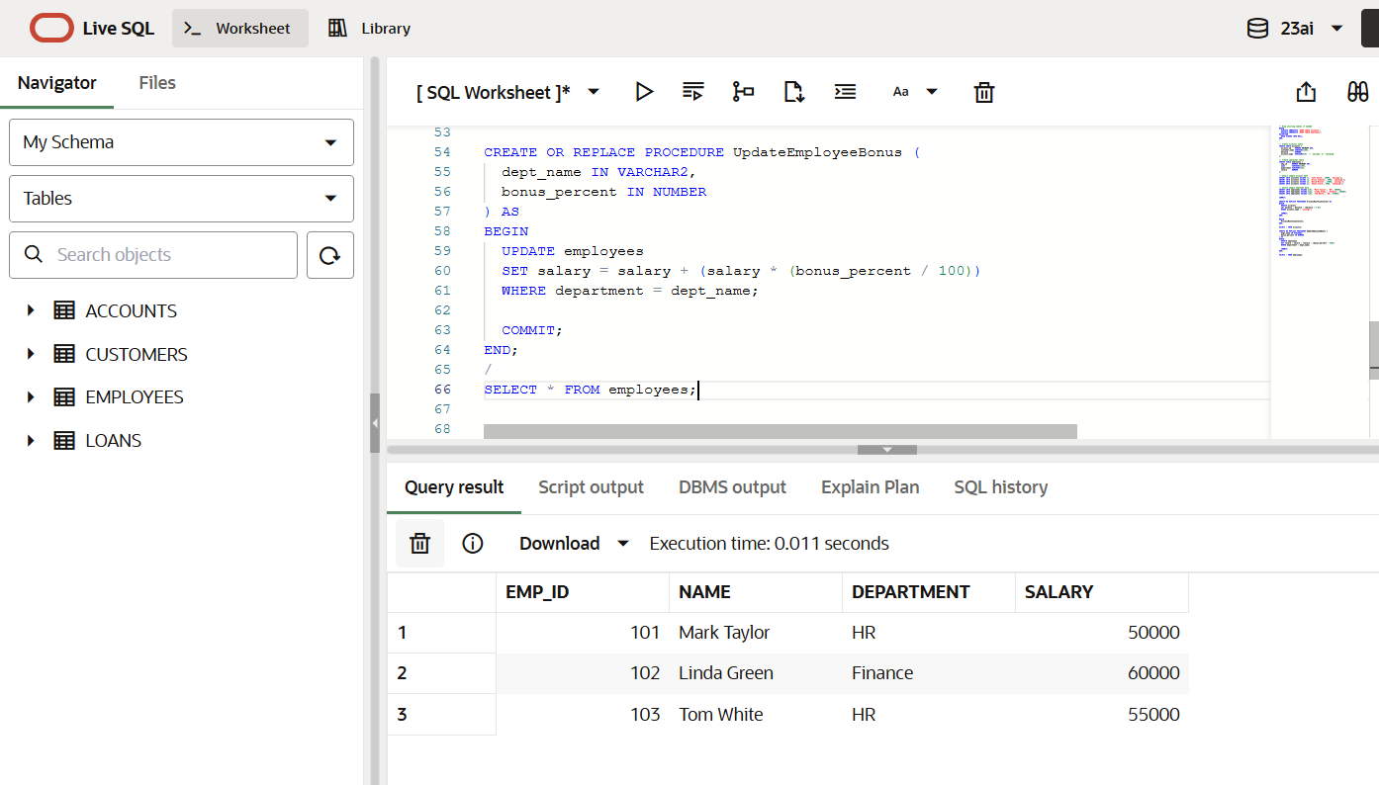

**Scenario 3:**

**Code:**

CREATE OR REPLACE PROCEDURE TransferFunds (

from_account_id IN NUMBER,

to_account_id IN NUMBER,

amount IN NUMBER

) AS

from_balance NUMBER;

BEGIN

-- Check balance

SELECT balance INTO from_balance

FROM accounts

WHERE account_id = from_account_id;

IF from_balance < amount THEN

RAISE_APPLICATION_ERROR(-20001, 'Insufficient balance in source account');

END IF;

-- Deduct from source

UPDATE accounts

SET balance = balance - amount

WHERE account_id = from_account_id;

-- Add to target

UPDATE accounts

SET balance = balance + amount

WHERE account_id = to_account_id;

COMMIT;

END;

BEGIN

TransferFunds(1, 2, 2000); -- Transfer 2000 from account 1 to account 2

END;

/

SELECT * FROM accounts;

**OUTPUT:**

