
(An Autonomous Institution, Affiliated to Anna University, Chennai)
MINI PROJECT
SALES PERFORMANCE ANALYTICS
Using Python, Power BI and Tableau
Submitted by
Name: AYSHWARYA S
Register Number: 241501028
Department: Artificial Intelligence and Machine Learning
Submitted to
Ms. AKSHAYA V
Academic Year: 2026–2027
AIM:
To analyse the sales performance of a retail store using Python, clean and prepare the Superstore dataset, visualize sales and profit trends, and build dashboards in Power BI and Tableau.
OBJECTIVES:
- Load the Superstore dataset and check data quality.
- Clean the data (dates, duplicates, missing values).
- Create new features such as Year, Month and Shipping Days.
- Find total sales and profit and visualize year, category and region performance.
- Export the cleaned data for Power BI and Tableau dashboards.
DATASET DESCRIPTION:
Dataset Name: Superstore Dataset (Sample - Superstore.csv)
Source: https://www.kaggle.com/datasets/vivek468/superstore-dataset-final
Attribute | Description
Row ID | Unique row number (used as index)
Order ID / Order Date / Ship Date | Order identifier and its order and shipping dates
Ship Mode | Shipping method used
Customer ID / Customer Name / Segment | Customer details and customer segment
Country / City / State / Postal Code / Region | Location of the order
Product ID / Category / Sub-Category / Product Name | Product details
Sales | Sales amount
Quantity | Units sold
Discount | Discount applied
Profit | Profit earned on the order

TOOLS USED:
- Python Libraries: Pandas, Matplotlib, KaggleHub (Google Colab)
- Data Visualization Tools: Power BI, Tableau
PYTHON IMPLEMENTATION
CODE:
import os
import pandas as pd
import matplotlib.pyplot as plt

# ---------- 1. Load data ----------
KAGGLE_PATH = '/kaggle/input/superstore-dataset-final/Sample - Superstore.csv'

if os.path.exists(KAGGLE_PATH): # running inside a Kaggle notebook
csv_path = KAGGLE_PATH
else: # Colab / local: download from Kaggle
import kagglehub
folder = kagglehub.dataset_download("vivek468/superstore-dataset-final")
csv_path = os.path.join(folder, "Sample - Superstore.csv")

data = pd.read_csv(csv_path, index_col='Row ID', encoding='cp1252')
data.head(2)

# ---------- 2. Cleaning ----------
data['Order Date'] = pd.to_datetime(data['Order Date'], errors='coerce')
data['Ship Date'] = pd.to_datetime(data['Ship Date'], errors='coerce')

print("Missing values:\n", data.isnull().sum())
print("Duplicate rows:", data.duplicated().sum())
data = data.drop_duplicates()
data = data.dropna(subset=['Order Date'])

median_shipping_days = (data['Ship Date'] - data['Order Date']).median()
data['Ship Date'] = data['Ship Date'].fillna(data['Order Date'] + median_shipping_days)

# ---------- 3. Feature engineering ----------
data['Year'] = data['Order Date'].dt.year
data['Month'] = data['Order Date'].dt.month
data['Month Name'] = data['Order Date'].dt.month_name()
data['Shipping Days'] = (data['Ship Date'] - data['Order Date']).dt.days

# ---------- 4. Key numbers ----------
print("Total Sales:", round(data['Sales'].sum(), 2))
print("Total Profit:", round(data['Profit'].sum(), 2))

# ---------- 5. Charts ----------
data.groupby('Year')['Sales'].sum().plot(kind='bar', figsize=(6, 4))
plt.title("Year-wise Sales"); plt.ylabel("Sales"); plt.tight_layout(); plt.show()

data.groupby('Category')['Sales'].sum().plot(kind='bar', color='orange', figsize=(6, 4))
plt.title("Sales by Category"); plt.ylabel("Sales"); plt.tight_layout(); plt.show()

data.groupby('Region')['Profit'].sum().plot(kind='bar', color='green', figsize=(6, 4))
plt.title("Profit by Region"); plt.ylabel("Profit"); plt.tight_layout(); plt.show()

# ---------- 6. Save cleaned file for Power BI / Tableau ----------
data.to_excel("Cleaned_Superstore.xlsx") # keeps Row ID as the first column
data.to_csv("Cleaned_Superstore.csv")
print("Saved Cleaned_Superstore.xlsx and Cleaned_Superstore.csv")

try: # auto-download only works in Colab
from google.colab import files
files.download("Cleaned_Superstore.xlsx")
except ImportError:
pass

PYTHON OUTPUT:
Data quality check and key numbers
The dataset has 20 columns and no missing values in any column. One duplicate row was found and removed.
Measure | Value
Missing values | 0 in all 20 columns
Duplicate rows removed | 1
Total Sales | 2,296,919.49
Total Profit | 286,409.08
Overall profit margin | about 12.5%

1. Year-wise Sales
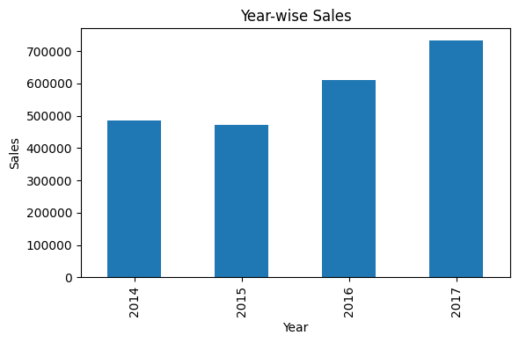
Observation: Sales were about 485,000 in 2014 and dipped slightly in 2015 (about 470,000). They then grew strongly to about 610,000 in 2016 and about 735,000 in 2017, the highest year. Sales rose by roughly 50% from 2015 to 2017.
2. Sales by Category
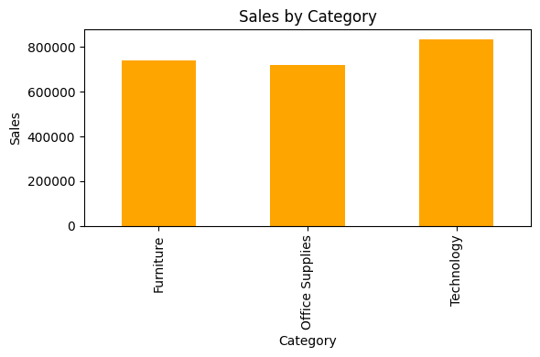
Observation: Technology is the top-selling category (about 835,000), followed by Furniture (about 740,000) and Office Supplies (about 720,000). The three categories contribute fairly evenly, with Technology leading.
3. Profit by Region
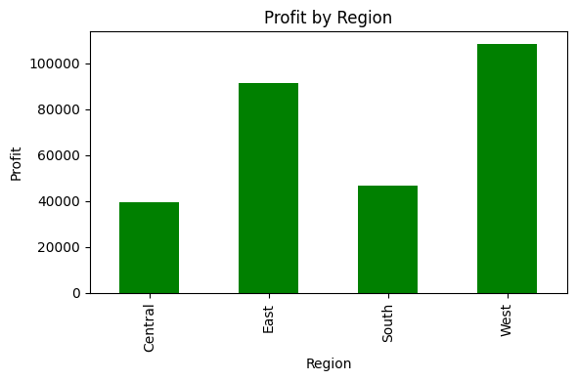
Observation: The West region earns the most profit (about 108,000), followed by the East (about 91,000). The South (about 47,000) and Central (about 39,000) regions earn much less, so they are the regions to improve.
The cleaned data was saved as Cleaned_Superstore.xlsx and Cleaned_Superstore.csv and used as the source for Power BI and Tableau.
POWER BI OUTPUT:
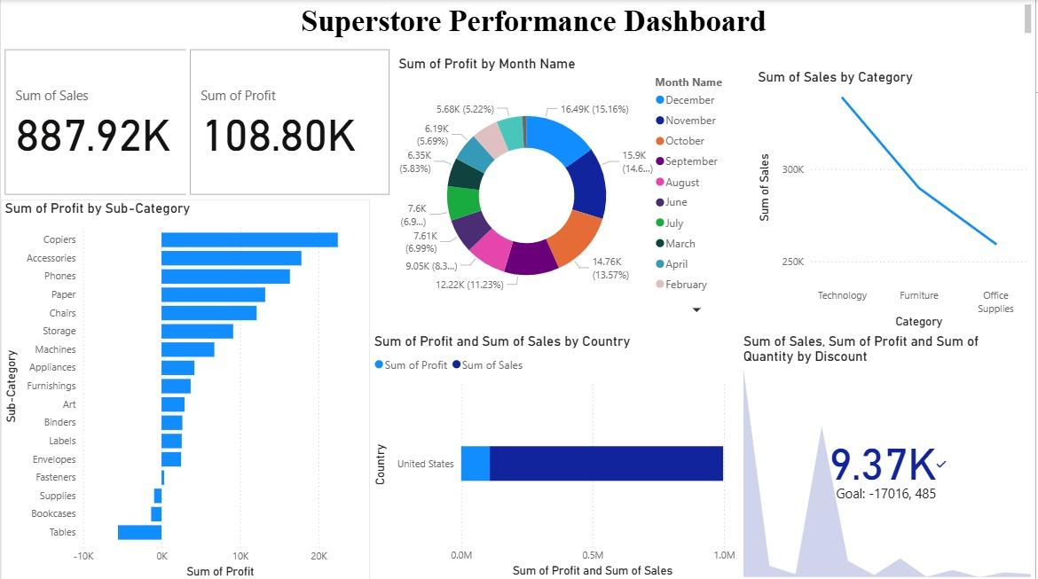
Observation: The Power BI "Superstore Performance Dashboard" shows cards for Sum of Sales (887.92K) and Sum of Profit (108.80K). Copiers, Accessories and Phones give the highest profit by sub-category, while Tables, Bookcases and Supplies make a loss. December is the most profitable month (16.49K, 15.16%), and Technology is the top category in sales, ahead of Furniture and Office Supplies.
TABLEAU OUTPUT:
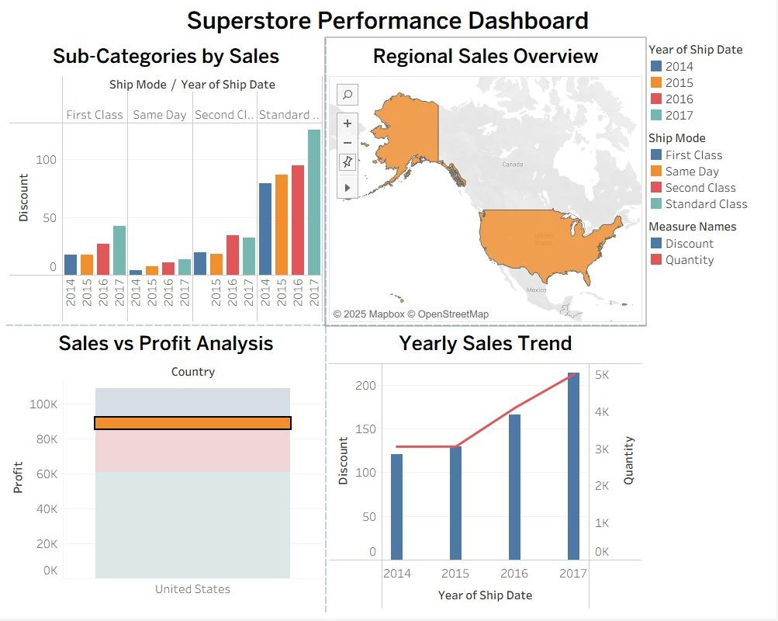
Observation: The Tableau "Superstore Performance Dashboard" combines four views: sub-categories by ship mode and year, a regional sales map, sales vs profit analysis for the United States, and a yearly sales trend. Standard Class shipping grows fastest from 2014 to 2017, and the yearly trend shows values rising every year, with 2017 the highest.
RESULT:
The Superstore sales data was cleaned and analysed. Total sales were about 2.30 million with a total profit of about 286 thousand. Sales grew every year from 2015 to 2017, Technology is the strongest category, and the West and East regions generate most of the profit.
CONCLUSION:
- Python makes data cleaning and quick charts easy and repeatable.
- Power BI and Tableau turn the cleaned data into interactive dashboards for decision makers.
- The analysis shows where to focus: grow Technology sales and improve profit in the South and Central regions.

