ClassTrack

Functional Requirement

Daniel Vu

Daniel Conner

Austin Riley

Jacob Meigs

Last Updated: 10-07-14

**Contents**

User System Requirements

Parent View

Registration Screen

Login Screen

Child Selection Screen

Selected Child Newsfeed Screen

Messages Screen

Conference Screen

School Newsfeed

# User System Requirements

Full functionality of our web application will require the following

* Browser
  + Chrome
  + Firefox
  + Safari
* Microphone
* Web Camera

## 

## 

## Login Screen

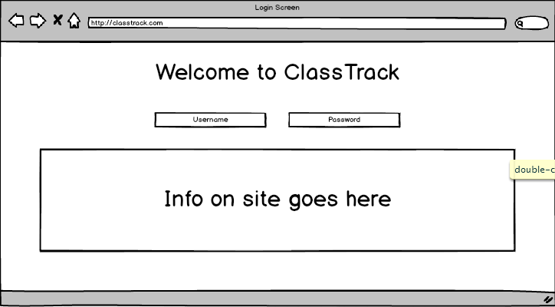

A user gets to the login screen by clicking on the login button from the static front page. The user does not have to distinctify what type of user they are, ie selecting if they are a parent, teacher, or administrator. This is done by the database and this sets up a variable that will determine the layout of the following pages. It can lead to three types of views for the three types of users.

1. Parent View
2. Teacher View
3. Administrator View

# Parent View

## Registration Screen

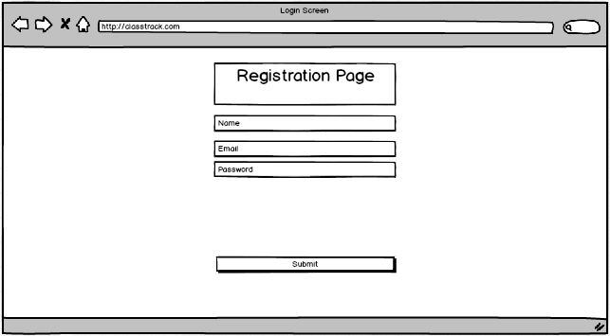

A page gets to the registration page by a link from the static front page. A parent should be able to register themselves without permission from the school. They’ll need to enter a name, email (which will also serve as their login), and a password.

We have chosen to not include other information on this page for various reasons. Because of the abundance of parents who have children in multiple schools, trying to connect the accounts to their children right here would be cumbersome and cluttered. We would like to keep the account creation simple and easy, and then use a series of pages to guide parents through the process of connecting their account to classrooms and their children.

## Child Connection Screens

* Select School
* Select Teacher
* Message Teacher
* Teacher Verifies
* Account Connected
* Repeat?

## Child Selection Screen

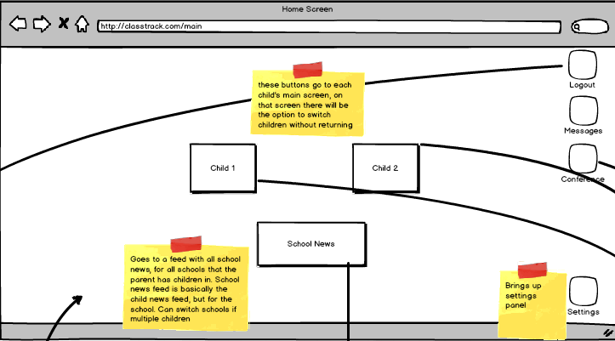

**Child Button(s):** Redirect parent to selected child’s newsfeed screen  
**School News Button:** Takes parent to a news feed that displays school news for any and all schools that their children attend.

**Logout Button:** Logs parent out of the application.

**Messages Button:** Redirects parent to their private messages page.

**Conference Button:** Redirects parent to the schedule conference page.

**Settings Button:** Redirects parent to their settings page.

## Selected Child Newsfeed Screen

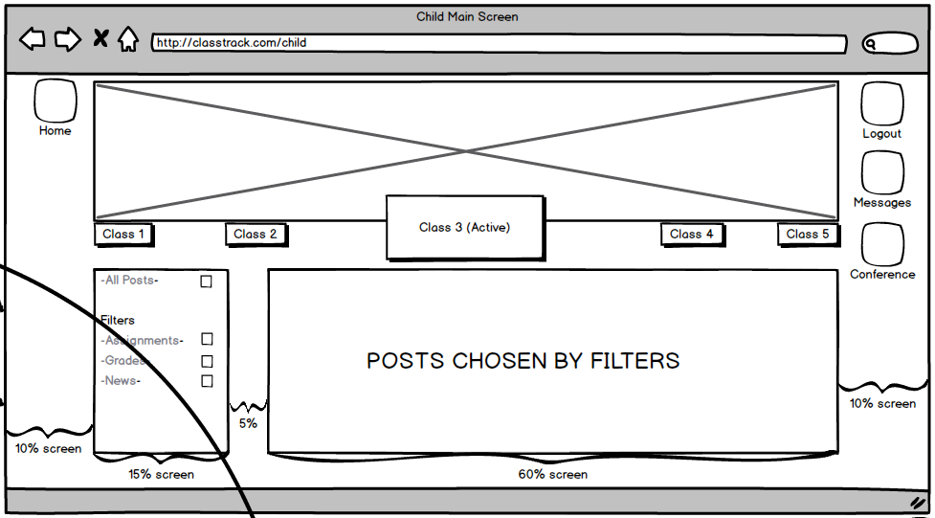

**Logout Button:** Logs parent out of the application.

**Messages Button:** Redirects parent to their private messages page.

**Home Button:** Redirects parent to select child screen.

**Cover Photo:** Large rectangle with “X” shape, contain a cover photo that the teacher of the active class will select to display.

**Class Options:** Displayed as small rectangles above. Allows parent to click on a class name and have the page content be refreshed. This will allow a parent to see information on their child on a per class basis.

**Options (Filter) Pane:** Box on the left of the page, allows a parent to filter the posts that are displayed. All posts will be selected by default upon a parent’s first time login.

**Posts:** Main area of page. All content published by the teacher of the selected class will be present.

## Messages Screen

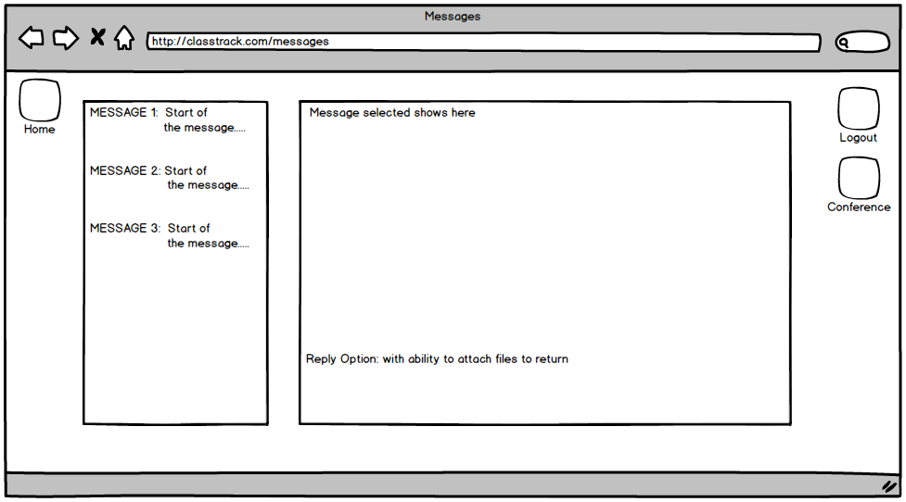

**Home Button:** Redirects parent to select child screen.

**Logout Button:** Logs parent out of the application.

Conference Button:

## Schedule Conference Screen

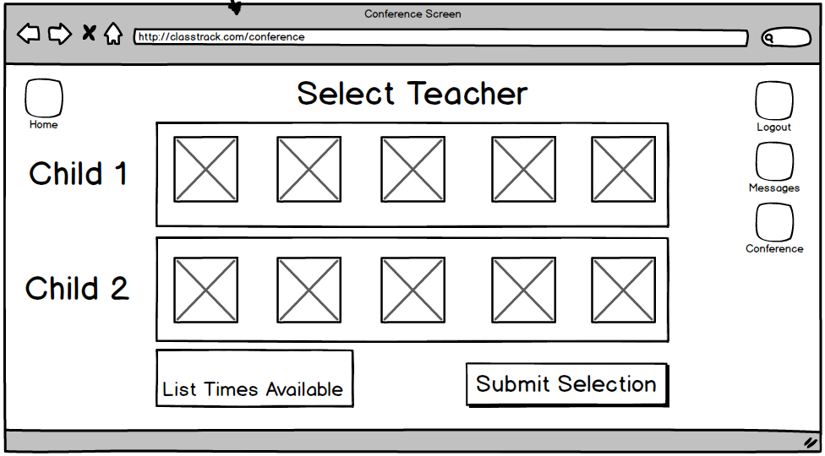

## Conference Screen

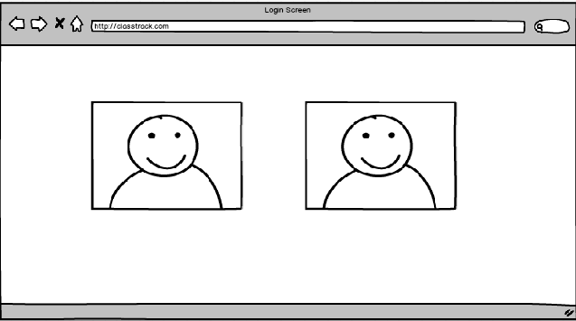

This screen will function like the rest of the conference screens, it simply allows for video communications between parents, teachers, and other administrators.

## School Newsfeed

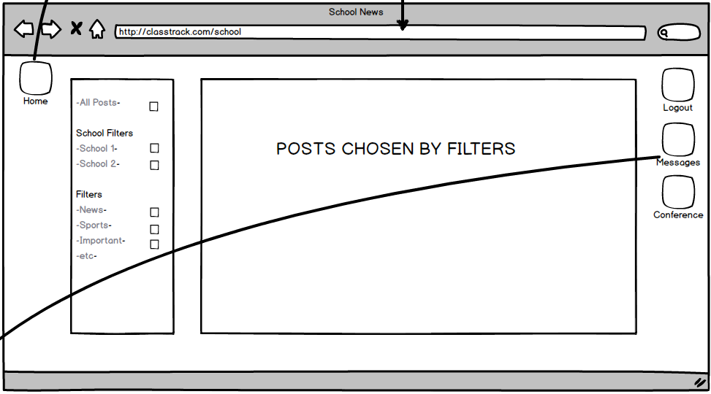

# Teacher View

## Registration Screen

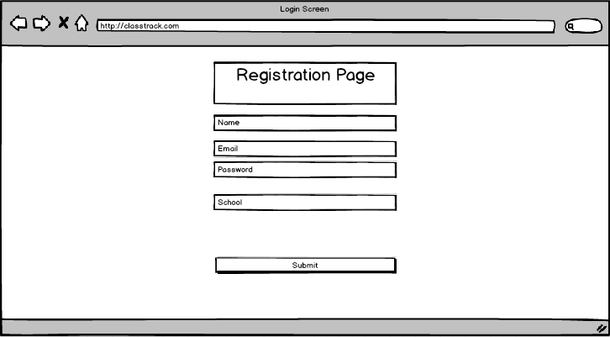

## Class Selection Screen

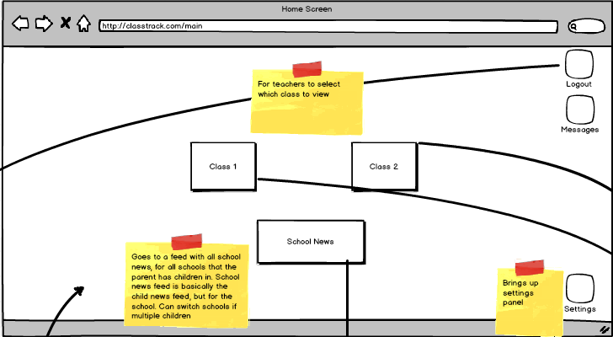

## Selected Class Newsfeed Screen

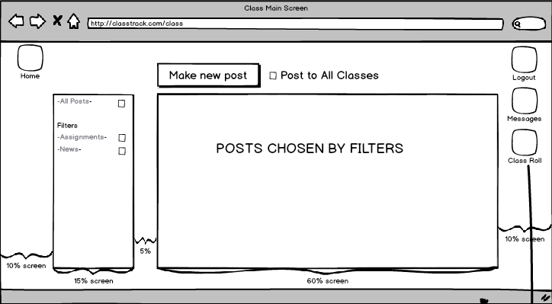

## Post News Screen

## Messages Screen

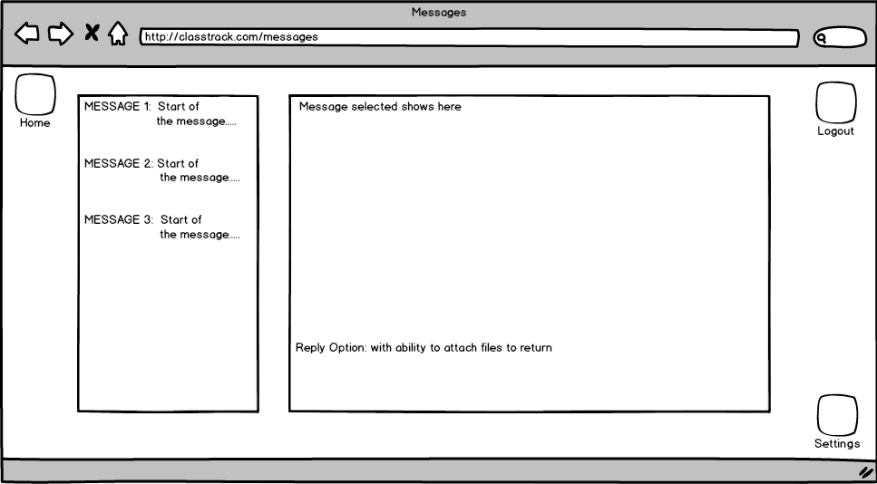

## Schedule Conference Screen

## Conference Screen

## Class Roster Screen

## Add Student/ Verify Student/Parent Screen

## Grade Screen

## 

# Administrator View

## Registration Screen



The administrator registration screen allows schools to register their own administrators into the system. The majority of administrator accounts will be created automatically when we import the school into the system, but this will allow on-the-fly account creation for changes to jobs in the middle of the year. This registration page is unique, so when someone creates an account using the administrative URL, it automatically makes a request to the system so that the user can be verified as an administrator.

## Administrator Newsfeed Screen

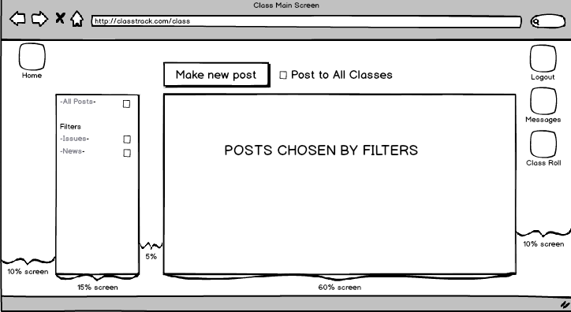

The administrator newsfeed screen looks identical to the other newsfeed screens. However, the content will contain

* teacher requests for various things, parent requests for various things
* news about conflicts, issues with teachers, etc
* PTA news

## Post News Screen

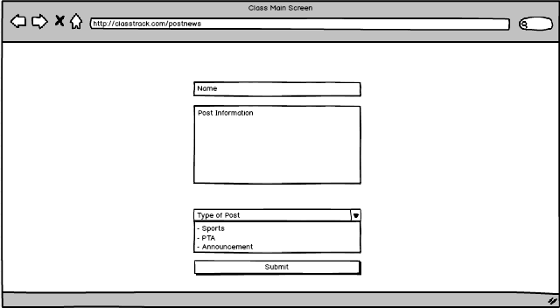

This screen will allow administrators to post to the school newsfeed, allowing parents and teachers to see the latest school news and information.

## Messages Screen

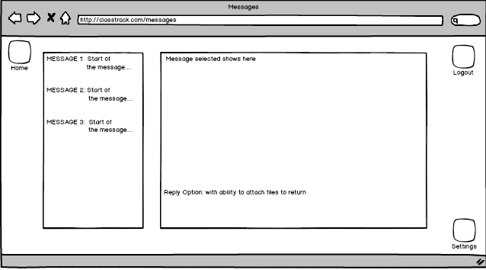

This screen will function like the rest of the messages screen, it simply allows for text communications between parents, teachers, and other administrators.

## Conference Screen



This screen will function like the rest of the conference screens, it simply allows for video communications between parents, teachers, and other administrators.