

Ankara Yıldırım Beyazıt University,

Business School,

Management Information Systems Department

PROJECT ASSIGNMENT:

EXECUTIVE INFORMATION SYSTEMS

Instructor: TUNÇ MEDENİ

Researchers: BETUL URHAN 15030411054 M.I.S.

HASAN EROL 15030411019 M.I.S.

AYSU KARAARSLAN 15030411027 M.I.S

MUHAMMED AKIF HAŞLAK 15030411018 M.I.S

MIS 441, Enterprise Information Systems

Spring , 2019-2020

**CONTENT**

1. **What Is The Executive Information System ? ……………………………………………….….…. 2**
2. **Executive Information System Feautures ………………………………………………………….. 3**
3. **Objectives Of Executive Information System ……………………………………………………… 4**
4. **Differences Between Decision Support Systems And Executive Information Systems …………. 4**
5. **Advantages And Disadvantages Of Executive Information System**
6. **Hıstory Of Eıs ………………………………………………………………………………………... 5**
7. **Is Eıs Reliable? ………………………………………………………...…………………………….. 6**
8. **What Are The Considerations Influencing The Working of EIS? ……………………………….. 6  
   8.1) Organizational Order ………………………………………………………………………….. 6  
   8.2) Other Considerations …………………………………………………………………………… 6**
9. **Components Of EIS …………………………………………………………………………………. 7**

**9.1) Hardware …………………………………………………………………………………….….. 7**

**9.2) Software …………………………………………………………………………………………. 7**

**9.3) User Interfaces …………………………………………………………………………….……. 8**

**9.4) Telecommunication ……………………………………………………………………….…….. 8**

**10) Domestic And International Examples Of EIS ……………………………………………………. 9**

**10.1) Executive Information Systems Software ……………………………………………………. 9**

**10.2) Examples From Around The World ………………………………………………………… 9**

**10.3) Examples From Turkey …………………………………………………………….…..…… 11**

**11) Oecd (Organization For Economic Cooperation And Development ) …………………….…… 12**

**12) Important Part Of EIS …………………………………………………………………………….. 15**

**13) Architecture Of Executive Information Systems ……………………………………………...…. 15**

**14) What Is Charactarestics Of Successful Eis Implementation ? ………………………………..… 16**

**15) Usage Areas of EIS ………………………………………………….……………………………… 17**

**16)Things Executive Information Systems Must Have ………………………………………………. 18**

**17) Conclucion ………………………………………………………………………………………….. 19**

**18) References ……………………………………………………………………………...…………… 20**

1. **WHAT IS THE EXECUTIVE INFORMATION SYSTEM ?**

It is an information management system designed to facilitate and support senior executives ' knowledge and decision-making needs by providing easy access to internal and external information needed to achieve the organization's strategic goals.It is a storage and communication system based on computers. Business sales, purchase, make, finance, etc. It offers a powerful but simple tool for examining and evaluating key factors and patterns in areas of success. Employees can use their personal computers to access company data. Not only for administrators, but for the whole organization, are information systems. The right allows everyone to access data from the company and share information with everyone in the business. It is easy to use executive information systems, user interfaces and visual displays. The benefits are that they provide effective reports and information. When going from descriptive details to detailed data with an emphasis on something, comprehensive skills apply. Executive Information Systems are important as they help senior managers analyze, compare and highlight trends in key areas in order to monitor performance and identify opportunities and problems.

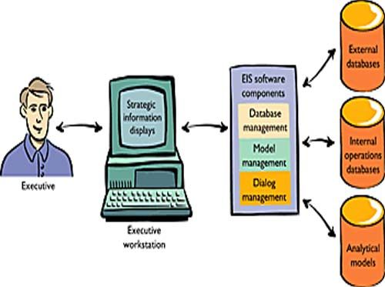

The user interface for administrator information systems is also very relevant. In order to collect data, decision makers need to be productive.

Within Manager Information Systems, there are many types of interfaces that can be found, so it is very important that the interface suits the personality of the decision maker.

The execution information system will not be fully available if the player is not happy with the program.

Executive Information Systems Hardware consists of 4 main components;

-Data Input Devices

-CPU (Central Processing Unit)

-Output Devices

-Data Storage Files

There are 4 main components to select the right software in Administrator Information Systems;

-Text base software

-Database

-Graphic base

-Model Base

**2) EXECUTIVE INFORMATION SYSTEM FEAUTURES**

The executive information system is designed to satisfy the management requirements, from the top to the bottom level and in accordance with the management requirements, taking into account the company's goals. The information system for management usually serves managers interested in weekly, monthly and annual results. Because the information management system deals with well-known structural problems, it is often inflexible and has less scope for research

1. The executive information system is an integrated system: Integrated information processing takes place within a large system strategy and is structured not as a single system but as a combination of subsystems.
2. 2. The executive information system is a human-machine system based on a computer: the executive information system can be created without the support of a computer. However, the computer is certainly a necessary tool for an effective information management system. Computer, executive information system saves time and effort by continuously and accurately storing the required information.
3. Executive information system is a system that provides knowledge support: a lot of information about daily operations is stored in the executive information system and feedback is provided to the enterprise's vital information stack.
4. The executive information system facilitates the decision-making process: the information needed for the program and the information obtained to make a decision; it must be collected, checked and delivered.Decision models that help decision-making are produced for this purpose by using numerical or non-numerical models that reach different decision situations.
5. **OBJECTIVES OF EXECUTIVE INFORMATION SYSTEM**

To ensure that the information plays an effective role in the company by providing organizational knowledge to be created, processed, accessed, exchanged and used;

- Providing the necessary support for problem solving and decision-making,

-Establishing and developing the organization's knowledge use and technological infrastructure,

-Coordinating and integrating sub-systems,

-Giving access to timely information

1. **DIFFERENCES BETWEEN DECISION SUPPORT SYSTEMS AND EXECUTIVE INFORMATION SYSTEMS**

**Decision support systems** are a system for solving complex issues, including efficient and optimal programming, information technology and human intelligence interaction and mixing. In other words, in solving unstructured problems, it is using the formulas obtained with the available data. It is intended to support decision-making. Acts as a module that helps Management information system

**DSS & EIS**

The main difference between Executive Information System and Decision Support System allows Decision Support System senior managers to make decisions to meet the organization's strategic objectives, while Decision Support System allows senior managers to make non-routine decisions**.**

**5) ADVANTAGES AND DISADVANTAGES OF EXECUTIVE INFORMATION SYSTEM**  
  
**ADVANTAGES**  
  
**1**. It is easy for upper-level executives to use; in operations, there is no need for extensive computer experience.

**2**. Punctual delivery of company summary information is ensured.

**3**. Information that is procured is easy to understand.

**4** Data for administration is filtered.

**5**. Tracking information is developed.

**6**. It presents efficiency decision makers

**7**. It is time saving.

**DISADVANTAGES**  
**1**. Functions may not perform complicated calculations, they are restricted.

2. It is hard to measure advantages and to justify application of an EIS.

3. Overloaded information can be encountered by administrator.

4. System can be large, slow and hard to operate.

5. Keeping current data is difficult.

6. Less secure and reliable data may be led.

7. Small companies can come up against too much costs for implementation.  
 **6) HISTORY OF EIS**  
Recognizedly, executive information systems were developed as mainframe computer based programs. The aim was to pack up the data of company and to procure sales performance or market research statistics for decision makers, such as marketing administrators, financial officers, and chief executive officers, who were not very aware of computer using. The goal was to enhance computer applications that would emphasize information to encounter senior executives’ requirements. Generally, an EIS procures the data that would only need to promote executive level decisions instead of the data for the all company. Today, the EIS implementation is not only used in normal foundation hierarchies, but also found at the personal computer levels or workstation levels on a local area network.

**7) IS EIS RELİABLE?**

The certainty and trustworthiness of the information it procures is too high because EIS can calculate many complex data that people will find difficult to calculate with major computer-based mathematical solutions.

**8) WHAT ARE THE CONSIDERATIONS INFLUENCING THE WORKING OF EXECUTIVE INFORMATION SYSTEM?**  
 **8.1) ORGANIZATIONAL ORDER**

The principles and methods that are followed in a setup have a big effect in the manner management information systems are applied in an organization. For instance, EIS will be procured for the topmost executives in the organization If a corporation put faith in centralization of authority and wavers to transfer the power. Quite the opposite, EIS will be applied in a different manner, if the company thinks that decentralization of power will serve a purpose in better management They will be given to a few managers even at the beginner level if they think that it will aid them anyway.

**8.2) OTHER CONSIDERATIONS**  
The interior and exterior considerations that are connected directly or indirectly with the establishment will have their own right to speak in constituting executive information systems in an organization.  
For instance, only if issues regarding compliance of tax supervision and other legal matters are conducted by the senior administrators then EIS will be aimed at to them alone.  
  
On the other side; if office work is also comprised in the same methods EIS they will also be able to gain access EIS and provide the essential supporting functions to the senior executives. After all, in application and working of executive information systems, men’s role in an organisation plays an important role.

The executive information systems’ success lies in two matters. First of all, the information ought to arrive the concerned executives appropriately. In the second place, they ought to synchronize the importance and act upon it. First and foremost, decision making authority must give due consideration to the things whatever they say. The system must be a fail-saving one. Only then the true picture will be revealed by the results.

1. **COMPONENTS OF EIS**

Especially in today's competitive markets where the decision-making environment is very uncertain, compiling and organizing the necessary information has been an important issue for decision-makers.

And in the meantime, it has become important for decision-makers to not drown in information and to make timely and accurate decisions by making use of technological opportunities. This system uses data obtained from summarizing graphical information, business project information, and non-business information. In order for this system to be effective, useful and useful, the four main components required must have appropriate properties. So what are these components and their properties?

**The four main components mentioned are:**

1. Hardware
2. Software
3. User Interface
4. Tele-Communications

**9.1) HARDWARE**

Hardware refers to devices from which users receive input, data processing, and output. Users can enter with keyboard and mouse and can be used for CPU operation and output can be taken from monitor or printer. The hardware configuration must meet both the management-level operating needs for Executive Information Systems and the needs of other departments that populate the database with information processed by the system. The most important point here is that we need to focus on the hardware that meets the needs of managers. This hardware system should make it more efficient, useful, easy to use As an example of increasing the efficiency and availability of this component, we can say that generally senior managers prefer touch screen devices for ease of use. Also it consists of 4 main components: Input Data-Entry Devices , CPU, Data Storages Files, Output Devices.

INPUT DATA-ENTRY DEVICES: This allows administrators to immediately enter, verify, and update data. Examples of hardware components are as follows; barcode reader, computers.

CPU: Central processing unit. Controls other computer components.

DATA STORAGES FILES: It is used to record injured operating information. It facilitates the search and reading of historical information.

OUTPUT DEVICES: An output device that provides a visual or permanent recording for administrators to read or record. It represents the devices such as a printer and a visual output device.

In addition, with the emergence of local area networks, access to EXECUTIVE INFORMATION SYSTEMS information has increased for more users in the company with less support and cheaper computer hardware. Because companies offer local area networks. Running EIS with these systems requires less support and also saves tons of money.

**9.2) SOFTWARE**

Choosing the most accurate software is crucial for efficient EXECUTİVE INFORMATİON SYSTEMS design. Therefore, software components and how data are integrated into a system are vital points. Provides a graphical view to management and stores data in the information format. Allows the user to retrieve information as necessary in the actual manner. Software component consists of 4 main components: Text base software, Database, Graphic Base, Model Base.

TEXT BASE: Most popular text format is documents.

DATABASE: Heterogeneous databases that have the ability to be vendor-specific to each vendor, help administrators reach both internal data and external data.

GRAPHIC BASE: Graphs can convert types of text and statistics into visual data for managers. Some of the examples. time series charts, scatter diagrams, maps, motion detectors, sequence charts, and bar charts.

MODEL BASE: Executive Information System models have routine and specific mathematical, economical and other quantitative descriptions.

**9.3) USER INTERFACE**

The interface of a device and application must be easy to understand and interpretable. It represents the communication element between the user and the recorded information. Users do not have to master complex programming languages, mathematical calculations, statistical formulas.

What should be the ideal interface for Executive Information System? It should be useful and simple, with help information, directing the administrator through error messages, so that the administrator can learn to use it easily.

**9.4) TELE-COMMUNICATIONS**

Today, communication is the most important element of our lives. For advanced, developing or small companies, transferring information from one point to another is a necessary feature.

Since localization is a day-to-day trend by companies, telecommunications has become more valuable for network-connected information systems.

Transmitting data from one business to another business is an important topic for providing a security network. Also, telecommunications within an Executive Information Systems can prove faster access to disturbed data.

**10) DOMESTIC AND INTERNATIONAL EXAMPLES OF EIS**

Why companies use the executive information systems? Unlike the traditional method, executive information systems can distinguish between the data required for the company and the less used data. This feature is very useful and important for managers to create strategic activity. As a result of such advantages, EIS is especially preferred in the fields of marketing, finance and production. There are many examples of the use of this system from around the world. Before giving examples from the world and Turkey, let's look at examples of software used for the executive information systems.

The important reason for prefering an executive information systems is to support executive decision making. This is accomplished by utilizing the following EIS features and approaches.

**10.1) EXECUTIVE INFORMATION SYSTEMS SOFTWARE**

* [Paylocity](https://www.g2.com/products/paylocity/reviews)

#### [BambooHR](https://www.g2.com/products/bamboohr/reviews)

#### [BambooHR](https://www.g2.com/products/bamboohr/reviews)

#### [GoCo](https://www.g2.com/products/goco/reviews)

#### [UltiPro](https://www.g2.com/products/ultipro/reviews)

#### [Justworks](https://www.g2.com/products/justworks/reviews)

#### [APS Core HR Solution](https://www.g2.com/products/aps-core-hr-solution/reviews)

#### [Gusto Payroll](https://www.g2.com/products/gusto-payroll/reviews)

#### [ADP Workforce Now](https://www.g2.com/products/adp-workforce-now/reviews)

#### [Workday HCM](https://www.g2.com/products/workday-hcm/reviews)

#### [TriNet](https://www.g2.com/products/trinet/reviews)

#### Ease

#### [Ceridian Dayforce](https://www.g2.com/products/ceridian-dayforce/reviews)

#### 10.2) EXAMPLES FROM AROUND THE WORLD

#### Quipus (1200-1525)

#### Verbal culture is, of course, not as resistant as written culture. Because in verbal culture, people have unfounded tools such as sounds and memories. Here, people of oral culture have produced various memory aids to prevent this resistance. Let's take a look at the most distinguished Quipu.

#### In this system, which is used as a registration and accounting system, the taxes collected from various regions, the order of the kings on the throne, agricultural production; it was regulated through the quipular. Because the Inca did not have writing! Ropes of various lengths and colors with various knots indicated the numbers.

#### The vehicle called "Quipus", which is accepted as one of the first examples of EIS, was used by the Incas from the beginning of the 13th century to the first quarter of the 16th century (1200-1525). This system was nothing but different colors and knotted strings.

#### Despite its complex use, with the help of Quipus, information about taxes in a state or territory, the amount of product in warehouses, the number of soldiers, the number of weapons, and the population of that place was reported to the rulers by knots.

#### Luca Pacioli, 1494

#### Another remarkable management information system was used in Italy during the city-states. In 1494, a Venetian scientist, Luca Pacioli developed a double-stranded accounting system based on creditor-debtor accounts. The aim of this practice was to assist management in planning and auditing.

#### Philips 66

#### Philips 66 is a good example of business indicator information to support the executive information systms. The EIS, implemented by Phillips 66 Company, is an example of successfully using basic business indicator information to support executive decision-making. This EIS uses external information from market sources, not internal information in the accounting system, to make effective decisions in a decentralized organization.

#### In 1987, Phillips faced a problem in pricing petroleum products as a result of a company-wide restructuring. Because they did not have the time needed to set flexible prices, top executives had to set standard, company-wide oil prices, which distracted Phillips from some local markets every day. As part of the restructuring, Phillips had eliminated many middle management positions and was trying to design a pricing information system. This information system was necessary to integrate information on competitors 'prices, oil market spot prices and Phillips' internal cost and supply levels on a daily basis.

#### To alleviate this pricing problem, Phillips designed an EIS that gathers daily information on Phillips 'pricing in each local market and compares it with local competitors' prices and market spot prices. This price information was then associated with the daily sales volume of that market. The result was shown as price-price graphs and charts, showing trends over the previous sixty days. This information was disclosed to both local market executives and senior executives at the company's office. Since local market managers were given the responsibility to make pricing decisions, senior managers were free to monitor pricing activity only. This decentralized pricing system and the EIS that supported it had an impact and importance. Phillips estimates that prices are lowered by a penny each day, and the company loses $ 40 million in annual profits.

#### Phillips designed the information system by providing the information needed to support an important business decision that sets the daily selling price. They then placed both price information and decision-making responsibility in the hands of local market executives who were in the best position to make decisions. Phillips has achieved its business objectives by effectively implementing key elements of the ESM to support executive decision-making.

#### Cambridge Systematics

#### Cambridge Systematics has EIS for the Ministry of Transportation. Thus, they provide efficient the investment strategy plan.

#### The Sutter Home Winery

#### The Sutter Home Winery usually prefer external information, including its data from the Internet for its EIS. It conducts market analysis of information and researches market trends and presents them to the manager to support the decision-making process of managers. In addition, to establish an effective EIS system, the status of competitors in market research is important data. Sutter uses these data for using them when they create forecasts of sales, marketing campaigns, and investment strategy.

#### 10.3) EXAMPLES FROM TURKEY

**Urban Informatıon System and Application: Atabey Example:**

KBS enables managers to quickly access the information they will evaluate in the decision-making process. In the information age we live in, information technology serves humanity in many different fields. Geographical Information Systems (GIS) play an important role in many spatial applications, especially in the management of location-related information. Urban Information Systems (KBS), which is accepted as a subgroup of GIS, makes significant contributions to local administrations in the management of urban activities and can control the rapid urban life. Developing countries such as our country should develop and implement KBS Projects in accordance with their own conditions and to meet their needs and expectations. In this study, a sample KBS application has been carried out in Atabey district of Isparta. With this study, KBS of Atabey District was developed and made available to local administrators. KBS makes it possible for institutions and organizations to provide efficient, contemporary and qualified services.

The City Information System (KBS) quickly accesses the information needed in order to make the right decision in the implementation of urban activities, which will be evaluated in the decision-making process in terms of basic services such as planning, engineering, education, health, and so on. They are defined as systems based on computer technology that examine and examine in many ways.

[**Ministry Of National Education**](https://tureng.com/en/turkish-english/ministry%20of%20national%20education)

In 1987 the ministry established an information system called MEBSIS. Personnel information is loaded into the system.

The Ministry of National Education aims to make more effective, fast, accurate and timely decisions by utilizing information technologies.

1. **OECD (ORGANIZATION FOR ECONOMIC COOPERATION AND DEVELOPMENT )**

It is an organization in which 36 countries with democratic structures and market economies work together to solve the economic, social and management problems of globalization and to take advantage of the opportunities of this process. Purpose of the organization is following as:

- Assisting governments in the welfare and fight against poverty through cooperation in the fields of economic growth, financial stability, trade and investment, technology, innovation, entrepreneurship and development.

- To maintain the balance between economic and social development and environmental protection.

- Creation of job opportunities for all and effective and healthy governance with social equality.

- To advise governments on understanding new developments and problems and finding solutions to them.

An manger can easily select an indicator in order to examinate ,enterprate datas. These indicators are following as:

* Population
* Education
* GDP
* Tax
* Income Inequality
* CO2 Emission
* Debt
* Unemployment

Also there are different topics. These topics following as:

* [Agriculture](https://data.oecd.org/turkey.htm#profile-agriculture)
* [Development](https://data.oecd.org/turkey.htm#profile-development)
* [Economy](https://data.oecd.org/turkey.htm#profile-economy)
* [Education](https://data.oecd.org/turkey.htm#profile-education)
* [Energy](https://data.oecd.org/turkey.htm#profile-energy)
* [Environment](https://data.oecd.org/turkey.htm#profile-environment)
* [Finance](https://data.oecd.org/turkey.htm#profile-finance)
* [Government](https://data.oecd.org/turkey.htm#profile-government)
* [Health](https://data.oecd.org/turkey.htm#profile-health)
* [Innovation and Technology](https://data.oecd.org/turkey.htm#profile-innovationandtechnology)
* [Jobs](https://data.oecd.org/turkey.htm#profile-jobs)
* [Society](https://data.oecd.org/turkey.htm#profile-society)

Some examples datas from OECD that can be helpful for an investor, ministry department etc.

* **Unemployment datas between 2018 and 2019**

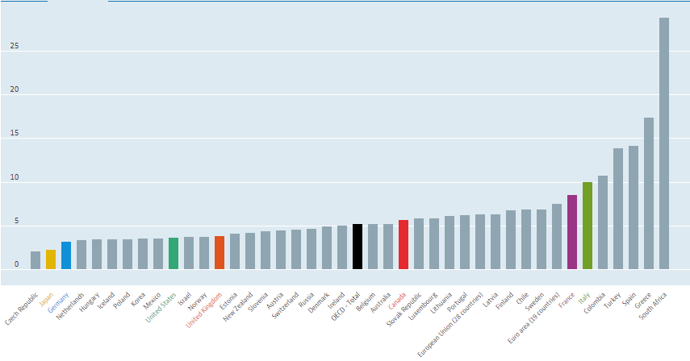

* **Population datas in 2014**

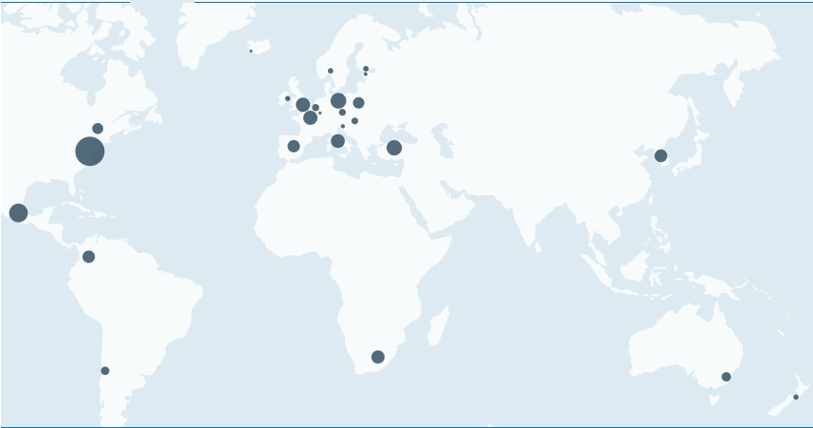

* **Gross domestic product (GDP) from 2014 to 2018**

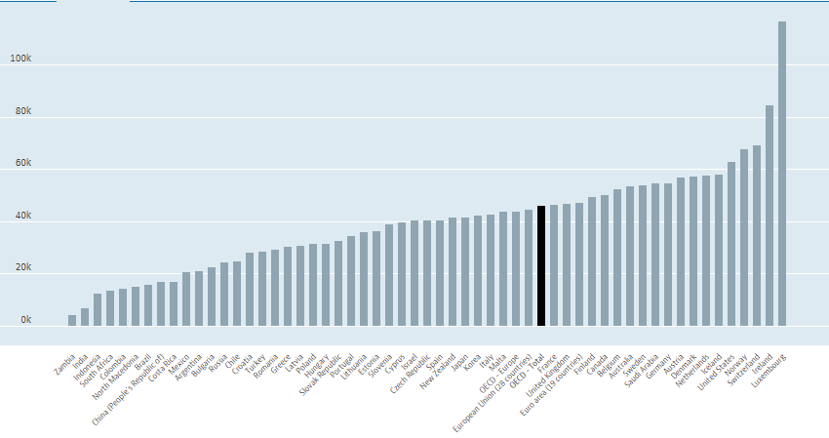

1. **IMPORTANT INFORMATION ABOUT EIS**

A human is an entity with one brain and with two hands. Therefore, it is not possible in a short period of time to analyze tasks that contain a lot of data. This lack of people has led companies to create a system that can do more work in a short period of time . In line with this need, a new technology called Executive Information Systems has been developed.

Thanks to Executive Inforfmatiom Sytems, governments and companies around the world have been able to analyze and visualize complex data in a very short period of time. In this way, both time savings and labor force savings were achieved. In a very short period of time, EIS has spread around the world. It is necessary to understand whether the systems that need to be considered here are literally EIS or not.

In the following sections, we will examine the executive information sytems under 4 headings. These:

1-) Structure of EIS

2-)Areas where EIS is used

3-)What is charactarestics of successful EIS implementation ?

4-) Four features that EIS should have

Under these four main headings; We will answer these questions in what areas a system is used in order to be Executive Informaton Systems.

In the previous pages, we talked about the history of EIS, its advantages, its disadvantages, and its major examples. Now let's look at the structure of the EIS together.

1. **ARCHITECTURE OF EXECUTIVE INFORMATION SYSTEMS**

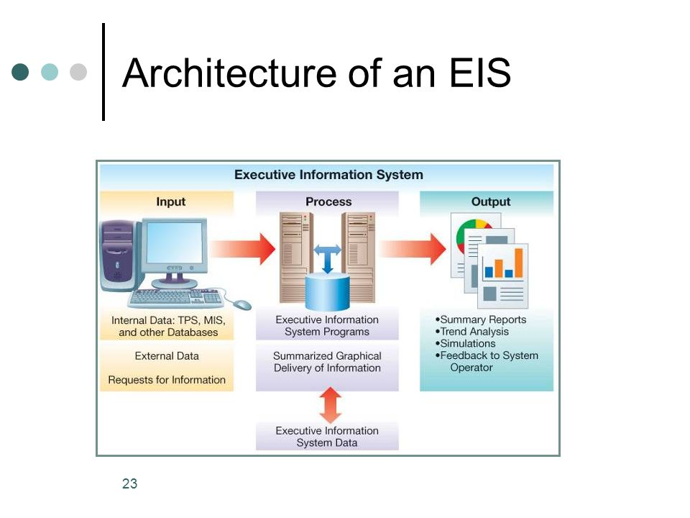

As shown in the image, Executive Informaton Systems consists of three stages: Input, Process, Output:

**a-) INPUT: All processable and analytical data that** enters to be processed from the outside. At this stage, we have two different data sources. The first of these is Internel Data. This data allows TPS, MIS and other databases. The data from these sources is transferred to the process section for processing. Our second source is External Data. This data source deals with data from outside. For example, the charts in Borsa İstanbul are external data or examples because the data is instantaneous and processed instantaneously.

**b-)PROCESS:** Data from Internel and Externel are processed and analyzed through major programs in the computer environment. The OUTPUT section is sent to show graphically. Thanks to this stage, thousands of data are brought to the level where they can be analyzed in the most accurate way in a very short period of time.

**c-) OUTPUT: The data processed in the Process section are presented to decision makers in the**form of graphs, summary reports, simulations. In this way, decision makers can analyze complex data much more easily and make the most accurate decision about it.

The output that a person can receive in a long period of time can be received in a very short time in the EIS family. And in order to call it EIS, it must have the structural features and stages that I mentioned above. So where is EIS often used?Now let's look at the areas where EIS is used, which is our second stage.

1. **USAGE AREAS OF EIS:**

EIS systems are used in many markets around the world. It is widely used in both private and public institutions. In our study We conducted research on 6 important sectors. These sectors are: Manufactrurıng, Fınance, Marketing, IT department, Madical and Government.

**MANUFACTURING: One of the important requirements in the manufacturing sector is to analyze the obtained data in the most accurate way in the shortest time and make the**most accurate decision about a possible investment to be made. Let's think of an investor; It will make an investment in major regions with a high cost and will generate high revenues if successful. For this purpose, necessary field analysis and financial reporting will be needed before the investment. The data obtained because it is a large project and important. EIS processes this data in a short time, visualizing it so that the decision maker makes the most accurate decision. In this way, investors who will invest at a high level in the production sector can make the most accurate decision about complex data.

**FINANCE: EIS plays a very important role in the** financial sector. For example, high-level organizations such as OECD, BIST: They analyze and visualize complex financial data through EIS.Companies and Governments determine future economic policies by looking at the reports and graphs of organizations such as OECD and BIST. For example its is able to instantly visualize data at the exchange rate by analyzing instantaneously according to the data received from the OECD and BIST EIS. This helps many organizations interested in the economy.

**MARKETING:**

Data from the EIS are also important in the marketing sector. Consider a marketer, according to the data he has, he can decide how right to market a good in a region, or any company plays a major role in making a possible decision to invest in that state by looking at the market share data in the EIS

**IT DEPARTMENT:**

One of the sectors where EIS systems are most frequently used is the computing departments. Computing departments are one of the most strategic positions of institutions where many data are analyzed. Therefore, when a computer-based project is to be done to an institution, the data obtained to avoid disruption of corporate functioning is analyzed in the most accurate way thanks to EIS and the projects are guided.

**MEDICAL:**

It is one of the important sectors where EIS is used in the pharmaceutical sector. In countries where population density is high, very complex data are normally obtained in these sectors as well. EIS is used for the most accurate analysis of all these data.

**GOVERNMENT:**

The government is the final decision-maker in a country. All sectors mentioned above, are interrelated. All of the sectors mentioned above can be guided by the policies they have made. It is necessary to analyze the data at its disposal very well and apply the most accurate policy in any sector. If it is analysed the data incorrectly, the whole country may experience the negative consequences. That's why EIS is utmost important to governments.

As mentioned above, EIS is used in many sectors, but these six sectors are among the most widely used sectors. Of course, the most important element in this sector is the successful use of EIS. Now we will examine the characteristics of a successful EIS.

1. **WHAT IS CHARACTARESTICS OF SUCCESSFUL EIS IMPLEMENTATION ?**

We talked about the importance of EIS for the sector above. So what are the features that a successful EIS should have? Now we're going to explore them out. A successful EIS should have the following three features.

1-) Fınd and approprıate executive champion

2-) delyver a simple prototype quıckly:

*In large projects: it is important to create small prototypes at certain stages before the project is concluded. It will summarize the operation up to that time and if there is a possible error, it will be prevented as soon as possible.

3-) involve your information systems department

*One of the reasons why EIS systems have failed in general. Corporate management usually participates in meetings held in institutions and companies. They sometimes misinterpret graphics and images because they don't have knowledge of EIS much as people who work in IT department. That's why EIS is not being used successfully.

If we want a truly successful EIS, attention should be paid to the three items mentioned above. Of course, we cannot accept every data interpreting system as EIS, it is required that system have these four features in order to call a system EIS.

**16) THINGS EXECUTIVE INFORMATION SYSTEMS MUST HAVE**

1-) VISIBILITY INTO ACCURATE REAL-TIMEDATA:

Old data is a corrupted data. In today's fast business environment, managers can't afford to make decisions about daily, weekly data or monthly data. Executive information systems with significant reporting times have the ability of a business to take advantage of dynamic market conditions, respond to critical issues in a timely manner, or correct time-sensitive errors. Decision makers need an admin information system that provides visibility to accurate and up-to-date actionable information.

An executive information system that provides real-time visibility to business management activities allows managers to see how efficiently resources are used across the organization. They can see how many people are working on each project, what each team member is working on, where the difficult moments might be, and whether business priorities need to be adjusted. Real-time visibility enables managers to make informed decisions with new and accurate information and make lesson corrections on time.

2-) PERFORMANCE CONSISTENTS:

Although different groups in an organization can offer different services or produce different types of output, all performance or work status indicators must also be consistently presented in EIS. Lack of consistency in status reporting prevents decision makers from achieving a true business performance opinion. To achieve the required level of consistency, performance indicators must be formalized and defined within the administrator information system, and then used consistently by all different groups.

To facilitate this effort, the administrator information system not only guarantees consistent reporting of business performance, but also simplifies the entire business lifecycle, including planning, coordination, execution and management provide the ability to create and customize automated workflows.

3-) UNIFIED AND AUTOMATED WORK MANAGEMENT AND REPORTING EFFORTS:

Organizations typically rely on e-tables, a combination of spreadsheets, project management utilities, PowerPoint presentations, report builders, and various other tools for business management and reporting. This can sometimes have negative consequences. An administrator information system should be able to combine and automate all these business management efforts by providing organizations with a single place to track, manage, and report to work.

4-) USER-FRIENDLY EXECUTIVE VIEWS:

Adequate efficiency cannot be achieved from an administrator information system that is difficult to deal with. Decision makers require and need an administrator information system that makes it easier for them to get the information they need quickly. This means a user-friendly interface and fully customizable dashboards. The more understandable an EIS interface is, the more useful it is for decision makers.

In a developing world where the number of data is increasing, the use of EIS will increase day by day due to the information we have provided above. As a result of efficient use of EIS, both governments and companies will bring enormous advantages i.in.

In addition to all these informations, EIS is used in the field of data mining. For example; WEKA, a data mining program, helps various decision makers make graphical data in different colors easier, and WEKA also allows decision makers to easily interpret and decide on a topic by pouring very complex data sets into a decision tree.

1. **CONCLUCION**

In today's world, the importance of functional data is increasing more and more day by day. Of course, knowing the importance of data is not enough to make it useful. It is also very important to analyze what that data means of community in a rapidly developing world and not interpret it in the most accurate way and make decisions. At this point, EIS is an indispensable pc program for us. Thanks to EIS, very complex data can be processed in a short time to make it determined. This allows both businesses and governments to easily come out of complex data.

**REFERENCES**

* [https://www.google.com/search?tbm=isch&sa=1&ei=qQfsXbjZLMeMa_egloAF&q=executive+information+systems+process&oq=executive+information+systems+process&gs_l=img.3... 7141.10550..10726...0.0.0.0.164.2421.0j18...... 0....1.gws-wiz-img....... 0i19j0i30i19. Hf2593rXjGQ&ved=0ahUKEwj40ba_rKTmAhVHxhoKHXeQBVAQ4dUDCAc&uact=5#imgrc=0PUe6sE9VB9aPM:](https://www.google.com/search?tbm=isch&sa=1&ei=qQfsXbjZLMeMa_egloAF&q=executive+information+systems+process&oq=executive+information+systems+process&gs_l=img.3...7141.10550..10726...0.0..0.164.2421.0j18......0....1..gws-wiz-img.......0i19j0i30i19.Hf2593rXjGQ&ved=0ahUKEwj40ba_rKTmAhVHxhoKHXeQBVAQ4dUDCAc&uact=5)
* [https://www.google.com/search?tbm=isch&sa=1&ei=qQfsXbjZLMeMa_egloAF&q=executive+information+systems+process&oq=executive+information+systems+process&gs_l=img.3... 7141.10550..10726...0.0.0.0.164.2421.0j18...... 0....1.gws-wiz-img....... 0i19j0i30i19. Hf2593rXjGQ&ved=0ahUKEwj40ba_rKTmAhVHxhoKHXeQBVAQ4dUDCAc&uact=5#imgrc=0PUe6sE9VB9aPM:](https://www.google.com/search?tbm=isch&sa=1&ei=qQfsXbjZLMeMa_egloAF&q=executive+information+systems+process&oq=executive+information+systems+process&gs_l=img.3...7141.10550..10726...0.0..0.164.2421.0j18......0....1..gws-wiz-img.......0i19j0i30i19.Hf2593rXjGQ&ved=0ahUKEwj40ba_rKTmAhVHxhoKHXeQBVAQ4dUDCAc&uact=5)
* <https://www.workfront.com/blog/4-things-executive-information-systems-must-have>
* <http://dergiler.ankara.edu.tr/dergiler/26/1007/12213.pdf>
* <https://www.slideshare.net/gohilrajdipsinh/c-executive-information-systems>
* <http://www.egitisim.gen.tr/tr/index.php/arsiv/sayi-11-20/sayi-16-yonetim-ve-insan-kaynagi-agustos-2007/192-yonetim-bilgi-sistemi>
* <https://www.slideshare.net/inam12/executive-information-system-28709086>
* <http://www.computerbusinessresearch.com/Home/decision-making/executive-information-system>
* Fraser, J., & Simkins, B. J. (2010). Enterprise Risk Management. Hoboken, NJ: Wiley.2.
* https://www.ukessays.com/essays/information-technology/what-is-an-executive-information-system-information-technology-essay.php3.
* https://pdfs.semanticscholar.org/ceb1/2835da3706adc6763018a7ba780f9daff34a.pdf4.
* http://aboutinformationsystem.blogspot.com/2011/07/advantages-and-disadvantages-executive.html
* [www.akademikbakis.org](http://www.akademikbakis.org/)
* [www.workfront.com](http://www.workfront.com/)
* [www.slideshare.net/MUHAMMEDMERBULAKIBAI](http://www.slideshare.net/MUHAMMEDMERBULAKIBAI)