TryHackMe Write-Up
Elastic: Using Logstash

Field | Value
Platform | TryHackMe
Module | Advanced ELK
Completed by | Aysu Nezirova
Date | June 27, 2026
Points earned | 128
Tasks completed | 9

Overview
This room covers the installation, configuration, and integration of Logstash as part of the ELK Stack. It includes creating real Logstash pipelines using input, filter, and output plugins, and analyzing the results in Kibana.

Logstash Pipeline
Input → Filter → Output

Part | Role
Input | Where data comes from (files, network, agents)
Filter | How data is processed and normalized
Output | Where processed data is sent (Elasticsearch, etc.)

Task 1 — Introduction
No questions. Learning objectives reviewed and ready to proceed.

Task 2 — Installing Logstash
Logstash was installed using the .deb package:
dpkg -i logstash.deb

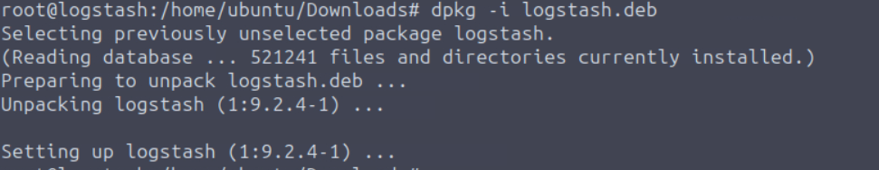

Q: Which Elastic stack component offers advanced filtering, parsing, and enrichment of log data?
A: Logstash
Q: Which Logstash version number did you just install?
A: 9.2.4

Task 3 — How Logstash Works
Logstash uses plugins for each pipeline stage. Key filter plugins:

Plugin | Role
Grok | Parses unstructured logs using custom patterns
Mutate | Renames, replaces, modifies event fields
Date | Parses and formats timestamps
Prune | Removes fields using whitelist/blacklist
Drop | Drops entire events from the pipeline
KV | Parses key=value pairs into separate fields

Q: Which plugin parses unstructured log data using custom patterns?
A: Grok
Q: Which filter plugin is used to perform mutation of event fields?
A: Mutate

Task 4 — Configuring Logstash
Pipeline config files are stored in /etc/logstash/conf.d/. The => operator defines field-value pairs. Example pipeline:
input {
tcp {
port => 5456
codec => json
}
}
filter {
json {
source => "message"
}
}
output {
elasticsearch {
hosts => ["localhost:9200"]
index => "your_index_name"
}
}

Q: Check the File input plugin documentation. Which configuration option is required?
A: path
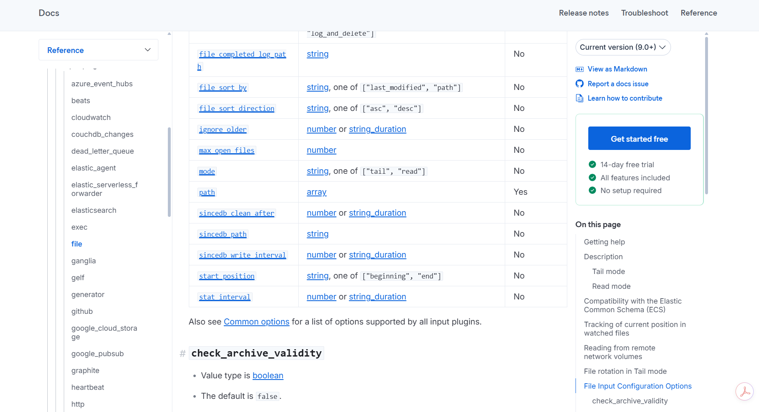

Q: Which field does the JSON filter plugin read the contents of?
A: message

Task 5 — Configuring Inputs
Logstash supports multiple input plugins:

Plugin | Default Port | Use Case
File | — | Local log files
Beats | 5044 | Filebeat, Winlogbeat agents
TCP | 5000 | Custom apps, network devices
UDP | 514 | Syslog, network devices
HTTP | 8080 | Webhooks, REST APIs

Q: Which Logstash input plugin would you use to monitor and ingest the locally hosted syslog file?
A: file
Q: Check the Google Cloud Storage input plugin documentation. What is the one required input configuration setting?
A: bucket_id
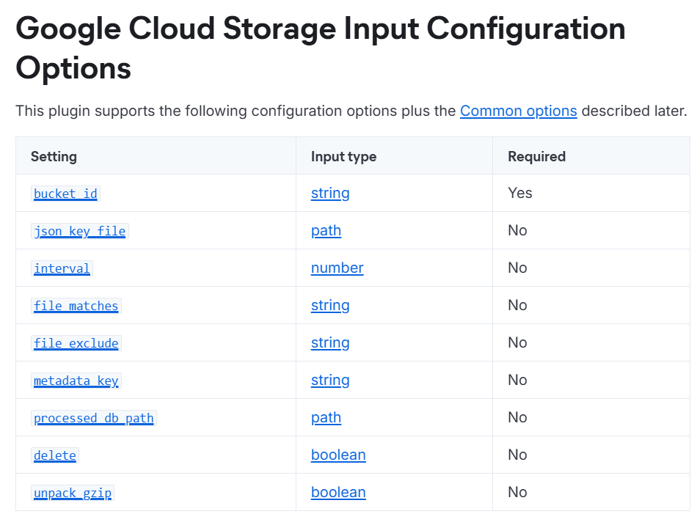

Task 6 — Filter Configurations

Mutate Filter
filter {
mutate {
add_field => { "new_field" => "new_value" }
rename => { "IPAddress" => "client_ip" }
}
}

Grok Filter
filter {
grok {
match => { "message" => "%{IP:client_ip} %{GREEDYDATA:msg}" }
}
}

Prune Filter
filter {
prune {
whitelist_names => ["field1", "field2"]
}
}

KV Filter
filter {
kv {
field_split => "&"
value_split => "="
}
}
# user=alice&status=active => { "user": "alice", "status": "active" }

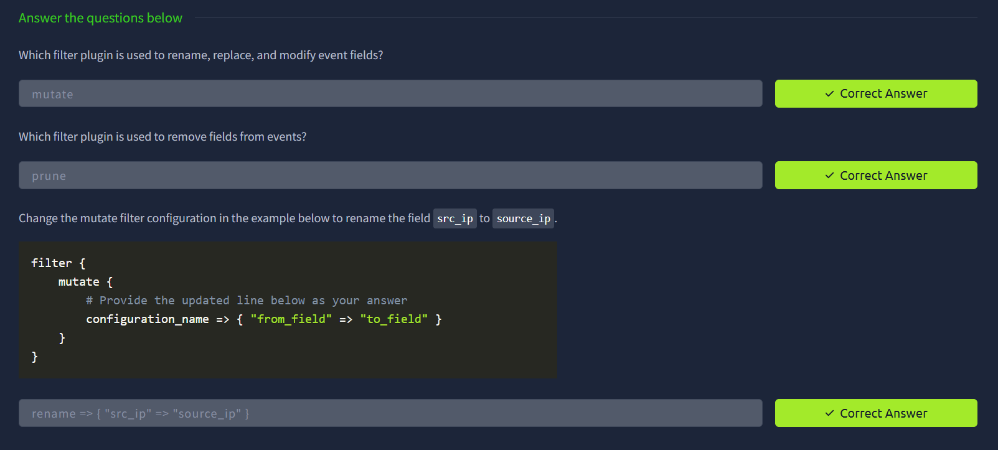

Q: Which filter plugin is used to rename, replace, and modify event fields?
A: mutate
Q: Which filter plugin is used to remove fields from events?
A: prune
Q: Change the mutate filter configuration to rename the field src_ip to source_ip.
A: rename => { "src_ip" => "source_ip" }

Task 7 — Defining the Destination

Elasticsearch Output
output {
elasticsearch {
hosts => ["localhost:9200"]
index => "your_index_name"
}
}

Stdout Output (debugging)
output {
stdout { }
}

RabbitMQ Output
output {
rabbitmq {
host => "localhost"
exchange => "my_exchange"
routing_key => "my_routing_key"
}
}

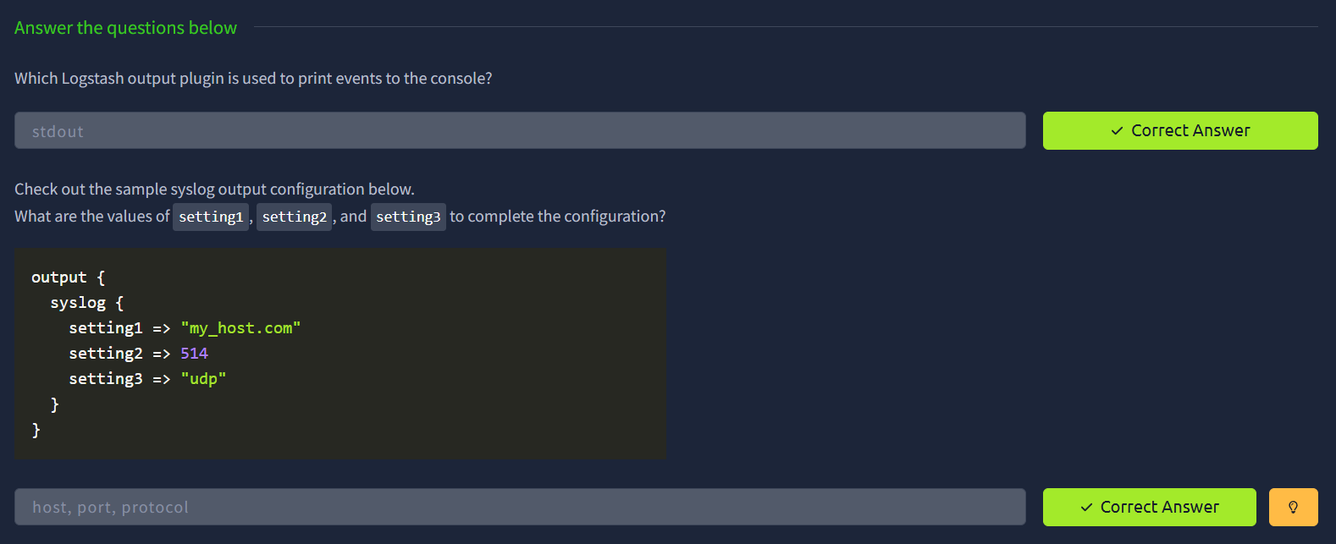

Q: Which Logstash output plugin is used to print events to the console?
A: stdout
Q: What are the values of setting1, setting2, and setting3 for the syslog output?
A: host, port, protocol

Task 8 — Putting Pipelines Into Practice
Goal: Monitor /var/log/auth.log → parse with Logstash → send to Elasticsearch → analyze in Kibana.

Step 1 — Create configuration file
sudo nano /etc/logstash/conf.d/auth.conf

Step 2 — Input configuration
input {
file {
path => "/var/log/auth.log"
start_position => "beginning"
sincedb_path => "/dev/null"
}
}
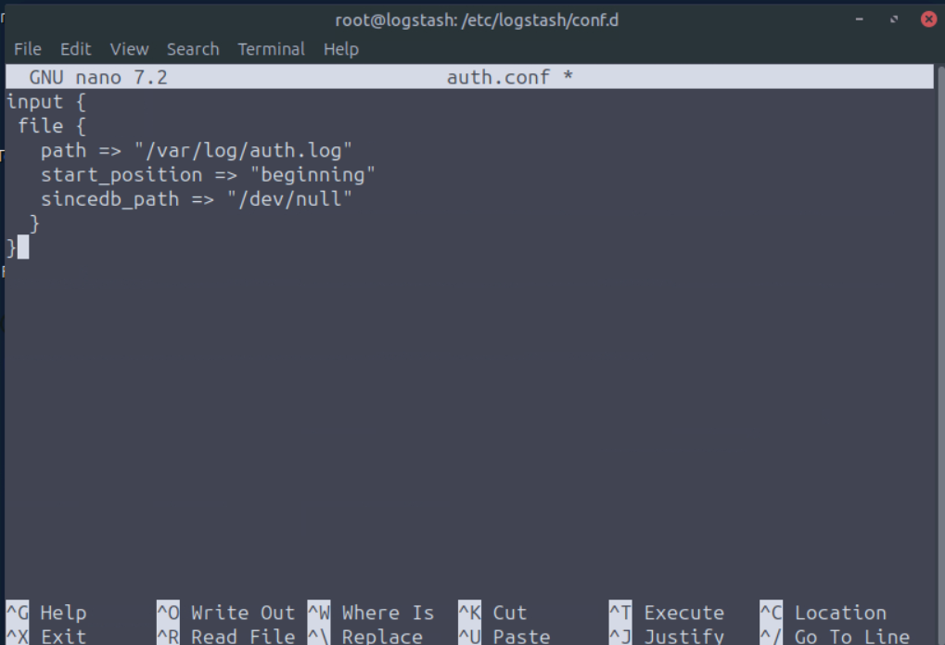

Step 3 — Filter + Output configuration
filter {
grok {
match => {
"message" => "^%{TIMESTAMP_ISO8601:timestamp} %{NOTSPACE:[host][name]} %{WORD:program}(?:\[%{NUMBER:pid}\])?: %{GREEDYDATA:msg}"
}
}
date {
match => ["timestamp", "ISO8601"]
target => "@timestamp"
}
}
output {
elasticsearch {
hosts => ["https://localhost:9200"]
user => "elastic"
password => "pn00IuML9u43_yKb688y"
index => "auth-logs-%{+YYYY.MM.dd}"
ssl_verification_mode => "none"
ssl_enabled => true
}
}
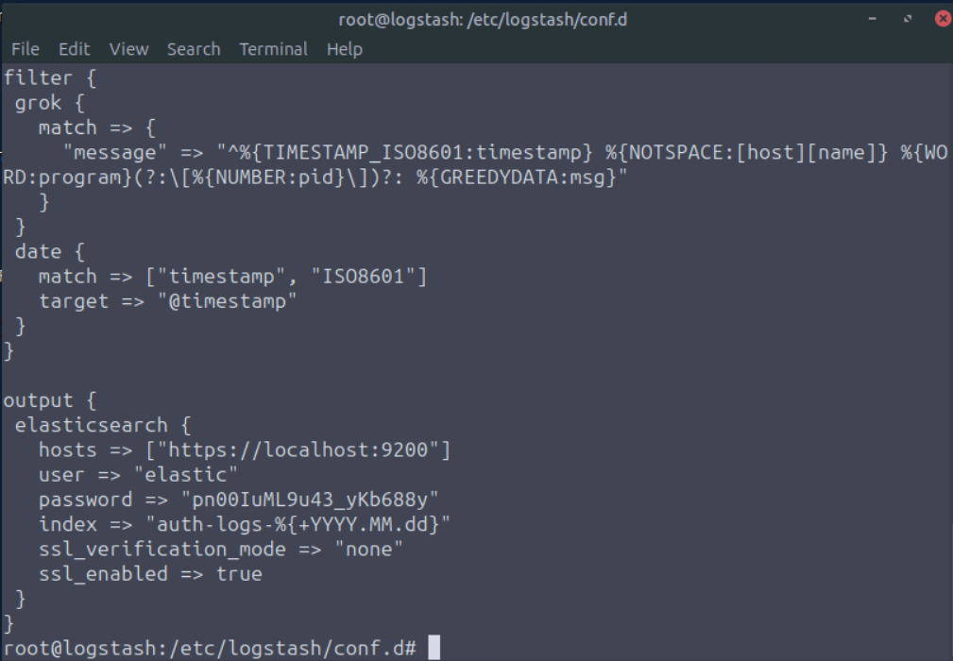

Step 4 — Grant permissions and start Logstash
usermod -aG adm logstash # give Logstash read access to auth.log
systemctl restart logstash # restart Logstash
systemctl status logstash # verify: active (running)
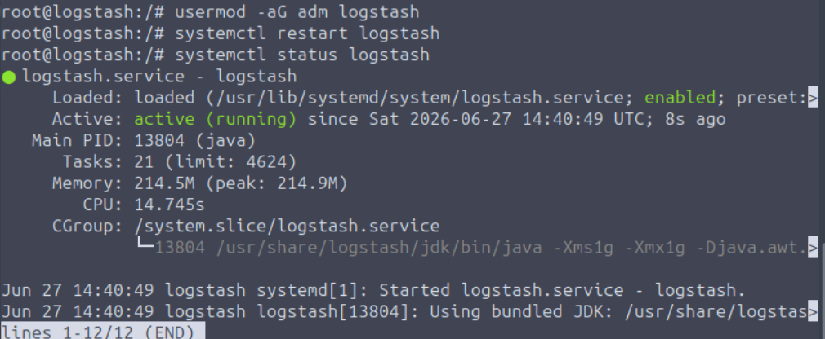

Step 5 — Test with new user creation
useradd -m detective_elastic
passwd detective_elastic
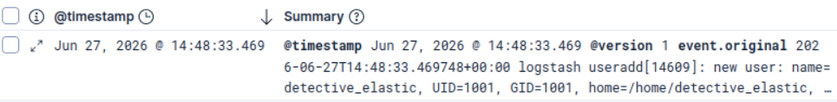
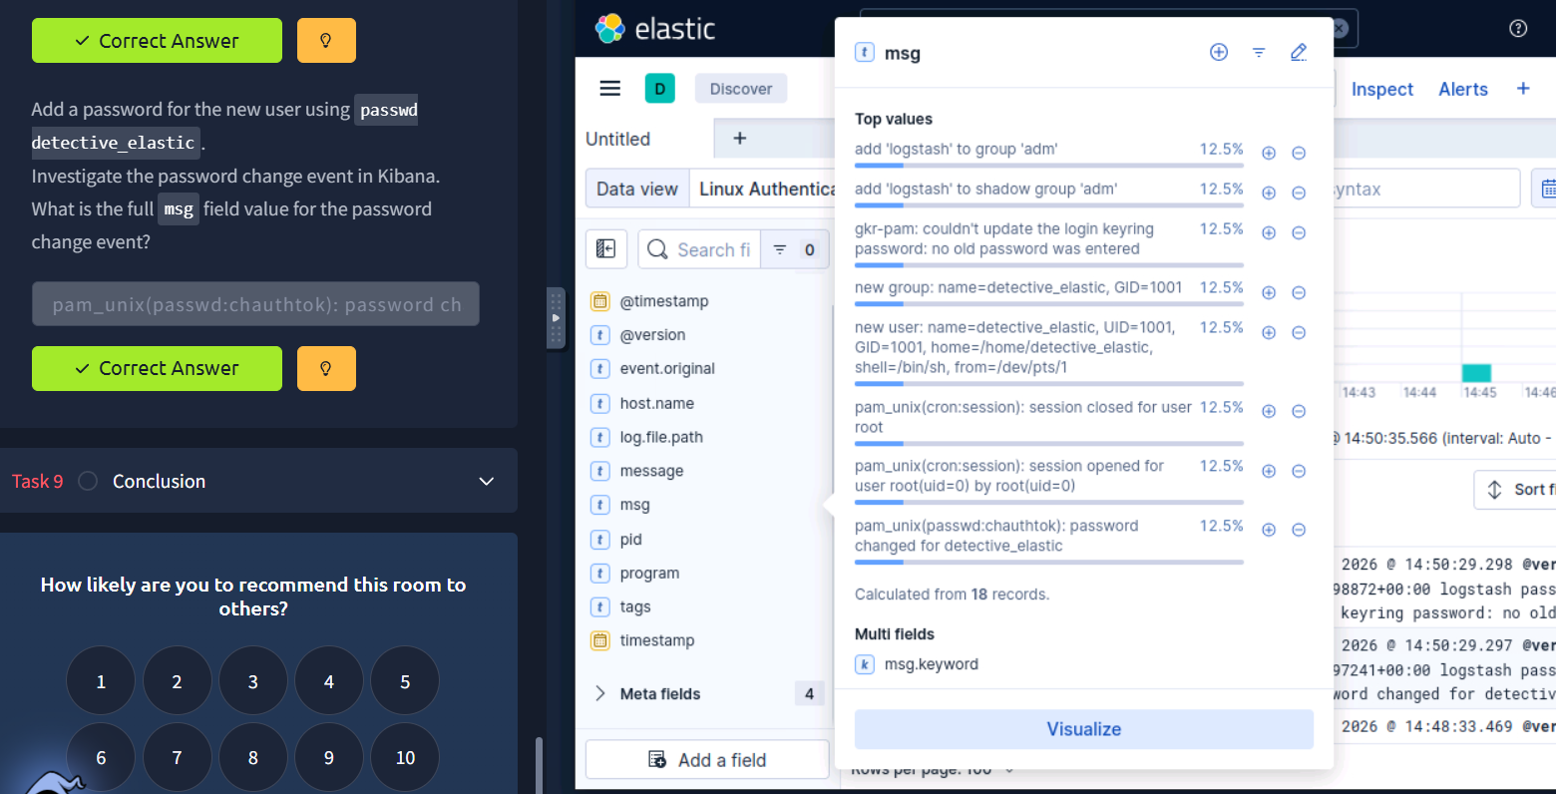

Q: Which two filters did you use in your auth.conf configuration file?
A: grok, date
Q: What is the program field value for the latest events?
A: useradd
Q: What is the full msg field value for the password change event?
A: pam_unix(passwd:chauthtok): password changed for detective_elastic

Task 9 — Conclusion
Room completed successfully!

Key Takeaways
- Logstash pipeline = Input → Filter → Output
- grok is the most powerful filter for parsing unstructured logs
- date filter ensures correct timestamp handling in Kibana
- sincedb_path => "/dev/null" resets file tracking on each restart
- usermod -aG adm logstash is required to read /var/log/auth.log
- Index naming with %{+YYYY.MM.dd} creates daily indices automatically
- Default ports: Beats=5044, Elasticsearch=9200, Kibana=5601, UDP/Syslog=514

References
- Logstash Documentation — https://www.elastic.co/docs/reference/logstash
- Input Plugins — https://www.elastic.co/docs/reference/logstash/plugins/plugins-inputs-file
- Filter Plugins — https://www.elastic.co/docs/reference/logstash/plugins/plugins-filters-grok
- Output Plugins — https://www.elastic.co/docs/reference/logstash/plugins/plugins-outputs-elasticsearch
- TryHackMe — https://tryhackme.com

