TryHackMe Write-Up
Elastic: Query Languages

Field | Value
Platform | TryHackMe
Module | Advanced ELK
Completed by | Aysu Nezirova
Date | June 29, 2026
Tasks completed | 8

Overview
This room covers advanced search techniques in Kibana, including KQL, Lucene, and ES|QL syntax, nested data queries, regular expressions, range queries, fuzzy and proximity searches, and core Elastic Stack architecture concepts (ECS and EQL).

Task 2 — Elastic Languages and Syntax

Supported Query Languages
Language | Description | Example
Lucene | Core Elasticsearch query syntax, supports advanced pattern matching | flag: thm
KQL | Simple, user-friendly language for filtering in Kibana | flag: thm
ES|QL | Pipe-based language for structured data analysis | FROM index | WHERE flag == "thm"

Special Characters
Characters such as + - && || ! ( { [ ^ ~ * ? : / are interpreted as operators and must be escaped or quoted.
Quotes: flag: "THM{kql!}"
Backslash: flag: THM\{kql\!\}

Field Types: text vs keyword
Type | Behavior | Wildcard Impact
text | Tokenized into separate words during indexing | Wildcards match per-token, not full value
keyword | Stored exactly as written, not analyzed | Wildcards match the full string

Q: The value david:davidson exists in the user.name field. What query would you use to search for this exact value?
A: user.name: "david:davidson"
Q: Suppose you want to find values such as hack and hacking in the activity field. What wildcard query would return these results?
A: activity: hack*

Task 3 — Navigating Nested Data
Nested fields store arrays of objects, allowing queries against specific attributes within those objects (e.g., comments.author, comments.text).
comments.author: * # match any value
comments.author: "Alice" # exact match
comments.author: "Alice" AND comments.text: "attack"
comments.author: ("Alice" AND "Bob") AND comments.text: "attack"
comments.author: ("Alice" OR "Bob") AND comments.text: "attack"

Query 1 — Exact filename match
affected_systems.affected_files.file_name: "marketing_strategy_2023_07_23.pptx"
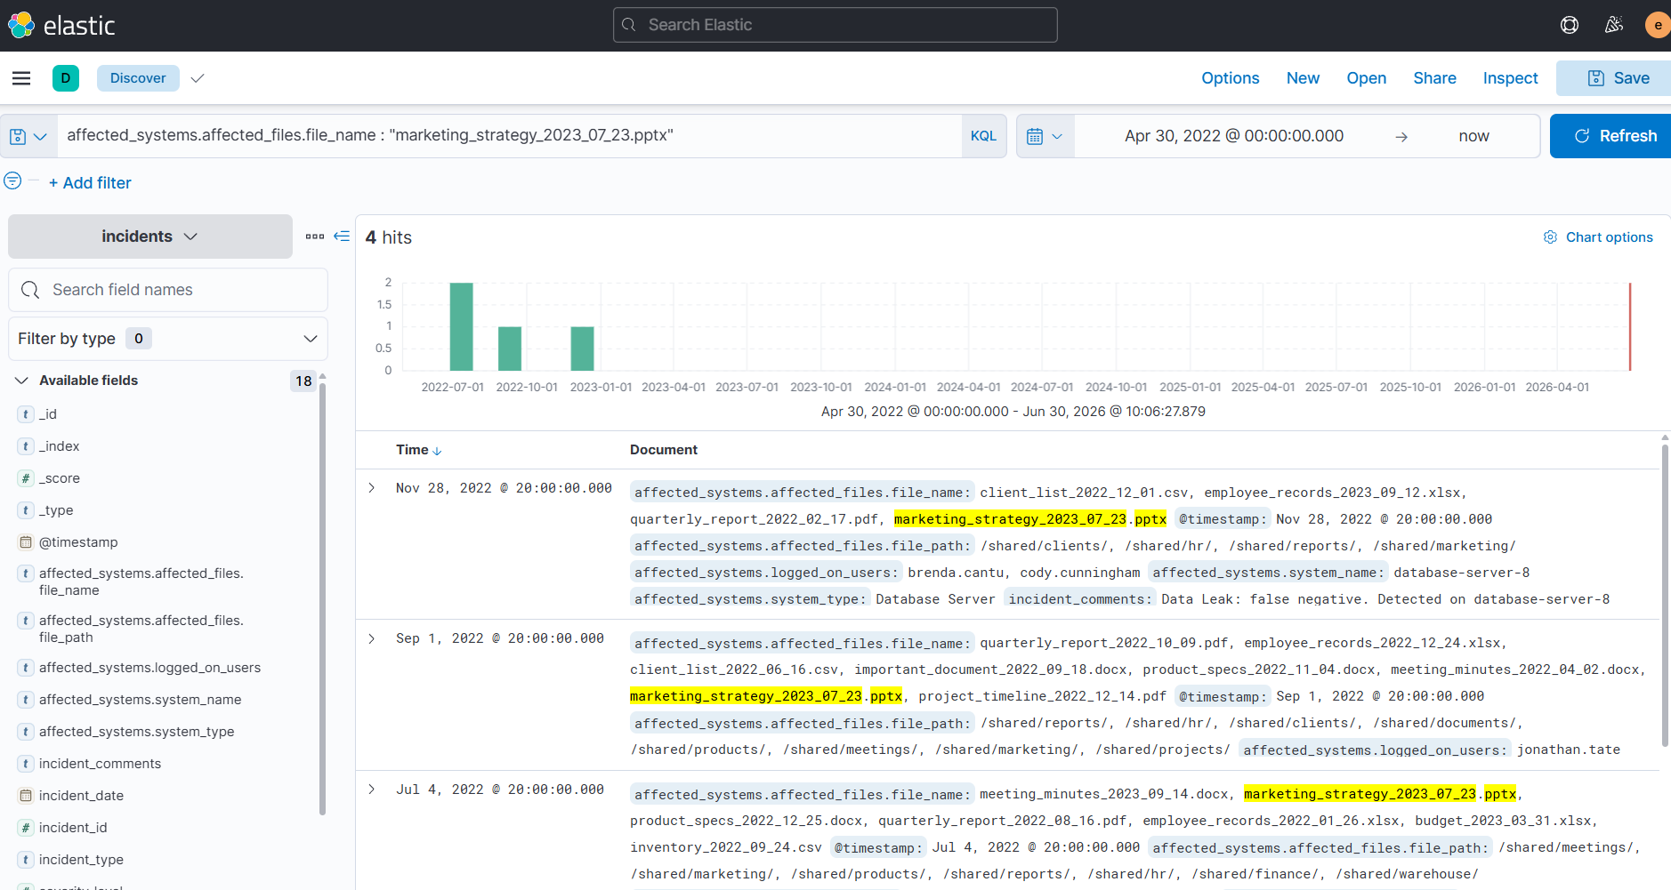

Query 2 — Wildcard + system type
affected_systems.affected_files.file_name: marketing_strategy* AND affected_systems.system_type: "File Server"
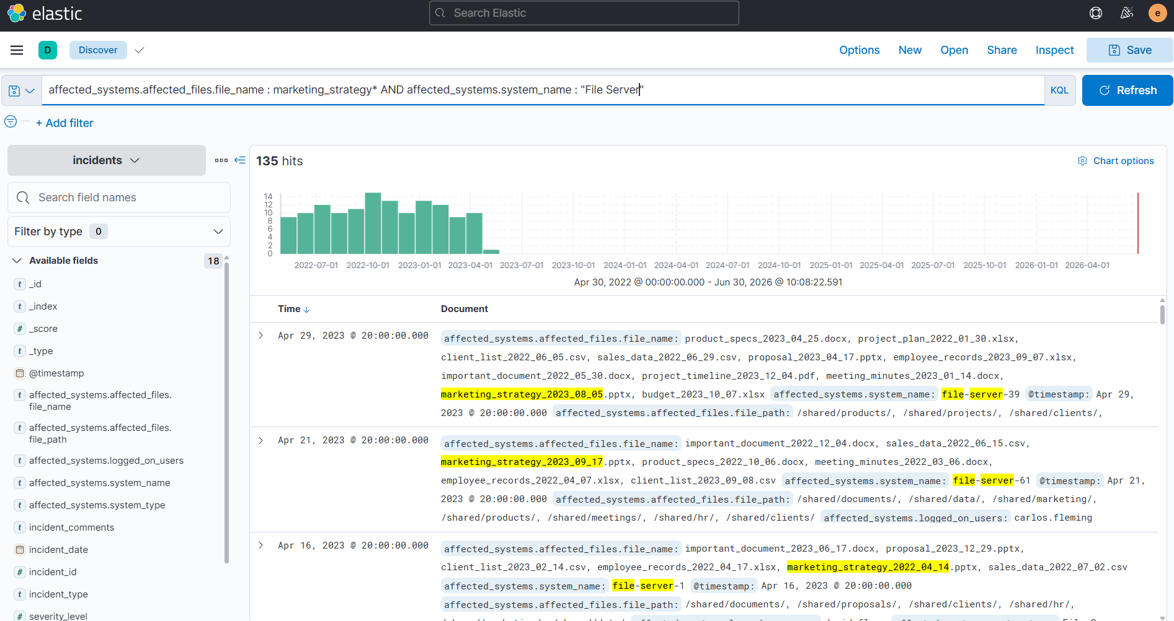

Query 3 — Multiple users + Web Server
affected_systems.system_type: "Web Server" AND affected_systems.logged_on_users: ("admin" AND "it")
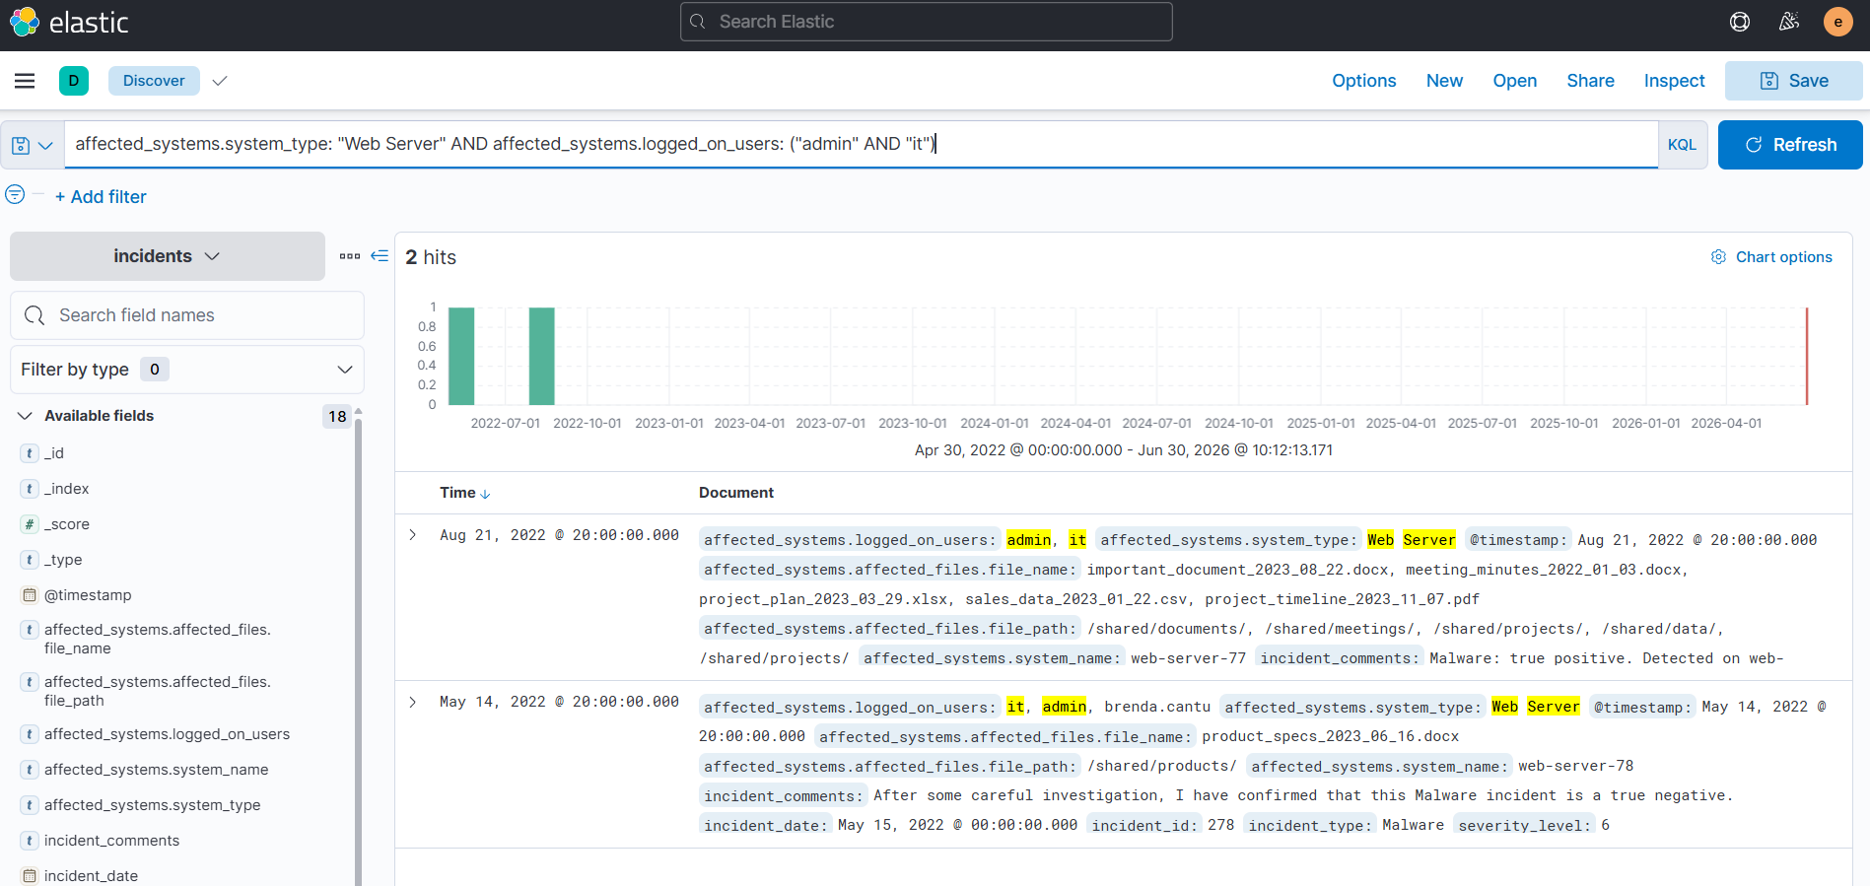

Q: How many incidents involve the file marketing_strategy_2023_07_23.pptx?
A: 4
Q: How many incidents involve files on a File Server with names that start with marketing_strategy?
A: 135
Q: Which Web Server had a true positive incident where both admin and it users were logged in?
A: web-server-77

Task 4 — Investigating With Regular Expressions
Lucene regex queries are wrapped in forward slashes /pattern/. Behavior differs between keyword fields (matches the full value) and text fields (matches per analyzed token).
Event_Type: /.*/ # match anything
Event_Type: /(S|M).*/ # starts with S or M
Description: /(s|m).*/ # matches individual words (text field)
Description: /(s|m).*/ AND /user.*/

Q: How many events exist where a client_list file was affected by ransomware?
A: 69 (using incident_comments: /ransomware/)
Q: Investigate affected_systems.affected_files.file_name using /.*project.*/. What is the affected system name on the latest event managed by EVenis?
A: web-server-37
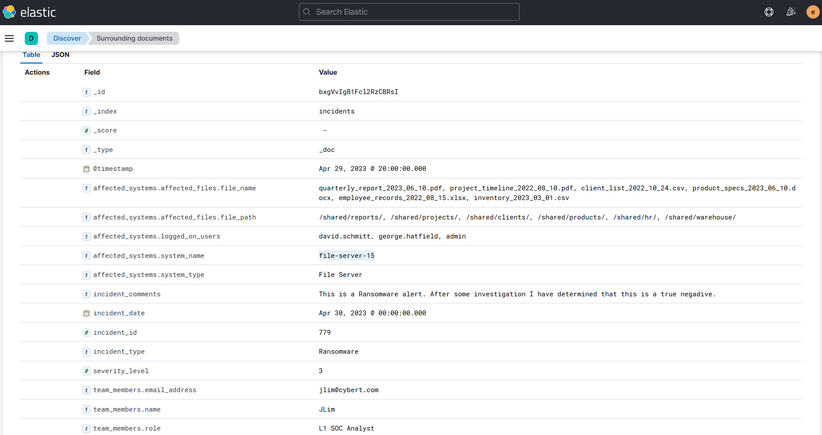

Task 5 — Defining Ranges and Boundaries
Range queries use comparison operators (>=, <=, >, <) to match numeric values, timestamps, or other ranges.
response_time_seconds >= 100
response_time_seconds < 300
response_time_seconds >= 100 AND response_time_seconds <= 300
@timestamp >= "2023-01-01"
@timestamp >= "2023-01-01" AND @timestamp < "2023-03-01"

Query 1 — Data Leak with high severity
incident_type: "Data Leak" AND severity_level >= 9
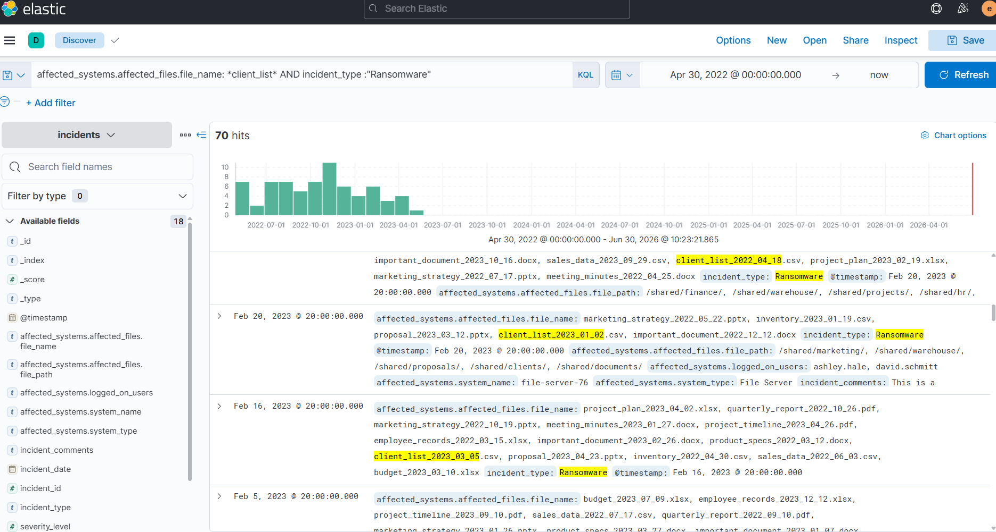

Query 2 — AJohnston before Dec 1, 2022
team_members.name: "AJohnston" AND @timestamp <= "2022-12-01" AND affected_systems.system_type: ("Email Server" OR "Web Server")
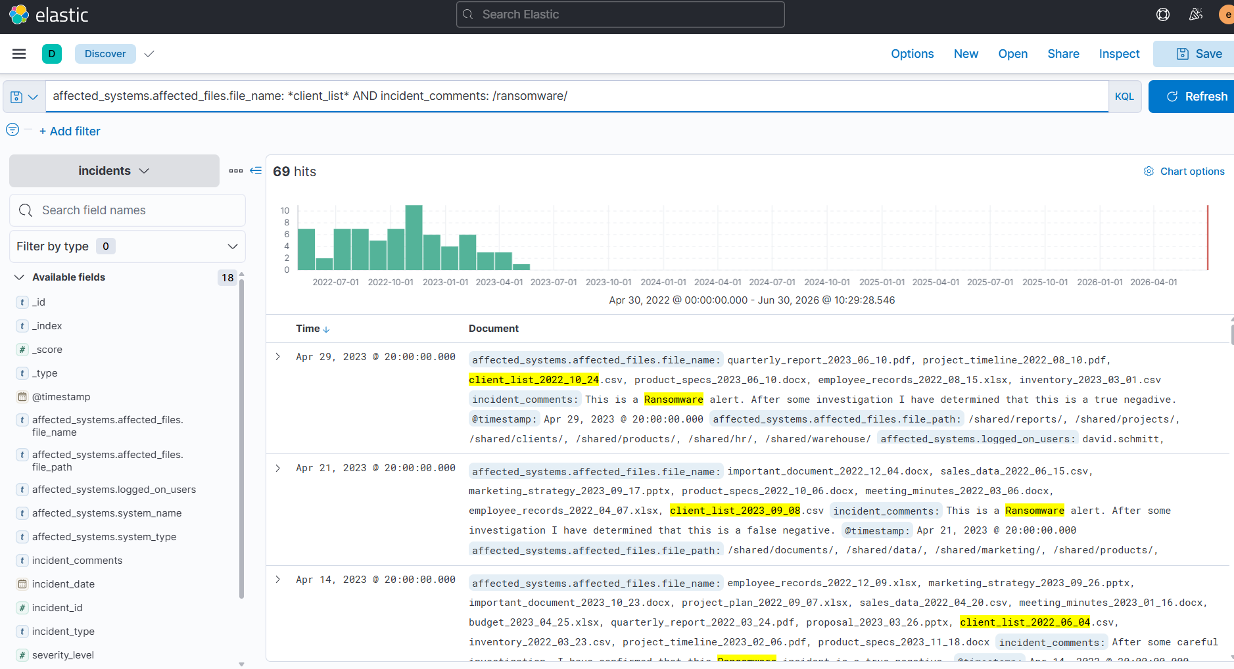

Query 3 — incident_id range + false positive lookup
incident_id >= 1 AND incident_id <= 500 AND incident_type: "Data Leak" AND affected_systems.system_name: "file-server-65"
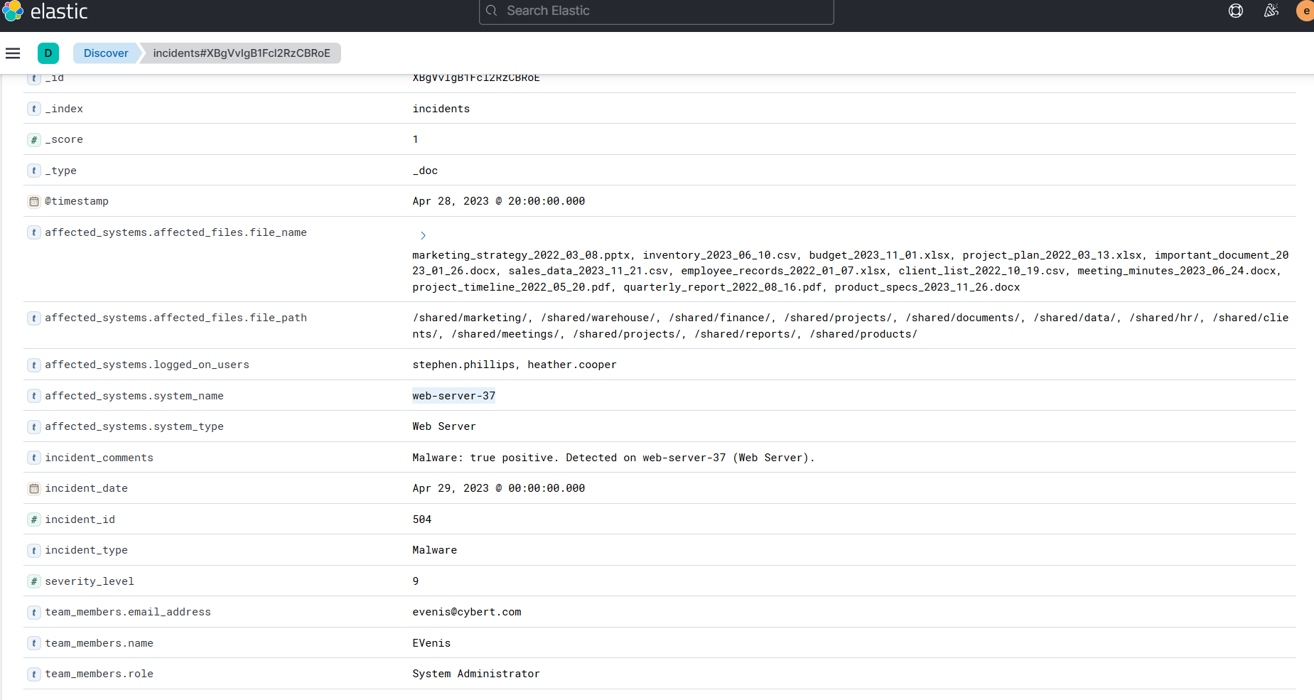

Q: How many Data Leak incidents have a severity_level of 9 or higher?
A: 52
Q: Check out incidents investigated by AJohnston on or before December 1, 2022. How many events occurred on an Email Server or Web Server?
A: 65
Q: Investigate incident_id 1-500. Which analyst stated that the Data Leak on file-server-65 was a false positive?
A: JLim

Task 6 — Searching Variants and Proximity
Fuzzy searches (~) find terms with character variations. Proximity searches find terms within a specified word distance using "phrase"~slop_value.
server01~1 # fuzzy: 1 character difference
server01~2 # fuzzy: 2 character differences
log_message: "server error"~1 # proximity: within 1 position

Query 1 — Fuzzy search on "true"
incident_comments: true~1 AND team_members.name: "JLim"
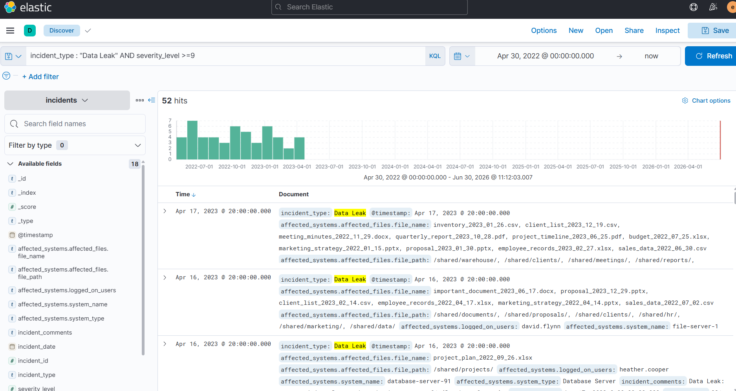

Query 2 — Proximity search
incident_comments: "data-leak true-negative"~3
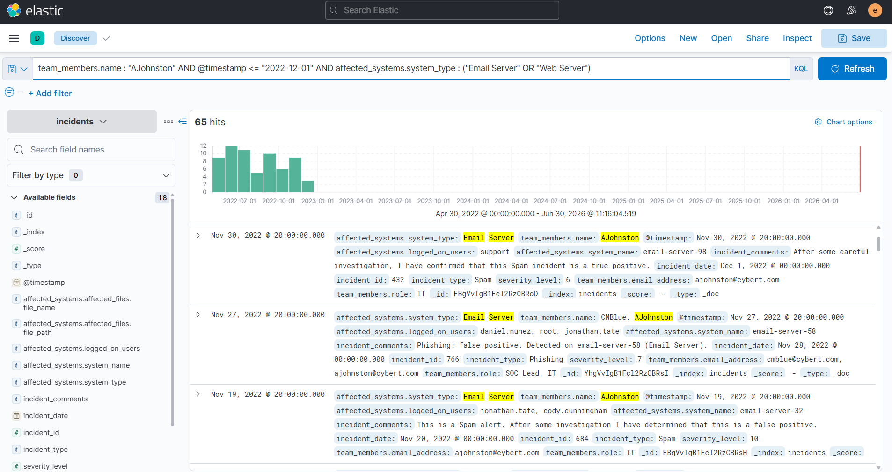

Query 3 — Proximity + AJohnston
incident_comments: "detected negative"~2 AND team_members.name: "AJohnston"
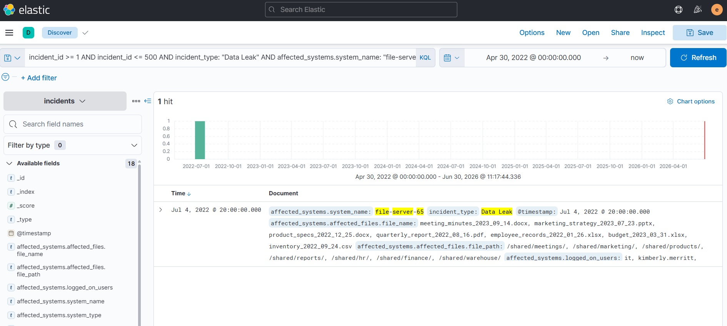

Q: How many incidents has JLim handled in which the word true appears with a single character difference?
A: 110
Q: How many events contain data-leak true-negative within three words of each other?
A: 33
Q: How many incidents handled by AJohnston contain detected and negative within two positions?
A: 40

Task 7 — Elastic Query Architecture

Elastic Common Schema (ECS)
ECS is a standardized set of field-naming conventions that normalizes how fields are structured across different data sources, enabling consistent cross-source querying.
VPN server: src_ip -> ECS: source.ip
Web server: client_address -> ECS: source.ip
Firewall: source_address -> ECS: source.ip

Event Query Language (EQL)
EQL is a correlation-focused query language for security use cases. Unlike KQL/Lucene, it identifies relationships between multiple events over time, and is primarily used in detection engineering and threat hunting.
file where host.os.type == "linux" and
event.action in ("rename", "creation") and
file.path in (
"/etc/crontab",
"/etc/cron.allow",
"/etc/cron.deny"
)

Q: Which Elastic component standardizes field names across different data sources?
A: ECS (Elastic Common Schema)
Q: Which Elastic language is often used to write event correlation detection rules?
A: EQL (Event Query Language)

Task 8 — Conclusion
Room completed successfully!

Key Takeaways
- KQL is simple and user-friendly; Lucene supports regex and fuzzy/proximity search; ES|QL uses pipe syntax
- text fields are tokenized (word-based matching); keyword fields match the full string exactly
- Nested data fields use dot notation (e.g., comments.author) and support AND/OR grouping with parentheses
- Lucene regex patterns are wrapped in forward slashes: /pattern/
- Range queries use >=, <=, >, < for numbers, dates, and other comparable values
- Fuzzy search (~N) finds spelling variations; proximity search ("phrase"~N) finds nearby terms
- ECS standardizes field names across data sources for consistent cross-source querying
- EQL is used for multi-event correlation in detection rules, not for ad-hoc Kibana searches

References
- Kibana Query Language — https://www.elastic.co/guide/en/kibana/current/kuery-query.html
- Lucene Query Syntax — https://lucene.apache.org/core/
- Elastic Common Schema — https://www.elastic.co/docs/reference/ecs/ecs-getting-started
- Event Query Language — https://www.elastic.co/docs/explore-analyze/query-filter/languages/eql
- TryHackMe — https://tryhackme.com

