 

**DEPARTMENT OF COMPUTER SCIENCE AND ENGINEERING**

**SESSION : 2019-20**

**SUBJECT: JAVA PROGRAMMING**

**TOPIC: BANK MANAGEMENT SYSTEM**

SUBMITTED BY: AMAN KHAN PATHAN (A-27)

AYUSH AGRAWAL (A-40)

SUBMITTED TO: ATIYA KHAN MA’AM

**WELCOME PAGE:**

Code:

public class Welcome extends javax.swing.JFrame {

Connection con = null;

PreparedStatement pst = null;

public Welcome() {

initComponents();

}

private void BUTTON_LOGINActionPerformed(java.awt.event.ActionEvent evt) {

Login_page Log = new Login_page();

Log.show();

dispose();

}

private void BUTTON_REGISTERActionPerformed(java.awt.event.ActionEvent evt) {

Register R = new Register();

R.show();

dispose();

}

private void EXIT_BUTTONActionPerformed(java.awt.event.ActionEvent evt) {

System.exit(0);

}

Output:

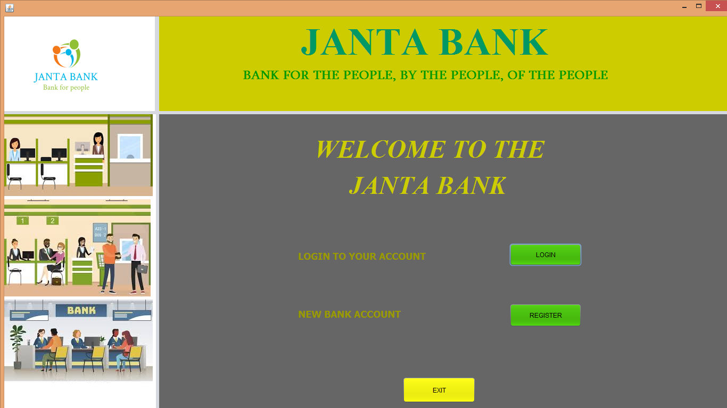

**REGISTRATION PAGE:**

Code:

public class Register extends javax.swing.JFrame {

Connection con = null;

PreparedStatement pst = null;

public Register() {

initComponents();

}

private void BUTTON_BACKActionPerformed(java.awt.event.ActionEvent evt) {

Welcome w = new Welcome();

w.show();

dispose();// TODO add your handling code here:

}

private void BUTTON_REGISTERActionPerformed(java.awt.event.ActionEvent evt) {

try{

Class.forName("com.mysql.jdbc.Driver");

con = DriverManager.getConnection("jdbc:mysql://localhost:3306/bankregisteration","root","");

String query = "INSERT INTO registeration(`FNAME`, `LNAME`, `DOB`, `Email ID`, `ADDRESS`, `MOBILE`, `ACC_NO`, `PIN`) VALUES(?, ?, ?, ?, ?, ?, ?, ?)";

pst = con.prepareStatement(query);

pst.setString(1,TEXT_FNAME.getText());

pst.setString(2,TEXT_LNAME.getText());

pst.setString(3,TEXT_DOB.getText());

pst.setString(4,TEXT_EMAIL.getText());

pst.setString(5,AREA_ADD.getText());

pst.setString(6,TEXT_MOBILE.getText());

pst.setString(7,TEXT_ACC_NO.getText());

pst.setString(8,TEXT_PIN.getText());

pst.executeUpdate();

JOptionPane.showMessageDialog(null,"REGISTERED SUCCESSFULLY");

}catch(Exception ex){

ex.printStackTrace();

JOptionPane.showMessageDialog(null,ex);

}

}

Output:

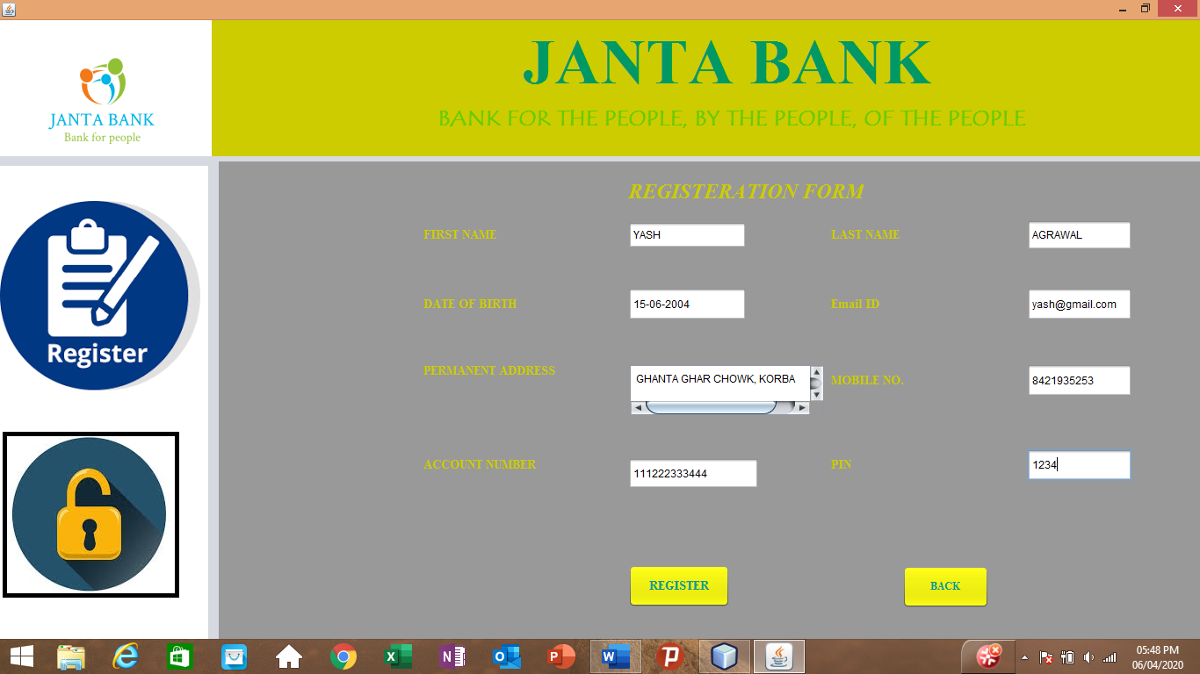

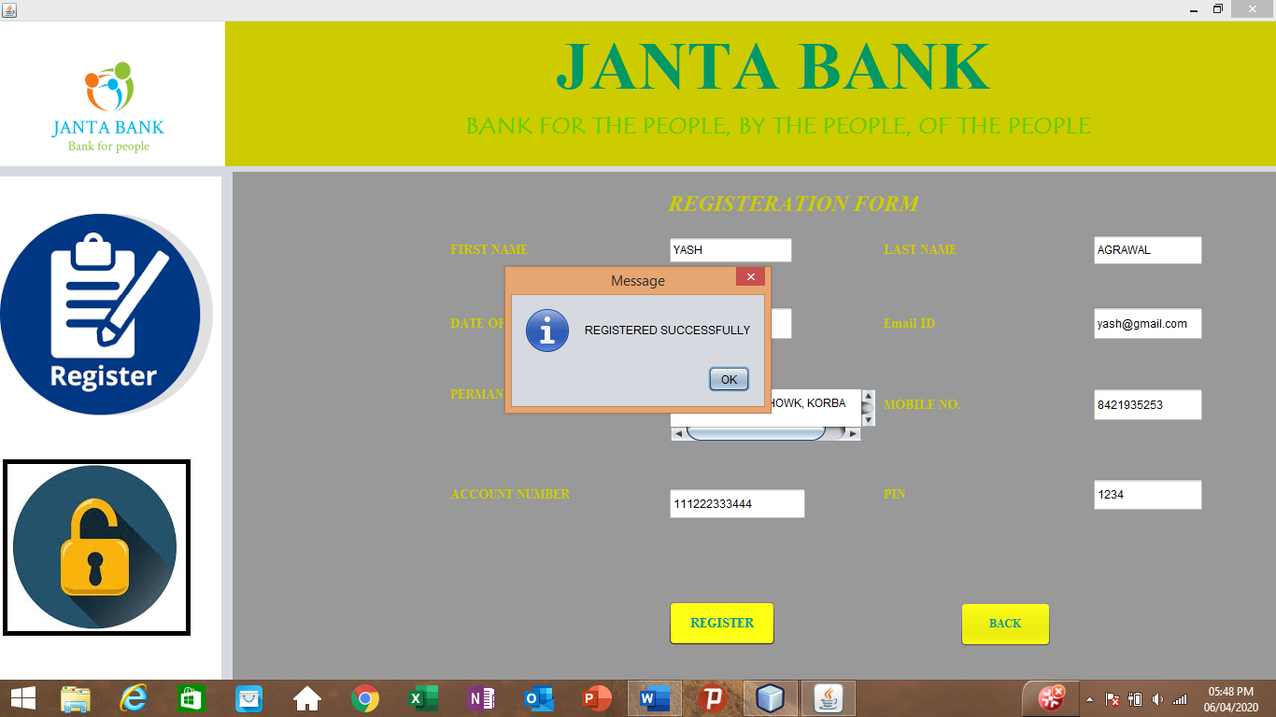

**LOGIN PAGE:**

Code:

private void BACKActionPerformed(java.awt.event.ActionEvent evt) {

Welcome w = new Welcome();

w.show();

dispose();// TODO add your handling code here:

}

private void SUBMITActionPerformed(java.awt.event.ActionEvent evt) {

try{ Class.forName("com.mysql.jdbc.Driver");

con = DriverManager.getConnection("jdbc:mysql://localhost:3306/bankregisteration","root","");

String query = "SELECT * FROM registeration WHERE ACC_NO=? AND PIN=?";

pst = con.prepareStatement(query);

pst.setString(1, USERNAME.getText());

pst.setString(2,PASSWORD.getText());

rs = pst.executeQuery();

if(rs.next()){

JOptionPane.showMessageDialog(this,"LOGIN SUCCESSFULLY");

Main_Page Main = new Main_Page();

Main.show();

dispose();

}

else{

JOptionPane.showMessageDialog(this,"LOGIN UNSUCCESSFULLY");

}

}catch(Exception ex){

JOptionPane.showMessageDialog(this,"LOGIN UNSUCCESSFULLY");

}

}

private void EXIT_BUTTONActionPerformed(java.awt.event.ActionEvent evt) {

System.exit(0);

}

Output:

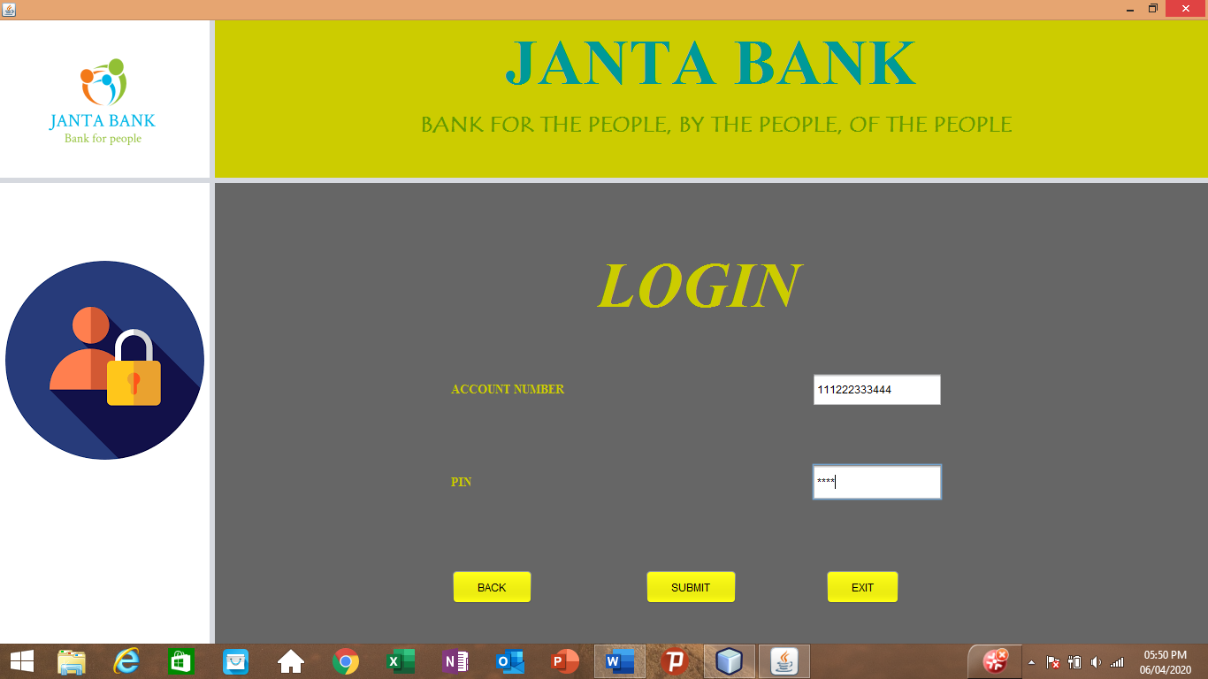

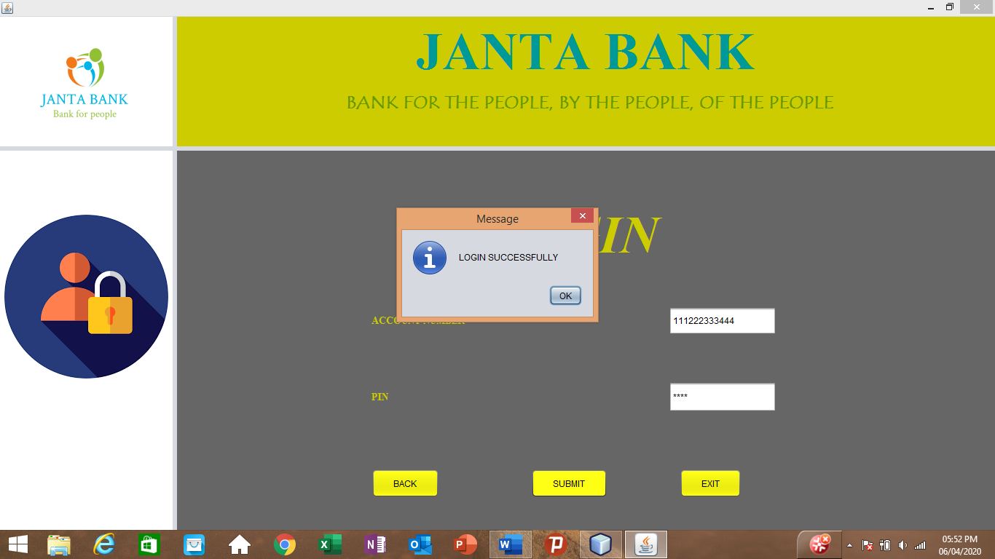

**HOME PAGE:**

Code:

private void EXIT_BUTTONActionPerformed(java.awt.event.ActionEvent evt) {

System.exit(0);

}

private void INSERTActionPerformed(java.awt.event.ActionEvent evt) {

INSERT_PAGE INSERT = new INSERT_PAGE();

INSERT.show();

dispose();

}

private void SEARCH_BUTTONActionPerformed(java.awt.event.ActionEvent evt) {

SEARCH_PAGE SEARCH = new SEARCH_PAGE();

SEARCH.show();

dispose();

}

private void UPDATE_BUTTONActionPerformed(java.awt.event.ActionEvent evt) {

UPDATE_PAGE UPDATE = new UPDATE_PAGE();

UPDATE.show();

dispose();

}

private void DELETE_BUTTONActionPerformed(java.awt.event.ActionEvent evt) {

DELETE_PAGE DELETE = new DELETE_PAGE();

DELETE.show();

dispose();

}

Output:

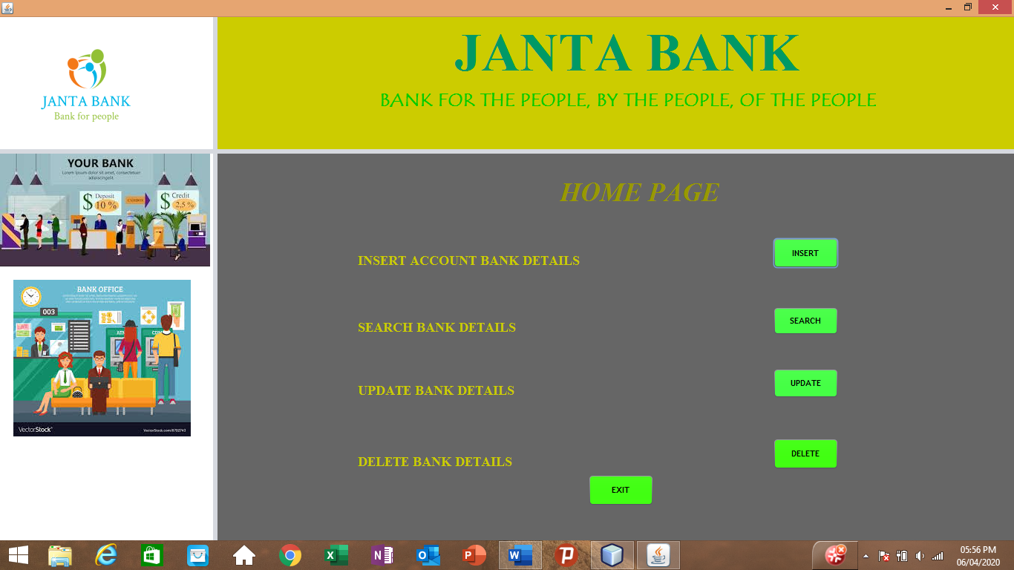

**INSERTION PAGE:**

Code:

private void BACK_BUTTONActionPerformed(java.awt.event.ActionEvent evt) {

Main_Page Main = new Main_Page();

Main.show();

dispose();

}

private void EXIT_BUTTONActionPerformed(java.awt.event.ActionEvent evt) {

System.exit(0);

}

private void SUBMITActionPerformed(java.awt.event.ActionEvent evt) {

try{ Class.forName("com.mysql.jdbc.Driver");

con = DriverManager.getConnection("jdbc:mysql://localhost:3306/bankform","root","");

String query = "INSERT INTO bank(`ACC_NO`, `NAME`, `EMAIL`, `MOBILE`, `PAN`, `TYPE`, `OCCUPATION`, `CREDIT AMOUNT`,`AGE`) VALUES(?, ?, ?, ?, ?, ?, ?, ?, ?)";

pst = con.prepareStatement(query);

pst.setString(1,TEXT_ACC_NO.getText());

pst.setString(2,TEXT_NAME.getText());

pst.setString(3,TEXT_EMAIL.getText());

pst.setString(4,TEXT_MOBILE.getText());

pst.setString(6,COMBO_ACCOUNT.getSelectedItem().toString());

pst.setString(5,TEXT_PAN.getText());

pst.setString(7,TEXT_OCCUPATION.getText());

pst.setString(8,TEXT_AMOUNT.getText());

pst.setString(9,TEXT_AGE.getText());

pst.executeUpdate();

JOptionPane.showMessageDialog(null,"DATA INSERTED SUCCESSFULLY");

}catch(Exception ex){

JOptionPane.showMessageDialog(null,ex);

}

}

private void CLEAR_BUTTONActionPerformed(java.awt.event.ActionEvent evt) {

TEXT_ACC_NO.setText("");

TEXT_NAME.setText("");

TEXT_EMAIL.setText("");

TEXT_MOBILE.setText("");

TEXT_PAN.setText("");

TEXT_OCCUPATION.setText("");

TEXT_AMOUNT.setText("");

TEXT_AGE.setText("");

}

Output:

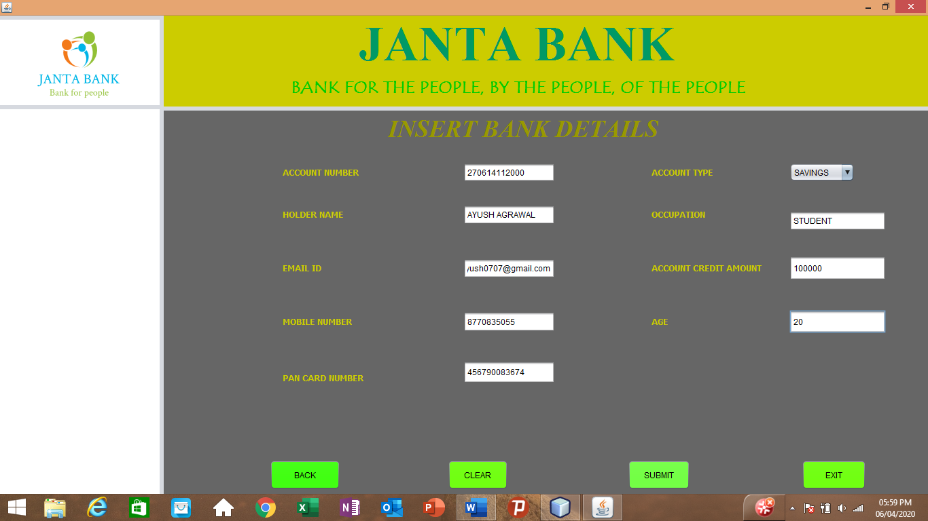

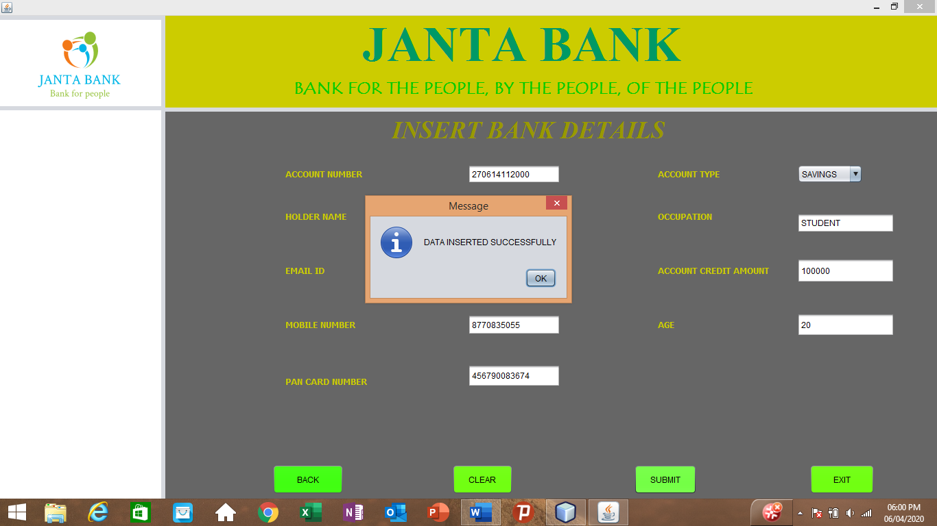

**UPDATE PAGE:**

Code:

private void BACK_BUTTONActionPerformed(java.awt.event.ActionEvent evt) {

Main_Page Main = new Main_Page();

Main.show();

dispose();

}

private void EXIT_BUTTONActionPerformed(java.awt.event.ActionEvent evt) {

System.exit(0);

}

private void UPDATE_BUTTONActionPerformed(java.awt.event.ActionEvent evt) {

try{

Class.forName("com.mysql.jdbc.Driver");

con = DriverManager.getConnection("jdbc:mysql://localhost:3306/bankform","root","");

String query = "UPDATE bank SET NAME=?,EMAIL=?,MOBILE=?,PAN=?,OCCUPATION=?,`CREDIT AMOUNT`=?,AGE=? WHERE ACC_NO=?";

pst = con.prepareStatement(query);

pst.setString(8,TEXT_ACC.getText());

pst.setString(1,TEXT_NAME.getText());

pst.setString(2,TEXT_EMAIL.getText());

pst.setString(3,TEXT_MOBILE.getText());

pst.setString(4,TEXT_PAN.getText());

pst.setString(5,TEXT_OCCUPATION.getText());

pst.setString(6,TEXT_AMOUNT.getText());

pst.setString(7,TEXT_AGE.getText());

pst.executeUpdate();

JOptionPane.showMessageDialog(null,"UPDATED SUCCESSFULLY");

showTableData();

TEXT_ACC.setText("");

TEXT_NAME.setText("");

TEXT_EMAIL.setText("");

TEXT_AGE.setText("");

TEXT_MOBILE.setText("");

TEXT_AMOUNT.setText("");

TEXT_PAN.setText("");

TEXT_OCCUPATION.setText("");

}catch(Exception ex){

ex.printStackTrace();

}

}

public void showTableData(){

try{

Class.forName("com.mysql.jdbc.Driver");

con = DriverManager.getConnection("jdbc:mysql://localhost:3306/bankform","root","");

String query = "SELECT * FROM bank";

pst = con.prepareStatement(query);

rs = pst.executeQuery();

BANK_TABLE.setModel(DbUtils.resultSetToTableModel(rs));

}catch(Exception ex){

JOptionPane.showMessageDialog(null, ex);

}

}

Output:

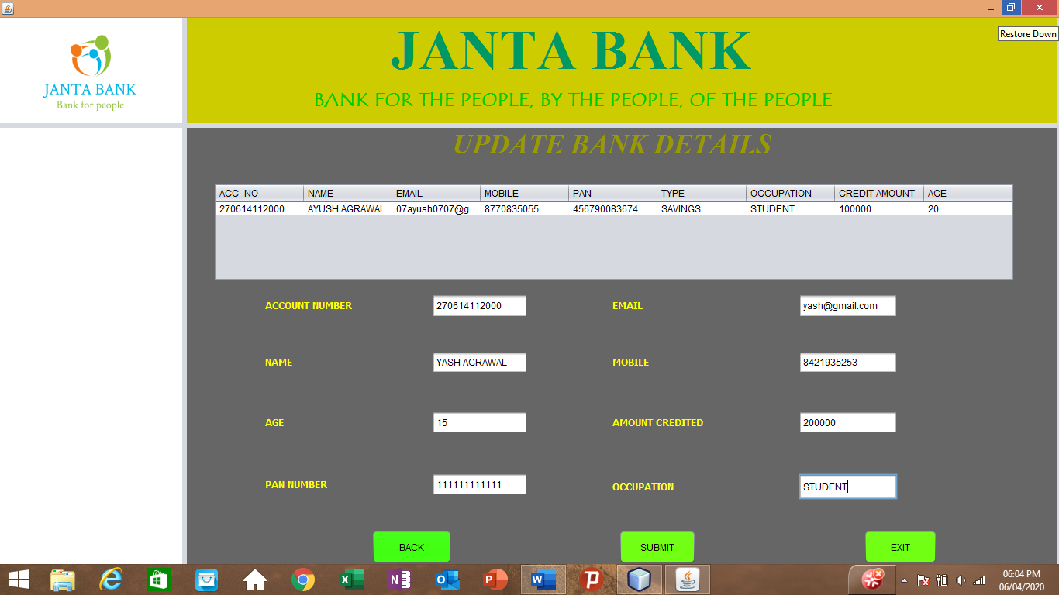

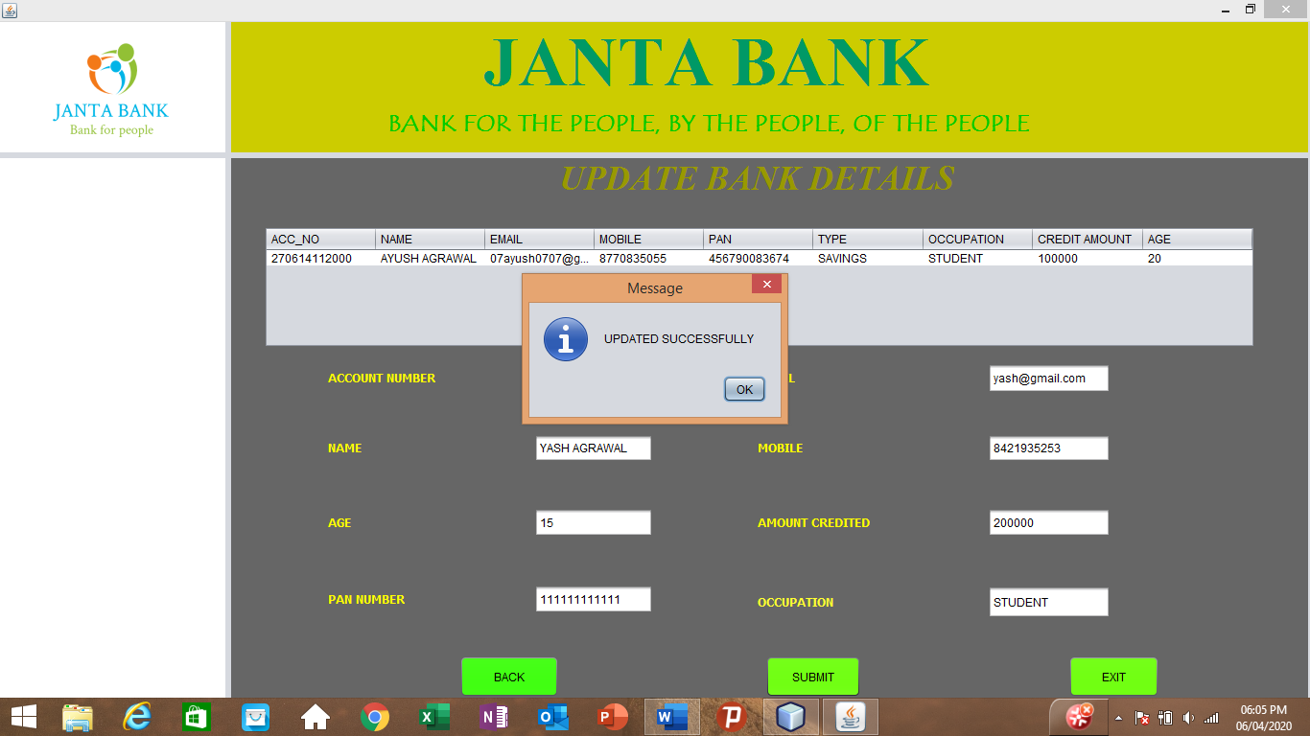

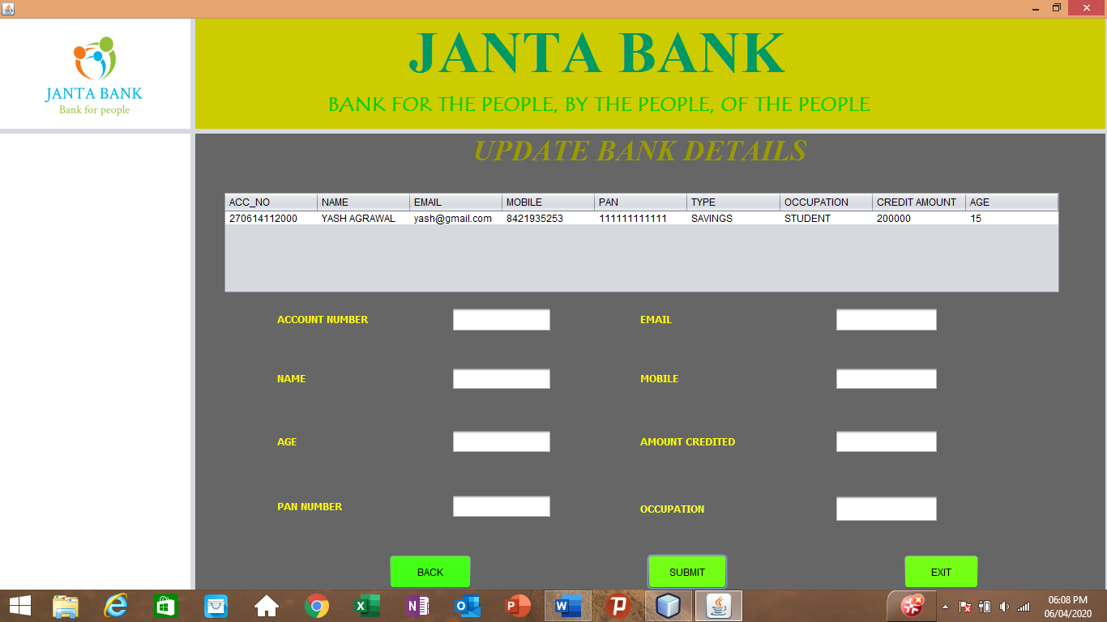

**SEARCH PAGE:**

Code:

public class SEARCH_PAGE extends javax.swing.JFrame {

Connection con = null;

PreparedStatement pst = null;

ResultSet rs = null;

public SEARCH_PAGE() {

initComponents();

showTableData();

}

private void EXIT_BUTTONActionPerformed(java.awt.event.ActionEvent evt) {

System.exit(0);

}

private void BACK_BUTTONActionPerformed(java.awt.event.ActionEvent evt) {

Main_Page Main = new Main_Page();

Main.show();

dispose();

}

private void SEARCH_BUTTONActionPerformed(java.awt.event.ActionEvent evt) {

try {

Class.forName("com.mysql.jdbc.Driver");

con = DriverManager.getConnection("jdbc:mysql://localhost:3306/bankform", "root", "");

int a = COMBO_SEARCH.getSelectedIndex();

String query = "";

if (a == 1) {

query = "select * from bank where " + "acc_no" + " = ?";

}

if (a == 2) {

query = "select * from bank where " + "name" + " = ?";

}

if (a == 3) {

query = "select * from bank where " + "pan" + " = ?";

}

PreparedStatement pst = con.prepareStatement(query);

pst.setString(1, TEXT_DETAILS.getText());

System.out.println(pst.toString());

ResultSet r = pst.executeQuery();

while (r.next()) {

JOptionPane.showMessageDialog(null, "SEARCH SUCCESSFUL");

ArrayList al = new ArrayList();

al.add("NAME: " + r.getString("name"));

al.add("EMAIL ID: " + r.getString("EMAIL"));

al.add("MOBILE NUMBER: " + r.getString("MOBILE"));

al.add("CREDITED AMOUNT: " + r.getString("CREDIT AMOUNT"));

al.add("OCCUPATION: " + r.getString("OCCUPATION"));

al.add("AGE: " + r.getString("AGE"));

JOptionPane.showMessageDialog(null, al);

}

} catch (Exception ex) {

ex.printStackTrace();

}

}

Output:

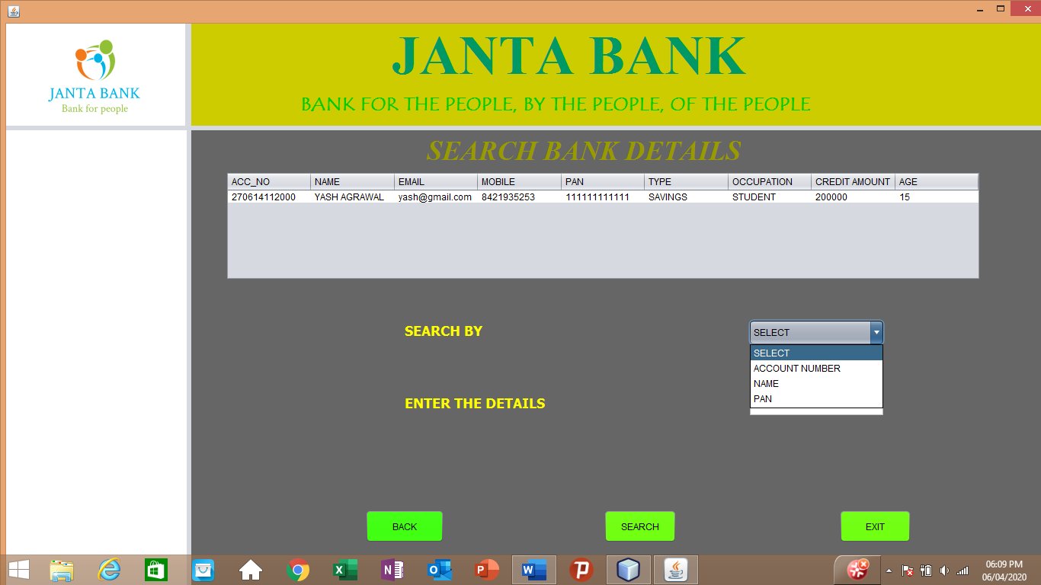

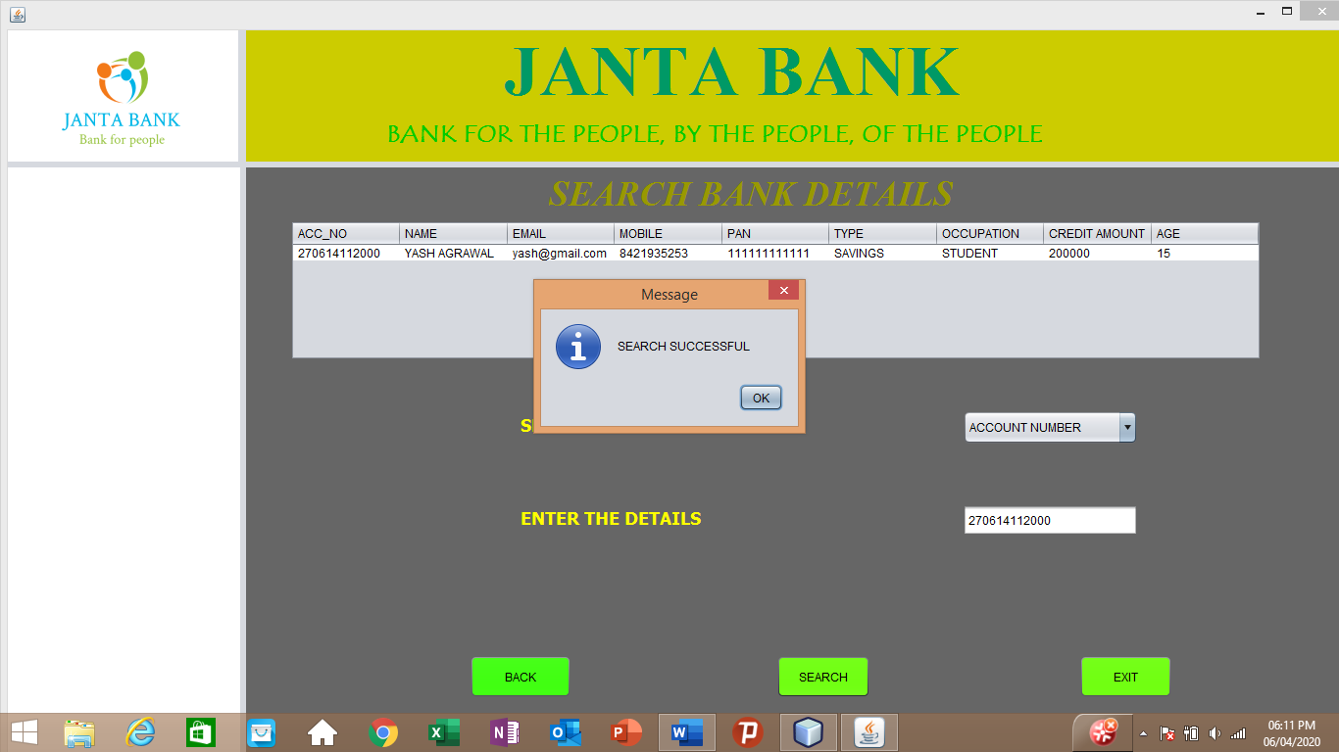

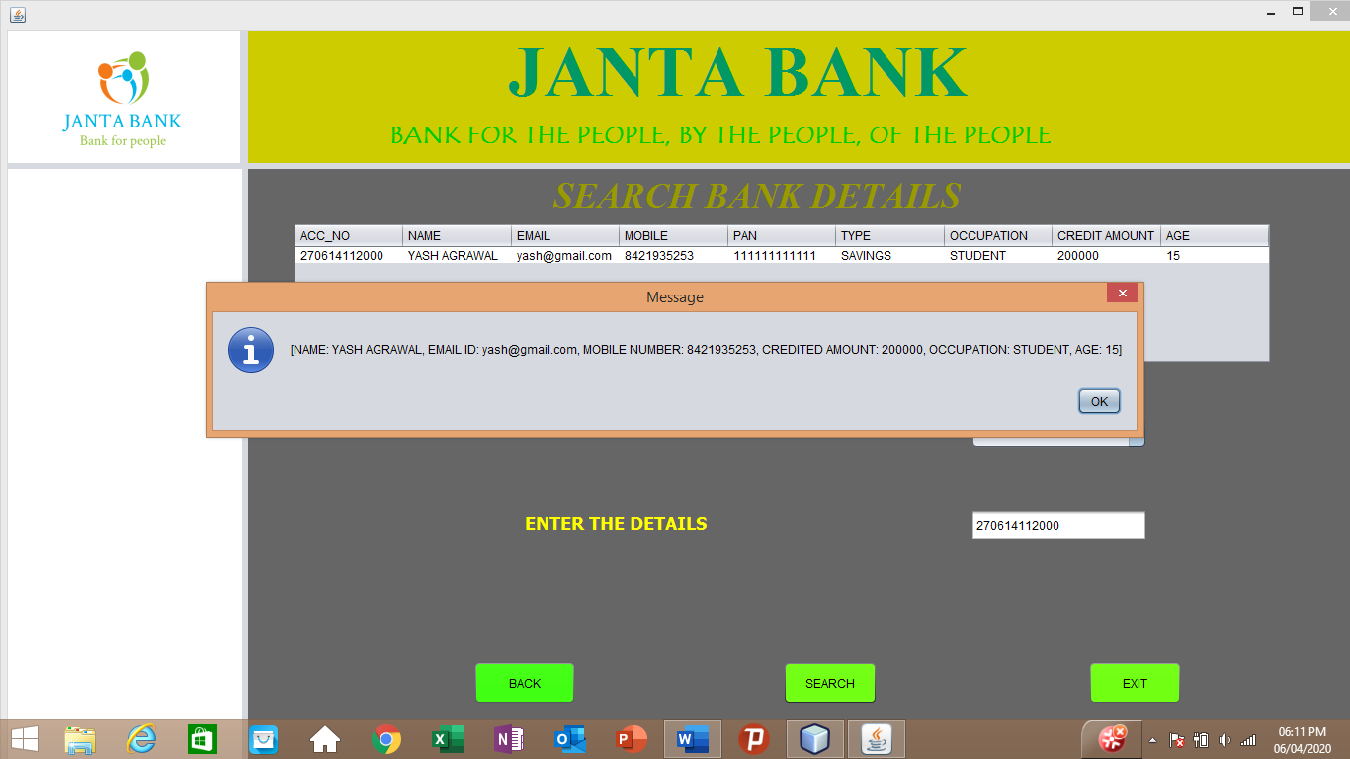

**DELETE PAGE:**

Code:

private void EXIT_BUTTONActionPerformed(java.awt.event.ActionEvent evt) {

System.exit(0);

}

private void BACK_BUTTONActionPerformed(java.awt.event.ActionEvent evt) {

Main_Page Main = new Main_Page();

Main.show();

dispose();

}

private void DELETE_BUTTONActionPerformed(java.awt.event.ActionEvent evt) {

int r = JOptionPane.showConfirmDialog(null,"Do You Really Want To Delete the Data","Confirmation", JOptionPane.YES_NO_OPTION);

if(r==0){

try{ Class.forName("com.mysql.jdbc.Driver");

con = DriverManager.getConnection("jdbc:mysql://localhost:3306/bankform","root","");

String query = "DELETE FROM bank WHERE ACC_NO = ?";

pst = con.prepareStatement(query);

pst.setString(1, TEXT_ACC.getText());

pst.executeUpdate();

JOptionPane.showMessageDialog(null,"ACCOUNT DELETED");

TEXT_ACC.setText("");

}catch(Exception ex){

JOptionPane.showInputDialog(null,ex);

}

showTableData();

}

}

public void showTableData(){

try{

Class.forName("com.mysql.jdbc.Driver");

con = DriverManager.getConnection("jdbc:mysql://localhost:3306/bankform","root","");

String query = "SELECT * FROM bank";

pst = con.prepareStatement(query);

rs = pst.executeQuery();

BANK_TABLE.setModel(DbUtils.resultSetToTableModel(rs));

}catch(Exception ex){

JOptionPane.showMessageDialog(null, ex);

}

}

Output:

