**TABLE OF CONTENTS**

**Chapter No. Topics Page No.**

**Chapter-1 Introduction 7-18**

1.1 General Introduction

1.2 Problem Statement

1.3 Significance/Novelty of the problem

1.4 Empirical Study

1.5 Brief Description of the Solution Approach

1.6 Comparison of existing approaches to the problem framed

**Chapter-2 Literature Survey 19-24**

2.1 Summary of papers studied

2.2 Integrated summary of the literature studied

**Chapter 3: Requirement Analysis and Solution Approach 25-30**

3.1 Overall description of the project

3.2 Requirement Analysis

3.5 Solution Approach

**Chapter-4 Modelling and Implementation Details 31-36**

4.1 Design Diagrams

4.1.1 Use Case diagrams

4.1.2 Class diagrams / Control Flow Diagrams

4.1.3 Sequence Diagram/Activity diagrams

**Chapter-5 Testing 37-42**

5.1 Testing Plan

5.2 Component decomposition and type of testing required

5.3 Error and Exception Handling

5.4 Limitations of the solution

**Chapter-6 Findings, Conclusion, and Future Work 43-47**

6.1 Findings

6.2 Conclusion

6.3 Future Work

**References**

**SUMMARY**

SeekReality is an advanced deepfake detection platform designed to verify the authenticity of images, videos, and voice recordings. Powered by state-of-the-art machine learning models like MesoNet and MesoLSTM, SeekReality helps you stay protected in a digital world where misinformation can spread rapidly.

**Key Features:**

1. **Secure Authentication**  
   Integrated with a robust authentication system, including Google Sign-In, to ensure user privacy and secure access.
2. **Multi-Modal Deepfake Detection**  
   Detects deepfakes across images, videos, and voice clips using a combination of cutting-edge neural networks for high accuracy and speed.
3. **Explainable Results**  
   Visual indicators and clear summaries help users understand *why* something is classified as a deepfake.

With SeekReality, you’re not just detecting deepfakes—you’re restoring trust in digital communication. Whether you're an individual, journalist, or organization, SeekReality equips you with the tools to stay informed and safe.

## CHAPTER-1

## INTRODUCTION

## General Introduction

In today’s digital era, content authenticity is more critical than ever due to the rise of generative AI and the growing threat of misinformation. The internet is evolving—from passive content consumption to active verification—driven by machine learning innovations that scrutinize images, videos, and audio for manipulation. Deepfakes, in particular, pose a significant risk to trust and safety online, creating an urgent need for scalable, reliable detection tools.

TruthScan is a cutting-edge deepfake detection platform built to combat digital media manipulation across multiple formats. By integrating services for image, video, and voice analysis within a unified interface, TruthScan empowers users to verify content with speed and precision. Leveraging advanced AI models like ResNet for robust image analysis and MesoNet for detecting subtle facial forgeries, the platform delivers accurate results through confidence scores and visual or auditory cues that reveal signs of tampering.

Traditional verification methods are slow and labor-intensive, falling short in a world flooded with manipulated user-generated content—be it fake videos of public figures, AI-generated voices used in scams, or misleading images. TruthScan tackles this with a centralized system that streamlines detection and scales with content volume.

A standout feature is its voice deepfake detection module, which uses spectrogram analysis and deep learning to distinguish between real and AI-generated audio. This is especially vital in the face of rising voice scams and impersonations. TruthScan delivers real-time feedback, helping users assess risks and avoid fraud.

Beyond detection, the platform offers a seamless and intuitive user experience—supporting direct uploads and URL-based scans, fast results, and a persistent scan history for tracking verified content. Built on a modern tech stack with a React frontend, Flask backend, and secure Google-authenticated login, TruthScan ensures both accessibility and security.

As synthetic media continues to rise, solutions like TruthScan will become essential. By combining advanced AI with user-centric design, TruthScan not only boosts digital trust but also empowers individuals, journalists, and organizations to make informed decisions. It fosters a culture of content verification—crucial for navigating an increasingly manipulated online world with confidence.

### Problem Statement

The digital ecosystem today faces an overwhelming surge in misinformation, disinformation, and synthetic content—threats that undermine the integrity of journalism, communication, and personal reputation. Four major challenges are driving the erosion of trust in digital media:

**Ineffective deepfake detection across formats**: As AI-generated content becomes more sophisticated, detecting manipulated images, videos, and audio has become increasingly challenging. Current tools often lack the accuracy or speed to catch subtle manipulations in real time, leaving users unable to confidently distinguish real from fake content.

**Inaccessible tools for everyday users**: While advanced forensic tools exist, they are typically limited to academia or corporate use, leaving the general public without reliable means to verify suspicious content. This accessibility gap increases the risk of falling victim to scams or misinformation.

**Fragmented media verification**: Most detection platforms are limited to a single media type—image, video, or audio—requiring users to juggle multiple tools for comprehensive analysis. This fragmented experience leads to inefficiency and a lack of cohesive insight.

**No real-time or explainable feedback**: Many systems only provide results after upload, with minimal interpretability. Without intuitive confidence scores or explanation of findings, users are left uncertain about how to act on the results. TruthScan addresses these challenges with a centralized, real-time, and user-friendly deepfake detection platform that verifies content across all major formats.

**Image, video, and audio detection**: TruthScan uses advanced AI models like MesoLSTM and MesoNet to detect subtle image and video manipulations, and deep learning-based spectrogram analysis to identify AI-generated audio. The system identifies signs such as unnatural facial movements or inconsistencies in voice patterns.

**Intuitive confidence scores and feedback**: After scanning, users receive a confidence percentage that reflects the likelihood of manipulation, along with visual or auditory cues to support the result. This helps users make informed judgments quickly and clearly.

By combining multiple detection models into a unified system, TruthScan delivers a much-needed solution for today’s content verification needs. It empowers users to detect synthetic media, reduce misinformation, and promote transparency. In doing so, it helps rebuild digital trust and equips users with the confidence to navigate the modern media landscape more responsibly.

**1.3 Novelty of the Problem**

The digital world is grappling with growing concerns over content authenticity, as synthetic media like deepfakes increasingly threaten reputations, public trust, and the reliability of information. Traditional content verification tools are often limited in scope, but TruthScan introduces a comprehensive, real-time platform that leverages advanced AI to authenticate multimedia content. This innovation empowers users to detect and combat manipulated media more effectively.

Several factors make TruthScan especially relevant in today’s evolving digital landscape:

**Unified Deepfake Detection Across Media Formats:** Most existing tools specialize in a single type of content—image, video, or audio—forcing users to switch between platforms. TruthScan brings these capabilities together, enabling deepfake detection across images, videos, and audio within one cohesive system. This streamlines the verification process, making it more efficient and accessible.

**Real-Time Detection with Actionable Insights:** Unlike platforms that only provide post-upload analysis, TruthScan offers instant feedback using AI models such as ResNet and MesoNet. Users receive a confidence score alongside immediate analysis of manipulated areas, allowing for quicker, better-informed decisions and reducing the risk of spreading misinformation.

**Advanced AI for Multi-Modal Detection:** TruthScan’s architecture integrates specialized models for each media type—ResNet for images, MesoNet for video, and spectrogram-based analysis for audio. This multi-model system provides a layered, accurate approach to deepfake detection, covering a wide range of manipulation techniques.

**Clear Feedback Through a User-Centered Design:** Where many tools present results with minimal explanation, TruthScan focuses on usability. The interface not only provides confidence scores but also outlines specific anomalies or manipulation cues in clear language, enabling users to understand and respond appropriately to the findings.

By combining real-time analysis, cross-format support, and intuitive feedback, TruthScan offers a powerful response to the challenges of synthetic media. It equips users with accurate, fast tools to authenticate content, enhances transparency in digital interactions, and plays a vital role in restoring trust in a media landscape increasingly shaped by artificial content.

### Empirical Study

This empirical study examines AI-powered systems for deepfake detection, leveraging advanced machine learning and computer vision to evaluate the authenticity of user-submitted images, videos, and voice recordings. The goal is to assess the effectiveness of these techniques in identifying manipulated media and providing reliable, explainable insights.

**Deepfake detection component:** Multiple machine learning models are employed to classify and predict the likelihood of manipulation in uploaded content. This system integrates and evaluates the performance of the following models:

* **MesoNet** – Used primarily for detecting manipulations in images.
* **MesoLSTM** – Utilized for **video-based** deepfake detection by incorporating temporal information.
* **WaveNet** – Applied for analyzing and extracting features from sample voice input .

To enhance accuracy, the models rely on robust feature extraction and engineering. Key visual features—including facial landmarks, pixel-level irregularities, and frame-to-frame inconsistencies—are used for image and video analysis. For audio detection, spectrogram-based features and pitch variations are analyzed to identify signs of tampering in voice recordings.

**Post processing and feedback component:** Upon detection, the system generates a confidence score indicating the probability of manipulation, along with a detailed explanation.. These results are complemented by recommendations for additional verification steps, giving users a clear understanding of the media’s authenticity.

For video and audio files, the system also performs temporal consistency checks, evaluating sequences of frames or audio segments to detect timing-related inconsistencies—a common signature of deepfakes. This enhances precision and provides users with a higher degree of trust in the detection results.

### Experimental Setup

### 1.4.1 Data Collection

**Image and Voice Dataset:** The dataset used for TruthScan comprises both images and audio clips sourced from Kaggle. The image set includes real and deepfake visuals, labeled accordingly to help train the system in detecting visual manipulations. The voice dataset contains genuine and AI-generated audio samples, spanning different accents, tones, and speaking styles. Together, these datasets provide a robust foundation for developing and evaluating TruthScan’s deepfake detection capabilities.

**1.4.2 Data Pre‑Processing**

* **Video Frame Pipeline**
  + **Face Detection & Alignment**: Detect and crop faces in each frame , then resize to the network’s input resolution (e.g. 256×256) and normalize pixel values to [–1,1].
  + **Sequence Sampling**: Extract fixed‑length clips (e.g. 16 consecutive frames) with configurable stride to capture temporal artifacts.
* **Audio Pipeline**
  + **Feature Encoding**: Compute Mel‑spectrograms or MFCCs (e.g. 40 coefficients over 25 ms windows) to serve as input for the WaveNet branch.

**1.4.3 Model Training and Testing**

* **MesoNet (Frame‑Level)**
  + Train on individual aligned frames with binary labels (“real” vs. “fake”).
* **MesoLSTM (Sequence‑Level)**
  + Feed feature maps from MesoNet into an LSTM to capture
* **WaveNet (Audio‑Level)**
  + Train on Mel‑spectrogram inputs to detect audio synthesis artifacts.

### 1.5 Brief Description Of The Solution Approach

### **SeekReality** is a comprehensive AI-powered system designed for deepfake detection across three modalities: images, videos, and audio. It integrates advanced deep learning models with a secure web-based interface to deliver accurate and user-friendly verification.

#### ****Image-Based Deepfake Detection:****

For static image analysis, SeekReality uses the **Meso4** model — a lightweight Convolutional Neural Network (CNN) specialized for identifying manipulation artifacts. Images are preprocessed (resized, normalized), and then passed through the Meso4 architecture, which applies multiple convolutional and pooling layers before generating a binary classification (“Real” or “Fake”) along with a confidence score. A threshold is used to finalize predictions.

#### ****Video-Based Deepfake Detection:****

Video detection is handled by the **MesoLSTM** model — a hybrid of the Meso4 CNN and a Long Short-Term Memory (LSTM) network. Videos are broken into frames, with face detection used to prioritize relevant content. The Meso4 component extracts spatial features from each frame, while the LSTM component captures temporal dependencies across sequences. The model aggregates frame-level predictions to output a final verdict on the video’s authenticity.

#### ****Audio (Voice) Deepfake Detection:****

To detect voice-based deepfakes, SeekReality incorporates **WaveNet,** a powerful generative model developed by DeepMind. Originally designed for high-quality speech synthesis, WaveNet is adapted in this system to learn subtle frequency and waveform-level artifacts common in synthesized or manipulated speech. The audio files are first preprocessed through feature extraction (e.g., MFCCs, spectrograms) before being analyzed by WaveNet-based classifiers. The system outputs whether the voice is genuine or synthesized, along with a probability score.

#### ****Frontend and Authentication:****

SeekReality includes a modern, responsive **React frontend** for users to interact with the platform. Users can upload images, videos, or audio files and view detailed detection results. The interface supports **real-time status updates, progress indicators**, and **detailed confidence metrics.**

Security is enforced through **authentication mechanisms** — including role-based access control, session handling, and secure user registration/login — ensuring only authorized users can upload content or view results. Sensitive data is protected using best practices in encryption and token management.

This unified, multi-modal approach empowers users to verify digital content across visual and auditory domains, with intuitive access and strong security built in.

### 1.6 Comparison of Existing Approaches to the Problem Framed

As deepfake technology continues to evolve, it presents serious challenges in fields such as digital forensics, media integrity, and online security. Existing solutions often focus on either static image analysis or temporal video inspection but fail to offer a cohesive framework that can handle both media types effectively. The proposed solution addresses these gaps by integrating deep learning techniques that are capable of detecting manipulated content in both images and videos through a dual-model architecture. This section compares our approach with existing solutions and highlights its distinct advantages.

* **Traditional way of Image Forensics:** This way is Manual and has Limited Feature Extraction  
  Conventional image forensics rely heavily on manual feature engineering and traditional image processing techniques to detect inconsistencies. These methods, such as examining noise patterns, lighting inconsistencies, or compression artifacts, are often time-consuming and not robust against sophisticated manipulation techniques used in modern deepfakes.  
  In contrast, our approach employs the Meso4 convolutional neural network (CNN**)**, which automatically extracts and learns discriminative features through multiple convolutional and pooling layers. The model processes normalized input images and classifies them as either "Real" or "Fake" with a confidence score. This deep learning-based approach significantly improves detection accuracy and adaptability to new types of deepfakes.
* **General-Purpose TruthScans**: These are very Inconsistent Across Media Types  
  Several deepfake detection tools and libraries focus exclusively on either images (e.g., Face X-ray, DeepFaceLab) or videos (e.g., Deepware Scanner). However, many of these tools are either not open-source, rely on precompiled rules, or lack support for temporal dynamics in videos.  
  Our solution addresses this limitation through a hybrid architecture. For videos, it uses the MesoLSTM model, which integrates the Meso4 CNN with an LSTM (Long Short-Term Memory) network. This allows the system to process sequences of video frames, extract spatial features using CNN layers, and then analyze temporal relationships using the LSTM component—essential for capturing subtle inconsistencies across frames.
* **AI-Based Detection Models:** Often are focused on single-frame classificationSome TruthScans utilize CNNs or transformer-based architectures for image classification but fail to capture temporal dependencies that are crucial in video-based deepfakes. Moreover, they often require extensive retraining for new datasets or manipulation technique. Our system overcomes these challenges by using pre-trained weights fine-tuned on task-specific datasets, ensuring robust performance while maintaining generalizability. In addition, face detection preprocessing ensures that the model focuses on human faces within frames—areas most likely to be manipulated—further improving the reliability of predictions.
* **Video-Level Analysis Tools**: Computationally Expensive and Inaccurate Aggregation Some tools attempt to detect deepfakes by analyzing videos frame by frame and aggregating results, but they do so with simplistic majority voting or threshold-based rules. These approaches often neglect temporal coherence and can be both computationally intensive and error-prone.  
  By combining CNNs with LSTMs, our method efficiently models both spatial and temporal **features**, producing more accurate predictions while reducing false positives and false negatives. The system aggregates frame-wise results intelligently, using temporal cues to detect inconsistencies across time rather than treating each frame in isolation.
* **Standalone Face Detection or Image Classification:** Lacking Integrated Pipelines Many current models are limited in scope and require separate preprocessing pipelines, such as external tools for face detection or manual frame extraction from videos. Our solution provides an integrated pipeline that includes face detection, image preprocessing (resizing, normalization), feature extraction, temporal modeling, and final prediction. This end-to-end system ensures consistency and ease of deployment in real-world applications.

**CHAPTER-2**

**LITERATURE SURVEY**

### 2.1 Summary of Papers Studied

A comprehensive literature survey is essential to understanding the current advancements and research trends in deepfake detection systems. This includes an in-depth analysis of various media manipulation techniques, detection algorithms, and the role of AI in combating misinformation. Below is a summary of key papers reviewed, highlighting their methodologies, findings, and relevance to the development of TruthScan — a robust AI-powered deepfake detection platform.

**Paper-1**

|  |  |
| --- | --- |
| **Title** | Deepfake Video Detection Based on MesoNet with Preprocessing Module |
| Author(s) | **Lanting Li, Tianliang Lu, Xingbang Ma, Mengjiao Yuan,Da Wan** |
| Year | 2022 |
| Publisher | MDPI, Symmetry, Volume 14, Issue 5, Article 939 |
| Summary | * **Objective**: The study aims to enhance the detection of deepfake videos by integrating a preprocessing module with the MesoNet architecture, improving the model's ability to identify manipulated content. * **Methodology**: The proposed approach incorporates a preprocessing module that refines input data before feeding it into the MesoNet model. This combination is designed to extract more discriminative features, thereby improving detection accuracy. * **Results**: Experimental evaluations demonstrate that the integrated model outperforms the baseline MesoNet in detecting deepfake videos, indicating the effectiveness of the preprocessing module in enhancing feature extraction. * **Conclusion**: The integration of a preprocessing module with MesoNet significantly improves the detection performance for deepfake videos, offering a promising direction for future research in multimedia forensics. |

**Paper-2**

|  |  |
| --- | --- |
| **Title** | **Deepfake Video Detection Based on MesoNet with Preprocessing Module** |
| Author(s) | **Zhiming Xia**, **Tong Qiao**, **Ming Xu**, **Xiaoshuai Wu**, **Li Han** and **Yunzhi Chen** |
| Year | 5 May 2022 |
| Publisher | MDPI (Journal: Symmetry) |
| Summary | * **Objective:** The study aims to enhance the accuracy and robustness of deepfake video detection by integrating a preprocessing module with the lightweight MesoNet deep learning architecture. * **Methodology:** The proposed method introduces a preprocessing module that performs image sharpening and enhancement to emphasize subtle facial cues. These preprocessed images are then passed into the MesoNet CNN model, which is trained to detect manipulations in facial features. * **Results:** The integrated approach shows improved detection accuracy compared to the original MesoNet model when tested on publicly available deepfake datasets. The preprocessing module helps the model extract more relevant and discriminative features. * **Conclusion:** Combining preprocessing techniques with deep learning architectures like MesoNet significantly boosts performance in identifying deepfakes, suggesting that data refinement is a crucial step in multimedia forensics. |

**Paper-3**

|  |  |
| --- | --- |
| **Title** | **The Effect of Deep Learning Methods on Deepfake Audio Detection for Digital Investigation** |
| Author(s) | **Mvelo Mcuba, Avinash Singh, Richard Adeyemi Ikuesan, Hein Venter** |
| Year | 22 March 2023 |
| Publisher | Elsevier (Procedia Computer Science) |
| Summary | * **Objective:** The study aims to evaluate and compare the effectiveness of various deep learning models in detecting deepfake audio, supporting digital forensic investigations by differentiating real and synthetic voices generated through voice cloning techniques. * **Methodology:** The researchers used four audio feature extraction techniques—MFCC, Mel-spectrogram, Chromagram, and Spectrogram—converted into image formats and applied to CNN-based models (VGG-16, FG-LCNN, ResNet, Custom CNN). They tested models using three optimizers (Adam, SGD, Adadelta) across five iterative trials to assess performance. * **Results:** The Custom CNN architecture achieved the best overall performance, especially with Chromagram, Mel-spectrogram, and Spectrogram inputs. VGG-16 outperformed others in MFCC-based detection. The study demonstrated that different feature-extraction methods and model architectures significantly impact accuracy, with context and architecture suitability playing key roles. * **Conclusion:** Deep learning models can detect deepfake audio with promising accuracy, but performance is highly dependent on the combination of architecture, input features, and optimization technique. Custom models may excel in specific contexts but lack generalizability, reinforcing the need for standardized forensic approaches. |

The reviewed literature offers a foundational understanding of the recent advancements in deepfake detection, computer vision, and the application of deep learning techniques in digital media forensics. This summary integrates insights from key domains, emphasizing their relevance to the proposed solution and highlighting the specific gaps addressed by our approach.

**2.2 Integrated Summary of the Literature Studied**

The literature reviewed provides an in-depth view of the current state of deepfake detection technologies, with a strong focus on the use of convolutional and recurrent neural networks, preprocessing strategies, and data-centric approaches. This section synthesizes key findings across different areas and relates them to the proposed solution, while identifying the limitations that this project aims to address.

**2.2.1 Deep Learning for Image-Based Deepfake Detection**

Research on convolutional neural networks (CNNs) has shown significant progress in detecting manipulated images. Models such as MesoNet, Resnet have been applied to detect subtle inconsistencies introduced during deepfake generation. Studies emphasize the importance of using multi-layered CNN architectures for feature extraction, particularly for face-centric manipulation detection. However, a common limitation is the generalization across different datasets and manipulation techniques.

* **Relevance:** Our approach builds on the Meso4 CNN model, which is lightweight yet effective for identifying deepfake content in images. The model is trained on diverse datasets and fine-tuned to detect various forgery patterns with high confidence, addressing challenges related to overfitting and poor cross-dataset performance.

**2.2.2 Temporal Analysis in Video-Based Deepfake Detection**

Several papers underscore the need to analyze temporal consistency in videos to detect frame-level manipulation. Techniques like Recurrent Neural Networks (RNNs), LSTM networks, and 3D CNNs are commonly used to model sequential dependencies. Notable research includes the use of temporal-aware architectures that track eye blinking patterns or facial expression inconsistencies. Despite promising results, many models are computationally intensive or lack real-time processing capabilities.

* **Relevance:** Our system employs the MesoLSTM model, a hybrid of CNN and LSTM, which balances spatial and temporal feature extraction. By leveraging temporal dependencies across video frames, it improves the accuracy of deepfake detection while maintaining reasonable computational efficiency.

**2.2.3 Data Preprocessing and Model Optimization**

Literature in this area highlights the significance of preprocessing steps such as resizing, normalization, and augmentation in improving deepfake detection performance. Additionally, transfer learning and fine-tuning of pre-trained models are widely recommended to improve convergence speed and generalization. A key issue remains the lack of standardization in preprocessing pipelines across different studies.

* **Relevance:** The proposed system employs consistent preprocessing techniques, including normalization and resizing, and leverages pre-trained weights, which are fine-tuned for task-specific datasets. This ensures robustness across different sources and manipulation techniques.

**2.2.4 Dataset Limitations and Evaluation Metrics**

Many studies acknowledge that existing datasets, such as FaceForensics++, DFDC, and Celeb-DF, are either limited in diversity or biased toward specific types of manipulation. Moreover, there is no universal benchmark, leading to inconsistent evaluation practices. Common metrics include accuracy, AUC, precision, and recall, but few works address real-world deployment constraints such as inference time.

* **Relevance:** Our solution is trained and evaluated on multiple benchmark datasets with a focus on generalization and real-time applicability. Evaluation is based on standard classification metrics, with an added emphasis on confidence scores and frame-level aggregation for video analysis.

**Chapter 3**

**3.1 Overall Description of the Deepfake Detection Project**

This project delivers an AI-powered, multimodal system designed to detect deepfake content across images, videos, and voice recordings. Leveraging advanced deep learning models, it offers high-accuracy classification and real-time predictions. The system is accessible through a user-friendly React-based web application, which connects to a Flask backend responsible for executing models and processing inputs.

**Objectives**

* Detect deepfakes in images, videos, and voice recordings using specialized neural network models.
* Provide real-time predictions with confidence scores and visual/audio feedback.
* Offer a seamless, intuitive web interface for uploading and analyzing media.
* Ensure modularity, scalability, and reliability of the backend via Flask-based API services.
* Implement secure user authentication using Auth0.

**Key Features**

**Image Deepfake Detection**

* Utilizes Meso4 CNN architecture to capture subtle pixel-level artifacts.
* Images are preprocessed and analyzed to classify them as "Real" or "Fake."

**Video Deepfake Detection**

* Employs the MesoLSTM model to analyze temporal patterns across face-cropped video frames.
* Generates per-frame predictions, aggregated into a final verdict with confidence scores.

**Voice Deepfake Detection**

* Implements CNN+LSTM hybrid models for evaluating audio authenticity.
* Converts audio into embeddings or spectrograms for classification as real or fake speech.

**Web-Based User Interface (React)**

* Developed using React.js with responsive design for both desktop and mobile platforms.
* Enables users to:
* Upload image, video, or audio files for analysis.
* Track prediction progress and receive verdicts along with confidence levels.
* Integrated with Auth0 for secure user authentication and session management.

**Flask Backend**

* Serves as the communication layer between the React frontend and deep learning models.
* Handles:
* File uploads
* Media-specific preprocessing
* Model inference and formatting of prediction results
* Real-time response delivery to the frontend

**Technologies Used**

* **Frontend**: React.js, Tailwind CSS, Auth0
* **Backend**: Flask, Python, TensorFlow
* **Deep Learning Models**:
* Meso4 (Image)
* MesoLSTM (Video)
* CNN+LSTM

**Scope and Limitations**

**Scope**

* Covers detection across three media types with a unified interface.
* Useful for journalists, content moderators, educational institutions, and security researchers.
* Easily extendable to support real-time video or livestream analysis.

**Limitations**

* Large media files may result in higher processing times.
* Performance may degrade under extreme compression, occlusion, or noise.
* Voice model may struggle with mixed speakers or dialectal variance.

**3.2 Requirement Analysis**

**Functional Requirements**

* **Deepfake Image Detection**: Accepts uploaded images and classifies them as real or fake using the Meso4 CNN model.
* **Deepfake Video Detection**: Processes video input by analyzing frames with the MesoLSTM model to detect manipulated content.
* **Voice Deepfake Detection**: Supports audio file uploads to identify synthesized or manipulated voice using deep learning models trained on spectrogram analysis.
* **User Interaction Portal**: Allows users to upload files, receive predictions with confidence scores, and view detection history.
* **Result Feedback and Logging**: Provides a downloadable report of results and logs detections for future reference and analytics.

**Non-Functional Requirements**

* **Performance**: Ensures low-latency responses for image detection and manages longer processing tasks efficiently for video and audio.
* **Scalability**: Designed to handle increased loads from multiple concurrent users and large media files.
* **Usability**: Offers a clean and intuitive web interface for users to interact with the system without requiring technical expertise.
* **Availability**: Maintains high uptime and responsiveness for real-time detection needs, particularly for sensitive or time-critical use cases.
* **Security**: Protects uploaded files and prediction results through encrypted communication and secure file handling practices.

**3.3 Solution Approach**

**TruthScan** is designed as a modular system with clearly defined components, each working in harmony to offer real-time, reliable deepfake detection for images, videos, and audio. The system includes a user-friendly frontend, an efficient backend, and powerful machine learning models for analysis.

**Frontend**

* Developed using React.js for a responsive and intuitive user interface.
* Users can easily upload images, videos, or audio files and view results with confidence scores.
* JavaScript handles form validation for secure file uploads and proper data handling.
* Interactive elements display detection results and allow users to download reports of the analysis.

**Backend**

* Built with Flask to manage API calls for deepfake detection and media processing.
* Flask routes handle user requests, such as uploading media files, passing them to the appropriate detection models, and returning the results.
* Models like Meso4 CNN for image classification, MesoLSTM for video analysis, and CNN+LSTM hybrid for voice detection are integrated into the backend using Python.
* The backend also manages real-time processing, ensuring efficient handling of files and detection requests.

**Machine Learning Models**

* **Image Detection**: Utilizes **Meso4** for analyzing image features and classifying them as "real" or "fake" with high precision.
* **Video Detection**: Uses MesoLSTM to break down video frames and analyze temporal patterns for deepfake detection.
* **Voice Detection**: Leverages deep learning models like CNN+LSTM hybrid to detect synthetic speech and ensure authenticity.
* All models are continuously improved and retrained with new datasets for enhanced accuracy.

**Module-Wise Solution**

* **Deepfake Image Detection**: Accepts uploaded images, preprocesses them, and applies the **Meso4 CNN** to identify if the image is real or fake, with confidence scores displayed on the frontend.
* **Deepfake Video Detection**: Users can upload video files, which are processed frame by frame through the MesoLSTM model. The backend analyzes the frames and aggregates results into a final classification (real or fake).
* **Voice Deepfake Detection**: Supports the upload of audio files where Wav2Vec2.0 extracts audio features, analyzes speech patterns, and classifies the audio as real or synthesized.
* **Real-Time Feedback**: Provides instant feedback on detection results and confidence levels, allowing users to assess the authenticity of the media they've uploaded.

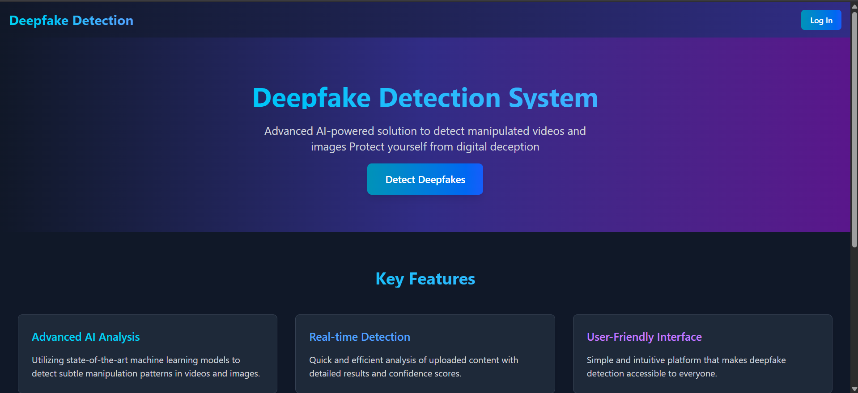

**Fig.1**

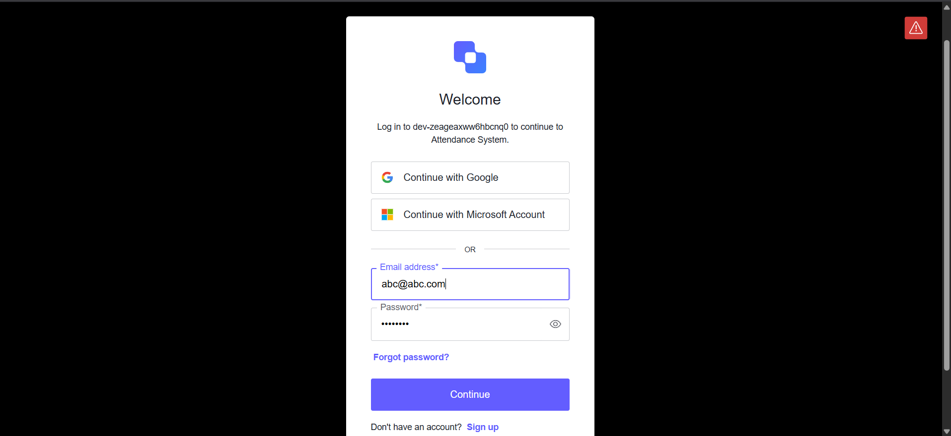

**Fig.2**

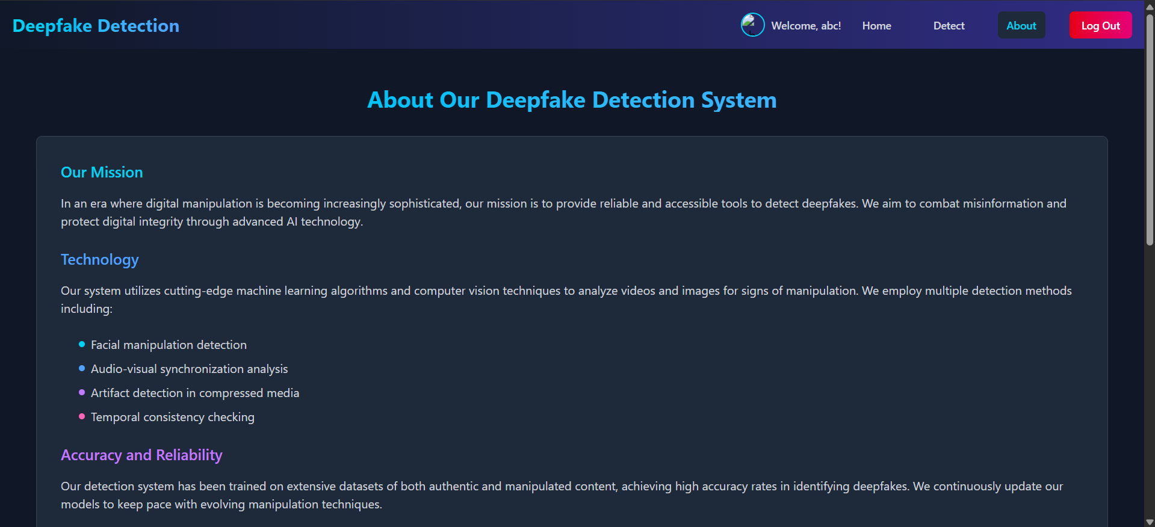

**Fig.3**

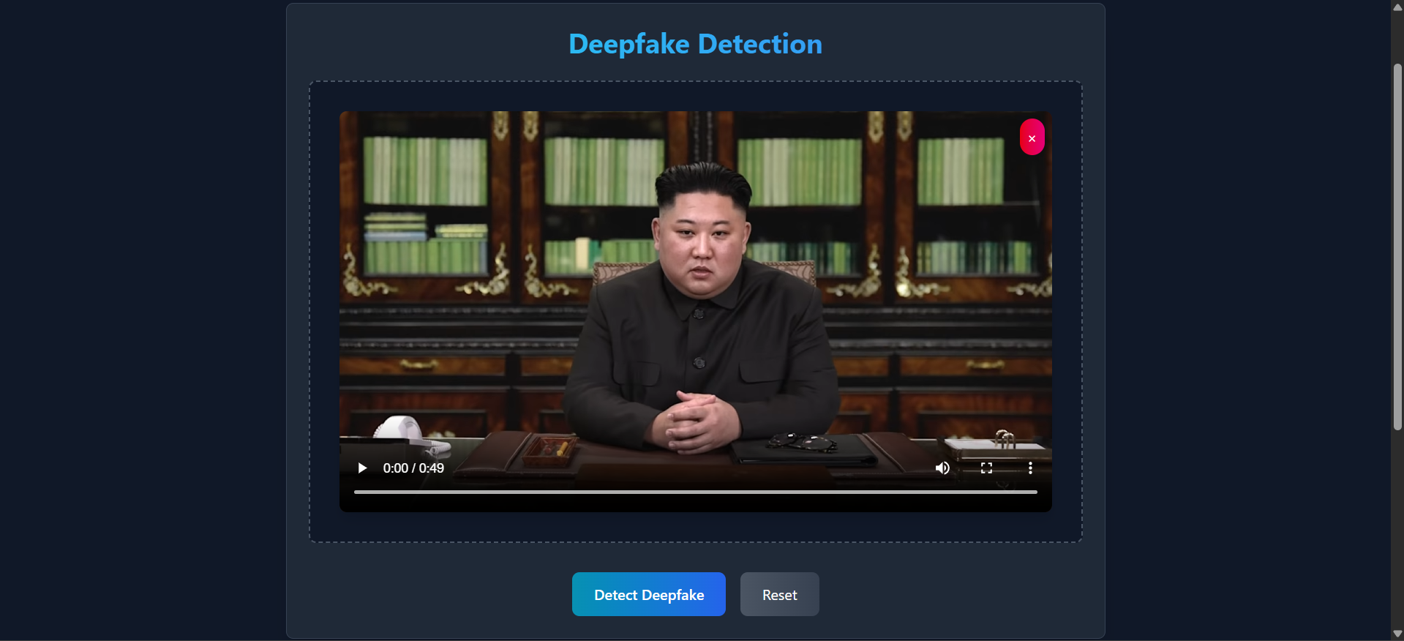

**Fig. 4**



**Fig. 5**

**CHAPTER-4**

**Modelling And Implementation Details**

### 4.1 DESIGN DIAGRAMS

The diagram shows how users interact with the Deepfake Detection platform. Key actors include Users, the Flask Backend, and Auth0 for authentication. Users can log in, upload media, and view detection results. The backend runs specific deep learning models for images, videos, and voice to identify deepfakes and returns confidence scores along with visual/audio feedback.

**4.1.1 USE CASE DIAGRAMS**

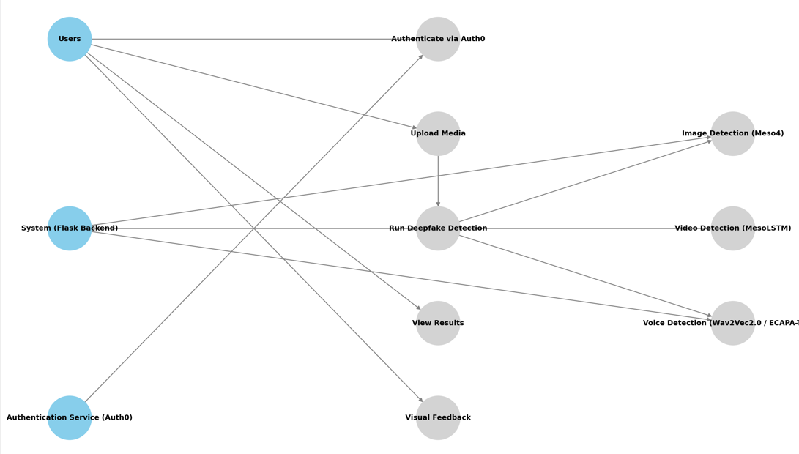

**Fig. 6**

**4.1.2 CLASS DIAGRAMS / CONTROL FLOW DIAGRAMS**

The class diagram represents the structure of the system by depicting the classes, their attributes, methods, and relationships. Key classes include Patient, HealthRecord, Appointment, HealthProvider, and PostureCorrection. The relationships between these classes are defined based on their roles within the system, such as aggregation, association, and inheritance.

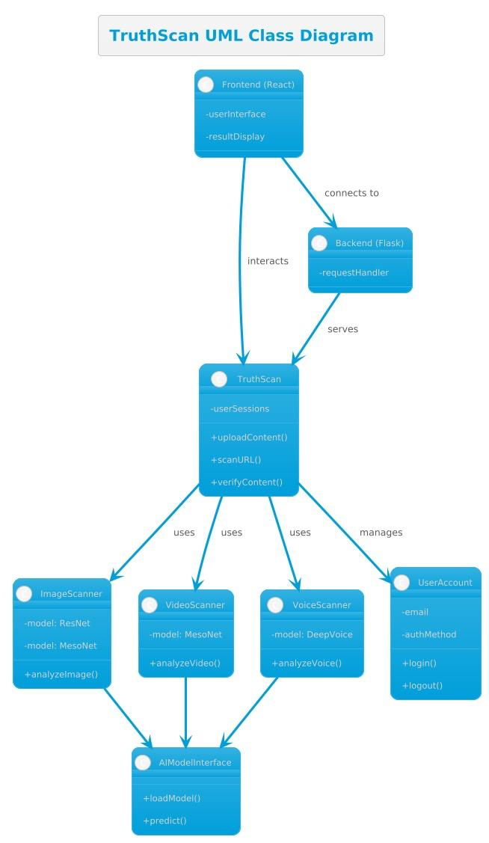

**Fig. 7**

**4.1.3 SEQUENCE DIAGRAM / ACTIVITY DIAGRAMS**

A user uploads media (file or URL) via the React frontend, which posts it to the Flask backend. The backend forwards it into the TruthScan core, which—depending on the media type—routes the content to the ImageScanner, VideoScanner, or VoiceScanner. Each scanner returns its analysis to TruthScan, which sends a consolidated result (with confidence score) back through the backend to the frontend, where the user sees the detection cues and final verdict.

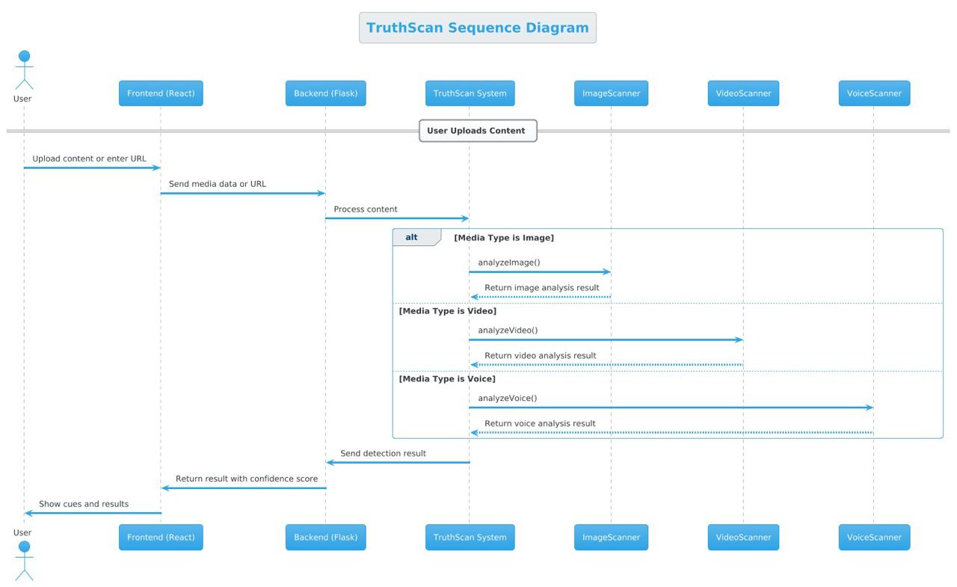

**Fig. 8**

**4.2 Implementation Details and Challenges**

**1. Overview of the System**

The deepfake detection system integrates React for frontend and Flask for backend, creating an efficient web-based tool for analyzing both image and video-based deepfakes. The model architecture relies on MesoNet (Meso4 and MesoLSTM) to classify whether media content is real or artificially manipulated.

**2. Model Components**

* **Meso4 (Image-Based Detection)**: Uses convolutional neural networks (CNNs) to extract deepfake features from static images.
* **MesoLSTM:** Enhances detection by incorporating Long Short-Term Memory (LSTM) networks to track consistency across frames.
* **Voice Deepfake Detection**: Future enhancement integrating spectrogram analysis and deeplearning models (such as WaveNet or ResNet) for identifying synthetic audio.

**3. Frontend & Backend Communication**

The system employs RESTful API endpoints, ensuring smooth data flow between React UI and Flask models:

* **Frontend (React)**: Handles user interaction, uploads media files, and displays results dynamically.
* **Backend (Flask)**: Preprocesses images/videos, invokes deepfake models, and returns confidence **scores** along with classification results.

**4. Challenges Faced**

* **Accuracy & False Positives**:
  + Deepfake techniques evolve rapidly, making classification difficult.
  + False positives occur due to compression artifacts and lighting variations.
* **Video Frame Selection**:
  + Efficiently extracting key frames while ensuring computational feasibility.
  + Balancing between full-frame processing and selective frame analysis.

**5. Performance Optimization**

* Implementing batch processing for video analysis improves efficiency.
* Optimized pre-trained weights allow faster inference while maintaining accuracy.
* Potential cloud deployment for handling larger datasets and real-time detection.

**4.3 RISK ANALYSIS AND MITIGATION FOR DEEPFAKE DETECTION SYSTEM**

**1. Data Privacy and Security Risks**

**Risk:** Since the system processes user-uploaded media (images, videos, and audio), potential threats include unauthorized access, data leaks, and misuse of sensitive media.

**Mitigation:**

* Secure file uploads with encryption protocols to prevent unauthorized access.
* Implement HTTPS for all transmissions to ensure secure data exchange between frontend and backend.
* Ensure temporary storage management, automatically deleting processed media after analysis to reduce security risks.
* Conduct regular security audits to detect vulnerabilities.

**2. Model Accuracy and Reliability**

**Risk:** Deepfake detection models may struggle with high-quality synthetic media, leading to false positives or negatives, especially with evolving AI-generated deepfakes.

**Mitigation:**

* Periodically retrain models with updated datasets to improve robustness.
* Use ensemble learning techniques (combining CNNs and LSTMs) to enhance accuracy.
* Incorporate confidence scoring and threshold adjustments for better interpretability of results.

**3. Performance and Scalability Challenges**

Risk: Processing multiple video frames or high-resolution images may lead to slow response times, especially under high traffic conditions.

**Mitigation:**

* Implement asynchronous processing to efficiently handle simultaneous requests.
* Optimize frame selection strategies (sampling key frames) for faster video analysis.
* Deploy the system on scalable cloud infrastructure for handling larger workloads dynamically.

**4. Voice Deepfake Detection Issues**

**Risk:** Differentiating real vs. synthetic voices requires high-quality spectrogramanalysis and advanced deep learning techniques. Misclassifications may occur due to natural variations in human speech.

**Mitigation:**

* Use deep audio models such as WaveNet or ResNet-based spectrogram analysis for better feature extraction.
* Integrate temporal consistency checks to identify unnatural speech patterns.
* Apply multi-modal fusion (combining voice and video analysis) to improve detection confidence.

**5. File Handling and Processing Limitations**

**Risk:** Uploading large media files (especially high-resolution videos) could lead to memory constraints, affecting the system’s responsiveness.

**Mitigation:**

* Implement file size limitations and compression before processing.
* Enable temporary caching to minimize redundant computations.
* Allow preprocessing techniques (resizing, format optimization) to ensure efficient handling.

**CHAPTER-5**

**5.1 Testing Plan**  
 **Testing Objectives**

* **Video Input & Capture:**
  + Verify that the system accepts both live webcam feeds and uploaded video files.
  + Ensure smooth streaming, frame extraction at expected frame‑rates, and correct handling of different video codecs and resolutions.
* **Preprocessing & Feature Extraction:**
  + Confirm that face and landmark detection modules correctly locate and align faces in each frame.
  + Validate that extracted features (e.g. optical flow, embeddings) match the input requirements of the MesoNet, MesoLSTM, and WaveNet models.
* **Model Inference & Accuracy:**
  + Test that each model (MesoNet, MesoLSTM, WaveNet) loads correctly and produces a prediction score for “real” vs. “deepfake.”
  + Measure classification metrics (accuracy, precision, recall, F1) against a held‑out video dataset.
* **Authentication & Authorization:**
  + Ensure Auth0 integration protects all routes: video upload, live inference, result retrieval, user settings.
  + Test role‑based access (e.g., standard users vs. admins).
* **Frontend‐Backend Integration:**
  + Verify that React components send and receive data correctly from the Flask backend.
  + Ensure proper display of inference results, including confidence scores and frame-by-frame visualization.
* **Persistence & Reporting:**
  + Confirm that inference jobs—and their metadata (timestamp, user ID, video hash, prediction)—are written to the database and can be retrieved via API.

**Testing Approach**

* **Unit Testing:**
  + **Video Utility Functions:** Mock video streams/files to test frame extraction, format conversion, and error cases (corrupt file, unsupported codec).
  + **Preprocessing Pipelines:** Feed synthetic images to the face‐alignment module; assert correct bounding box outputs and normalized tensor shapes.
  + **Model Wrappers:** Using small dummy inputs, validate that each model returns a numeric score and handles missing or malformed input gracefully.
  + **Auth0 Middleware:** Simulate valid and invalid JWTs to ensure endpoints enforce authentication and respect scopes/roles.
* **Integration Testing:**
  + **End‑to‑End API Calls:** From React test suite, simulate user login, video upload, inference request, and result polling.
  + **Model & DB Integration:** Run inference on a small sample video and verify that the prediction is stored, retrievable, and correctly linked to the user.
* **System Testing:**
  + Deploy on a staging environment and perform:
    - **Live Webcam Demo:** Real‐time inference latency and UI responsiveness.
    - **Batch Processing:** Upload a folder of videos and measure throughput and error rates.
    - **Cross‐Browser Checks:** Chrome, Firefox, Edge, Safari (desktop & mobile).
* **User Acceptance Testing (UAT):**
  + Enlist non–technical testers to:
    - Authenticate via Auth0 and navigate the dashboard.
    - Upload videos of known deepfakes vs. originals; validate that results align with expectations.
    - Provide feedback on UI clarity (e.g., how confidence is shown) and overall usability.

**Test Environment**

* **Hardware:**
  + Development workstation with GPU support (e.g., NVIDIA RTX series) for model inference.
  + Webcam–equipped laptops/desktops for live testing.
* **Software:**
  + **Backend:** Flask (or “fkasjk”) app running on Python 3.9+, with TensorFlow (depending on model implementations).
  + **Frontend:** React 18 with Jest and React Testing Library.
  + **Auth & Storage:** Auth0 tenant for authentication; MongoDB or PostgreSQL for persistence.
  + **CI/CD:** GitHub Actions or GitLab CI for automated test runs on pushes and pull requests.

**5.2 Component Decomposition & Testing Types**

* **Video I/O Module (Unit Tests):**
  + Frame capture, format conversion, error handling.
* **Preprocessing Pipeline (Unit & Integration Tests):**
  + Face detection → alignment → tensor normalization.
* **Model Inference Layer (Unit & Integration):**
  + Wraps MesoNet, MesoLSTM, WaveNet; handles batching, GPU/CPU fallback.
* **API Layer (Integration & System):**
  + Flask routes for upload, status, results; Auth0 middleware.
* **Frontend Components (Unit & Integration):**
  + Login flow, upload form, progress bar, result display, webcam preview.
* **Database Access Layer (Integration & Performance):**
  + CRUD operations for jobs, user settings, audit logs.

**5.3 Error & Exception Handling**

* **Video Module Errors:**
  + *Unsupported Format:* Return 400 with clear message.
  + *Timeouts:* If frame extraction stalls > 10 s, abort and notify user.
* **Model Failures:**
  + *Load Error:* Fallback to CPU or return 503 “Inference temporarily unavailable.”
  + *Nan/Inf in Output:* Catch and return “Model error, please retry.”
* **Auth & Session Errors:**
  + *Invalid Token:* 401 + prompt to re‑login.
  + *Insufficient Scope:* 403 + “Access denied for this resource.”
* **Database Errors:**
  + *Connection Refused:* Retry up to 3×, then 500 + “Storage currently unavailable.”
  + *Duplicate Job IDs:* Ensure idempotency by checking existing entries.

**5.4 Limitations**

* **Real‑Time Latency:** Performance depends on client GPU and network; live webcam inference may lag on low‑end devices.
* **Scalability:** Current architecture is single‑node; high throughput may require model‑serving platforms (e.g., Triton Inference Server) and horizontal scaling.
* **Model Generalization:** MesoNet/MesoLSTM/WaveNet accuracy may drop on novel deepfake techniques not seen during training; periodic retraining will be necessary.
* **Auth0 Rate Limits:** Excessive login or token‐refresh requests may hit tenant rate limits; caching tokens and using silent auth flows is recommended.

**CHAPTER-6**

**Findings, Calculation and Future Work**

### 6.1 Findings

* **User Experience and Interface:**  
  The Truth Scan system offers an intuitive and simple user interface that is easy to navigate for all users, including both technical and non-technical individuals. Core functionalities, such as uploading videos, viewing detection results, and verifying authenticity, are easily accessible through the interface. The responsive design ensures that the platform can be used effectively across various devices, including desktops and mobile browsers.
* **System Usability:**  
  The system has significantly simplified the process of detecting deepfakes, allowing users to quickly upload and analyze videos. The integration of React on the frontend with Flask on the backend ensures smooth user interactions, minimizing downtime and providing a seamless experience. This efficient architecture has helped improve the overall usability of the platform, making it accessible for anyone concerned with digital media authenticity.
* **System Performance:**  
  The system performs well under typical usage, providing fast response times when uploading and processing videos. However, as the system handles more complex videos and larger datasets, performance starts to degrade. Scalability testing shows that the system works well under moderate load, but additional optimization is necessary to maintain high performance when handling a large volume of video content or high concurrency, particularly during simultaneous deepfake analyses.
* **Modular Architecture:**  
  The system's modular design, including separate modules for video upload, deepfake detection, and result processing, allows for efficient development and testing. The communication between the frontend, backend, and detection models is smooth, with minimal latency in processing requests. This modular architecture also allows for flexibility in adding new features or optimizing individual components, such as the integration of advanced detection models or real-time notifications.
* **Integration with External Systems:**  
  Early feedback from users has highlighted the practical benefits of the Truth Scan , including quicker verification of videos and greater awareness of digital media authenticity. To further improve the system’s adoption, integration with external platforms, such as social media and video-sharing websites, is a critical next step. Additionally, making the platform available as a **Chrome extension** or integrating it with existing security tools would help expand its reach and effectiveness in detecting deepfake content across various platforms.

### 6.2 Conclusion

This project underscores the critical role of technology in combating the rising threat of deepfake content across digital platforms. By leveraging advanced models like MesoNet and MesoLSTM, the system effectively identifies and mitigates the spread of manipulated media. The integration of React for the frontend, Flask for the backend, and Auth0 for secure authentication enhances the overall functionality, scalability, and security of the platform.

Key conclusions drawn from the project are as follows:

* **System Functionality:**  
  The system successfully meets the core requirements for deepfake detection, providing accurate and reliable identification of manipulated videos. Real-time detection and user authentication through **Auth0** ensure both seamless functionality and secure user interactions.
* **Frontend and Backend:**  
  The React frontend provides a user-friendly interface, ensuring ease of use and accessibility. The Flask backend efficiently handles the logic for video processing, ensuring smooth performance even with large video files. Together, they form a robust and scalable solution for deepfake detection.
* **Model Performance:**  
  The MesoNet and MesoLSTM models perform well in detecting deepfakes, but additional optimization is required to improve accuracy, particularly in more complex scenarios. Further hyper-tuning of the models will lead to enhanced performance and detection precision.
* **Data Management and Security:**  
  The system efficiently manages video datasets required for deepfake detection, with secure handling of user data through Auth0 integration for authentication and authorization. Future improvements will focus on additional security measures, including end-to-end encryption.
* **Scalability and Performance:**  
  While the system works well under moderate load, there is room for improvement in scalability. Optimizing the platform to handle high traffic and large volumes of video content will be essential as the user base grows.
* **Areas for Improvement:**  
  Several areas for enhancement have been identified:
  + Improving scalability to accommodate more users and larger datasets.
  + Adding real-time features, such as instant notifications to alert users about deepfake content.
  + Implementing predictive analytics to anticipate emerging deepfake trends.

In conclusion, the Deepfake Detection project establishes a strong foundation for an effective tool in the fight against digital misinformation. With ongoing improvements in model optimization, scalability, and real-time capabilities, the system will continue to evolve. Future features like a Chrome extension and real-time notifications will raise awareness and offer users enhanced protection against deepfake threats.

### 6.3 Future Work

Future work on the Deepfake Detection project will focus on several key areas to enhance its functionality, security, and scalability:

* **Scalability and Performance:**
  + Optimize the system to handle large datasets and improve performance, ensuring accurate detection even with high concurrency.
  + Implement load balancing and optimize the database structure for efficient querying and data processing.
* **Real-time Features:**
  + Add real-time detection capabilities to flag deepfakes instantly across multiple platforms.
  + Implement a notification system to alert users and raise awareness about potential deepfakes in real time.
* **Integration with External Systems:**
  + Explore integration with social media platforms and video-sharing websites to detect deepfakes in uploaded content.
  + Integrate with existing security tools to enhance the detection and reporting of deepfakes in various media.
* **Analytics and Reporting:**
  + Develop analytics tools for users to analyze patterns in deepfake detection, including success rates and types of deepfakes detected.
  + Introduce predictive analytics using machine learning to forecast potential deepfake content based on trends in data.
* **Model Optimization:**
  + Focus on hyper-tuning the MesoNet and MesoLSTM models to further improve accuracy and performance in detecting deepfakes.
  + Explore advanced deep learning techniques and integrate state-of-the-art models to enhance detection capabilities.
* **User Experience Improvements:**
  + Simplify the user interface, ensuring accessibility for all user groups, especially those with limited technical skills.
  + Include multi-language support to cater to a wider demographic and ensure inclusivity.
* **Chrome Extension:**
  + In the future, plan to develop a Chrome extension to allow users to easily verify the authenticity of videos while browsing the web.

**References**

. [1.] Xia, Z., Qiao, T., Xu, M., Wu, X., Han, L., & Chen, Y. (2022). Deepfake video detection

based on MesoNet with preprocessing module.Symmetry, 14(5).

[https://doi.org/10.3390/sym14050939

[2.] Li, L., Lu, T., Ma, X., Yuan, M., & Wan, D. (2023). Voice deepfake detection using the

self-supervised pre-training model HuBERT. Applied Sciences, 13(14), 8488.

[https://doi.org/10.3390/app13148488]

[3.] Mcuba, M., Singh, A., Ikuesan, R. A., & Venter, H. (2023). The effect of deep learning methods on deepfake audio detection for digital investigation. *Procedia Computer Science, 219*, 211–219

[4.] MesoNet GitHub. (n.d.). Deep learning-based tool for brain image registration and segmentation using Keras, OpenCV, and TensorFlow. Retrieved from [https://github.com]

[5.] HDF Group. (n.d.). HDF5: A file format and data model for managing large datasets. Retrieved from [https://www.hdfgroup.org](https://www.hdfgroup.org)