***WEB TECHNOLOGY LAB***

Faculty name : MR. ANUPAM Student name : AYUSH GARG

Roll No. : 43714802715

Semester : 6th

Group : C-11



Maharaja Agrasen Institute of Technology, PSP Area,

Sector – 22, Rohini, New Delhi – 110085

**WEB TECHNOLOGY**

**PRACTICAL RECORD**

**PAPER CODE : ETCS-308**

Name of the student : AYUSH GARG

University Roll No. : 43714802715

Branch : CSE

Section/ Group : C-11

**PRACTICAL DETAILS**

List of experiments

|  |  |  |  |  |  |
| --- | --- | --- | --- | --- | --- |
| Exp. no | Experiment Name | Date of performance | Date of checking | Remarks | Marks  (10) |
|  |  |  |  |  |  |
|  |  |  |  |  |  |
|  |  |  |  |  |  |
|  |  |  |  |  |  |
| Exp. no | Experiment Name | Date of performance | Date of checking | Remarks | Marks  (10) |
|  |  |  |  |  |  |
|  |  |  |  |  |  |
|  |  |  |  |  |  |
|  |  |  |  |  |  |
|  |  |  |  |  |  |
|  |  |  |  |  |  |
|  |  |  |  |  |  |
|  |  |  |  |  |  |
|  |  |  |  |  |  |

EXPERIMENT – 2

**AIM – Create a static Home Web page of your interest.**

<!DOCTYPE html>

<html>

<head>

<title>CV Creator</title>

<meta charset="utf-8">

<meta name="viewport" content="width=device-width, initial-scale=1">

<link rel="stylesheet" href="https://maxcdn.bootstrapcdn.com/bootstrap/3.3.7/css/bootstrap.min.css">

<script src="https://ajax.googleapis.com/ajax/libs/jquery/3.3.1/jquery.min.js"></script>

<script src="https://maxcdn.bootstrapcdn.com/bootstrap/3.3.7/js/bootstrap.min.js"></script>

</head>

<style>

body {margin:0;}

.topnav {

overflow: hidden;

background-color: #333;

}

.topnav a {

float: left;

color: #f2f2f2;

text-align: center;

padding: 14px 16px;

text-decoration: none;

font-size: 17px;

}

.topnav a:hover {

background-color: #ddd;

color: Black;

}

.topnav a.active {

background-color: #4CAF50;

color: white;

}

.topnav input[type=text] {

float: right;

padding: 6px;

margin-top: 8px;

margin-right: 16px;

border: none;

font-size: 17px;

}

#p1{

position: absolute;

left: 130px;

top: 100px;

height:150px;

width:150px;

}

table {

font-family: arial, sans-serif;

border-collapse: collapse;

width: 100%;

}

td, th {

border: 1px solid #dddddd;

text-align: left;

padding: 8px;

}

tr:nth-child(even) {

background-color: #dddddd;

}

</style>

<body background="/home/ayush/Downloads\background.jpg" >

<div class="topnav">

<a class="active" href="#Home">Home</a>

<a href="#Login">Login</a>

<a href="#Registration">Registration</a>

<a href="#Profile">Profile</a>

<a href="#Feedback">Feedback</a>

<a href="#ContactUs">Contact Us</a>

<input type="text" placeholder="Search..">

</div>

<center font = "" marquee behavior="alternate"><h1>Welcome To C.V Creator</h1></center>

<div align="center">

<img class="img-responsive" src="https://cdn.colorlib.com/wp/wp-content/uploads/sites/2/split-simple-html-resume-website-template.jpg" >

</div>

<div class="container-fluid">

<h1 align="center">

<B>How it works</B>

</h1>

<h3 align="center">

Advance your Career today using the ResumeCoach <strong>Online CV Creator</strong>

</h3>

</div>

</div>

<div class="row">

<div class="col-sm-4">

<h3 class="text-center">

<b> Pick the perfect CV template</b>

</h3>

<img class="img-responsive" align = "center" id="p1" src="/home/ayush/Downloads\catalogue.png" alt="logo_resume_coach">

<p class="text-center">

Browse our Catalogue of Optimized CV Templates.

</p>

</div>

<div class="col-sm-4">

<h3 class="text-center">

<b>Make your Professional CV</b>

<img class="text-center" class="img-responsive" id="p1" src="/home/ayush/Downloads\startwriting.png" alt="logo_resume_coach">

</h3>

<p class="text-center">

Start Writing your CV using ResumeCoach advice.

</p>

</div>

<div class="col-sm-4">

<h3 class="text-center">

<b>Share Online or Download your CV</b>

<img class="text-center" class="img-responsive" id="p1" src="/home/ayush/Downloads\share.png" alt="logo_resume_coach">

</h3>

<p class="text-center">

Download or Share your Digital CV and start applying.

</p>

</div>

</div>

</div>

</body>

</html>

**OUTPUT-**

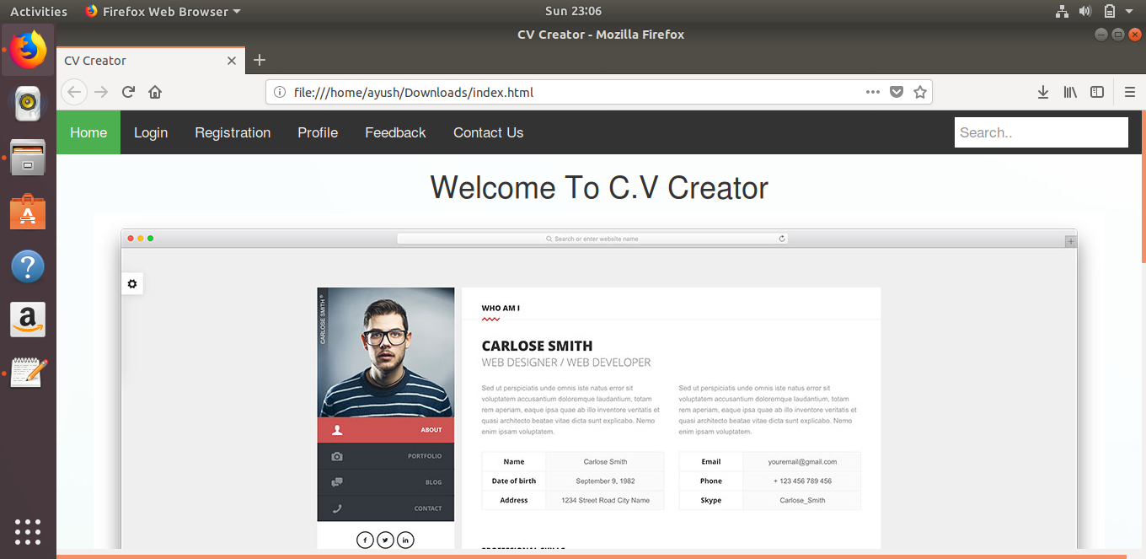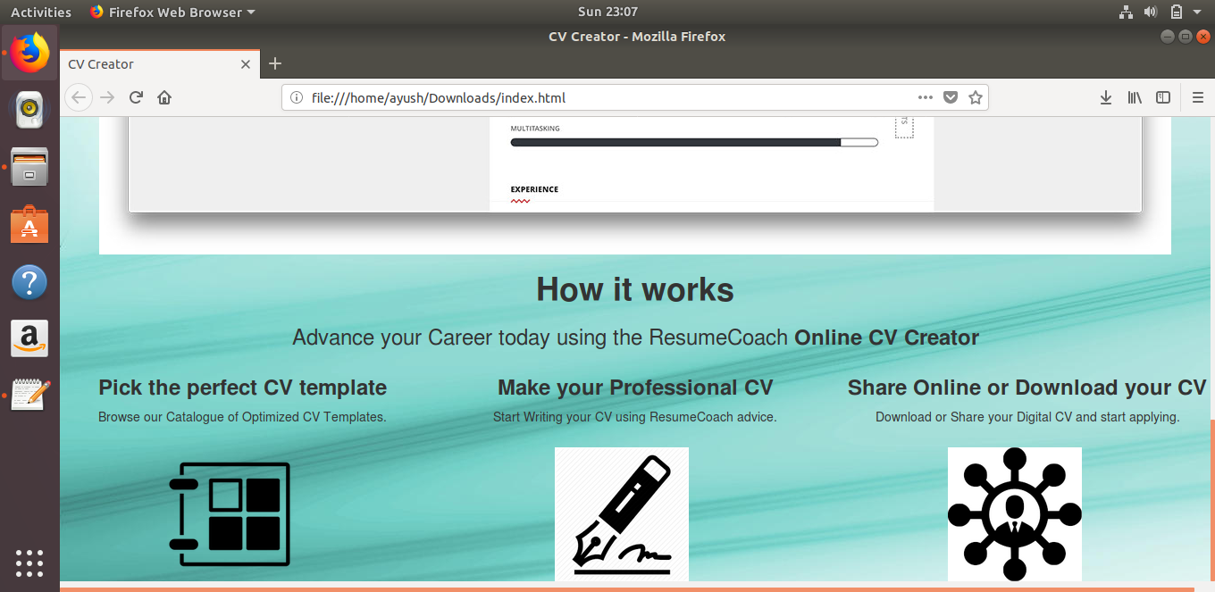

EXPERIMENT – 3

**AIM – Create table in your webpage.**

<center align="center">  
        <pre><h2><a name="Login"><B>LOGIN</B></a></h2></pre>  
        <form action="mylogin" method="get">  
            <table>  
                <thead>Fill the login Details to use our site  
                </thead>  
                <tr>  
                    <td>User name</td>  
                    <td><input type="text" name="txtusername" /></td>  
                </tr>  
                <tr>  
                    <td>Password</td>  
                    <td><input type="password" name="txtpwd" /></td>  
                </tr>  
                </table>  
                <tr>  
                    <td><input type="submit" name="Login"  /></td>  
                    <td><input type="reset" name="Clear" value="Clear"/></td>  
                </tr>  
        </form>  
    </center>

**OUTPUT-**

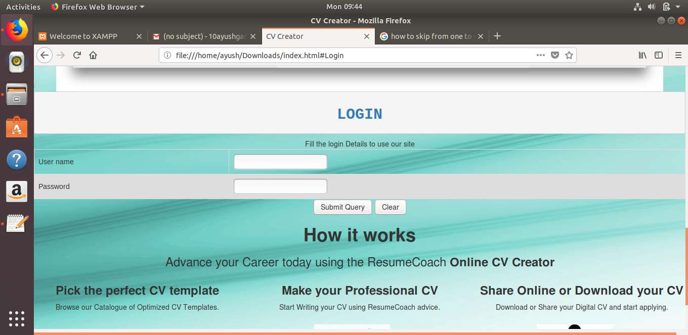

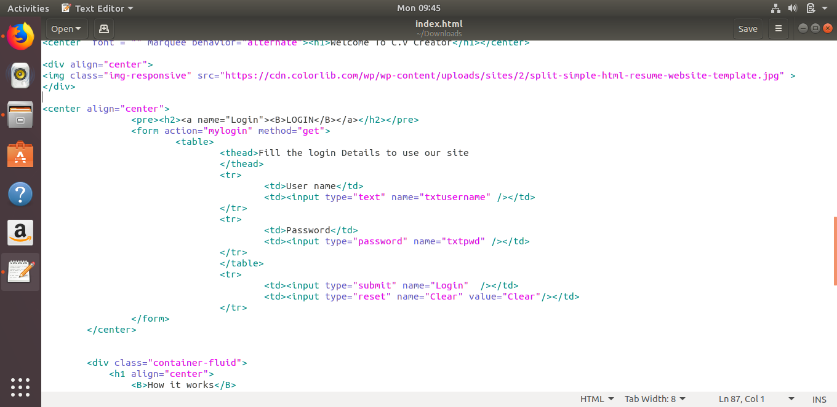

EXPERIMENT – 4

**AIM – Create contact form in your website.**

<!DOCTYPE html>

<html>

<head>

<title>CV Creator</title>

<meta charset="utf-8">

<meta name="viewport" content="width=device-width, initial-scale=1">

<link rel="stylesheet" href="https://maxcdn.bootstrapcdn.com/bootstrap/3.3.7/css/bootstrap.min.css">

<script src="https://ajax.googleapis.com/ajax/libs/jquery/3.3.1/jquery.min.js"></script>

<script src="https://maxcdn.bootstrapcdn.com/bootstrap/3.3.7/js/bootstrap.min.js"></script>

</head>

<style>

body {margin:0;}

.topnav {

overflow: hidden;

background-color: #333;

}

.topnav a {

float: left;

color: #f2f2f2;

text-align: center;

padding: 14px 16px;

text-decoration: none;

font-size: 17px;

}

.topnav a:hover {

background-color: #ddd;

color: Black;

}

.topnav a.active {

background-color: #4CAF50;

color: white;

}

.topnav input[type=text] {

float: right;

padding: 6px;

margin-top: 8px;

margin-right: 16px;

border: none;

font-size: 17px;

}

#p1{

position: absolute;

left: 130px;

top: 100px;

height:150px;

width:150px;

}

table {

font-family: arial, sans-serif;

border-collapse: collapse;

width: 100%;

}

td, th {

border: 1px solid #dddddd;

text-align: left;

padding: 8px;

}

tr:nth-child(even) {

background-color: #dddddd;

}

</style>

<body background="/home/ayush/Downloads\background.jpg" >

<div class="topnav">

<a class="active" href="#Home">Home</a>

<a href="#Login">Login</a>

<a href="#Registration">Registration</a>

<a href="#Profile">Profile</a>

<a href="#Feedback">Feedback</a>

<a href="#ContactUs">Contact Us</a>

<input type="text" placeholder="Search..">

</div>

<center font = "" marquee behavior="alternate"><h1>Welcome To C.V Creator</h1></center>

<div align="center">

<img class="img-responsive" src="https://cdn.colorlib.com/wp/wp-content/uploads/sites/2/split-simple-html-resume-website-template.jpg" >

</div>

<center align="center">

<pre><h2><a name="Login"><B>LOGIN</B></a></h2></pre>

<form action="mylogin" method="get">

<table>

<thead>Fill the login Details to use our site

</thead>

<tr>

<td>User name</td>

<td><input type="text" name="txtusername" /></td>

</tr>

<tr>

<td>Password</td>

<td><input type="password" name="txtpwd" /></td>

</tr>

</table>

<tr>

<td><input type="submit" name="Login" /></td>

<td><input type="reset" name="Clear" value="Clear"/></td>

</tr>

</form>

</center>

<center>

<br><h2><a name="Registration"><pre><B>REGISTRATION</B></pre></a></h2>

<form action="" method="">

<a href="#prfsnlsec"> GO to Professional Section</a><br />

<table>

<a name="personalsec"></a>

<thead>Fill the Personal Details to use our site

</thead>

<tr>

<td>Full name</td>

<td><input type="text" name="txtfullname" /></td>

</tr>

<tr>

<td>Email</td>

<td><input type="text" name="txtemail" /></td>

</tr>

<tr>

<td>User name</td>

<td><input type="text" name="txtusername" /></td>

</tr>

<tr>

<td>Password</td>

<td><input type="password" name="txtpwd" /></td>

</tr>

<tr>

<td>Phone</td>

<td><input type="text" name="txtphone" /></td>

</tr>

<tr>

<td>Address</td>

<td><textarea rows="4" cols="50"></textarea></td>

</tr>

<tr>

<td>Country</td>

<td><select name="drpcountry">

<option value="india">INDIA</option>

<option value="russia">RUSSIA</option>

<option value="spain">SPAIN</option>

<option value="italu">ITALY</option>

</select></td>

</tr>

<tr>

<td>Language knows</td>

<td><select name="listboxlang" multiple>

<option value="hindi">HINDI</option>

<option value="russian">RUSSIAN</option>

<option value="spanish">SPAINISH</option>

<option value="italian">ITALIAN</option>

</select></td>

</tr>

<tr>

<td>Gender</td>

<td><input type="radio" name="rdgender" value="male" checked>MALE</input>

<input type="radio" name="rdgender" value="female">FEMALE</input>

</td>

</tr>

<tr>

<td>ID Proof</td>

<td><input type="checkbox" name="chkvid" value="voterid">VOTER

ID</input> <input type="checkbox" name="chkpancard" value="pancard">PAN

CARD</input></td>

</tr>

</table>

<a href="#personalsec">Go to personal section</a><br />

<table>

<a name="prfsnlsec"></a>

<thead>Fill the professional Details

</thead>

<tr>

<td>Highest Qualification</td>

<td><input type="text" name="txtqual" /></td>

</tr>

<tr>

<td>Job Designation</td>

<td><input type="text" name="txtdesig" /></td>

<td><input type="submit" name="Registration" /></td>

<td><input type="reset" name="Clear" /></td>

</tr>

</table>

</form>

</center>

<div class="container-fluid">

<h1 align="center">

<B>How it works</B>

</h1>

<h3 align="center">

Advance your Career today using the ResumeCoach <strong>Online CV Creator</strong>

</h3>

</div>

</div>

<div class="row">

<div class="col-sm-4">

<h3 class="text-center">

<b> Pick the perfect CV template</b>

</h3>

<img class="img-responsive" align = "center" id="p1" src="/home/ayush/Downloads\catalogue.png" alt="logo_resume_coach">

<p class="text-center">

Browse our Catalogue of Optimized CV Templates.

</p>

</div>

<div class="col-sm-4">

<h3 class="text-center">

<b>Make your Professional CV</b>

<img class="text-center" class="img-responsive" id="p1" src="/home/ayush/Downloads\startwriting.png" alt="logo_resume_coach">

</h3>

<p class="text-center">

Start Writing your CV using ResumeCoach advice.

</p>

</div>

<div class="col-sm-4">

<h3 class="text-center">

<b>Share Online or Download your CV</b>

<img class="text-center" class="img-responsive" id="p1" src="/home/ayush/Downloads\share.png" alt="logo_resume_coach">

</h3>

<p class="text-center">

Download or Share your Digital CV and start applying.

</p>

</div>

</div>

</div>

</body>

</html>

**OUTPUT-**

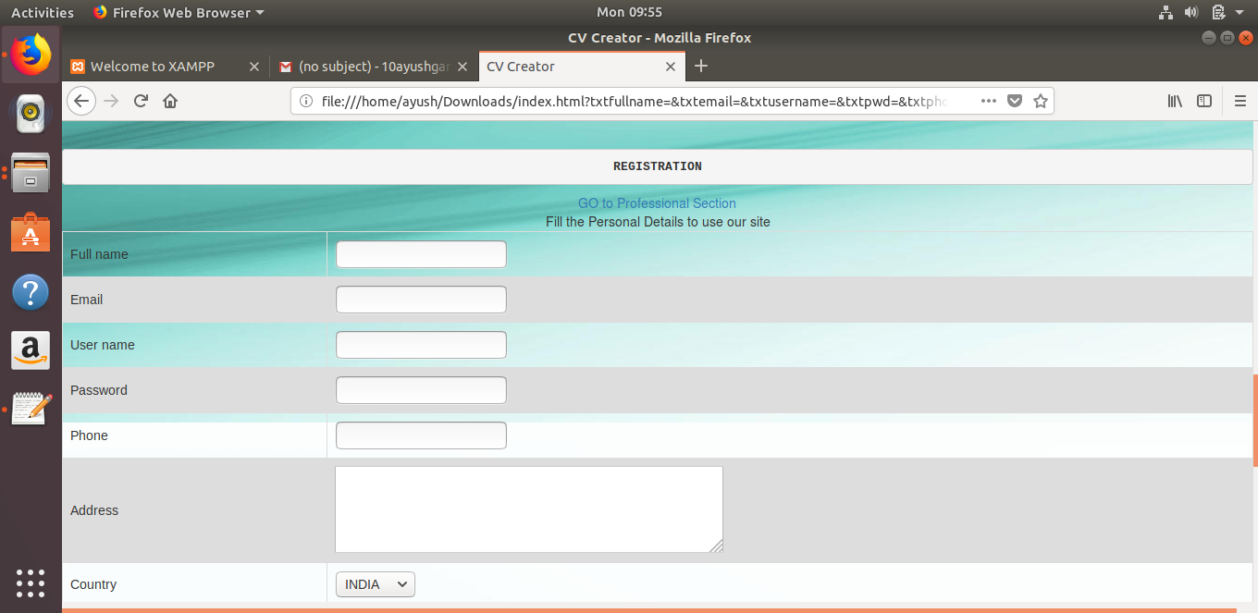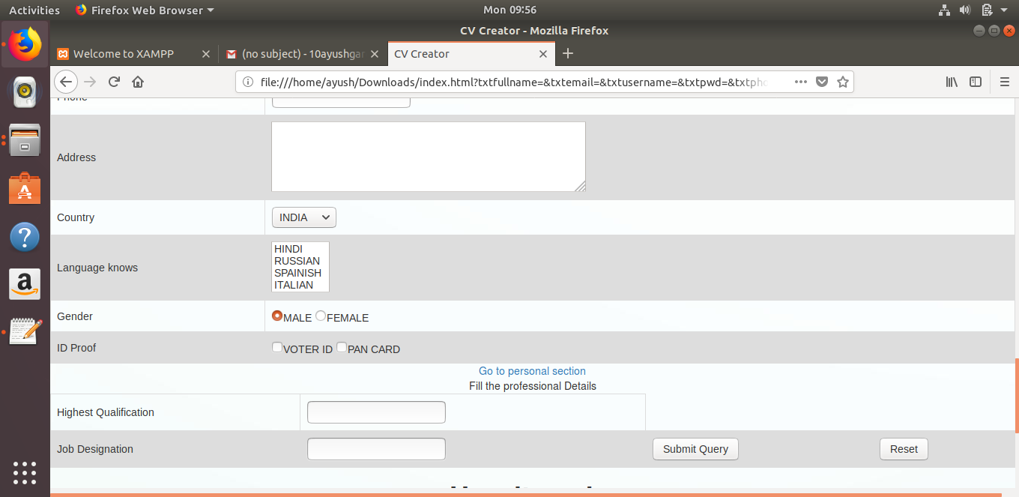

EXPERIMENT – 1

**AIM – Installation of Xampp.**

We have to follow some steps to download and install the XAMPP server in Ubuntu. The following steps are mentioned below –

**Step 1 –** To download XAMPP server from the official website.

**Step 2 –** Go into the SuperUser Mode

sudo su

The sudo command. The sudo command stands for "superuser do". It prompts you for your personal password and confirms your request to execute a commandby checking a file, called sudoers , which the system administrator configures

**Step 3 –** Run the installer, but don't close the Terminal.

xampp – linux – x64 – 7.2.1 -0-installer.run

A dialog box will open, if you get an error, ignore it. In the dialog box, click next(for each step) and move through the process of installation. Once XAMPP is installed, click finish.

XAMPP is a free and open source cross-platform web server solution stack package developed by Apache Friends, consisting mainly of the Apache HTTP Server, MariaDB database, and interpreters for scripts written in the PHP and Perl programming languages. XAMPP stands for Cross-Platform (X).

**OUTPUT -**

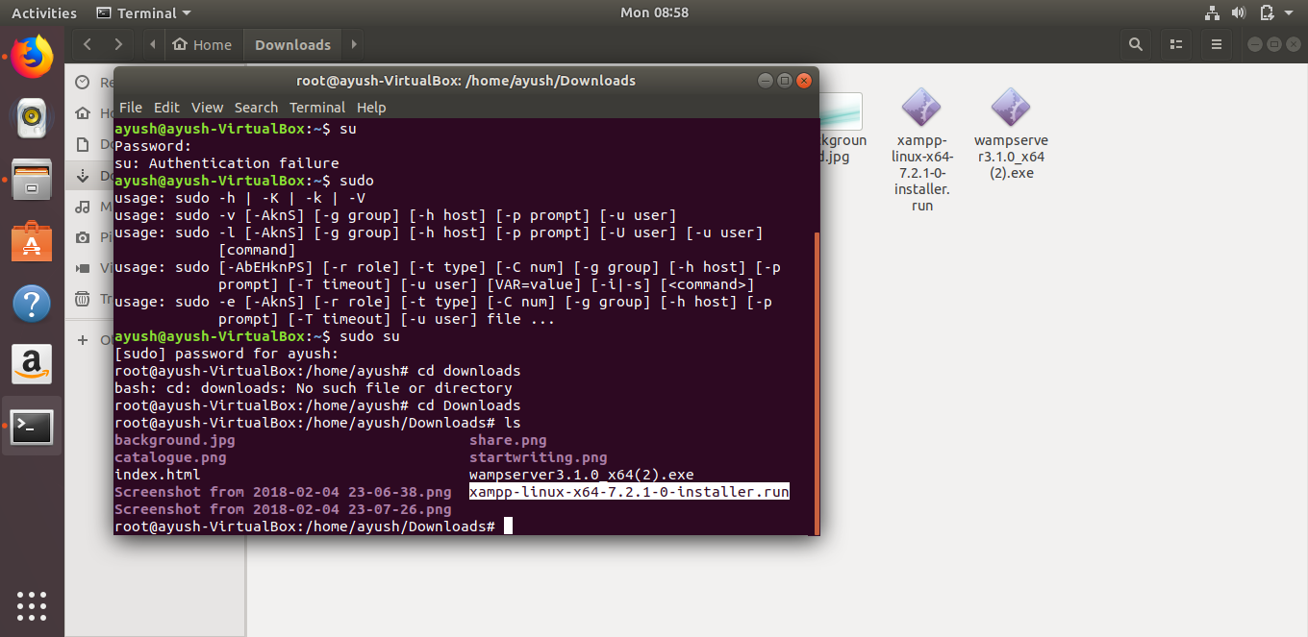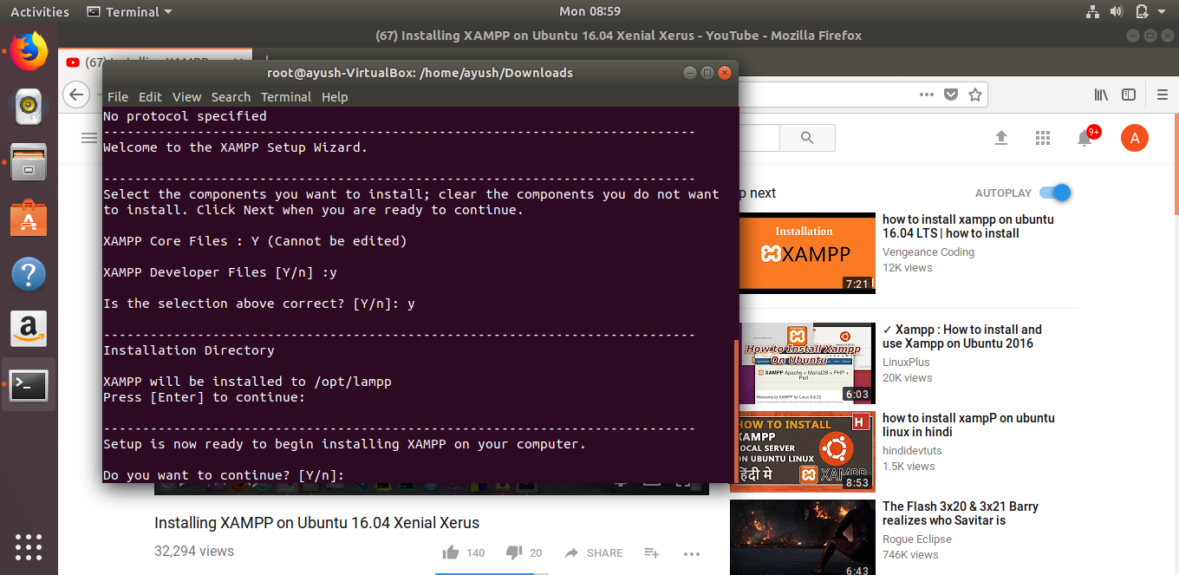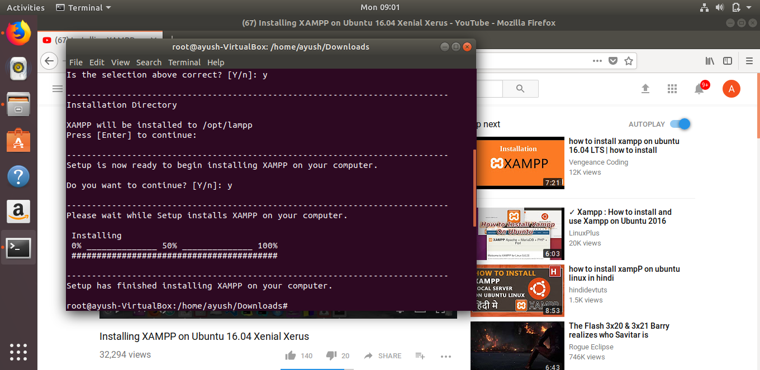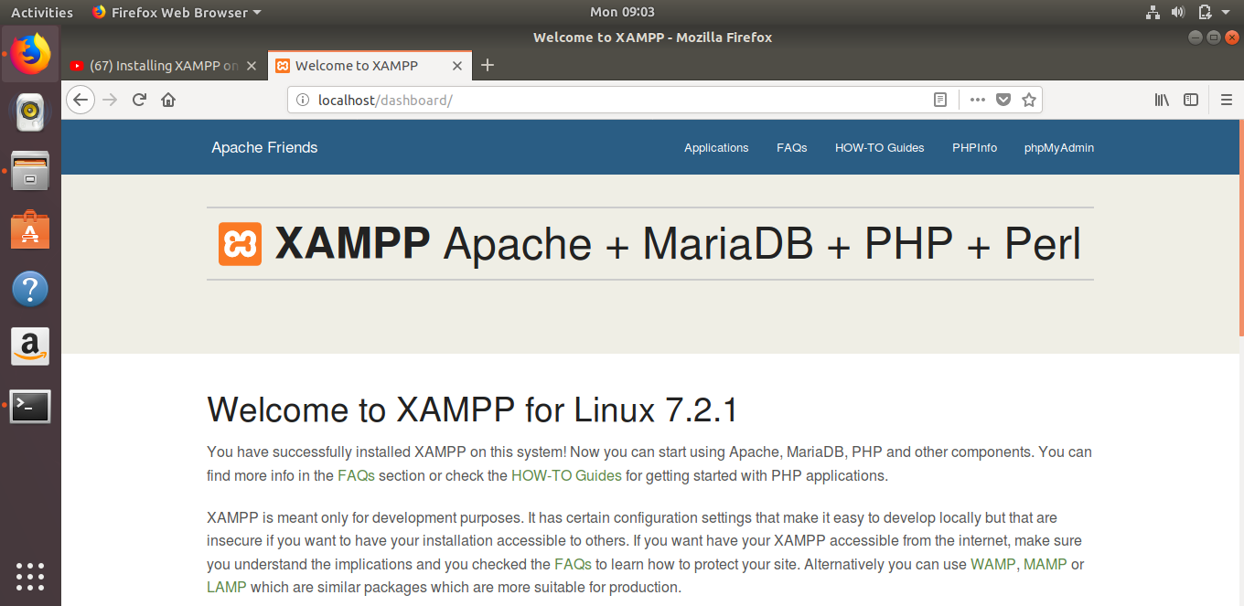

EXPERIMENT – 5

**AIM – Create header, footer, radio button, check box, ordered list, unordered list in your web page.**

<!DOCTYPE html>

<html>

<head>

<title>CV Creator</title>

<meta charset="utf-8">

<meta name="viewport" content="width=device-width, initial-scale=1">

<link rel="stylesheet" href="https://maxcdn.bootstrapcdn.com/bootstrap/3.3.7/css/bootstrap.min.css">

<script src="https://ajax.googleapis.com/ajax/libs/jquery/3.3.1/jquery.min.js"></script>

<script src="https://maxcdn.bootstrapcdn.com/bootstrap/3.3.7/js/bootstrap.min.js"></script>

</head>

<style>

body {margin:0;}

.topnav {

overflow: hidden;

background-color: #333;

}

.topnav a {

float: left;

color: #f2f2f2;

text-align: center;

padding: 14px 16px;

text-decoration: none;

font-size: 17px;

}

.topnav a:hover {

background-color: #ddd;

color: Black;

}

.topnav a.active {

background-color: #4CAF50;

color: white;

}

.topnav input[type=text] {

float: right;

padding: 6px;

margin-top: 8px;

margin-right: 16px;

border: none;

font-size: 17px;

}

#p1{

position: absolute;

left: 130px;

top: 100px;

height:150px;

width:150px;

}

table {

font-family: arial, sans-serif;

border-collapse: collapse;

width: 100%;

}

td, th {

border: 1px solid #dddddd;

text-align: left;

padding: 8px;

}

tr:nth-child(even) {

background-color: #dddddd;

}

</style>

<body background="/home/ayush/Downloads\background.jpg" >

<div class="topnav">

<a class="active" href="#Home">Home</a>

<a href="#Login">Login</a>

<a href="#Registration">Registration</a>

<a href="#Profile">Profile</a>

<a href="#Feedback">Feedback</a>

<a href="#ContactUs">Contact Us</a>

<input type="text" placeholder="Search..">

</div>

<center font = "" marquee behavior="alternate"><h1>Welcome To C.V Creator</h1></center>

<header >

<h5 align="right">Ayush Garg</h5>

<h5 align="right">43714802715</h5>

<h5 align="right">C-11</h5>

</header>

<footer>

<p>For further Information Contact Me</p>

<p>Contact information: <a href="mailto:10ayushgarg@gmail.com">

10ayushgarg@gmail.com</a>.</p>

<p>98998XXXXX</p>

</footer>

<div align="center">

<img class="img-responsive" src="https://cdn.colorlib.com/wp/wp-content/uploads/sites/2/split-simple-html-resume-website-template.jpg" >

</div>

<center align="center">

<pre><h2><B>RESUME TYPES</B></h2></pre>

<ol>

<li>Resume Writing Guide</li>

<li>Resume Format</li>

<li>Resume Template</li>

<li>Professional Resume</li>

<li>Entry Level Resume</li>

<li>Student Resume</li>

</ol>

</center>

<center align="center">

<pre><h2><a name="Login"><B>LOGIN</B></a></h2></pre>

<form action="mylogin" method="get">

<table>

<thead>Fill the login Details to use our site

</thead>

<tr>

<td>User name</td>

<td><input type="text" name="txtusername" /></td>

</tr>

<tr>

<td>Password</td>

<td><input type="password" name="txtpwd" /></td>

</tr>

</table>

<tr>

<td><input type="submit" name="Login" /></td>

<td><input type="reset" name="Clear" value="Clear"/></td>

</tr>

</form>

</center>

<center>

<br><pre><h2><a name="Registration"><pre><B>REGISTRATION</B></a></h2></pre>

<form action="" method="">

<a href="#prfsnlsec"> GO to Professional Section</a><br />

<table>

<a name="personalsec"></a>

<thead>Fill the Personal Details to use our site

</thead>

<tr>

<td>Full name</td>

<td><input type="text" name="txtfullname" /></td>

</tr>

<tr>

<td>Email</td>

<td><input type="text" name="txtemail" /></td>

</tr>

<tr>

<td>User name</td>

<td><input type="text" name="txtusername" /></td>

</tr>

<tr>

<td>Password</td>

<td><input type="password" name="txtpwd" /></td>

</tr>

<tr>

<td>Phone</td>

<td><input type="text" name="txtphone" /></td>

</tr>

<tr>

<td>Address</td>

<td><textarea rows="4" cols="50"></textarea></td>

</tr>

<tr>

<td>Country</td>

<td><select name="drpcountry">

<option value="india">INDIA</option>

<option value="russia">RUSSIA</option>

<option value="spain">SPAIN</option>

<option value="italu">ITALY</option>

</select></td>

</tr>

<tr>

<td>Language knows</td>

<td><select name="listboxlang" multiple>

<option value="hindi">HINDI</option>

<option value="russian">RUSSIAN</option>

<option value="spanish">SPAINISH</option>

<option value="italian">ITALIAN</option>

</select></td>

</tr>

<tr>

<td>Gender</td>

<td><input type="radio" name="rdgender" value="male" checked>MALE</input>

<input type="radio" name="rdgender" value="female">FEMALE</input>

</td>

</tr>

<tr>

<td>ID Proof</td>

<td><input type="checkbox" name="chkvid" value="voterid">VOTER

ID</input> <input type="checkbox" name="chkpancard" value="pancard">PAN

CARD</input></td>

</tr>

</table>

<a href="#personalsec">Go to personal section</a><br />

<table>

<a name="prfsnlsec"></a>

<thead>Fill the professional Details

</thead>

<tr>

<td>Highest Qualification</td>

<td><input type="text" name="txtqual" /></td>

</tr>

<tr>

<td>Job Designation</td>

<td><input type="text" name="txtdesig" /></td>

<td><input type="submit" name="Registration" /></td>

<td><input type="reset" name="Clear" /></td>

</tr>

</table>

</form>

</center>

<div class="container-fluid">

<h1 align="center">

<B>How it works</B>

</h1>

<h3 align="center">

Advance your Career today using the ResumeCoach <strong>Online CV Creator</strong>

</h3>

</div>

</div>

<div class="row">

<div class="col-sm-4">

<h3 class="text-center">

<b> Pick the perfect CV template</b>

</h3>

<img class="img-responsive" align = "center" id="p1" src="/home/ayush/Downloads\catalogue.png" alt="logo_resume_coach">

<p class="text-center">

Browse our Catalogue of Optimized CV Templates.

</p>

</div>

<div class="col-sm-4">

<h3 class="text-center">

<b>Make your Professional CV</b>

<img class="text-center" class="img-responsive" id="p1" src="/home/ayush/Downloads\startwriting.png" alt="logo_resume_coach">

</h3>

<p class="text-center">

Start Writing your CV using ResumeCoach advice.

</p>

</div>

<div class="col-sm-4">

<h3 class="text-center">

<b>Share Online or Download your CV</b>

<img class="text-center" class="img-responsive" id="p1" src="/home/ayush/Downloads\share.png" alt="logo_resume_coach">

</h3>

<p class="text-center">

Download or Share your Digital CV and start applying.

</p>

</div>

</div>

</div>

</body>

</html>

**OUTPUT-**

