-- Show all workers' details.

SELECT * FROM Worker;

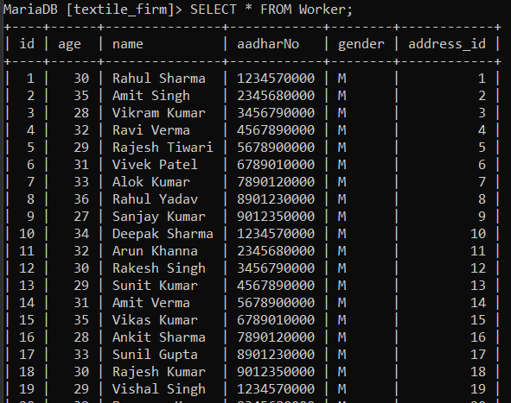

-- Display all customers' information.

SELECT * FROM Customer;

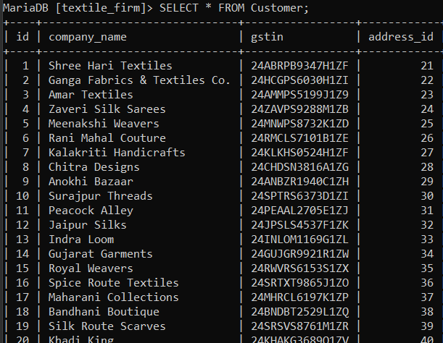

-- List all machines with their capacities.

SELECT id, identifier, capacity FROM Machine;

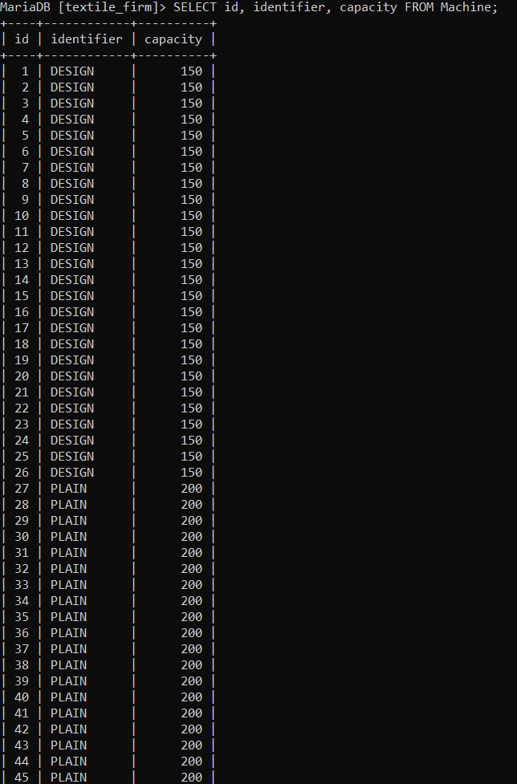

-- Show all maintenance records.

SELECT * FROM Maintenance;

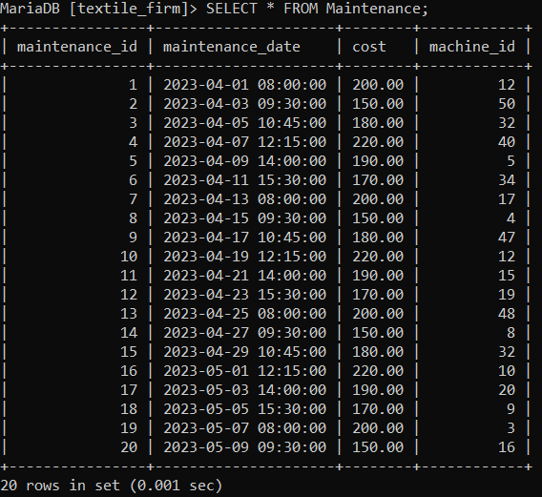

-- Display all produced items with their production dates.

SELECT * FROM Produced;

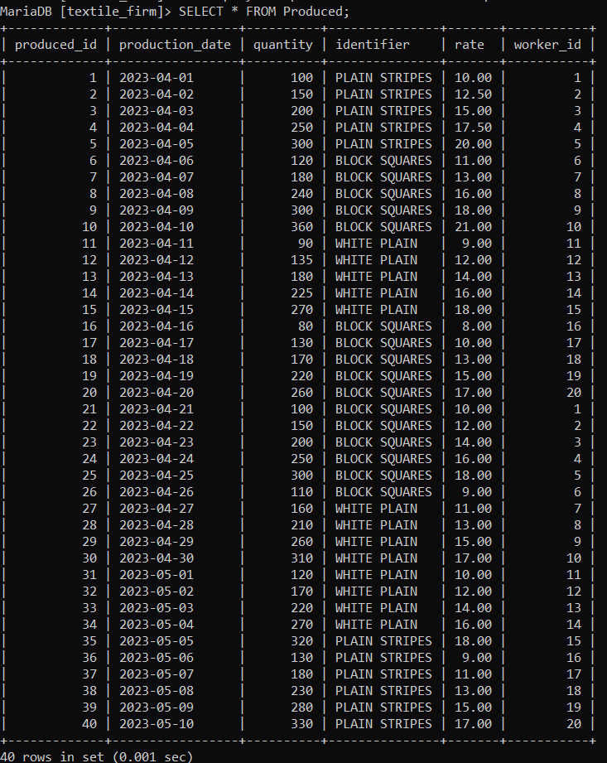

-- List all inventory items.

SELECT * FROM Inventory;

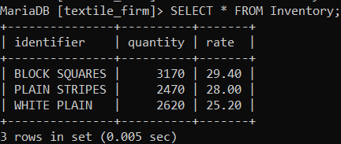

-- Show all orders placed.

SELECT * FROM Orders;

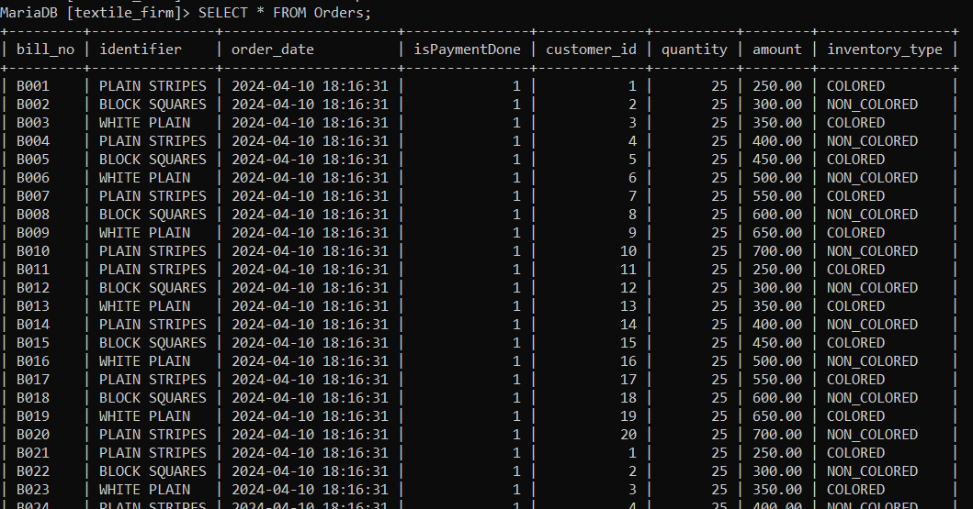

-- List all material purchases.

SELECT * FROM Material;

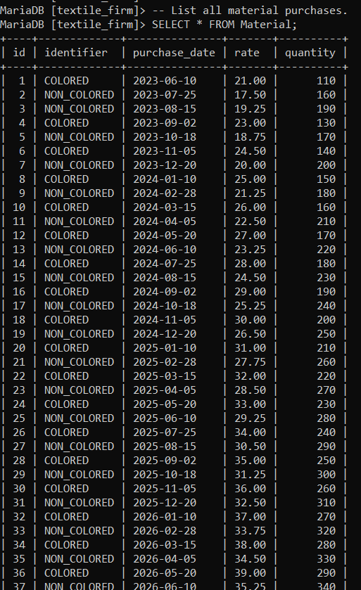

-- Show all workers who are older than 25 years.

SELECT * FROM Worker WHERE age > 25;

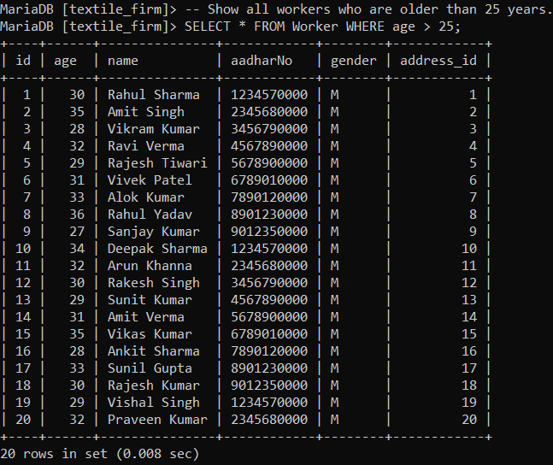

-- Display all customers whose company name starts with 'A'.

SELECT * FROM Customer WHERE company_name LIKE 'A%';

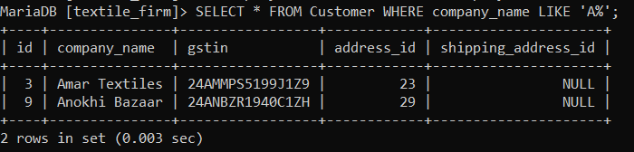

-- List all machines with a capacity greater than or equal to 150 meters.

SELECT * FROM Machine WHERE capacity >= 150;

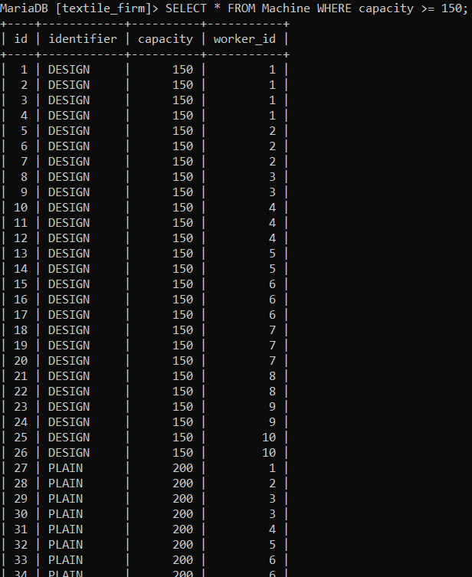

-- Show all maintenance records with a cost less than 100.

SELECT * FROM Maintenance WHERE cost < 100;



-- Display all produced items with a quantity greater than 50.

SELECT * FROM Produced WHERE quantity > 50;

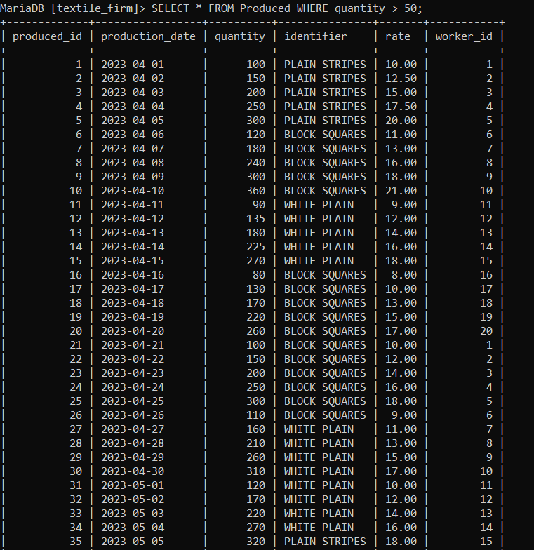

-- List all inventory items with a rate greater than 5.

SELECT * FROM Inventory WHERE rate > 5;

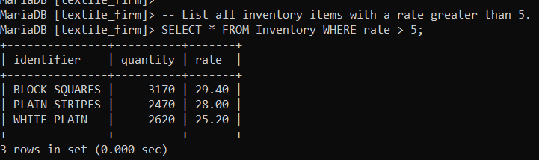

-- Show all orders where payment is not done.

SELECT * FROM Orders WHERE isPaymentDone = FALSE;



-- List all workers who are male and older than 30 years.

SELECT * FROM Worker WHERE gender = 'M' AND age > 30;

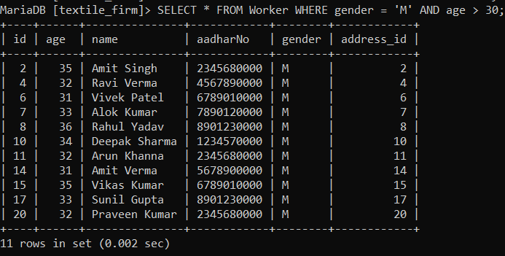

-- Display all customers whose company name starts with 'A' or 'B'.

SELECT * FROM Customer WHERE company_name LIKE 'A%' OR company_name LIKE 'B%';

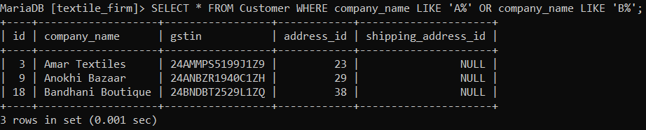

-- Show all machines with a capacity greater than 200 or assigned to worker ID 2.

SELECT * FROM Machine WHERE capacity > 200 OR worker_id = 2;

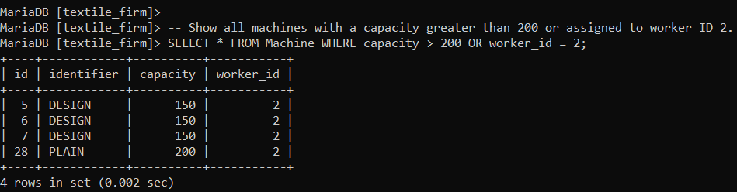

-- Display all maintenance records with a cost less than 50 or done for machine ID 1.

SELECT * FROM Maintenance WHERE cost < 50 OR machine_id = 1;



-- List all produced items with a quantity greater than 100 and produced by worker ID 1.

SELECT * FROM Produced WHERE quantity > 100 AND worker_id = 1;



-- Show all inventory items with a rate greater than 10 and a quantity less than 200.

SELECT * FROM Inventory WHERE rate > 10 AND quantity < 200;



-- Display all orders where payment is not done and the amount is greater than 1000.

SELECT * FROM Orders WHERE isPaymentDone = FALSE AND amount > 1000;



-- List all workers who are older than 25 years or have an Aadhar number.

SELECT * FROM Worker WHERE age > 25 OR aadharNo IS NOT NULL;

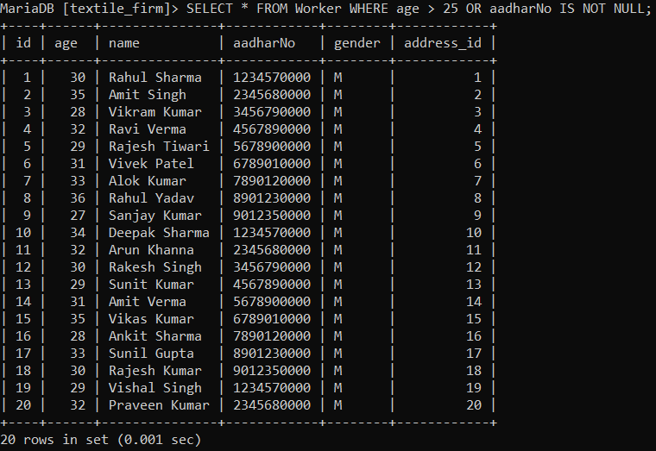

-- Show the total number of workers.

SELECT COUNT(*) AS total_workers FROM Worker;

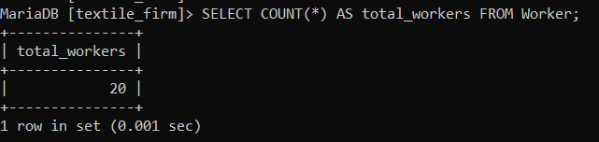

-- Show the total number of customers.

SELECT COUNT(*) AS total_customers FROM Customer;

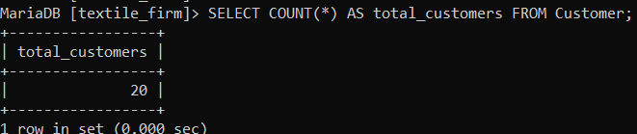

-- Show the total number of machines.

SELECT COUNT(*) AS total_machines FROM Machine;

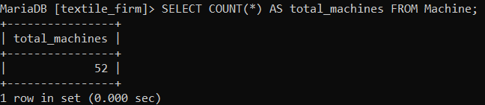

-- Show the total number of maintenance records.

SELECT COUNT(*) AS total_maintenance FROM Maintenance;

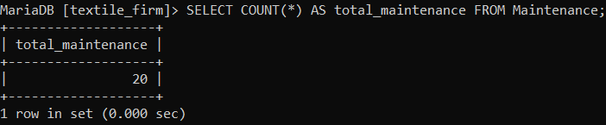

-- Show the total number of produced items.

SELECT COUNT(*) AS total_produced FROM Produced;

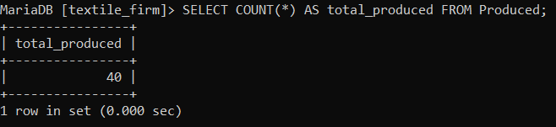

-- Show the total number of inventory items.

SELECT COUNT(*) AS total_inventory FROM Inventory;

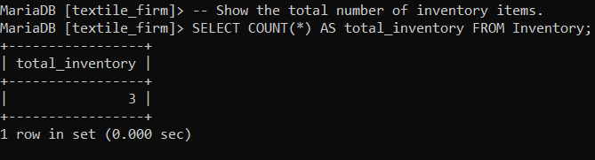

-- Show the total number of orders.

SELECT COUNT(*) AS total_orders FROM Orders;

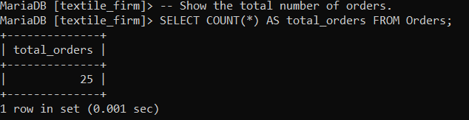

-- Show the total number of material purchases.

SELECT COUNT(*) AS total_material FROM Material;

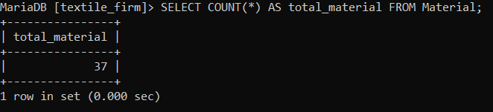

-- Display the average age of workers.

SELECT AVG(age) AS average_age FROM Worker;

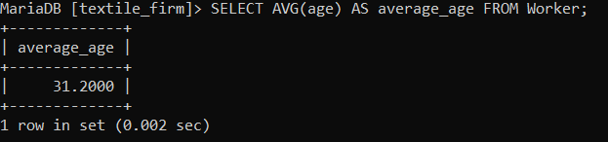

-- Display the total cost of maintenance.

SELECT SUM(cost) AS total_maintenance_cost FROM Maintenance;

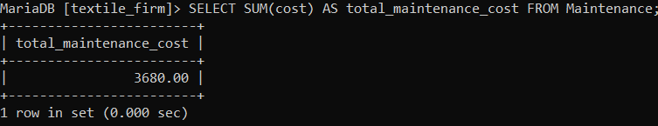

-- Show the total quantity of produced items.

SELECT SUM(quantity) AS total_produced_quantity FROM Produced;

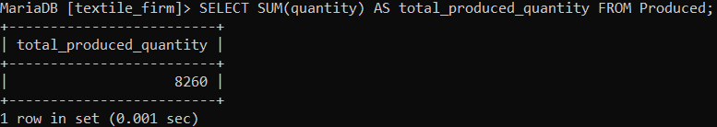

-- Show the total quantity of inventory items.

SELECT SUM(quantity) AS total_inventory_quantity FROM Inventory;

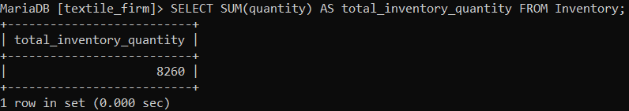

-- Show the total amount of orders.

SELECT SUM(amount) AS total_orders_amount FROM Orders;

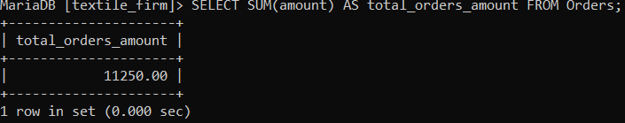

-- Show the total quantity of material purchases.

SELECT SUM(quantity) AS total_material_quantity FROM Material;

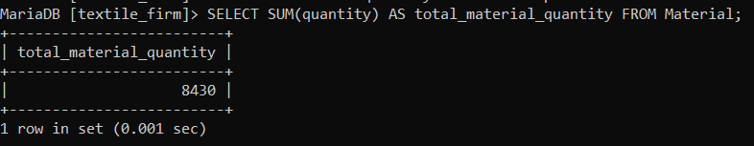

-- Display the workers along with their addresses.

SELECT Worker.*, Address.street, Address.city, Address.postal_code

FROM Worker

INNER JOIN Address ON Worker.address_id = Address.address_id;

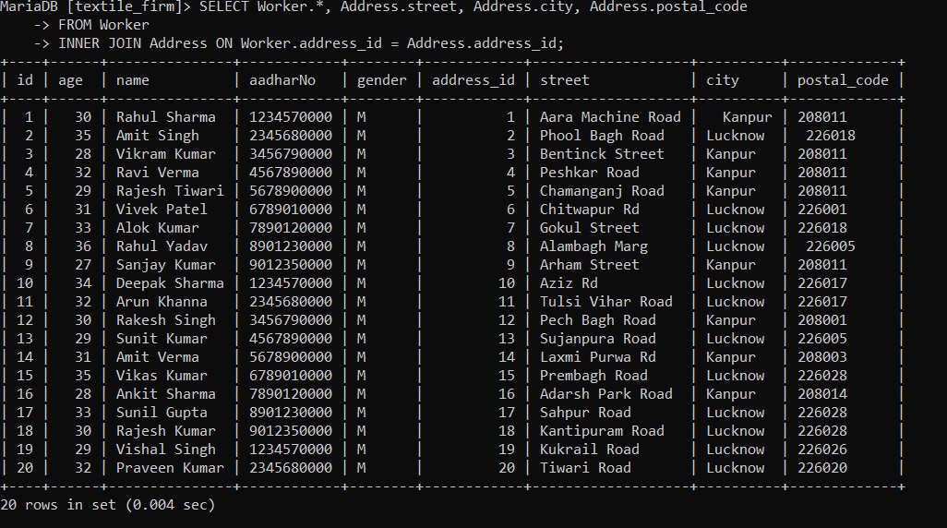

-- Display the customers along with their addresses.

SELECT Customer.*, Address.street, Address.city, Address.postal_code

FROM Customer

INNER JOIN Address ON Customer.address_id = Address.address_id;

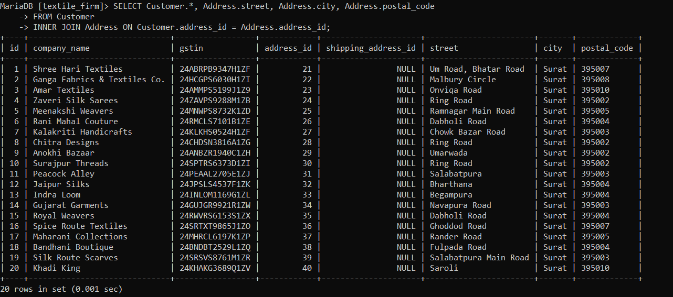

-- Show the machines along with the workers assigned to them.

SELECT Machine.*, Worker.name AS worker_name

FROM Machine

LEFT JOIN Worker ON Machine.worker_id = Worker.id;

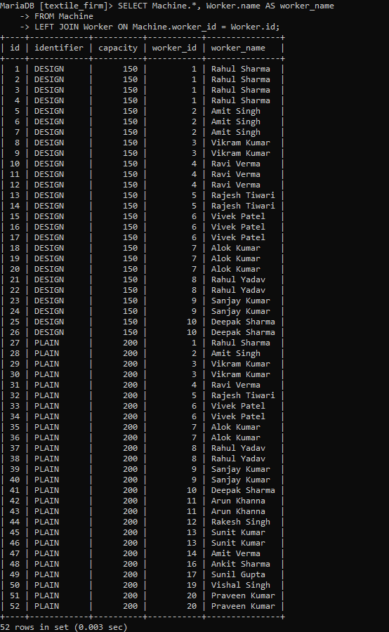

-- Show the orders along with the customer details.

SELECT Orders.*, Customer.company_name, Customer.gstin

FROM Orders

INNER JOIN Customer ON Orders.customer_id = Customer.id;

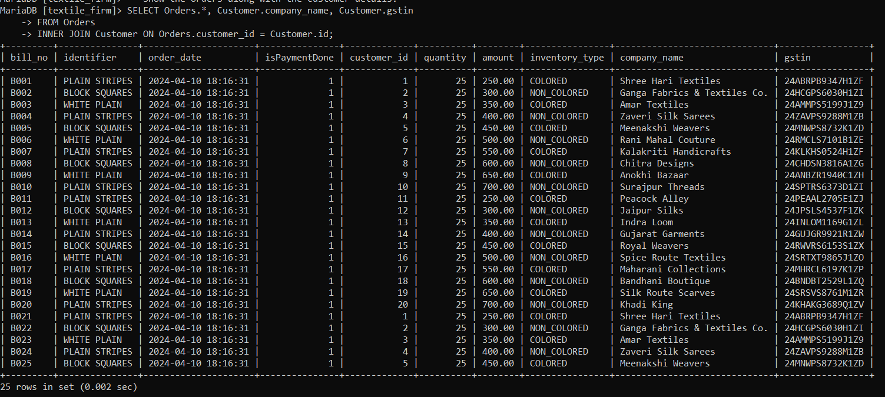

-- Show the produced items along with the worker details.

SELECT Produced.*, Worker.name AS worker_name

FROM Produced

INNER JOIN Worker ON Produced.worker_id = Worker.id;

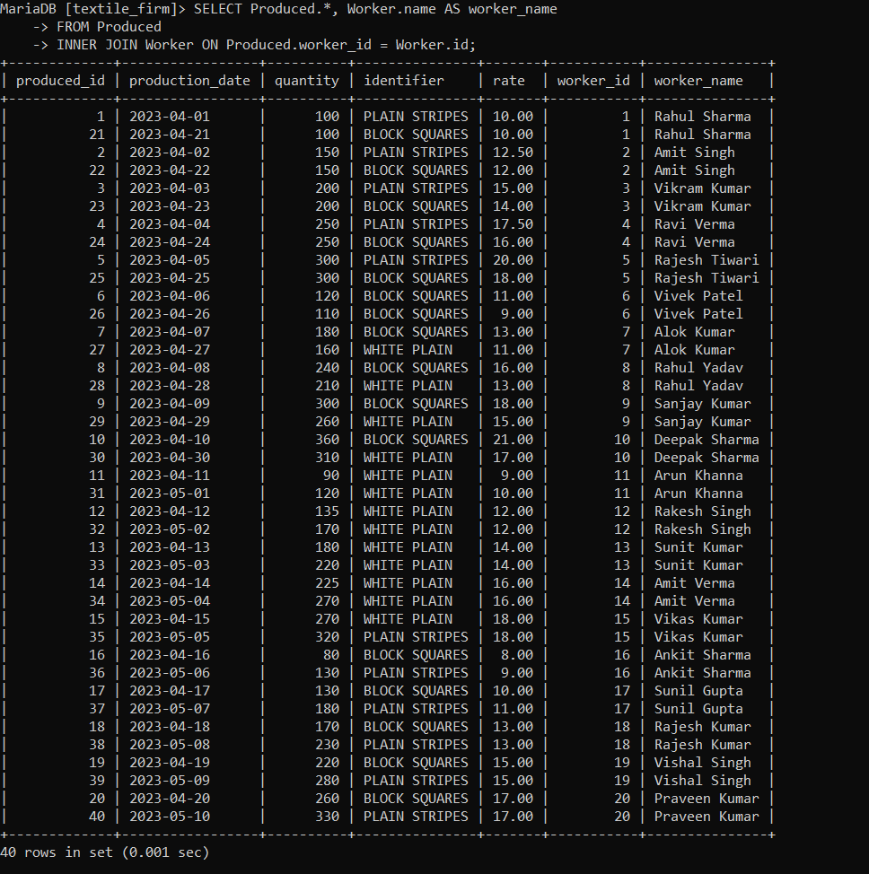

-- Show the maintenance records along with the machine details.

SELECT Maintenance.*, Machine.identifier

FROM Maintenance

INNER JOIN Machine ON Maintenance.machine_id = Machine.id;

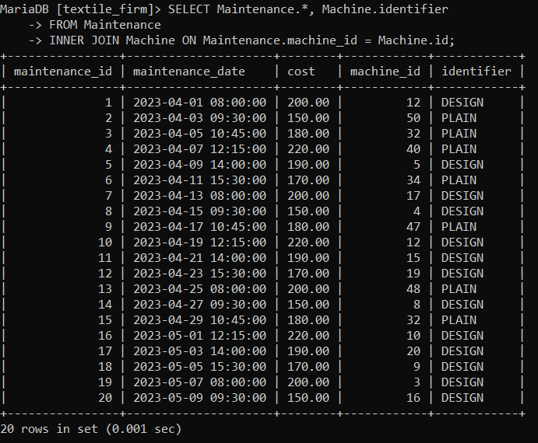

-- Show the material purchases along with their types.

SELECT Material.*, CASE WHEN identifier = 'COLORED' THEN 'Colored' ELSE 'Non-Colored' END AS type

FROM Material;

-- Display the orders along with the inventory items.

SELECT Orders.*, Inventory.*

FROM Orders

INNER JOIN Inventory ON Orders.identifier = Inventory.identifier;

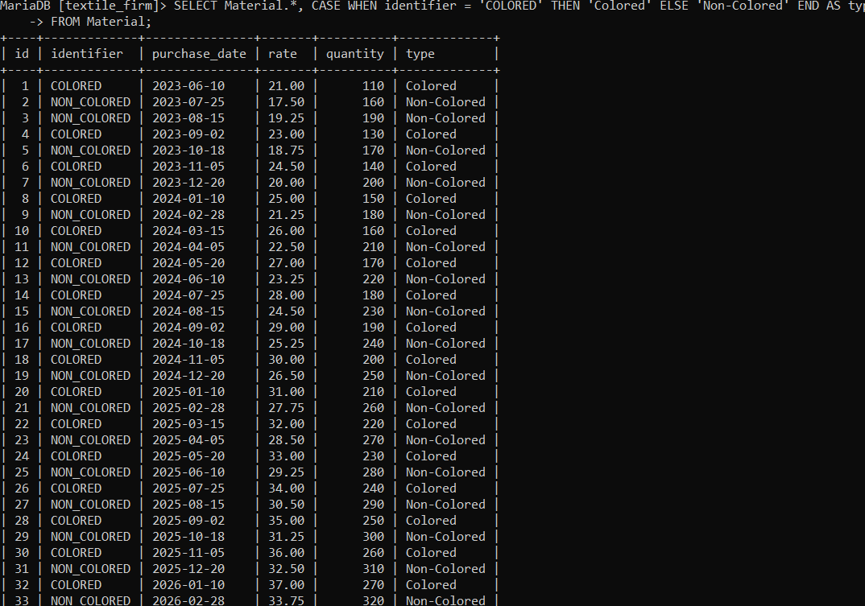

-- Show the total quantity produced by each worker.

SELECT Worker.id, Worker.name, SUM(Produced.quantity) AS total_quantity_produced

FROM Worker

LEFT JOIN Produced ON Worker.id = Produced.worker_id

GROUP BY Worker.id, Worker.name;

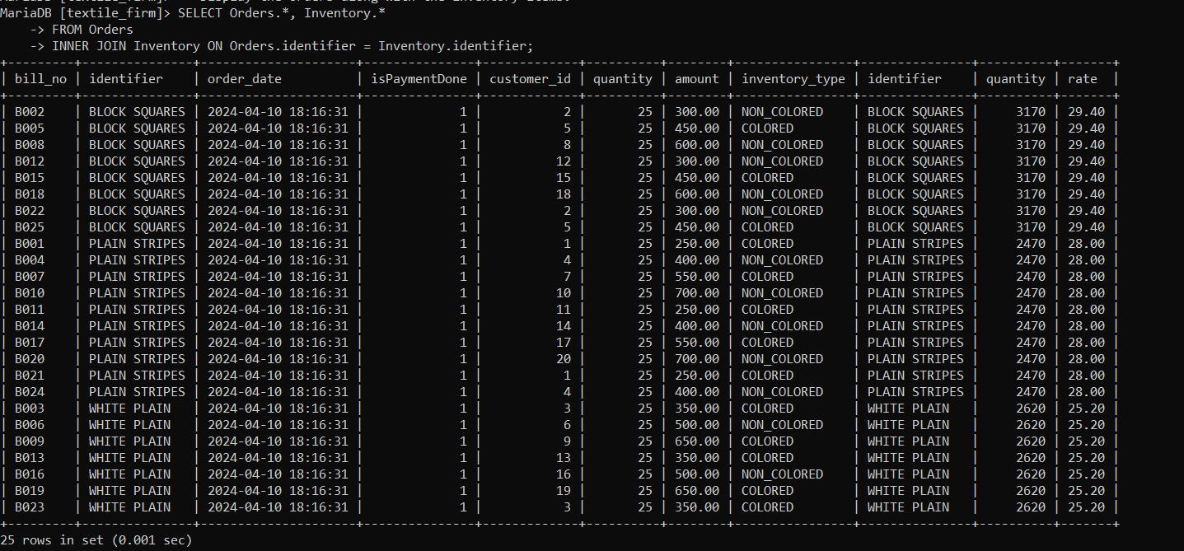

-- Show the total cost of maintenance for each machine type.

SELECT Machine.identifier, SUM(Maintenance.cost) AS total_maintenance_cost

FROM Machine

LEFT JOIN Maintenance ON Machine.id = Maintenance.machine_id

GROUP BY Machine.identifier;

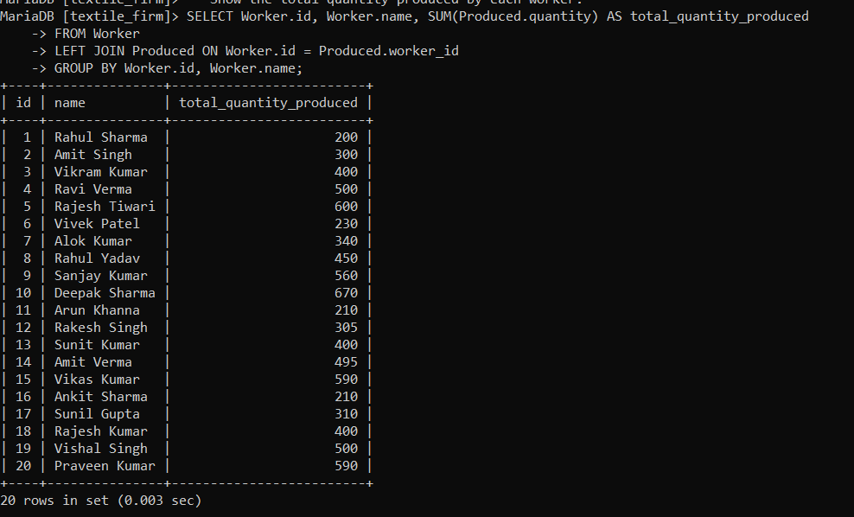

-- Show the total quantity of inventory items for each type.

SELECT identifier, SUM(quantity) AS total_quantity

FROM Inventory

GROUP BY identifier;

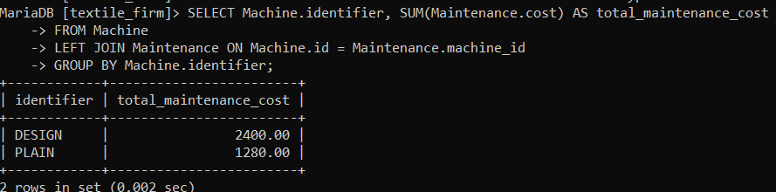

-- Show the total amount of orders for each customer.

SELECT Customer.id, Customer.company_name, SUM(Orders.amount) AS total_order_amount

FROM Customer

LEFT JOIN Orders ON Customer.id = Orders.customer_id

GROUP BY Customer.id, Customer.company_name;

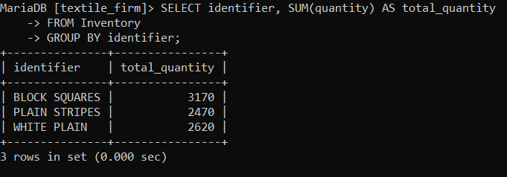

-- Show the total quantity produced for each type of identifier.

SELECT identifier, SUM(quantity) AS total_quantity_produced

FROM Produced

GROUP BY identifier;

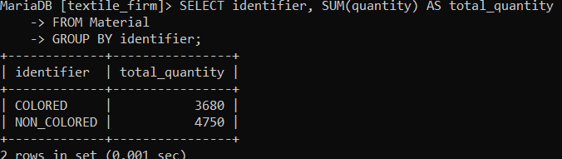

-- Show the average age of workers grouped by gender.

SELECT gender, AVG(age) AS average_age

FROM Worker

GROUP BY gender;

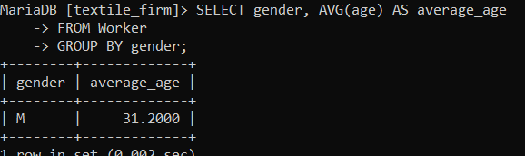

-- Show the total quantity of material purchases for each type of identifier.

SELECT identifier, SUM(quantity) AS total_quantity

FROM Material

GROUP BY identifier;

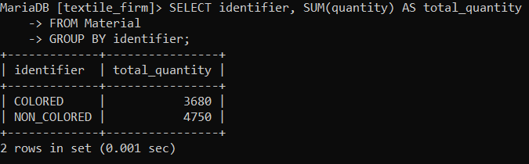

-- Show the average rate of material purchases for each type of identifier.

SELECT identifier, AVG(rate) AS average_rate

FROM Material

GROUP BY identifier;

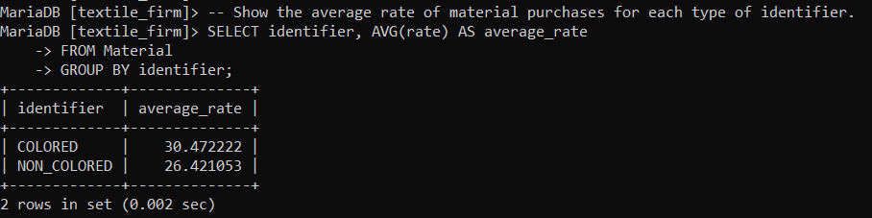

-- Show the total number of orders placed by each customer.

SELECT customer_id, COUNT(*) AS total_orders

FROM Orders

GROUP BY customer_id;

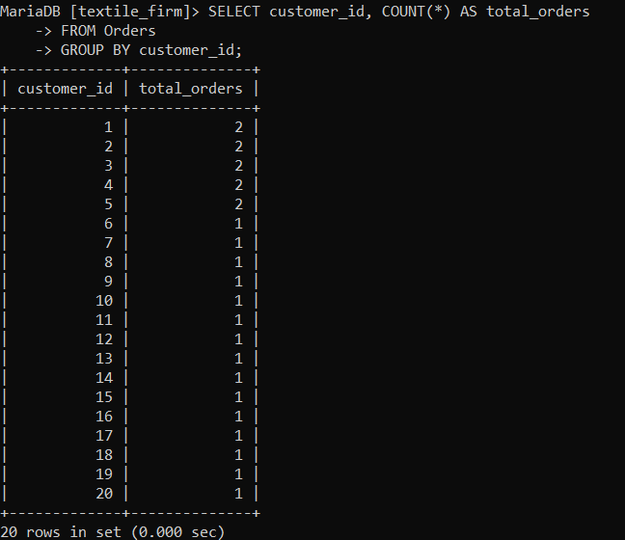

-- Show the total quantity of inventory items produced by each worker.

SELECT Worker.id, Worker.name, SUM(Produced.quantity) AS total_quantity_produced

FROM Worker

LEFT JOIN Produced ON Worker.id = Produced.worker_id

GROUP BY Worker.id, Worker.name;

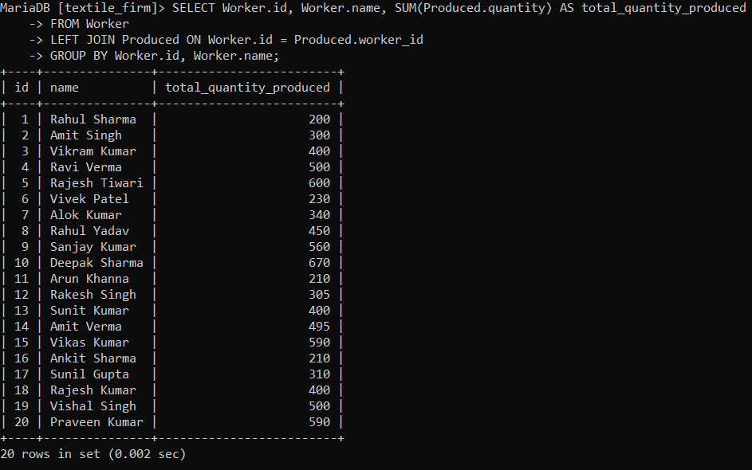

-- Show the total amount of orders placed for each type of identifier.

SELECT identifier, SUM(amount) AS total_amount

FROM Orders

GROUP BY identifier;

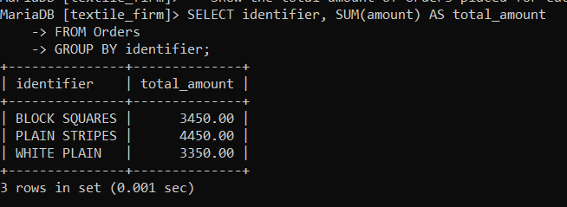

-- Show the total quantity of material purchases for each month.

SELECT MONTH(purchase_date) AS month, SUM(quantity) AS total_quantity

FROM Material

GROUP BY MONTH(purchase_date);

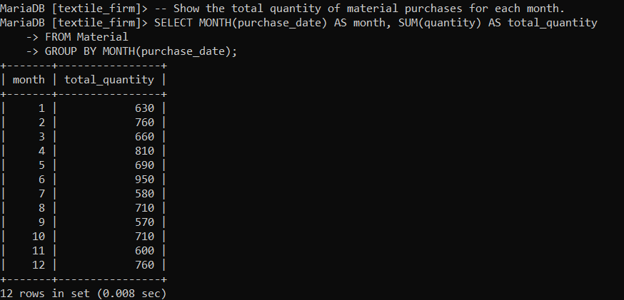

-- Show the total amount of orders placed for each month.

SELECT MONTH(order_date) AS month, SUM(amount) AS total_amount

FROM Orders

GROUP BY MONTH(order_date);

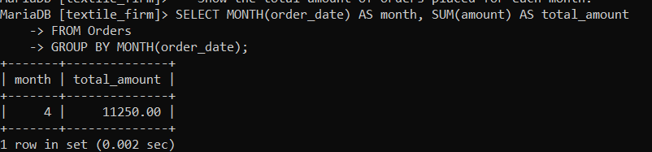

-- Show the average rate of maintenance for each machine type.

SELECT Machine.identifier, AVG(Maintenance.cost) AS average_maintenance_cost

FROM Machine

LEFT JOIN Maintenance ON Machine.id = Maintenance.machine_id

GROUP BY Machine.identifier;

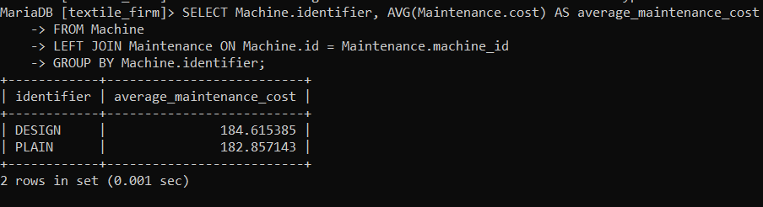

-- Show the total quantity of produced items for each customer and worker.

SELECT Customer.id, Customer.company_name, Worker.name, SUM(Produced.quantity) AS total_quantity_produced

FROM Customer

LEFT JOIN Orders ON Customer.id = Orders.customer_id

LEFT JOIN Produced ON Orders.identifier = Produced.identifier

LEFT JOIN Worker ON Produced.worker_id = Worker.id

GROUP BY Customer.id, Customer.company_name, Worker.name;

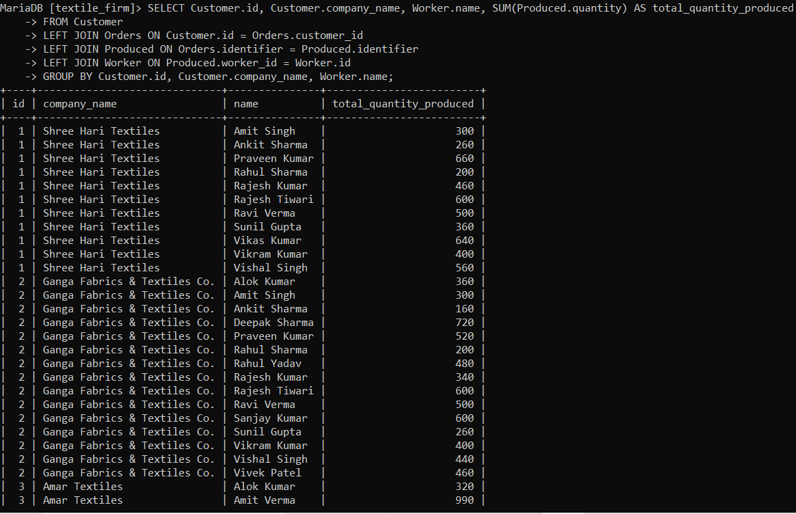

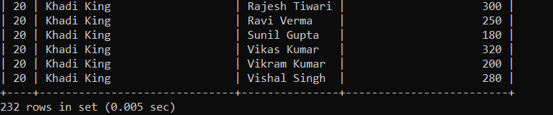

-- Show the total quantity of inventory items for each worker and machine type.

SELECT Worker.id, Worker.name, Machine.identifier, SUM(Inventory.quantity) AS total_quantity

FROM Worker

LEFT JOIN Machine ON Worker.id = Machine.worker_id

LEFT JOIN Inventory ON Machine.identifier = Inventory.identifier

GROUP BY Worker.id, Worker.name, Machine.identifier;

