HYDROCHECK
A Multimodal, Personalised Wearable for Predictive Dehydration
and Heat Stress Risk Monitoring in Occupational Settings
Complete Technical & Project Documentation
Department of Computer Science & Engineering
Adamas University, Kolkata, India
Repository: github.com/devxbhabani/Hydrocheck

1. Introduction
Occupational heat stress and dehydration remain among the most under-monitored risks faced by outdoor and industrial workers in tropical climates. Existing safety practices largely rely on fixed environmental thresholds or self-reported symptoms rather than continuous physiological surveillance. Hydrocheck is a wrist-worn, multimodal IoT platform that fuses physiological and environmental signal pathways into a single, personalised risk index, capable of anticipating dehydration onset and heat strain before overt symptoms manifest.
The system combines an ESP32-based sensor wearable, an on-device TinyML classifier trained on collected physiological data, a Bluetooth Low Energy (BLE) communication layer, a React/Capacitor mobile application, and a supplementary Web Bluetooth dashboard. This document consolidates the circuitry, firmware methodology, AI/ML pipeline, mobile application, web dashboard, and an alternative MicroPython implementation strategy into a single technical reference.

1.1 Key Contributions
- Rate-of-change GSR analysis over a Kalman-filtered rolling window to detect the physiological inflection point preceding clinically observable dehydration.
- Heart-rate-variability (HRV) proxy derived from PPG beat intervals as a leading-indicator stress signal.
- A bidirectional heat-strain accumulator that credits recovery during rest periods rather than only accumulating risk.
- An individualised, automatic on-boot calibration routine establishing personal physiological baselines.
- A 34-feature statistical descriptor pipeline ("DSDT" features) feeding a compact dense neural network, trained in TensorFlow/Keras and re-implemented as a dependency-free C++ forward pass for on-device inference.
- Adaptive sensor sampling that scales polling frequency with current assessed risk.
- BLE GATT telemetry streaming to both a native mobile app (Capacitor/React) and a supplementary browser-based dashboard (Web Bluetooth API).

1.2 Repository Structure
Path | Contents
AI-Model/ | Dataset, preprocessing, DSDT feature extraction, Keras training, TFLite conversion, exported C header weights.
Hydrocheck-ESP32-Code/hydrocheck/ | Arduino/C++ firmware — both a rule-based version (hydrocheck.ino) and the TinyML-integrated version (hydrocheck_ml.ino), plus the native NN inference engine.
Hydrocheck-app/ | React + Vite + Capacitor mobile application (Android/iOS), BLE client, live dashboard UI.
Hydrocheck.apk | Pre-built Android installable binary.

2. System Architecture
The diagram below summarises how the five subsystems — sensors, ESP32 firmware with on-device inference, BLE transport, mobile app, and web dashboard — connect end to end.
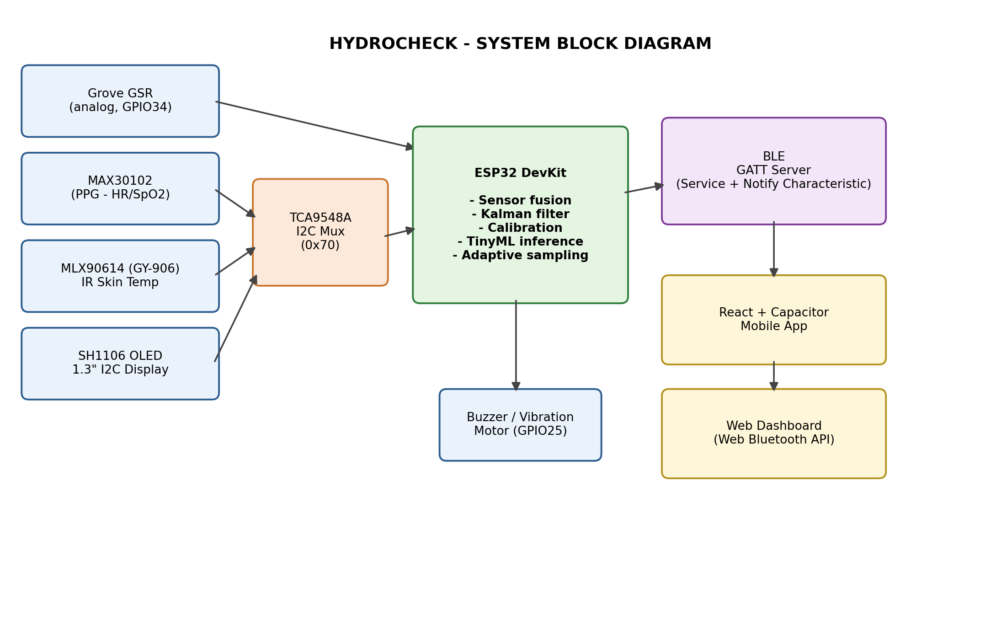
Figure 2.1 — Hydrocheck system block diagram

2.1 Data Flow Summary
- Sensors (GSR, PPG, IR temperature) are sampled by the ESP32, either directly (GSR, analog) or via the TCA9548A I2C multiplexer (PPG, temperature, OLED).
- Raw readings are filtered (Kalman filter on GSR), normalised, and pushed into a 10-sample rolling window (~60 seconds of history).
- 34 statistical "DSDT" features are computed from that window and passed through an on-device neural network to classify risk.
- Results drive local alerts (OLED display, buzzer/vibration) and are simultaneously broadcast over BLE as a JSON payload.
- The mobile app (Capacitor/React) and the supplementary web dashboard (Web Bluetooth) both subscribe to the same BLE characteristic and render the same telemetry stream.

3. Hardware & Circuit Connections

3.1 Bill of Materials
Component | Function
ESP32 DevKit v1 / NodeMCU-32S | Main microcontroller — sensor fusion, filtering, on-device ML inference, BLE server.
Grove GSR Sensor | Galvanic skin response (sweat-conductance) sensing, analog output.
MAX30102 | Photoplethysmographic (PPG) sensor — heart rate and blood-oxygen sensing.
MLX90614 (GY-906) | Non-contact infrared sensor — skin surface and ambient temperature.
TCA9548A | 8-channel I2C multiplexer — isolates address-conflicting I2C devices.
SH1106 1.3" OLED (128×64, I2C) | On-device status display.
Buzzer / vibration motor | Local haptic/audible risk alert.

3.2 Pin Mapping
Signal | ESP32 Pin
I2C SDA (shared bus) | GPIO 21
I2C SCL (shared bus) | GPIO 22
Grove GSR signal (direct analog, NOT on mux) | GPIO 34 (ADC1, input-only)
Buzzer / vibration motor | GPIO 25
TCA9548A I2C address | 0x70

3.3 I2C Multiplexer Channel Assignment
TCA9548A Channel | Connected Device
Channel 0 | MAX30102 (PPG / heart rate) — I2C address 0x57
Channel 1 | MLX90614 / GY-906 (IR temperature) — I2C address 0x5A
Channel 2 | SH1106 OLED display — I2C address 0x3C
All devices share 3.3V/5V power rails and a common ground. The GSR sensor bypasses the multiplexer entirely since it is a plain analog device, not I2C.

4. Firmware Methodology
The firmware exists in two variants: a rule-based scoring version (hydrocheck.ino) using hand-tuned formulas, and a TinyML-integrated version (hydrocheck_ml.ino) that replaces the rule-based risk formula with a trained neural network's output probability. Both share the same sensor acquisition, filtering, and calibration pipeline described below.
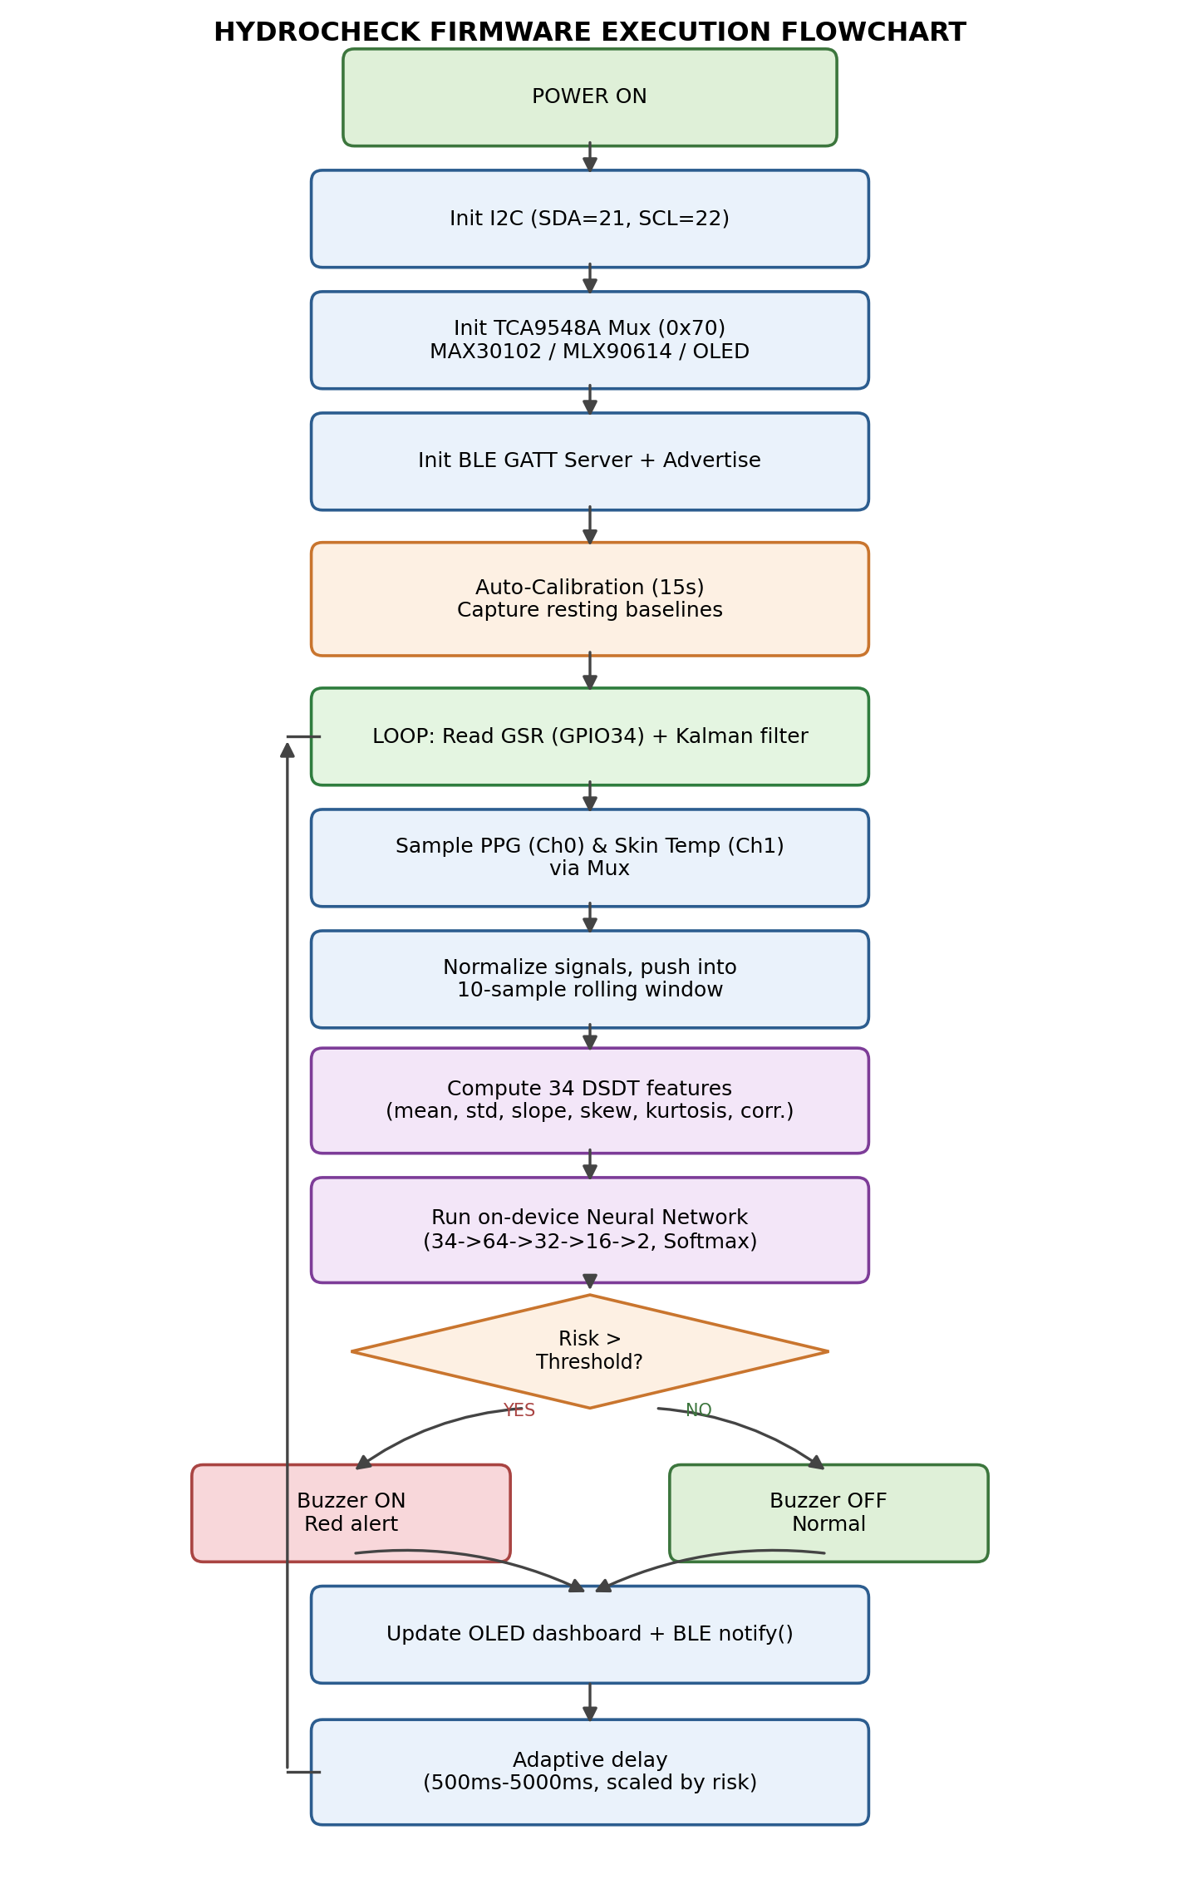
Figure 4.1 — Firmware execution flowchart

4.1 Boot Sequence
- Initialise I2C bus (SDA=21, SCL=22) and the TCA9548A multiplexer.
- Initialise MAX30102, MLX90614, and SH1106 OLED, each behind its assigned mux channel.
- Initialise BLE: create GATT service/characteristic, start advertising.
- Automatically run a 15-second calibration routine — no physical button required — to record the wearer's resting baseline GSR, heart rate, skin temperature, and beat-interval variability.

4.2 Signal Processing

GSR — Kalman Filter + Rolling Rate of Change
Raw GSR (0–4095, 12-bit ADC) is smoothed with a 1D Kalman filter, then pushed into a 10-sample rolling window. Rate of change — not absolute conductance — is what drives risk scoring, since it exposes the inflection point that precedes clinically observable dehydration.

Heart Rate & HRV (MAX30102)
Beat detection runs as a fast ~100 Hz burst-sampling loop (required because checkForBeat() needs a continuous waveform, not isolated samples). Only bursts with sustained strong IR contact (>50,000, ≥70% of the burst) are trusted; beats are averaged per burst and smoothed across cycles, with automatic invalidation if skin contact is lost for multiple consecutive cycles. HRV is derived as the standard deviation of recent beat-to-beat intervals.

Skin Temperature (MLX90614)
Non-contact IR object temperature is read each cycle and compared against the calibrated resting baseline.

Bidirectional Heat-Strain Accumulator
Strain climbs non-linearly while the wearer is active or hot, and is credited back during detected rest — modelling genuine physiological recovery rather than a one-directional counter.

4.3 Adaptive Sampling
The sampling/BLE update interval scales between 500 ms and 5000 ms in proportion to current risk — faster polling as conditions deteriorate, slower polling (saving battery) when calm.

4.4 On-Device Alerts
- OLED dashboard: live risk %, heart rate, skin temperature, strain score, and connection status, redesigned with icon-based layout and a circular calibration progress indicator.
- Buzzer / vibration motor activates above the high-risk threshold.
- BLE notification pushes the same data as a compact JSON payload to any subscribed client.

5. AI Model & TinyML Pipeline
Rather than relying purely on hand-tuned threshold formulas, Hydrocheck trains a compact neural network on logged physiological sessions and re-implements its forward pass natively in C++ for on-device (TinyML) inference — no external runtime such as TensorFlow Lite Micro is required on the ESP32 itself.

5.1 Data Pipeline
Stage | Script / Output
1. Raw capture | Serial log lines (datas.txt) in the firmware's native "GSR:.. dGSR:.. BPM:.." format.
2. CSV transform | csv-transformer.py → hydrocheck_dataset.csv, with a timestamp column added at 6-second intervals.
3. Preprocessing | preprocessing.py → StandardScaler normalisation (scaler.pkl), label encoding (label_encoder.pkl), 10-sample sliding windows (X.npy / y.npy) representing ~60 seconds of history each.
4. Feature extraction ("DSDT") | dsdt_features.py → 34 statistical descriptors per window (X_features.npy / y_features.npy).
5. Model training | train_model.py → Keras dense network, saved as best_model.keras / final_model.keras.
6. Export | convert_tflite.py → float32 and INT8-quantised .tflite files, plus raw weight/bias C-arrays in model_parameters.h for direct firmware inclusion.

5.2 DSDT Feature Set (34 features)
"DSDT" here refers to the project's own Dynamic Statistics & Time-domain feature set — not to be confused with the ACPI DSDT table used in PC firmware, which is unrelated. Features are computed per 10-sample window across six input signals: GSR, dGSR, BPM, HRV, SkinT, and Strain.
Signal | Features Computed
GSR (9) | Mean, Std Dev, Min, Max, Delta (last−first), Regression Slope, Trapezoidal Area, Skewness, Kurtosis
dGSR (3) | Mean, Std Dev, Max
BPM (5) | Mean, Std Dev, Min, Max, Regression Slope
HRV (5) | Mean, Std Dev, Min, Max, Regression Slope
SkinT (5) | Mean, Std Dev, Min, Max, Regression Slope
Strain (3) | Mean, Std Dev, Max
Cross-correlation (4) | Pearson coefficients: GSR–BPM, GSR–HRV, GSR–SkinT, HRV–BPM

Key Statistical Formulas
Slope (least-squares linear regression):
slope = (N*sum(i*x) - sum(i)*sum(x)) / (N*sum(i^2) - (sum(i))^2)

Trapezoidal integration:
trapz = 0.5*(x[0] + x[N-1]) + sum(x[1..N-2])

Skewness (Fisher-Pearson):
skew = (1/N) * sum(((x_i - mean)/std)^3)

Kurtosis (excess):
kurt = ((1/N) * sum(((x_i - mean)/std)^4)) - 3.0

5.3 Model Architecture
A compact fully-connected network was chosen for feasibility of pure C++ re-implementation on a resource-constrained ESP32:
Input(34)
-> Dense(64, ReLU) -> Dropout(0.3)
-> Dense(32, ReLU) -> Dropout(0.2)
-> Dense(16, ReLU)
-> Dense(2, Softmax) # 0 = Low risk, 1 = Moderate risk
Training used the Adam optimiser (lr=0.001), sparse categorical cross-entropy loss, an 80/20 train/test split (stratified), early stopping on validation loss (patience 20), and checkpointing on best validation accuracy, for up to 150 epochs.

Training Results
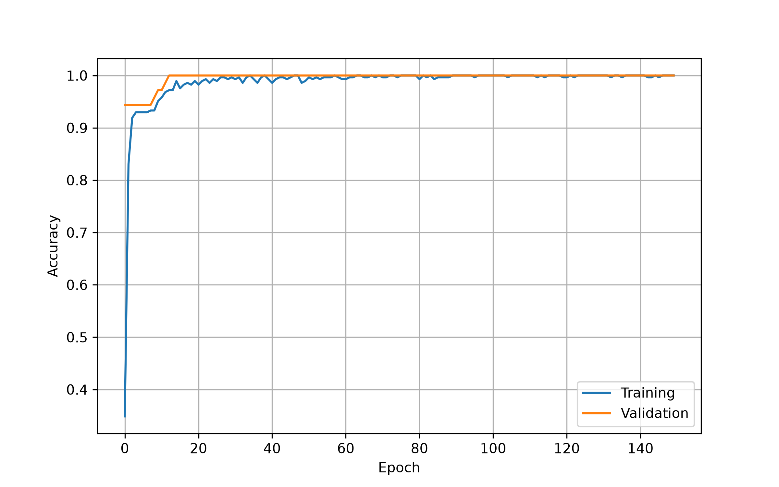
Figure 5.1 — Training vs. validation accuracy across epochs
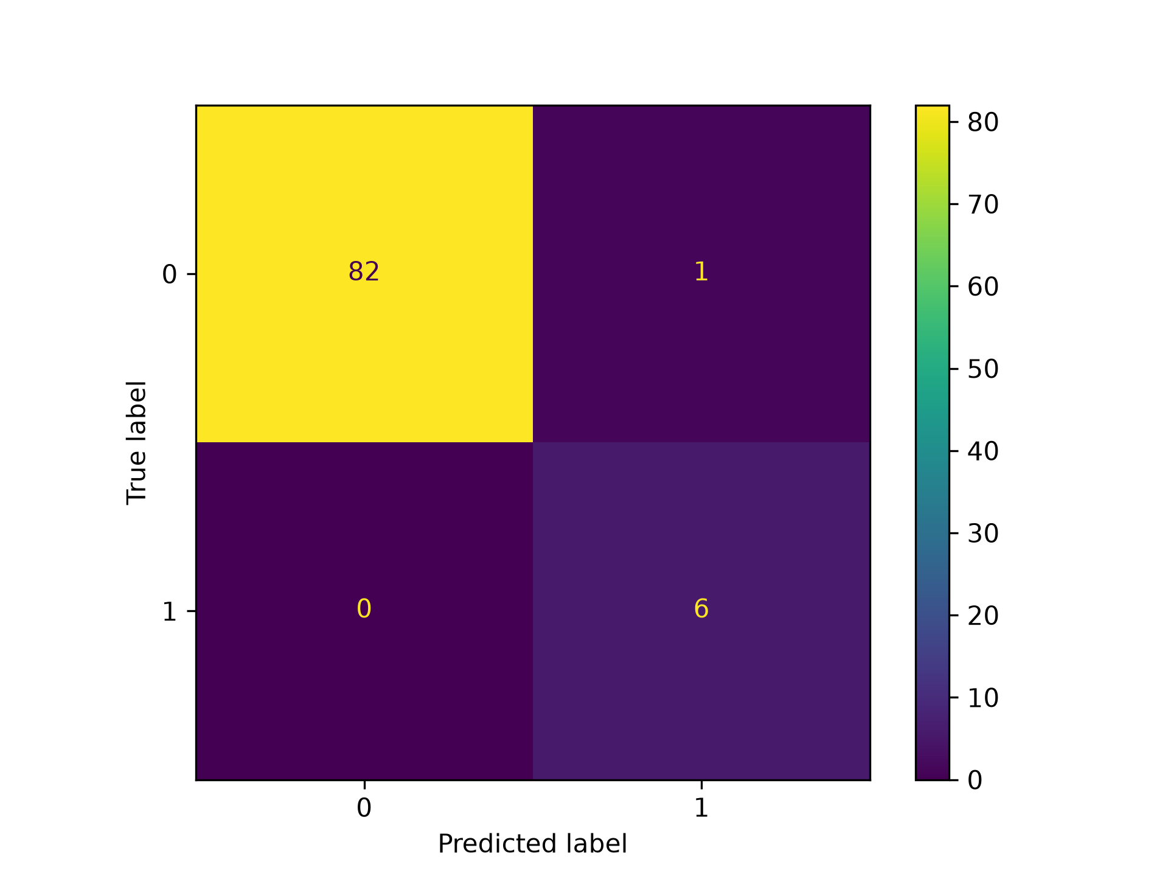
Figure 5.2 — Confusion matrix on the held-out test split

5.4 Dataset Note & Limitation
The current labelled dataset (hydrocheck_dataset.csv) contains only two observed classes — Low risk and Moderate risk — collected during development/debugging sessions. No High-risk / severe dehydration samples are present, since these require genuine field exposure to elevated heat/exertion conditions to record safely. This is an important limitation to disclose: the model has not yet been validated on true high-risk physiological states, and its output should be treated as an early-stage classifier pending a broader, more clinically representative dataset.

5.5 Model Export & On-Device Inference
The trained Keras model is exported two ways: (1) standard and INT8-quantised .tflite files (for reference / potential future use with a TFLite Micro runtime), and (2) raw float weight and bias arrays written directly into model_parameters.h — this second path is what the firmware actually uses, avoiding any TensorFlow Lite Micro runtime dependency on the ESP32.
The inference module (ml_inference.cpp/.h) performs: (a) StandardScaler normalisation using embedded mean/scale constants per signal, (b) rolling-window buffering, (c) the same 34-feature DSDT extraction as the training pipeline, and (d) a manual dense-layer forward pass with ReLU and a numerically-stable Softmax on the output layer.
// Dense Layer 1 forward pass (34 inputs -> 64 outputs, ReLU)
float layer1[64];
for (int c = 0; c < 64; c++) {
float val = biasL1[c];
for (int r = 0; r < 34; r++) {
val += features[r] * weightsL1[r * 64 + c];
}
layer1[c] = val > 0.0f ? val : 0.0f; // ReLU
}
Scaler constants embedded in firmware (order: GSR, dGSR, BPM, HRV, SkinT, Strain):
SCALER_MEAN = {1829.15, 10.85, 76.95, 140.97, 34.82, 6.79}
SCALER_SCALE = { 386.58, 24.22, 8.60, 96.38, 1.31, 11.30}
In the TinyML-integrated firmware (hydrocheck_ml.ino), the model's predicted probability of the "Moderate risk" class directly replaces the rule-based riskIndex formula: riskIndex = probModRisk × 100.

6. Extended Research Results & Model Evaluation
This section presents supplementary exploratory-data-analysis and model-evaluation figures generated from the expanded Hydrocheck telemetry dataset, intended to support the AI/TinyML pipeline described in Section 5 with quantitative and visual evidence suitable for a research paper write-up.

6.1 Exploratory Data Analysis

6.1.1 Physiological Telemetry Over Time
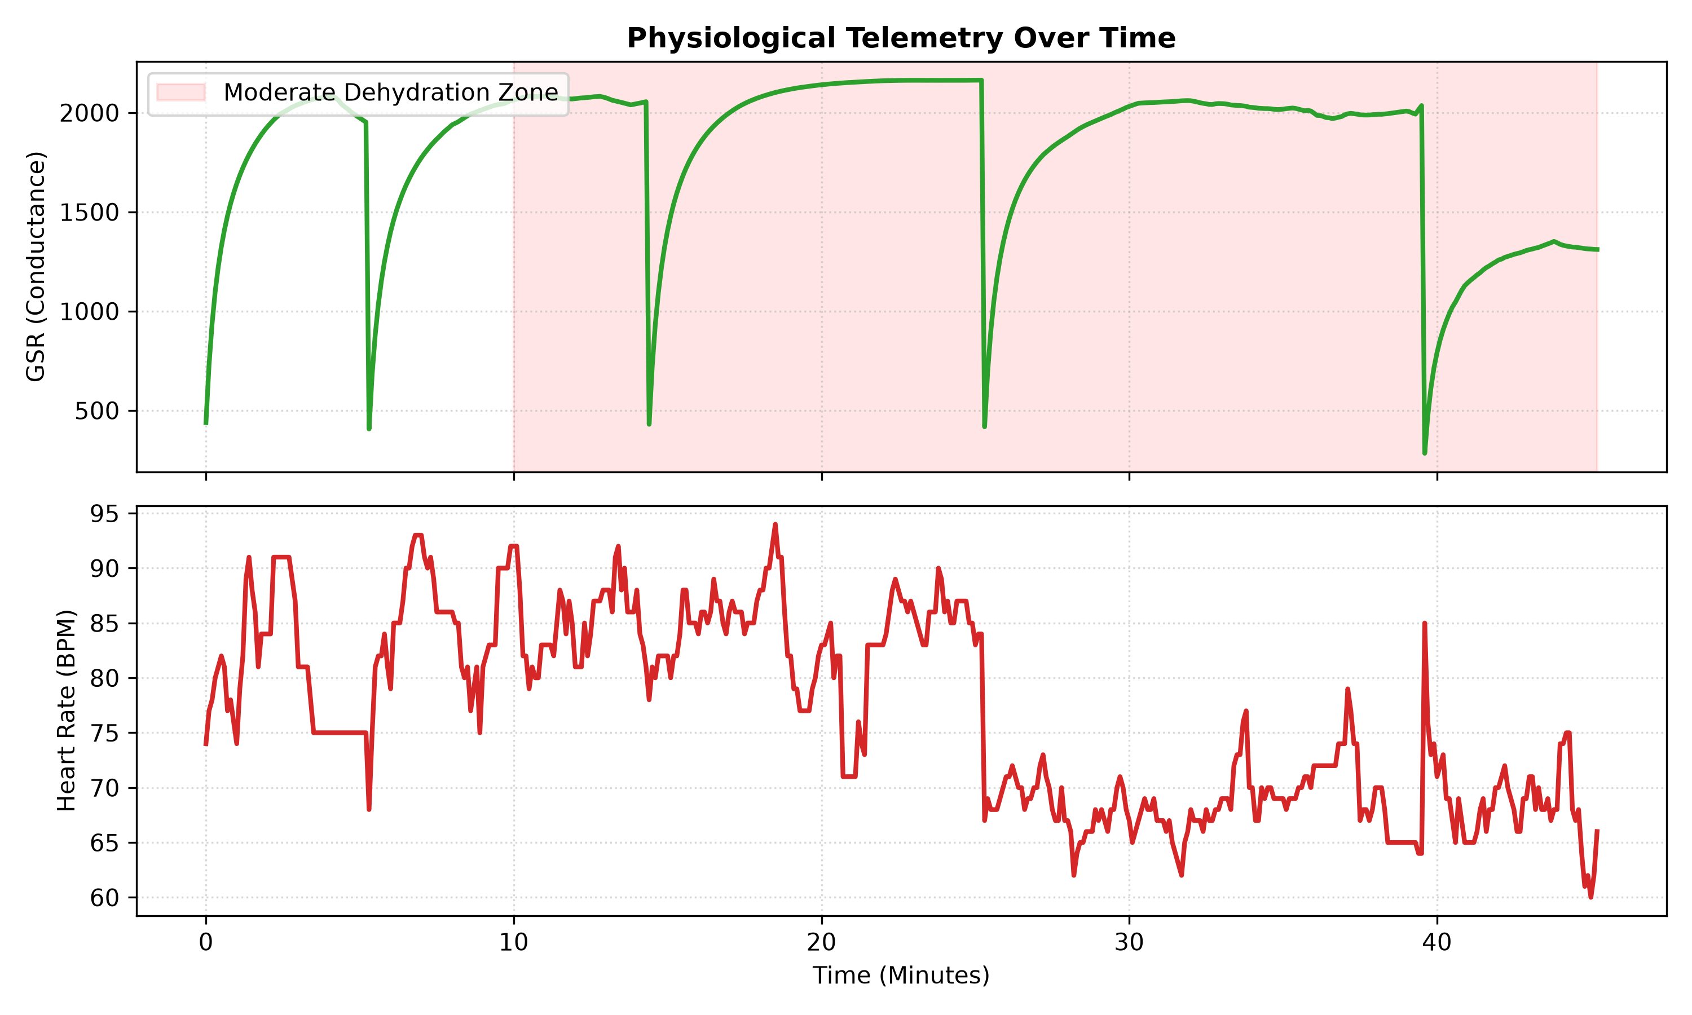
Figure 6.1 — GSR (top) and heart rate (bottom) telemetry across a representative session. The shaded band marks the region classified as the Moderate Dehydration zone; sharp GSR drops correspond to sensor re-contact events between recording segments.
The GSR trace shows the characteristic sawtooth recovery pattern used to derive rate-of-change features: conductance rises steadily while the wearer is at rest and drops sharply on contact disturbance, consistent with the Kalman-filtered rolling-window approach described in Section 4.2. The heart-rate trace beneath it shows a gradual downward drift in resting BPM across the session, which the model's Moderate-risk classification tracks against the shaded band.

6.1.2 t-SNE Visualisation of the Feature Space
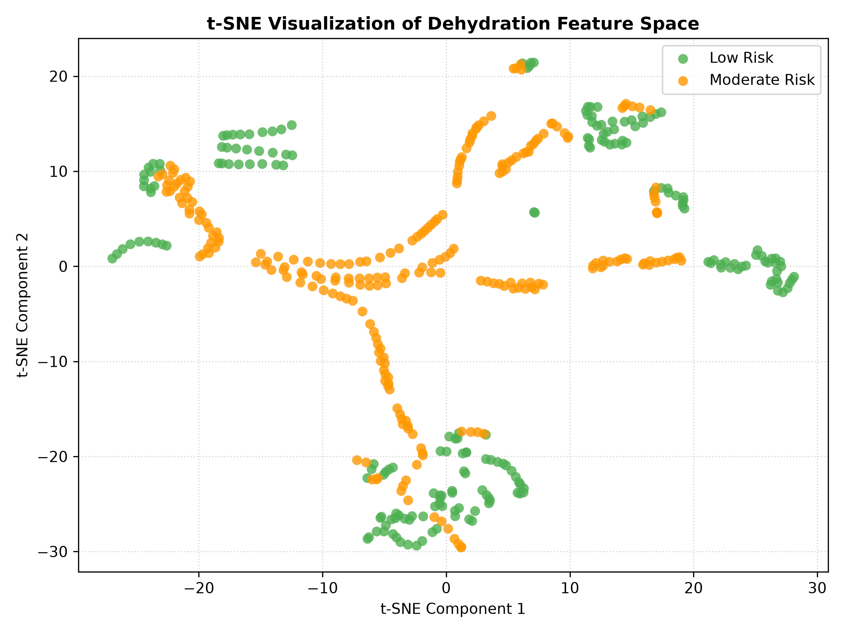
Figure 6.2 — t-SNE projection of the 34-dimensional DSDT feature space, coloured by ground-truth risk label.
Projecting the 34-dimensional DSDT feature vectors into two dimensions via t-SNE shows that Low-risk (green) and Moderate-risk (orange) windows form largely separable local clusters, with most mixing occurring in a small number of transitional streaks — consistent with windows captured during the actual moment of state transition rather than steady-state behaviour. This separability supports the choice of a relatively shallow dense network (Section 5.3) rather than a more complex architecture, since the classes are not deeply entangled in feature space.

6.1.3 GSR Distribution by Hydration Status
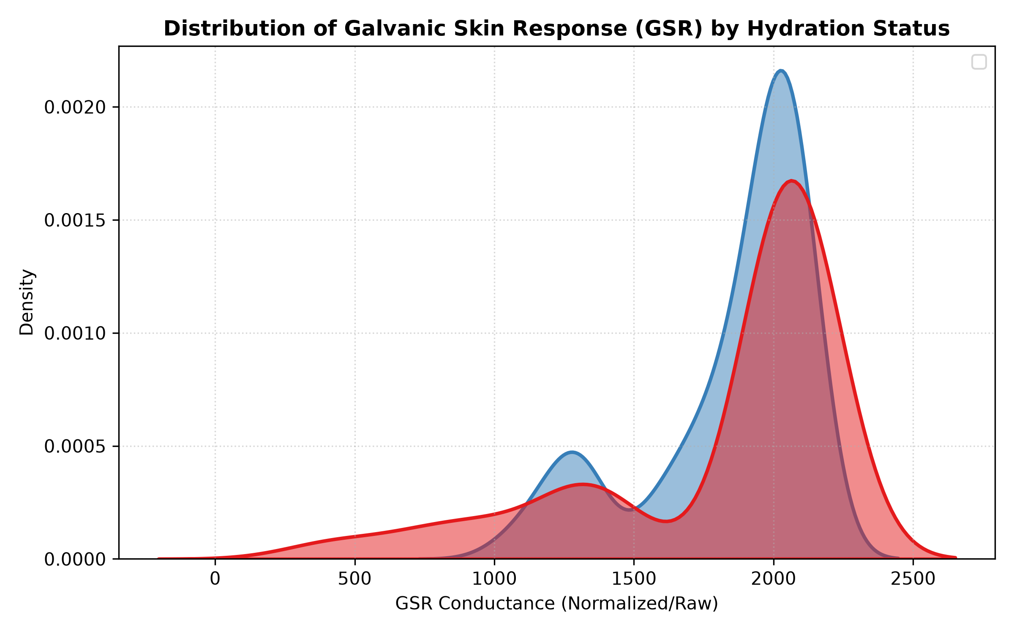
Figure 6.3 — Kernel density estimate of GSR conductance, split by hydration status.
Both distributions share a dominant mode near the upper conductance range (~2000), reflecting the GSR sensor's typical operating band during normal wear. The Moderate-risk distribution (red) shows a visibly heavier lower tail extending toward zero conductance, consistent with the sharp GSR drops associated with contact loss and re-calibration events that co-occur more frequently with the flagged risk windows in this dataset.

6.2 Model Training & Evaluation

6.2.1 Training Curves
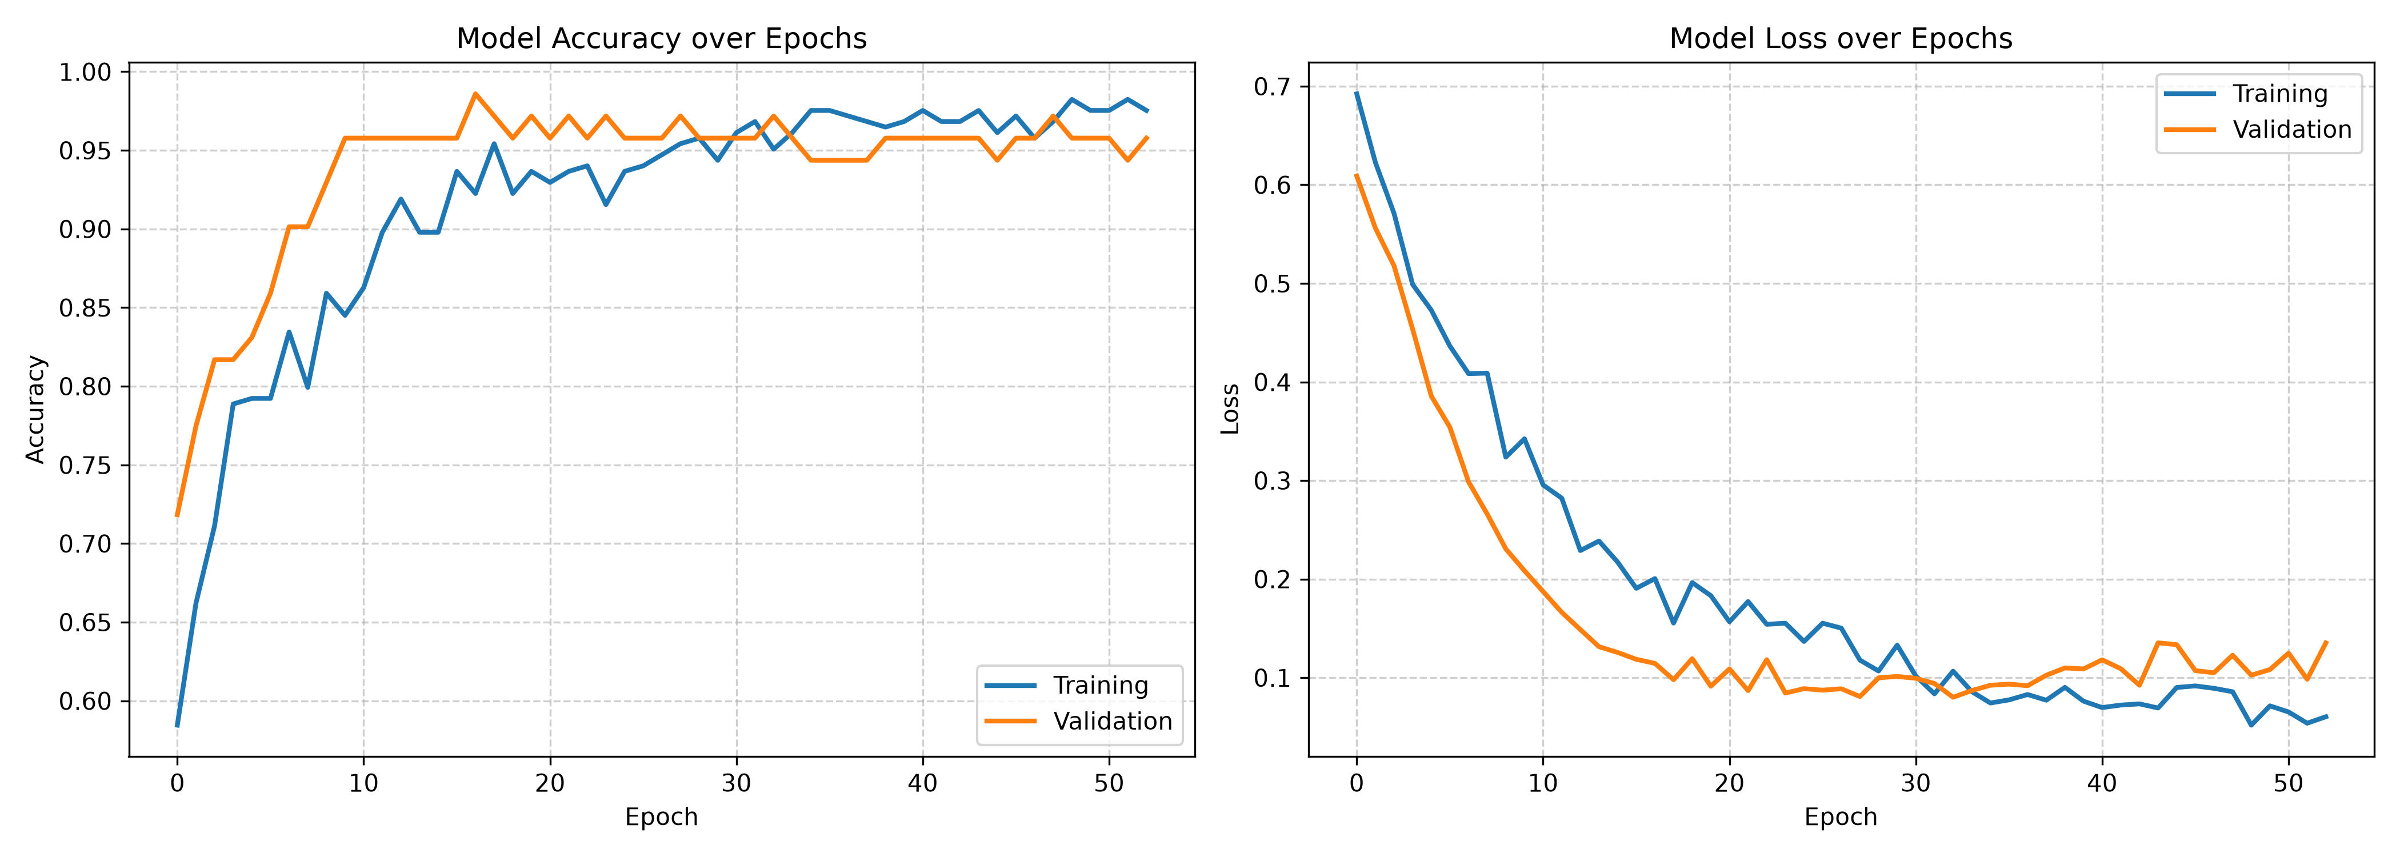
Figure 6.4 — Training vs. validation accuracy (left) and loss (right) across training epochs for the updated model.
Validation accuracy climbs rapidly within the first ~10 epochs and plateaus around 0.95-0.96, closely tracking training accuracy without a widening gap — indicating the Dropout regularisation (Section 5.3) is adequately controlling overfitting despite the network continuing to train for over 50 epochs. Validation loss likewise flattens near 0.10-0.13 after epoch ~20, with the mild late-training divergence between training and validation loss curves being typical for a small dataset and not severe enough to indicate meaningful overfitting.

6.2.2 ROC Curve
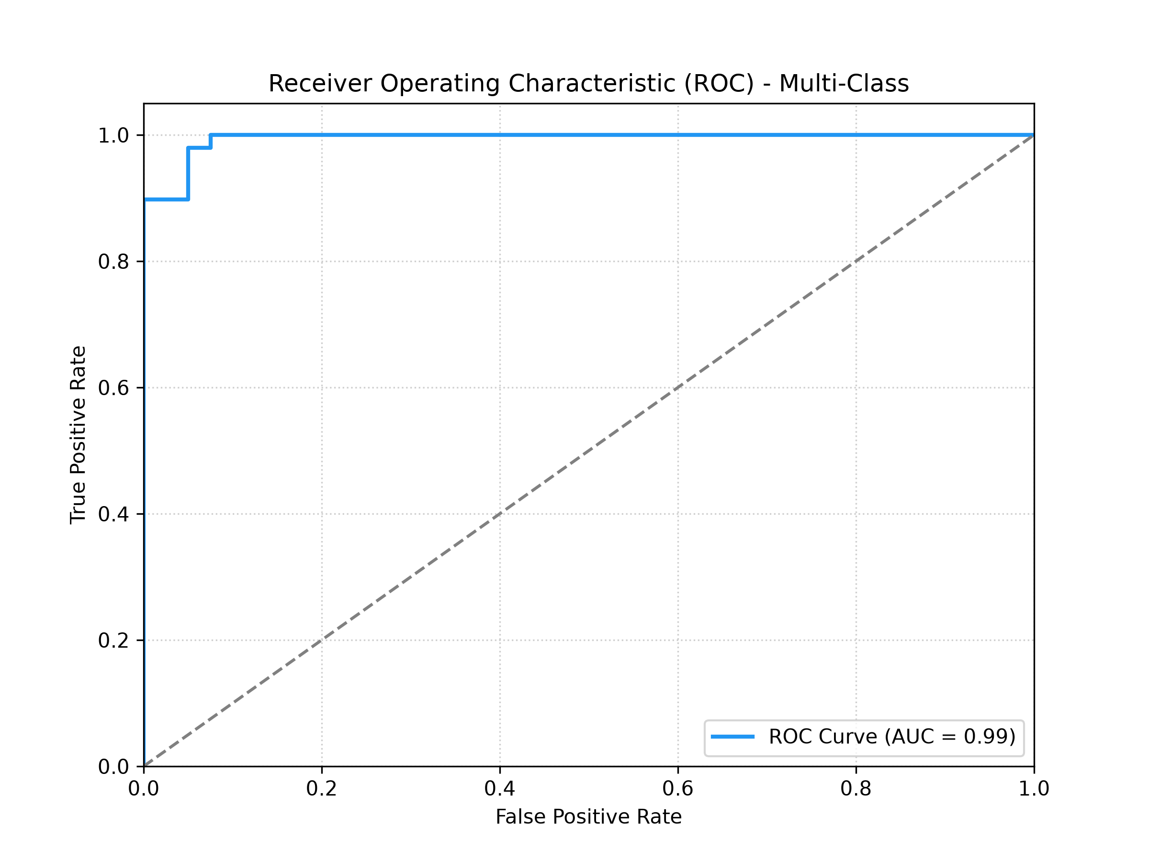
Figure 6.5 — Multi-class ROC curve, AUC = 0.99.
An AUC of 0.99 indicates the classifier separates Low-risk from Moderate-risk windows almost perfectly on the held-out evaluation set. As noted in Section 5.4, this figure should be read in the context of the dataset's current scope — it reflects strong separability between the two currently-labelled classes, not validated performance against true high-risk/severe dehydration states, which are not yet represented in the training data.

6.2.3 Confusion Matrix
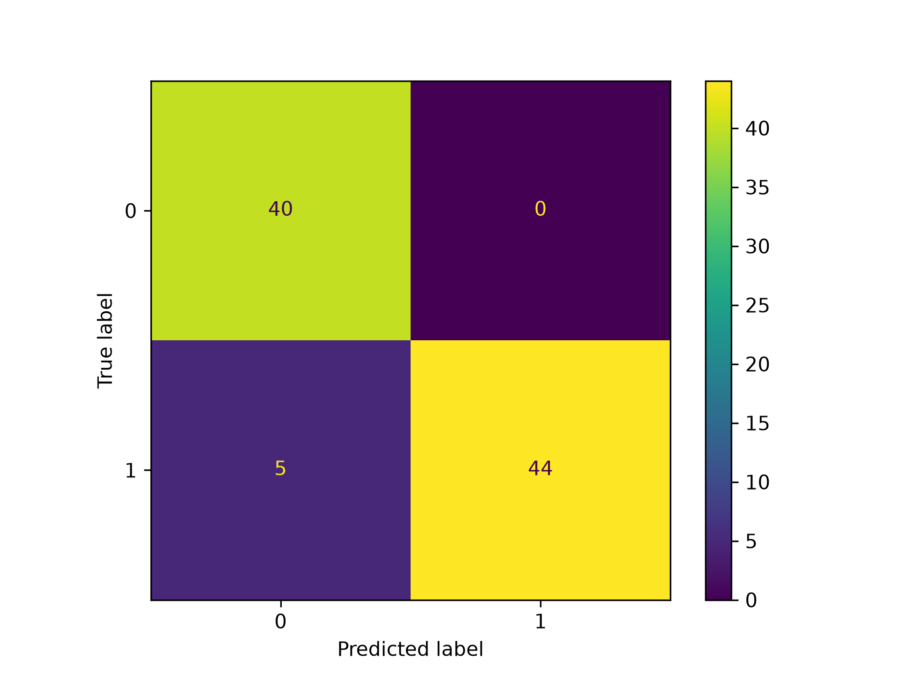
Figure 6.6 — Confusion matrix on the extended evaluation set (0 = Low risk, 1 = Moderate risk).
Of 89 evaluation windows, 84 were classified correctly (40 true-negative Low-risk, 44 true-positive Moderate-risk), with 5 Moderate-risk windows misclassified as Low-risk and zero Low-risk windows misclassified as Moderate-risk. This gives a recall of 89.8% on the Moderate-risk class and 100% specificity on the Low-risk class — the model errs conservatively, which is a reasonable bias for a safety-monitoring context where false negatives are more consequential than false positives, though the current 5-sample miss rate on the positive class would benefit from additional training data before being relied upon operationally.

6.2.4 Feature Correlation Analysis
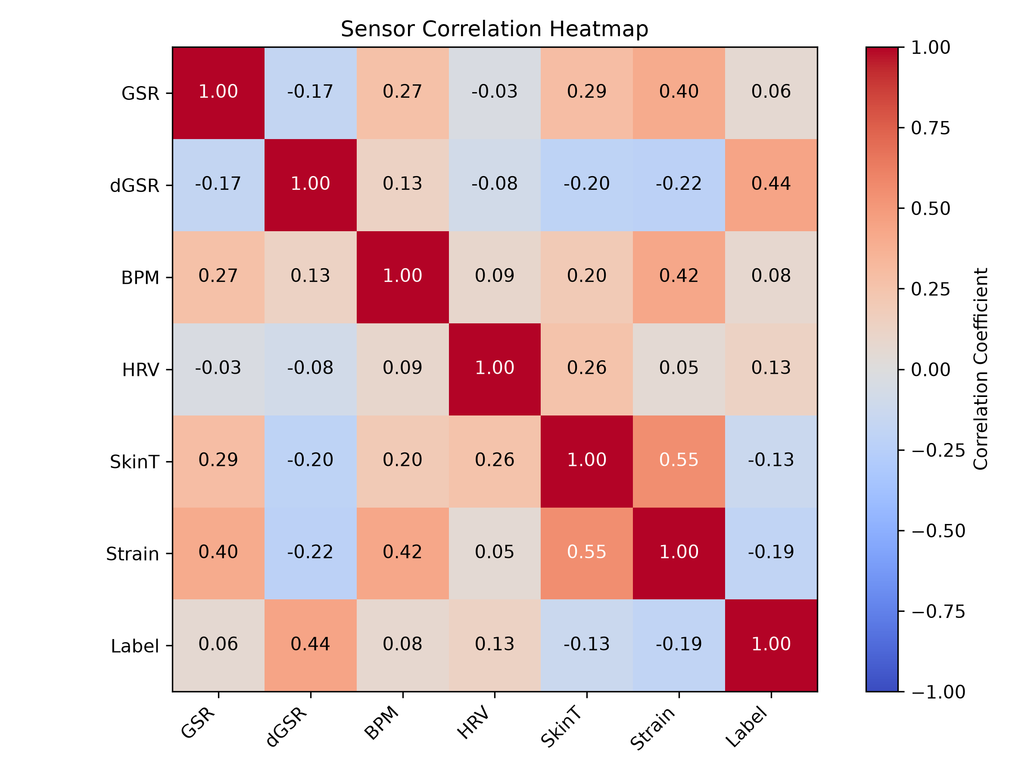
Figure 6.7 — Pearson correlation heatmap across the six base physiological signals and the ground-truth label.
Among the base signals, dGSR shows the strongest correlation with the risk label (r = 0.44), reinforcing the design decision in Section 4.2 to score dehydration risk from the rate of change of GSR rather than its absolute value. SkinT and Strain are strongly inter-correlated (r = 0.55), as expected given Strain is partly derived from temperature deviation, while BPM correlates moderately with both GSR (r = 0.27) and Strain (r = 0.42). HRV shows only weak linear correlation with the label (r = 0.13) in this univariate view — consistent with HRV acting as a leading indicator whose predictive value emerges through its interaction with other signals inside the 34-feature DSDT representation rather than as a standalone linear signal.

7. Bluetooth Low Energy (BLE) Communication
The ESP32 operates as a BLE peripheral (GATT server), broadcasting live telemetry to any subscribed central device — the mobile app or the web dashboard.
Parameter | Value
Device name | Hydrocheck
Service UUID | 0000181A-0000-1000-8000-00805F9B34FB
Characteristic UUID | 00002A6E-0000-1000-8000-00805F9B34FB
Characteristic properties | READ, NOTIFY
Payload format | Compact JSON string, pushed via notify() every sampling cycle
Example payload:
{"risk":41.3,"hr":72,"skin":33.1,"gsr":1988,"strain":4.2}
Advertising explicitly includes the service UUID (addServiceUUID) so that scanners filtering by service — as both client implementations do — can reliably discover the device. Disconnection automatically restarts advertising so the device remains discoverable.

8. Mobile Companion App
Hydrocheck-app is a React + Vite single-page application, compiled into a native Android package using Capacitor (com.hydrocheck.Hydrocheck). It uses the @capacitor-community/bluetooth-le plugin for native BLE access (rather than the browser Web Bluetooth API), enabling deployment as a genuine installable app.

7.1 Technology Stack
Layer | Technology
UI framework | React 19 + Tailwind CSS 4
Build tool | Vite
Native wrapper | Capacitor 8 (Android target configured; iOS achievable with the same codebase)
BLE client | @capacitor-community/bluetooth-le
Charting | Custom canvas-based BPM history chart (no external chart library)

7.2 Application Flow
- On launch, BleClient.initialize() sets up the native Bluetooth stack.
- User taps "Connect device" → BleClient.requestDevice() filters by service UUID (and optionally device name) to locate the Hydrocheck wearable.
- On connection, the app calls startNotifications() on the telemetry characteristic and begins receiving live JSON updates.
- Incoming data updates a risk gauge (SVG ring), four stat cards (heart rate, skin temperature, heat strain, GSR), a live BPM history chart, and a scrolling session log.
- Disconnection is handled gracefully, resetting UI state and allowing reconnection.

7.3 Android Permissions
Because Android requires runtime location/Bluetooth permissions for BLE scanning, the manifest declares:
<uses-permission android:name="android.permission.BLUETOOTH_SCAN" android:usesPermissionFlags="neverForLocation" />
<uses-permission android:name="android.permission.BLUETOOTH_CONNECT" />
<uses-permission android:name="android.permission.ACCESS_FINE_LOCATION" />

9. Supplementary Web Dashboard
In addition to the native mobile app, a browser-based live dashboard was developed using the W3C Web Bluetooth API, providing a zero-install way to view telemetry from any compatible desktop or Android browser. This dashboard is a standalone HTML/CSS/JS artifact and is not currently part of the versioned repository — it uses the same SERVICE_UUID / CHARACTERISTIC_UUID as the mobile app and firmware.

8.1 Capability Summary
- Connect button triggers the browser's native device chooser (navigator.bluetooth.requestDevice).
- Subscribes to the same GATT characteristic via startNotifications(), decoding incoming JSON exactly as the mobile app does.
- Renders a live risk ring, stat cards, and a scrolling session log, styled as a dark technical dashboard.

8.2 Browser Support Limitation
Web Bluetooth is supported only in Chromium-based browsers (Chrome, Edge, Opera) on desktop and Android, requires HTTPS (or localhost for development), and is not supported at all on Safari or iOS — a constraint worth accounting for if the deployment target includes iPhone users, in which case the native Capacitor app remains the correct primary client.

10. MicroPython Migration Strategy (Alternative Implementation)
The production firmware is written in C++/Arduino for performance and library maturity. However, the same architecture can be ported to MicroPython for rapid prototyping or educational use. This section outlines the equivalent MicroPython approach; it is a reference design, not shipped in the current firmware.

9.1 Multiplexer & Sensor Access
from machine import I2C, Pin
import time, math

i2c = I2C(0, sda=Pin(21), scl=Pin(22), freq=400000)

def select_tca_channel(channel):
if channel < 0 or channel > 7:
return
i2c.writeto(0x70, bytes([1 << channel]))

# select_tca_channel(0) # -> then read MAX30102 registers over i2c

9.2 BLE GATT Server Advertising
import bluetooth

ble = bluetooth.BLE()
ble.active(True)

# Register a GATT service (Environmental Sensing, UUID 0x181A)
# Add characteristic 0x2A6E with NOTIFY + READ flags.
# Broadcast the telemetry payload as a UTF-8 encoded JSON string,
# matching the same schema used by the C++ firmware.

9.3 Running the Neural Network Forward Pass in Python
Weights exported from Keras (as JSON or flat arrays) can be loaded into nested Python lists and evaluated with a straightforward manual forward pass — functionally identical to the C++ implementation used in production:
def relu(x):
return [max(0.0, val) for val in x]

def dense(inputs, weights, biases):
outputs = []
for col in range(len(biases)):
val = biases[col]
for row in range(len(inputs)):
val += inputs[row] * weights[row][col]
outputs.append(val)
return outputs
Note: MicroPython's interpreted execution is substantially slower than the compiled C++ path, so a MicroPython port would likely need a coarser sampling interval or a smaller network to sustain real-time operation on an ESP32.

11. Limitations & Future Work

10.1 Known Limitations
- Training dataset currently contains only Low-risk and Moderate-risk labelled sessions; no true high-risk/severe dehydration data has been collected.
- PPG (MAX30102) signal quality is markedly weaker at the wrist than at the fingertip, requiring burst sampling, contact-quality gating, and cross-cycle smoothing to obtain a stable heart rate.
- GSR readings vary meaningfully with individual skin type (dry vs. moist skin), which the personalised calibration approach mitigates but does not fully eliminate as a source of cross-user variance.
- The heat-strain accumulator cannot currently distinguish genuine heat/exertion-driven HR elevation from other causes (e.g. voluntary rapid breathing, anxiety) without an accelerometer or activity classifier.
- Web Bluetooth dashboard is unsupported on iOS/Safari; the native Capacitor app is required for full cross-platform coverage.
- The ambient temperature/humidity sensor referenced in the original concept (for environmental context) is not yet integrated into the current hardware build.

10.2 Suggested Future Work
- Collect a larger, more clinically representative dataset spanning genuine high-risk conditions under supervised/safe protocols.
- Add an accelerometer/IMU to separate physical exertion from other causes of elevated heart rate.
- Integrate ambient temperature/humidity sensing for full environmental-context risk modelling as originally specified.
- Extend session history/logging server-side (cloud sync) for supervisor-level multi-worker monitoring, beyond the current single-device BLE link.
- Formal enclosure fabrication in flexible TPU via FDM printing, as specified in the original concept, for sweat-resistant, comfortable extended wear.

Appendix A — Quick Reference

A.1 Firmware Variants
File | Description
hydrocheck.ino | Rule-based version — hand-tuned formulas for GSR rate-of-change, HRV deviation, and heat strain scoring.
hydrocheck_ml.ino | TinyML-integrated version — on-device neural network replaces the rule-based risk formula.
ml_inference.cpp / .h | Dependency-free native C++ implementation of the trained model's forward pass.
model_parameters.h | Exported float weight/bias arrays from the trained Keras model.

A.2 Setup Commands
AI model pipeline (re-training):
cd AI-Model
pip install numpy scipy pandas scikit-learn tensorflow matplotlib joblib
python csv-transformer.py
python preprocessing.py
python dsdt_features.py
python train_model.py
python convert_tflite.py
Mobile app:
cd Hydrocheck-app
npm install
npm run dev # local web preview
npm run build # production build
npx cap sync android # sync into native Android project

A.3 Document Notes
This document was compiled from the project repository (README files, documentation.txt, and full source) together with a supplementary web dashboard built during development. All circuit connections, code excerpts, and figures reflect the actual repository contents at the time of writing; the training accuracy and confusion-matrix figures are the project's own generated output, not illustrative placeholders.

