**Practical No. 13 :** Latin Square Design (LSD)

The effects of five different ingredients (A, B, C, D, E) on the reaction time of a chemical process is being studied. Each batch of new material is only large enough to permit five runs to be made. Furthermore, each run requires approximately 1.5 hours, so only five runs can be made in one day. The experimenter decides to run the experiment as 5X5 LSD so that day and batch effects may be systematically controlled. Data is as follows:

|  |  |  |  |  |  |
| --- | --- | --- | --- | --- | --- |
| **Batch** | **Day** | | | | |
| 1 | 2 | 3 | 4 | 5 |
| 1 | A = 8 | B = 7 | D = 1 | C = 7 | E = 3 |
| 2 | C = 11 | E = 2 | A = 7 | D = 3 | B = 8 |
| 3 | B = 4 | A = 9 | C = 10 | E = 1 | D = 5 |
| 4 | D = 6 | C = 8 | E = 6 | B = 6 | A = 10 |
| 5 | E = 4 | D = 2 | B = 3 | A = 8 | C = 8 |

Enter this data in Minitab and generate the following report:

**Question :**

Analyze the data from this experiment and draw conclusions.

**Solution :**

**Step 1 :** Type your data into the data pane of a worksheet. Make sure you put your data into columns. Use column headers for “Reaction Time”, “Ingredients”, “Batch and “Day”. Type the “Reaction Time” data into column C1, “Ingredients” data into column C2-T, “Batch” data into column C3 and “Day” data into column C4.

**Step 2 :** To perform latin square design (LSD), under the drop-down menu “Stat”, choose “ANOVA” then “General Linear Model” then “Fit General Linear Model…”. A “General Linear Model” dialogue box will appear. Set the “Response:” as “C1 Reaction Time” and “Factors:” as “C2 Ingredients”, “C3 Batch” and “C4 Day” from the table on the left.

**Step 3 :** Click on the “Graphs…” option. A “General Linear Model: Graphs” dialogue box will appear. Set the “Residual for plots:” as “Regular”. Under “Residual plots”, check the “Four in one” radio box. Click “OK”. Click “OK” again.

**Step 4 :** Under the drop-down menu “Stat”, choose “ANOVA” then “General Linear Model” then “Comparisons…”. A “Comparisons” dialogue box will appear. Set the “Response:” as “Reaction Time”, “Type of Comparison:” as “Pairwise”. Under “Method”, check the “Tukey” checkbox. Under “Choose terms for comparisons:” check the “Ingredients”, ”Batch” and “Day” checkboxes. Click “OK”. Click “OK” again.

**Step 5 :** To create a line plot, under the drop-down menu “Graph”, choose “Graph Builder…”. A “Graph Builder” dialogue box will appear. Choose the “Line Plot” option. Set the “Summarized variables” as “C1 Reaction Time” and “Categorical variable” as “C2 Ingredients” from the table on the left. Click on “Create”.

**Method :**

|  |  |
| --- | --- |
| Factor coding | (-1, 0, +1) |

**Factor Information :**

|  |  |  |  |
| --- | --- | --- | --- |
| **Factor** | **Type** | **Levels** | **Values** |
| Ingredients | Fixed | 5 | A, B, C, D, E |
| Batch | Fixed | 5 | 1, 2, 3, 4, 5 |
| Day | Fixed | 5 | 1, 2, 3, 4, 5 |

**Test of significance of factor level :**

**Analysis of Variance :**

|  |  |  |  |  |  |
| --- | --- | --- | --- | --- | --- |
| **Source** | **DF** | **Adj SS** | **Adj MS** | **F-Value** | **P-Value** |
| Ingredients | 4 | 141.44 | 35.360 | 11.31 | 0.000 |
| Batch | 4 | 15.44 | 3.860 | 1.23 | 0.348 |
| Day | 4 | 12.24 | 3.060 | 0.98 | 0.455 |
| Error | 12 | 37.52 | 3.127 |  |  |
| Total | 24 | 206.64 |  |  |  |

**Conclusion :**

1. Since p-value (0.000) of ingredients is lower than significance probability (0.05), we reject the null hypothesis that mean reaction times is same for all ingredients. Hence, ingredients is a significant factor for the reaction time.
2. Since the p-value (0.348) of batch is greater than significance probability (0.05), we accept the null hypothesis that mean reaction time is same for all levels of batches. Hence, batches of raw material is not significant factor for reaction time.
3. Since p-value (0.455) of day of reaction is greater than significance probability (0.05), we accept the null hypothesis that mean reaction times is the same for all days on which experiment was done. Hence, day is not a significant factor for reaction time.

**Model Summary :**

|  |  |  |  |
| --- | --- | --- | --- |
| **S** | **R-sq** | **R-sq(adj)** | **R-sq(pred)** |
| 1.76824 | 81.84% | 63.69% | 21.19% |

**Interpretation :**

1. The coefficient of determination is 63.69 %, which means that the reliability of linear model of LSD is only about 64 %.
2. The standard error of estimate is 1.76824 which is quite small, indicating high reliability of fitted linear model.

**Coefficients :**

|  |  |  |  |  |  |
| --- | --- | --- | --- | --- | --- |
| **Term** | **Coef** | **SE Coef** | **T-Value** | **P-Value** | **VIF** |
| Constant | 5.880 | 0.354 | 16.63 | 0.000 |  |
| Ingredients |  |  |  |  |  |
| A | 2.520 | 0.707 | 3.56 | 0.004 | 1.60 |
| B | -0.280 | 0.707 | -0.40 | 0.699 | 1.60 |
| C | 2.920 | 0.707 | 4.13 | 0.001 | 1.60 |
| D | -2.480 | 0.707 | -3.51 | 0.004 | 1.60 |
| Batch |  |  |  |  |  |
| 1 | -0.680 | 0.707 | -0.96 | 0.355 | 1.60 |
| 2 | 0.320 | 0.707 | 0.45 | 0.659 | 1.60 |
| 3 | -0.080 | 0.707 | -0.11 | 0.912 | 1.60 |
| 4 | 1.320 | 0.707 | 1.87 | 0.087 | 1.60 |
| Day |  |  |  |  |  |
| 1 | 0.720 | 0.707 | 1.02 | 0.329 | 1.60 |
| 2 | -0.280 | 0.707 | -0.40 | 0.699 | 1.60 |
| 3 | -0.480 | 0.707 | -0.68 | 0.510 | 1.60 |
| 4 | -0.880 | 0.707 | -1.24 | 0.237 | 1.60 |

**Regression Equation :**

Reaction Time = 5.880 + 2.520 Ingredients_A – 0.280 Ingredients_B + 2.920 Ingredients_C – 2.480 Ingredients_D – 2.680 Ingredients_E – 0.680 Batch_1 + 0.320 Batch_2 – 0.080 Batch_3 + 1.320 Batch_4 – 0.880 Batch_5 + 0.720 Day_1 – 0.280 Day_2 – 0.480 Day_3 -0.880 Day_4 + 0.920 Day_5

**Interpretation :**

This is the fitted regression model of LSD.

**Residual Analysis :**

Fig 1 : Residual Analysis

1. **Normality check of error distribution**: The histogram and normal probability plot shows that the error distribution is not normal i.e., it is right skewed. It may be due to the small sample size.
2. **Equal variance check**: The second graph shows that the homogeneity of variance is maintained as dots in the graph do not exhibit any patten below and above the reference line e = 0.
3. **Linear relationship check**: The second graph also shows that the distribution of dots about the reference line e = 0 (below and above the line) has no obvious pattern (pattern is random), indicating linear model is valid for LSD.
4. **Independence of error check**: The fourth graph (graph of error vs observation order) shows that error distribution is in random pattern, indicating independence of errors. However, errors show some patterns in the first few observations and random afterwards.

**Grouping Information Using the Tukey Method and 95% Confidence :**

**Tukey Pairwise Comparisons: Ingredients :**

|  |  |  |  |  |
| --- | --- | --- | --- | --- |
| **Ingredients** | **N** | **Mean** | **Grouping** | |
| C | 5 | 8.8 | A |  |
| A | 5 | 8.4 | A |  |
| B | 5 | 5.6 | A | B |
| D | 5 | 3.4 |  | B |
| E | 5 | 3.2 |  | B |

*Means that do not share a letter are significantly different.*

**Tukey Pairwise Comparisons: Batch**

|  |  |  |  |
| --- | --- | --- | --- |
| **Batch** | **N** | **Mean** | **Grouping** |
| 4 | 5 | 7.2 | A |
| 2 | 5 | 6.2 | A |
| 3 | 5 | 5.8 | A |
| 1 | 5 | 5.2 | A |
| 5 | 5 | 5.0 | A |

*Means that do not share a letter are significantly different.*

**Tukey Pairwise Comparisons: Day**

|  |  |  |  |
| --- | --- | --- | --- |
| **Day** | **N** | **Mean** | **Grouping** |
| 5 | 5 | 6.8 | A |
| 1 | 5 | 6.6 | A |
| 2 | 5 | 5.6 | A |
| 3 | 5 | 5.4 | A |
| 4 | 5 | 5.0 | A |

*Means that do not share a letter are significantly different.*

**Interpretation :**

The pairwise comparisons of ingredients factor shows that treatment levels A and C have the same effects and are grouped into the first group. The ingredients (A, C) in group 1 produces the highest average reaction time for the chemical process. We can choose between ingredients A or C for the experiment. Group 2 comprising of ingredient B which has intermediate effect. The third group comprising of ingredients D and E, has an inferior effect on the reaction time because they have lowest average reaction time.

**Mean plot :**

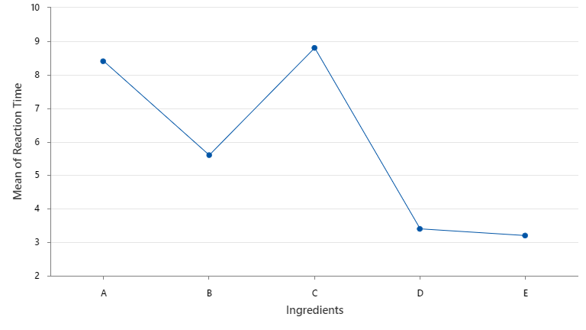

Fig 2 : Mean plot of Reaction Time vs Ingredients

**Worksheet :**

