**Practical No. 3 :** Paired t test

Suppose a sample of 20 students were given a diagnostic test before studying a particular module and then again after completing the module.

|  |  |  |
| --- | --- | --- |
| Student | Pre-module score | Post-module score |
| 1 | 18 | 22 |
| 2 | 21 | 25 |
| 3 | 16 | 17 |
| 4 | 22 | 24 |
| 5 | 19 | 16 |
| 6 | 24 | 29 |
| 7 | 17 | 20 |
| 8 | 21 | 23 |
| 9 | 23 | 19 |
| 10 | 18 | 20 |
| 11 | 14 | 15 |
| 12 | 16 | 15 |
| 13 | 16 | 18 |
| 14 | 19 | 26 |
| 15 | 18 | 18 |
| 16 | 20 | 24 |
| 17 | 12 | 18 |
| 18 | 22 | 25 |
| 19 | 15 | 19 |
| 20 | 17 | 16 |

**Enter this data in Minitab and generate the following report:**

**Question :**

We want to find out if, in general, our teaching leads to improvements in students’ knowledge/skills (i.e. test scores).

**Solution :**

**Step 1 :** Type your data into the data pane of a worksheet. Make sure you put your data into columns. Use column header for “Pre-module scores” and “Post-module scores”. Type the “Pre-module scores” data into column C1 and “Post-module scores” data into column C2.

**Step 2 :** To perform paired t test for mean, under the drop-down menu “Stat”, choose “Basic Statistics” then “Paired t…”. A “Paired t for the Mean” dialogue box will appear.

**Step 3 :** Under the drop-down menu, choose “Each sample is in its own column”. Set “Sample 1” as “Pre-module Score” and “Sample 2” as “Pre-module Score”.

**Step 4 :** Click the “Options…” option. A “Paired t: Options” dialogue box will appear. Set the “Confidence level” as 95.0, “Hypothesized difference” as 0 and “Alternative hypothesis” drop-down menu as “Difference < hypothesized difference”.

**Step 5 :** Click the “Graphs…” option. A “Paired t: Graphs” dialogue box will appear. Check the “Histogram of differences“ and “Boxplot of differences” checkboxes and click “OK”. Click “OK” again. The following histogram and box plot will be generated.

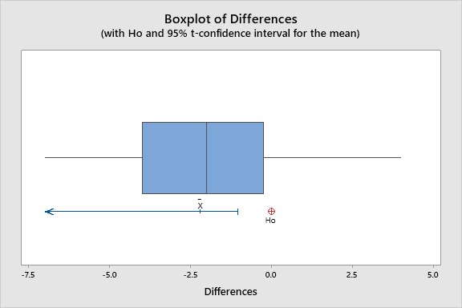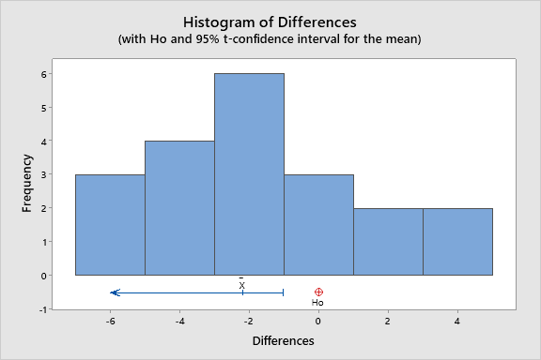

Fig 1 : Histogram of differences

**Fig 2 : Boxplot of differences**

io

**Interpretation :**

1. The post module mean score (20.6) is higher than pre module mean score (18.4), which needs to be confirmed via statistical test.
2. The post module S.D. of score (4.3) is higher than that of pre module score (3.2).
3. The box plot shows that the distribution of pre module score is almost symmetrical while the distribution of post module score is right skewed ,meaning there are more low scores than high scores.
4. The histogram shows that distribution of difference of two scores is almost symmetrical and meets the main test assumption that the difference of scores is normally distributed.

**Descriptive Statistics :**

|  |  |  |  |  |  |
| --- | --- | --- | --- | --- | --- |
| **Sample** | **N** | **Mean** | **StDev** | **SE Mean** | **95% CI** |
| Pre-module Score | 20 | 18.400 | 3.152 | 0.705 | (16.925, 19.875) |
| Post-module Score | 20 | 20.600 | 4.285 | 0.958 | (18.595, 22.605) |

**Method :**

|  |
| --- |
| μ₁: mean of Sophomores |
| µ₂: mean of Juniors |

|  |
| --- |
| Difference: μ₁ - µ₂ |

*Equal variances are assumed for this analysis.*

**Hypothesis :**

|  |  |
| --- | --- |
| Null hypothesis | H₀ : μ_difference = 0 (Average score of pre-module and post-module are same) |
| Alternative hypothesis | H₁ : μ_difference < 0 (Average score of pre-module is significantly lower than post-module) |

**Estimation for Difference :**

|  |  |  |  |
| --- | --- | --- | --- |
| **Mean** | **StDev** | **SE Mean** | **95% Upper Bound for μ_difference** |
| -2.200 | 3.019 | 0.675 | -1.033 |

*µ_difference: mean of (Pre-module Score - Post-module Score)*

**Test :**

|  |  |
| --- | --- |
| **T-Value** | **P-Value** |
| -3.26 | 0.002 |

**Conclusion :**

Since the p-value of the test (0.002) is very less than significance probability (0.05), we we reject our null hypothesis H0 at 5 % level of significance. It means that the test is highly significant i.e. the average post module score is significantly higher as compared to average pre-module score. Hence, our teaching leads to improvements in students’ knowledge/skills (i.e. test scores).

**Worksheet :**

