**Practical No. 11 :** Completely Random Design

| Noise level | Circuit type |
| --- | --- |
| 19 | 1 |
| 20 | 1 |
| 19 | 1 |
| 30 | 1 |
| 8 | 1 |
| 80 | 2 |
| 61 | 2 |
| 73 | 2 |
| 56 | 2 |
| 80 | 2 |
| 45 | 3 |
| 26 | 3 |
| 25 | 3 |
| 35 | 3 |
| 50 | 3 |
| 95 | 4 |
|  | 4 |
|  | 4 |
|  | 4 |
|  | 4 |

Enter this data in Minitab and generate the following reports:

**Questions :**

1. Fit the multiple regression equation of market price of house on size of the house and age of the house
2. Interpret the meaning of the slopes
3. Compute the coefficient of multiple determination and interpret the meaning of value
4. Determine the adjusted R2 interpret the meaning of value
5. Determine whether there is a significant relationship between market price of house and the two independent variables (size and age) at the 0.05 level of significance.
6. At the 0.05 level of significance, determine whether each independent variable makes a significant contribution to the regression model.
7. Perform residual analysis for checking model assumptions.

**Solution :**

**Step 1 :** Type your data into the data pane of a worksheet. Make sure you put your data into columns. Use column header for “Noise level”, and “Circuit type”. Type the “Noise level” data into column C1 and “Circuit type” data into column C2.

**Step 2 :** To perform completely random design(CRD), under the drop-down menu “STAT, choose “ANOVA” then “One-Way’…”. A “One-Way Analysis of Variance” dialogue box will appear. In the drop-down menu, choose “Response data are in one column for all factor levels”. Set the “Response:” as “C1 Noise level” and “Factor:” as “C2 Circuit type” from the table on the left.

**Step 3 :** Click on the “Options…” option. A “One-Way Analysis of Variance: Options” dialogue box will appear. Check the “Assume equal variances” checkbox. Set the “Confidence level:” as 95 and “Type of confidence interval:” as “Two-sided”. Click “OK”.

**Step 4 :** Click on the “Comparisons…” option. A “One-Way Analysis of Variance: Comparisons” dialogue box will appear. Set the “Error rate for comparisons:” as 5. Under the “Comparison procedures assuming equal variances”, check the “Tukey” checkbox. Under the “Results”, check the “Interval plot for differences of means” and “Grouping information” checkboxes. Click “OK”.

**Step 5 :** Click on the “Storage…” option. A “One-Way Analysis of Variance: Storage” dialogue box will appear. Check the “Fits” and “Residuals” checkboxes. Click “OK”.

**Step 6 :** Click on the “Graphs…” option. A “One-Way Analysis of Variance: Graphs” dialogue box will appear. Under the “Data plots”, check the “Interval plot” checkbox. Under “Residual plots”, check the “Four in one” radio box. Click “OK”.

**Method :**

**Null hypothesis All means are equal**

**Alternative hypothesis Not all means are equal**

**Significance level α = 0.05**

**Equal variances were assumed for the analysis.**

**Factor Information**

**Factor Levels Values**

**Circuit type 4 1, 2, 3, 4**

**Test of significance of factor level**

**Analysis of Variance**

**Source DF Adj SS Adj MS F-Value P-Value**

**Circuit type 3 12102 4033.9 22.18 0.000**

**Error 16 2910 181.9**

**Total 19 15012**

**Interpretation:**

Since p-value (0.000) is less than significance level (0.05), we strongly reject H0 in favour of H1 at 5% level of significance. Hence, there is a significant difference in the mean noise levels of circuit designs.

Model Summary

S R-sq R-sq(adj) R-sq(pred)

13.4870 80.61% 76.98% 69.71%

Interpretation:

The reliability of linear model for CRD is 76.98%. We are 76.98% confident in predicting noise level knowing the circuit type using linear model.

Means

Circuit type N Mean StDev 95% CI

1 5 19.20 7.79 (6.41, 31.99)

2 5 70.00 11.02 (57.21, 82.79)

3 5 36.20 11.17 (23.41, 48.99)

4 5 79.80 20.51 (67.01, 92.59)

Pooled StDev = 13.4870

Interpretation:

The table shows that circuit 1 has the lowest mean noise level (best design) and circuit 4 has highest mean noise level (worst design).

Pairwise Comparison :

Grouping Information Using the Tukey Method and 95% Confidence

Circuit type N Mean Grouping

4 5 79.80 A

2 5 70.00 A

3 5 36.20 B

1 5 19.20 B

Means that do not share a letter are significantly different.

**Interpretation :**

On performing pairwise comparison, we found 2 clusters or groups: Group A includes circuit design 2 and 4 (similar effects) and Group B includes circuit design 1 and 3 (similar effects).

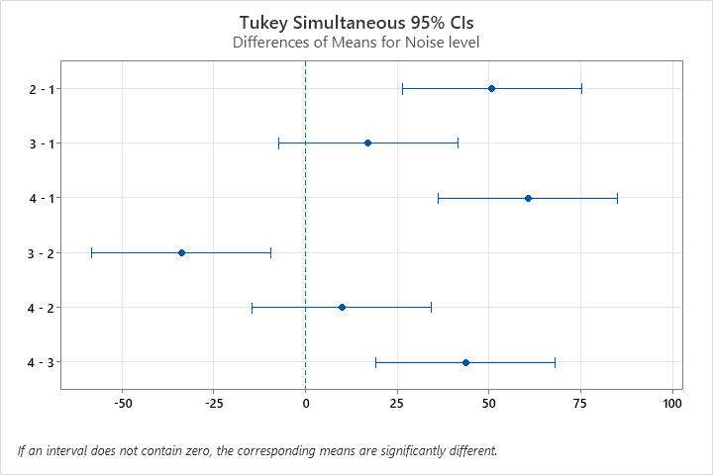

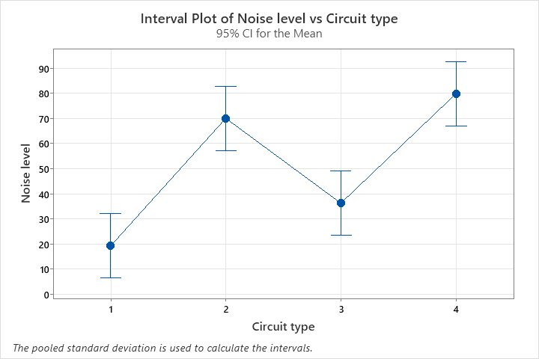





**Residual Analysis :**

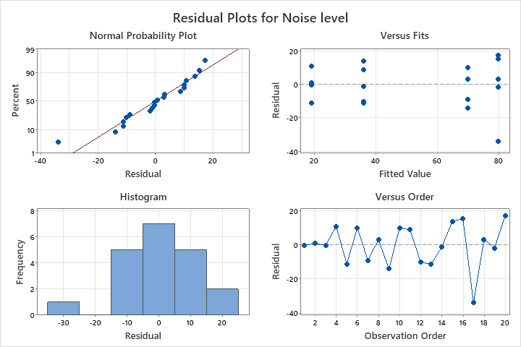



1. **Normality check of error distribution**: The histogram and normal probability plot shows that the error distribution is not satisfactorily normal i.e. it is left skewed. It may be due to the small sample size.
2. **Equal variance check**: The second graph shows that the distribution of dots about reference line e = 0 is almost same or equal, suggesting homoscedasticity. Hence, the assumption of equal variance across different levels of primary factor is satisfactorily met, however there is one potential extreme value in the graph.
3. **Linear relationship check**: The second graph also shows that the distribution of dots about the reference line e = 0 (below and above the line) has no obvious pattern (pattern is random), indicating linear model is valid for CRD.
4. **Independence of error check**: The fourth graph (graph of error vs observation order) shows that error distribution is in random pattern, indicating independence of errors. It means that positive and negative errors are in random order.

**Fits and Diagnostics for Unusual Observations :**

| **Obs** | **Market Price** | **Fit** | **Resid** | **Std Resid** |  |
| --- | --- | --- | --- | --- | --- |
| 8 | 78.00 | 105.70 | -27.70 | -2.40 | R |
| 21 | 129.00 | 105.06 | 23.94 | 2.07 | R |

*R  Large residual*

**Conclusion :**

The observations no. 8 and 21 are unusual observations since their residual are quite high, and they should be considered for removal from the data set, in order to improve the reliability of the fitted equation.

**Worksheet :**

