**Practical No. 2** : Independent sample t test

Independent random samples of 17 sophomores and 13 juniors attending a large university yield the following data on grade point averages .

|  |  |  |  |  |  |
| --- | --- | --- | --- | --- | --- |
| **Sophomores** | | | **Juniors** | | |
| 3.04 | 2.92 | 2.86 | 2.56 | 3.47 | 2.65 |
| 1.71 | 3.60 | 3.49 | 2.77 | 3.26 | 3.00 |
| 3.30 | 2.28 | 3.11 | 2.70 | 3.20 | 3.39 |
| 2.88 | 2.82 | 2.13 | 3.00 | 3.19 | 2.58 |
| 2.11 | 3.03 | 3.27 | 2.98 |  |  |
| 2.60 | 3.13 |  |  |  |  |

**Enter this data in Minitab and generate the following report:**

**Question:**

At the 5% significance level, do the data provide sufficient evidence to conclude that the mean GPAs of sophomores and juniors at the university differ?

**Solution:**

**Step 1 :** Type your data into the data pane of a worksheet. Make sure you put your data into columns. Use column header for sophomores and juniors. Type the sophomores data into column C1 and juniors data into column C2.

**Step 2 :** To perform independent sample t test for mean, under the drop-down menu “STAT”, choose “Basic Statistics” then “2-Sample t…”. A “Two-Sample t for the Mean” dialogue box will appear.

**Step 3 :** Under the drop-down menu, choose “Each sample is in its own column”. Set “Sample 1” as “Sophomores” and “Sample 2” as “Juniors”.

**Step 4 :** Click the “Options…” option. A “Two-Sample t: Options” dialogue box will appear. Set the “Confidence level” as 95.0, “Hypothesized difference” as 0 and “Alternative hypothesis” drop-down menu as “Difference ≠ hypothesized difference”. Check the “Assume equal variances” checkbox and click “OK”.

**Step 5 :** Click the “Graphs…” option. A “Two-Sample t: Options” dialogue box will appear. Check “Boxplot” checkbox and click “OK”. Click “OK” again. The following box plot will be generated.

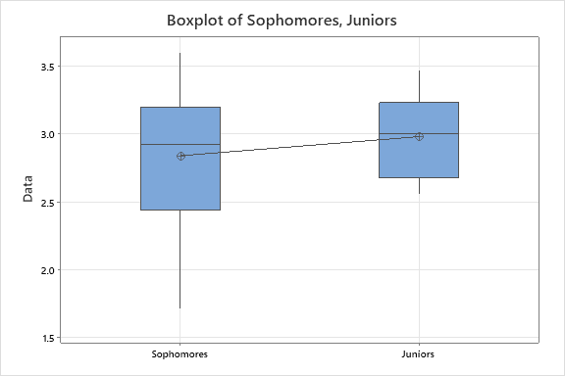

Fig 1 : Box plot of Sophomores and Juniors

**Step 6 :** For creating a histogram under the drop-down menu “GRAPH”, choose “Histogram”. A “Histograms” dialogue box will appear. Choose the “With Fit” option and click “OK”. A “Histogram: With Fit” dialogue box will appear. For the “Graph variables” box, choose “C1 Sophomores” from the table on the left and click “OK”. Repeat this step for juniors as well. The following histograms will be generated.

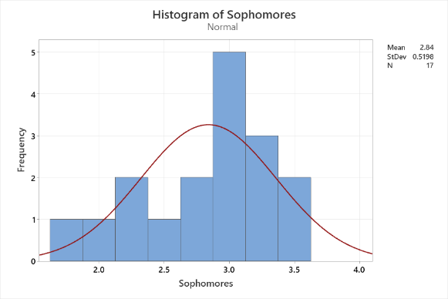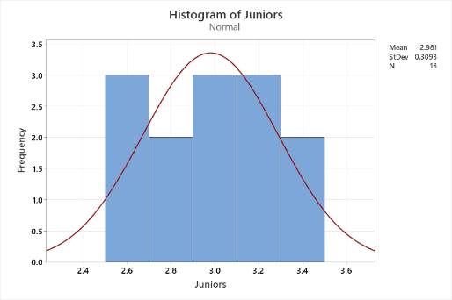

Fig 2: Histogram of sophomores

**Fig 3: Histogram of juniors**

**Interpretation :**

The box plot shows that the distribution of GPA of Sophomores is slightly left skewed and that of Juniors is almost symmetrical. Both distributions do not seriously violate the test assumption that distribution of each sample is normal, which is also confirmed by graph of histogram of individual data sets.

**Descriptive Statistics :**

|  |  |  |  |  |  |
| --- | --- | --- | --- | --- | --- |
| **Sample** | **N** | **Mean** | **StDev** | **SE Mean** | **95% CI** |
| Sophomores | 17 | 2.840 | 0.520 | 0.126 | (2.573, 3.107) |
| Juniors | 13 | 2.9808 | 0.3093 | 0.0858 | (2.7939, 3.1677) |

**Hypothesis :**

|  |
| --- |
| μ₁ : mean of Sophomores |
| µ₂ : mean of Juniors |
| Difference: μ₁ - µ₂ |

*Equal variances are assumed for this analysis.*

**Estimation for Difference :**

|  |  |  |
| --- | --- | --- |
| **Difference** | **Pooled StDev** | **95% CI for Difference** |
| -0.141 | 0.442 | (-0.474, 0.193) |

**Test :**

|  |  |
| --- | --- |
| Null hypothesis | H₀ : μ₁ - µ₂ = 0 (Average GPA of Sophomores and Juniors are same) |
| Alternative hypothesis | H₁ : μ₁ - µ₂ ≠ 0 (Average GPA of Sophomores and Juniors are not same) |

|  |  |  |
| --- | --- | --- |
| **T-Value** | **DF** | **P-Value** |
| -0.86 | 28 | 0.395 |

**Conclusion:**

Since p-value (0.395) of the test is greater than significance probability (0.05) of the test, we accept our null hypothesis H0 at 5 % level of significance. It means that that there is no significant difference between the average gpa of GPA of Sophomores and Juniors. Hence two distributions are same in terms of average.

**Worksheet :**

