Assignment 1:

1. Differentiate between intranet, extranet and internet. 1

2. Define data communication. Briefly explain the elements required for data communication. 2

I. Message: 2

II. Sender: 2

III. Receiver: 2

IV. Transmission Medium: 2

V. Protocol: 3

3. What is network topology? Explain different types of topologies with advantages, disadvantages and diagram. 3

II. Bus Topology: 3

III. Star Topology: 4

IV. Ring Topology: 5

V. Mesh Topology: 6

VI. Tree Topology: 6

VII. Hybrid Topology: 7

1. Differentiate between intranet, extranet and internet.

| **Feature** | **Intranet** | **Extranet** | **Internet** |
| --- | --- | --- | --- |
| **Definition** | A private network accessible only within an organization. | A controlled network allowing access to external partners. | A global public network that connects millions of computers. |
| **Access** | Only employees or internal users. | Authorized external users (e.g., suppliers, partners). | Anyone with internet connectivity. |
| **Security** | High – used within the organization. | Moderate to High – requires secure access. | Varies – public network, prone to threats if unprotected. |
| **Usage** | Share internal information, documents, and applications. | Collaborate with partners, vendors, or customers. | Public websites, email, social media, cloud services, etc. |

|  |  |  |  |
| --- | --- | --- | --- |
| **Ownership** | Owned and maintained by an organization. | Shared access – partially maintained by the host org. | No single owner; governed by global standards. |

1. Define data communication. Briefly explain the elements required for data communication.

Data communication is the process of establishing a link between 2/more devices through a transmission medium under a set of rules to exchange information.

The elements required for data communication are:

1. **Message**:
   * The actual data or information to be communicated.
   * Example: Text, audio, video, or files.
2. **Sender**:
   * The device that generates and sends the message.
   * Example: A computer, smartphone, or a sensor.
3. **Receiver**:
   * The device that receives the message.
   * Example: Another computer, mobile device, or server.
4. Transmission Medium:
   * The physical path through which the message travels from sender to receiver.
   * Example: Twisted-pair cable, fiber optics, radio waves, etc.
5. **Protocol**:
   * A set of rules that govern the data communication process.
   * Ensures proper formatting, transmission, and interpretation of data.
   * Example: TCP/IP, HTTP, FTP.
6. What is network topology? Explain different types of topologies with advantages, disadvantages and diagram.

A network topology is the physical arrangement of computers, cables and other components in a computer network. It defines how devices are interconnected and how data flows between them. The type of topology you use affect the speed and performance of the computer network.

The different types of topologies are:

1. Bus Topology:

In a bus topology, all devices are connected to a single central cable called the bus/backbone in a linear format. Data is sent in both directions along the bus, and terminators are used at both ends to absorb signals and prevent signal reflection.

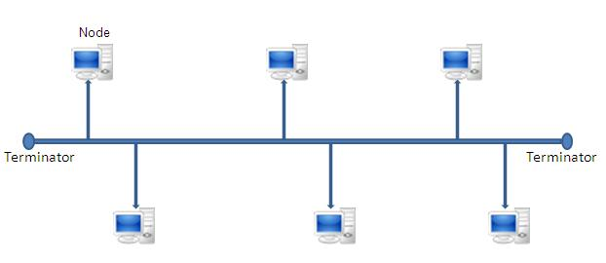

**Advantages:**

* It is simple, reliable (in very small network), easy to use and understand.
* It is less expensive.
* It is easy to add a new node in the network.
* It requires less cable than star topology.

**Disadvantages:**

* Heavy network traffic can slow a bus considerably.
* It is difficult to troubleshoot.
* If the backbone fails, the entire network goes down.
* Performance degrades as more devices are added.

1. Star Topology:

In a star topology, all devices are connected to a central device (hub or switch). Data is sent from the source to the central device, which then forwards it to the destination. Each node on a star topology must be located relatively close to the hub.

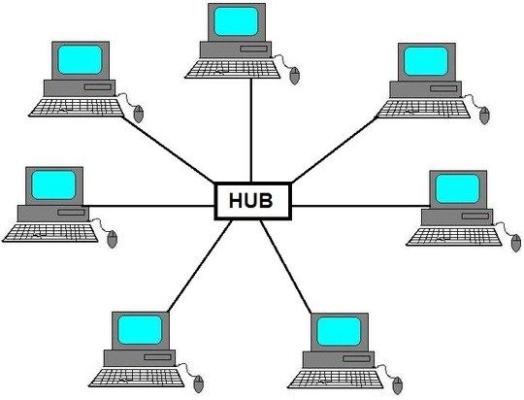

**Advantages:**

* It is easy to install and manage.
* It is easy to add/remove new computers without disturbing the rest of the network.
* Single computer failure does not bring down the whole network.
* It is easy to detect the errors in star topology

**Disadvantages:**

* It the central device fails, the whole network stops.
* Requires more cable than bus topology.
* More expensive due to central device.

1. Ring Topology:

In a ring topology, each device is connected to the next and previous one, forming a closed loop. The ring topology provides equal access for all computers on the network. The information on a ring network travels in one direction either clockwise or anti clockwise direction.

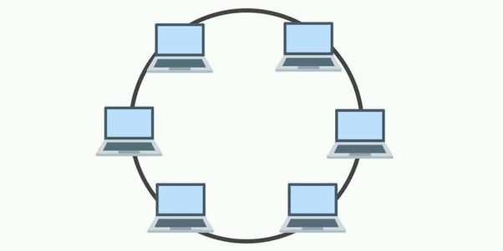

**Advantages:**

* Ring topology is easy to setup.
* Each computer is given equal opportunity to access the network resources.
* No data collisions due to token passing (in token ring).
* Performs better than bus topology under heavy load.

**Disadvantages:**

* Failure of one computer on the ring breaks the entire network.
* Adding/removing computers disturbs the networks.
* It is difficult to troubleshoot.

1. Mesh Topology:

Each device is connected to every other device in the network. This provides multiple paths for data to travel, increasing reliability and redundancy.

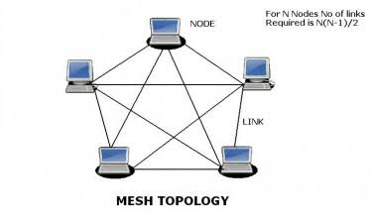

**Advantages:**

* The mesh topology is extremely reliable and fault-tolerant.
* It is easy to troubleshoot.
* Failure of one link does not affect the network.
* Data can be transmitted simultaneously through different paths.

**Disadvantages:**

* Difficult to installation and reconfigure.
* High cabling and installation cost.
* Complex to manage and scale.

1. Tree Topology:

Tree Topology is a topology having a tree structure in which all the devices are connected like the branches in a tree. It is a combination of a star and bus topology. Groups of star-configured networks are connected to a linear bus backbone.

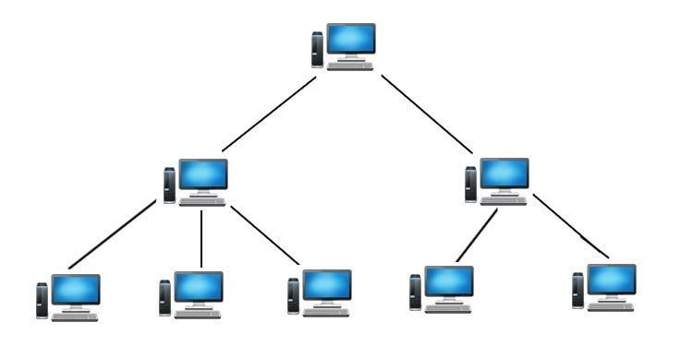

**Advantages:**

* One/more nodes can be added to the leaf nodes in the hierarchical chain, providing high scalability.
* Suitable for large networks.
* Tree topology provides easy maintenance and easy fault identification can be done.

**Disadvantages:**

* Failure of the backbone affects the entire system.
* Requires large number of cables compared to star and ring topology.
* The establishment cost increases as well.
* If the bulk of nodes are added in this network, then the maintenance will become complicated.

1. Hybrid Topology:

Hybrid topology is a combination of 2/more topologies. It inherits the advantages and disadvantages of included topologies.

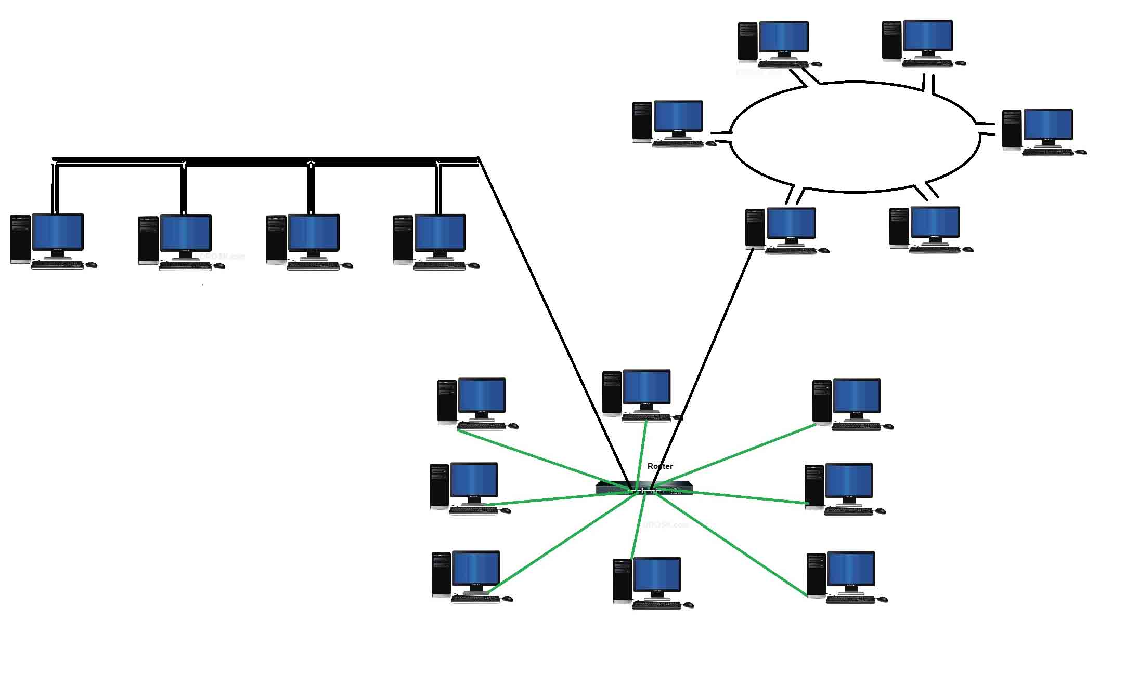

**Advantages:**

* It combines the benefits of different types of topologies into one topology.
* It can be customized to meet network demands.
* It is very reliable, flexible and scalable.
* Error detecting and troubleshooting is easy.
* It is used for create large network.

**Disadvantages:**

* Hardware and maintenance are expensive.
* It is very complex to design and implement.
* There is change hardware in order to connect topology with another topology.
* Difficult to manage large-scale hybrids.