Assignment 1:

1. What are different types of Database users and their roles? Explain the Data independence with example. 2

I. End Users: 2

II. Application Programmers: 2

III. Database Administrators (DBAs): 2

Data Independence: 3

I. Logical Data Independence: 3

II. Physical Data Independence: 4

2. What are the components of ER diagram? Explain the function of various symbols use in ER diagram. Construct an ER diagram to store data in a library of your college. 4

I. Entity: 4

II. Weak 4

III. Attribute: 5

IV. Key 5

V. Multi-valued 5

VI. Derived 5

VII. Relationship: 5

VIII. Weak 5

IX. Line: 5

X. Cardinality: 5

ER diagram for a library in a college: 5

I. Identify the entities: 5

II. Set 5

III. Identify 6

I. Set 6

IV. Join 7

3. What is difference between logical data independence and physical data independence? 7

4. Explain Relationship and Relationship sets with example. 8

5. Retrieve the TName, SName, SPhone for "ABC" school using SQL from given relation as below. 9

6. What are the advantages of using Database Management System over traditional filing system? Explain different data models with example. 10

7. Explain the use of primary and foreign key in DBMS with example. What is the role of foreign key? 11

8. Define data independence. Explain three-schema architecture. 11

9. Consider a banking database with three labels and primary key underlined as given below: 11

10. Write both relational algebra and SQL queries: 11

11. What do you mean by Schema and Instance in DBMS? Explain both with examples. 11

1. What are different types of Database users and their roles? Explain the Data independence with example.

A database user is an individual, application, or system that interacts with a database to perform operations such as storing, retrieving, updating, or managing data. Each user is typically assigned specific access rights and privileges based on their role to ensure security and proper data management.

Database users can be categorized based on their level of interaction with the database system:

1. End Users:

End users are database users who interact with database by issuing commands from a terminal through predefined application programs to perform functions like create, retrieve, modify and delete. Example: Bank tellers using an interface to access customer accounts

1. Application Programmers:

Application programmers are database users who develop applications that interact with the database using programming languages and APIs like Access, FoxPro, COBOL, etc. These application programs are used by end users to operate on data. Example: Developers creating e-commerce websites that connect to product databases.

1. Database Administrators (DBAs):

DBAs are database users who maintains the database description in original form. It is responsible for overall control of the database system. Example: Database managers ensuring that the product database runs smoothly, securely, and efficiently—supporting developers, customers, and business operations.

The responsibilities of a DBA are:

1. **Schema definition and modification:**

The creation and modification of the original description of the database structure and the way that structure is reflected by the files of the physical database.

1. **Storage structure and access method definition:**

The DBA determines how data is physically stored on disk, including file organization, portioning and tablespace management. The DBA also chooses the best access methods for query efficiency through indexing strategies like B-tree, hashmap, bitmaps.

1. **Granting authorization for data access:**

Granting access to the database to different users.

1. **Routine maintenance:**

Making backup copies of the database and repairing damage to the database due to hardware or software failures or misuse.

Data Independence:

Data independence refers to the ability to modify the database schema at one level without affecting the schema at the next higher level.



Figure 1: Levels of Abstraction

The types of data independence are:

1. Logical Data Independence:

It is the ability to change the conceptual schema without affecting external schemas or application programs. It protects from changes in logical structure of data. Logical data independence is harder to achieve as the application programs are usually heavily dependent on the logical structure of the data. Example: Adding a new entity (table), attribute (column), or relationship to the database without requiring changes to existing applications that don't use these new elements.

1. Physical Data Independence:

It is the ability to change the physical schema without affecting the conceptual schema. It allows tuning of the physical database for efficiency while permitting application programs to run as if no change had occurred. Example: Changing file organizations or storage structures (e.g., from B-trees to hash indexes), changing storage devices, all without requiring changes to the logical database design or applications.

Example:

Consider a university database with a STUDENT table:

* Original schema: STUDENT (ID, Name, Address, Major)
* Logical change: Adding a "Phone_Number" column - existing applications that don't use phone numbers continue working (logical independence)
* Physical change: Creating an index on the Major field - this improves performance without changing how applications query the data (physical independence)

1. What are the components of ER diagram? Explain the function of various symbols use in ER diagram. Construct an ER diagram to store data in a library of your college.

An Entity-Relationship (ER) Diagram is a visual representation of a database’s logical structure. It consists of entities, attributes, relationships, and associativity, each represented by specific symbols.

The various symbols used in ER diagram are:

1. Entity: It represents a real-world object. It is the table in a database. Example: Student, Book, Library.
2. Weak Entity: It depends on another entity. It doesn’t have a primary key on its own. Example: Book_Copy (needs Book).
3. Attribute: It describes an entity. It is the column in database. Example: student_name, book_id.
4. Key Attribute: It uniquely identifies an entity. It is also called primary key. Example: student_id.
5. Multi-valued Attribute: It can have multiple values. Example: phone_numbers.
6. Derived Attribute: It is computed from other attributes. Example: age (calculated from date_of_birth).
7. Relationship: It connects 2/more entities. Example: Borrows (Student->Book).
8. Weak relationship: It exists when a weak entity depends on a strong entity for its identity. Example: ‘Has’ is a weak relationship relating weak entity Book_Copy with strong entity Book.
9. Line: It links attributes to entities and entities to relationships.
10. Cardinality: It defines how entities relate. Its types are one-to-one (1 Student : 1 Library_Card), one-to-many (1 student: N books), many-to-one (N Borrowing_Records : 1 Librarian) and many-to-many (M Student : N Book, a student can borrow many books and a book can be borrowed by many students over time).

ER diagram for a library in a college:

1. Identify the entities: Student, Book, Library_Staff, Borrowing_Record(weak entity)



1. Set attributes:
2. Student: student_id (PK), name, email, phone
3. Book: book_id (PK), title, author, publish_date
4. Library_Staff: staff_id (PK), name, position
5. Borrowing_Record: borrow_id (PK), issue_date, due_date, return_status

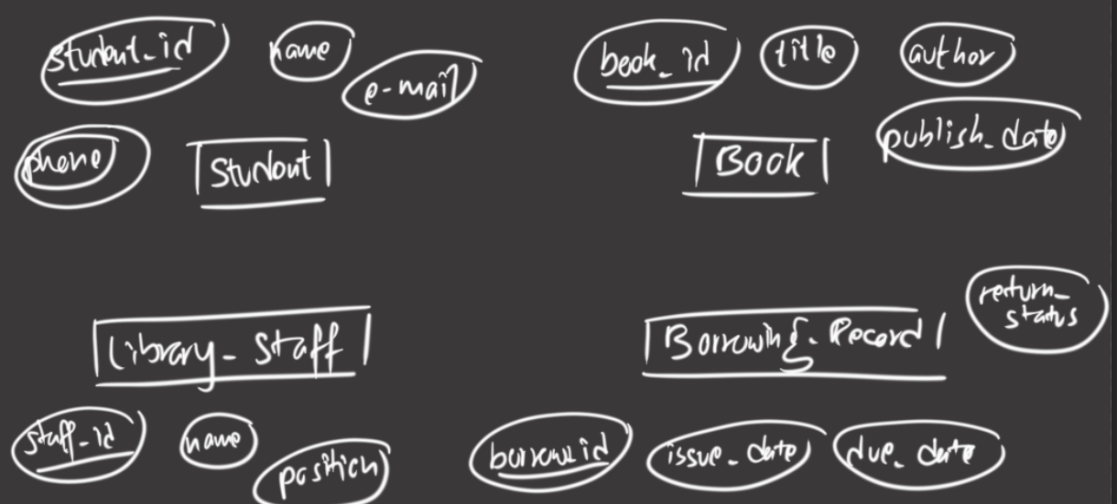

1. Identify relationship:
2. Student borrows Book.
3. Library_Staff manages Borrowing_Record
4. Book has Borrowing_Record
5. Student has Borrowing Record

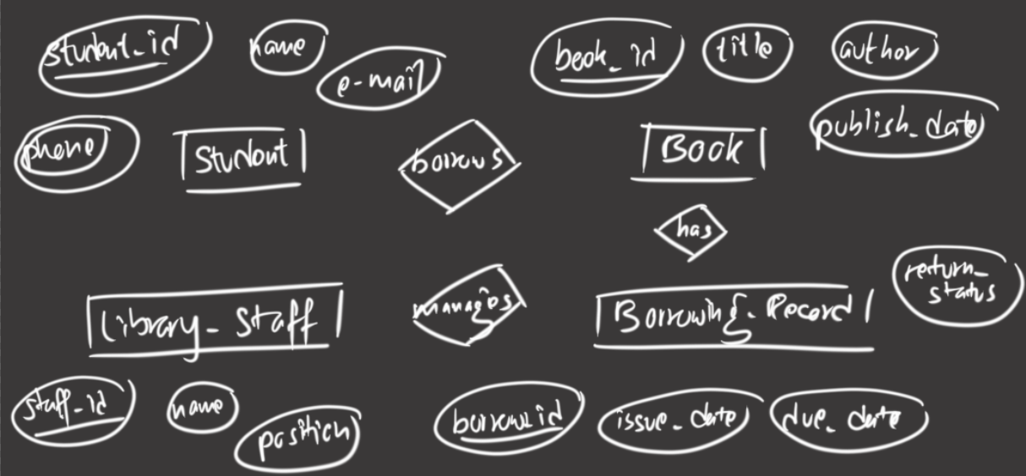

1. Set cardinality:
2. 1 Student borrows N Book.
3. 1 Library_Staff manages N Borrowing_Record
4. 1 Book has N Borrowing_Record
5. 1 Student has N Borrowing_Record

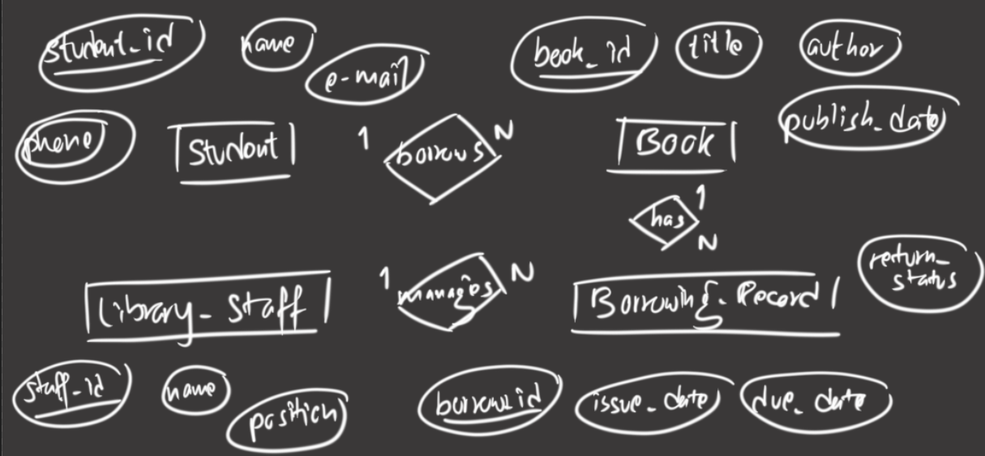

1. Join entities with relationship:

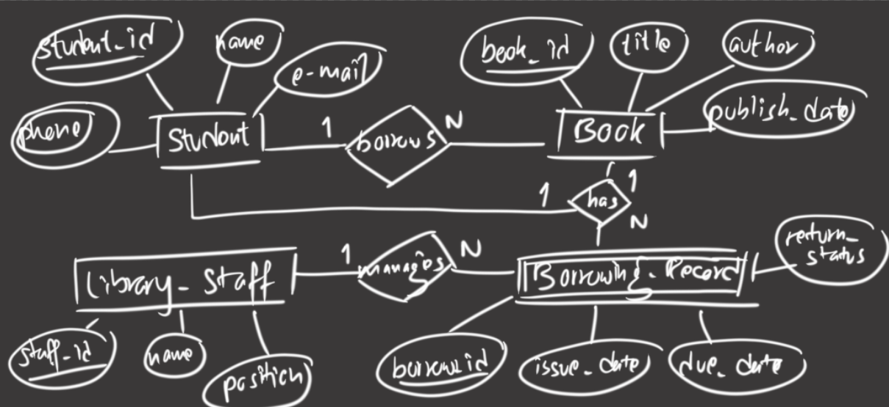

1. What is difference between logical data independence and physical data independence?

| **Aspect** | **Logical Data Independence** | **Physical Data Independence** |
| --- | --- | --- |
| **Definition** | Ability to change the conceptual schema without affecting external schemas (user views). | Ability to change the internal schema without affecting the conceptual schema. |
| **Level Affected** | Between conceptual and external levels. | Between internal and conceptual levels. |
| **What Changes?** | Modifications to tables, relationships, or constraints (e.g., adding/removing entities or attributes). | Changes in file structures, storage devices, or access methods (e.g., indexing, hashing). |
| **Impact on Users** | Applications not using the modified schema remain unaffected. | No impact on application programs or user queries. |
| **Purpose** | Protects applications from changes in the logical database design. | Protects the database design from changes in physical storage. |
| **Complexity** | Harder to achieve (may require view definitions). | Easier to achieve (handled by the DBMS). |
| **Example** | Adding a phone_number column to a Student table without breaking existing apps that don’t use this field. | Switching from B-tree to hash indexing for faster searches without altering table structures. |

1. Explain Relationship and Relationship sets with example.

A relationship defines associationship between 2/more entities in a database. It is represented as a diamond (◇) in ER diagrams. It is defined by cardinality (1:1, 1:N, M:N).

Example:

* Entities: Student, Course
* Relationship: Enrolls
* Meaning: "A Student enrolls in a Course."

**ER Diagram:**

text

+----------+ +----------+

| Student |━━━━━┓ | Course |

+----------+ Enrolls

┗━━━━━┛

A relationship set is a collection of similar relationships between entity sets. It is analogous to a table in a relational database. Each row represents one relationship instance.

Formally it is a mathematical relation on n>=2 (possibly non-distinct) sets. If E1, E2,……..En are entity sets, then a relationship set R is a subset of {( e1, e2,…….., en ) | e1 Î E1, e2 Î E2 ,…….., en Î En } where ( e1, e2,…….., en ) is a relationship.

Example: University Database  
Entity Sets:

Student = {S1, S2, S3}

Course = {C101, C102}

Relationship Set Enrolls:

| **Student** | **Course** | **Enrollment_Date** | **Grade** |
| --- | --- | --- | --- |
| S1 | C101 | 2023-09-01 | A |
| S2 | C101 | 2023-09-01 | B+ |
| S3 | C102 | 2023-09-05 | A- |

This table captures:

* S1 and S2 enrolled in C101.
* S3 enrolled in C102.

1. Retrieve the TName, SName, SPhone for "ABC" school using SQL from given relation as below.

        TEACHER(TID, TName, TAddress, TQualification)

        SCHOOL(SID, SName, SAddress, SPhone)

        SCHOOL_TEACHER(SID, TID, No_of Period).

CREATE DATABASE SCHOOL_INFO;

USE SCHOOL_INFO;

CREATE TABLE TEACHER (

TID INT PRIMARY KEY,

TName VARCHAR(30),

TAddress VARCHAR(10),

TQualification VARCHAR(10)

);

CREATE TABLE SCHOOL (

SID INT PRIMARY KEY,

SName VARCHAR(30),

SAddress VARCHAR(10),

SPhone NUMERIC(10)

);

CREATE TABLE SCHOOL_TEACHER (

SID INT,

TID INT,

No_of_Period INT(2)

);

INSERT INTO TEACHER VALUES

(1001, 'Heung-Min Son', 'South Korea', 'M.Sc.'),

(1002, 'Cristiano Ronaldo', 'Portugal', 'PhD'),

(1003, 'Marco Reus', 'Germany', 'M.Ed.'),

(1004, 'Mesut Ozil', 'Germany', 'B.Sc.'),

(1005, 'Jesse Lingard', 'England', 'M.A.');

INSERT INTO SCHOOL VALUES

(2001, 'ABC', '101 Maple St', 5551234567),

(2002, 'Swarnim', '203 Oak Ave', 5552345678),

(2003, 'Bella Pre-School', '304 Pine Rd', 5553456789),

(2004, 'Trinity College', '505 Birch Blvd', 5554567890),

(2005, 'NCCS', '607 Cedar Dr', 5555678901);

INSERT INTO SCHOOL_TEACHER VALUES

(2001, 1001, 5),

(2001, 1002, 3),

(2002, 1003, 6),

(2003, 1004, 4),

(2001, 1005, 2),

(2001, 1002, 4),

(2004, 1003, 3),

(2005, 1005, 5),

(2005, 1001, 2);

SELECT T.TName,S.SName,S.SPhone FROM TEACHER AS T

JOIN SCHOOL_TEACHER AS ST ON T.TID=ST.TID

JOIN SCHOOL AS S ON ST.SID=S.SID

WHERE S.Sname='ABC';

1. What are the advantages of using Database Management System over traditional filing system? Explain different data models with example.

A **Database Management System (DBMS)** is a software system designed to store, retrieve, manage, and manipulate data efficiently. It provides a structured way to organize data in databases, ensuring data integrity, security, and easy access.. A **Traditional File System** is a method of storing data in flat files (e.g., .txt, .csv, .dat) without a structured database. Each file contains records, but there is no relationship between files, leading to data redundancy and inconsistency.

The advantages of using DBMS over traditional filing system are given below:

1. **Data Redundancy Control**: DBMS minimizes duplication of data through normalization, while file systems often have redundant data across multiple files stored in different locations.
2. **Data Consistency**: Ensures all data conforms to rules and constraints, unlike file systems where consistency must be manually maintained.
3. **Data Sharing**: Allows concurrent access by multiple users/applications, while file systems typically allow only one user at a time.
4. **Data Integrity**: Provides mechanisms to maintain accuracy and validity of data through constraints and validation rules.
5. **Security Features**: Offers user authentication, authorization, and access controls at various levels.
6. **Backup and Recovery**: Built-in mechanisms for data backup and recovery from failures.
7. **Data Independence**: Separates physical storage from logical representation, allowing changes without affecting applications.
8. **Efficient Query Processing**: Provides powerful query languages (like SQL) for complex data retrieval.
9. **Centralized Management**: Single repository for data with centralized administration.
10. **Concurrency Control**: Manages simultaneous access by multiple users to prevent inconsistencies.

Data Model:

Data models are a collection of conceptual tools for describing data, relationships, data semantics and data constraints.

The types of data models are:

1. Object-based Logical Models:

The Object-Based Logical Model represents data as objects, similar to object-oriented programming concepts. It focuses on encapsulation, inheritance, and polymorphism, making it suitable for complex data structures.

1. E-R Model:

The entity-relationship model is a conceptual data modeling technique used to represent real-world data requirements in a structured way.. It helps in designing databases by defining entities, attributes, relationships, and constraints before actual implementation.

An entity is a distinguishable object that exists. Each entity is associated with a set of attributes describing it. E.g. number and balance for an account entity. A relationship is an association among several entities. e.g. A cust_acct relationship associates a customer with each account he or she has. The set of all entities or relationships of the same type is called the entity set or relationship set. mapping cardinalities express the number of entities to which another entity can be associated via a relationship set.

The overall logical structure of a database can be expressed graphically by an E-R diagram:



1. rectangles: represent entity sets.
2. ellipses: represent attributes.
3. diamonds: represent relationships among entity sets.
4. lines: link attributes to entity sets and entity sets to relationships.

The davantages of ER model are:

1. Easy to Understand: Visual representation helps non-technical users.
2. Database Design: Serves as a blueprint before SQL implementation.
3. Reduces Ambiguity: Clearly defines relationships and constraints.
4. Flexible: Can be extended (EER) for complex scenarios.

The limitations of ER model are:

1. No Standard Notation: Different tools use different symbols (Chen, Crow’s Foot, UML).
2. No Query Support: Only a design tool, not executable.
3. Limited to Conceptual Level: Does not optimize storage/physical design.
4. Object-Oriented Model:

The Object-Oriented Data Model (OODM) is a database model that integrates object-oriented programming (OOP) concepts with database systems. It represents data as objects, similar to how objects work in programming languages like Java, C++, or Python.

The object-oriented data model treats data as objects, similar to objects in programming. Each object stores data in instance variables (like attributes) and includes methods (functions) that operate on that data. Objects can contain other objects, allowing deep nesting. Objects with the same structure and behavior are grouped into classes, which act like blueprints. To interact with an object's data, you must call its methods—this is called sending a message, keeping internal details hidden. For example, a bank account object might store an account number and balance, with a pay-interest method to update the balance. Unlike traditional models, changing logic (like interest rates) only requires modifying the method, not application code. Each object has a unique identity, even if two objects hold identical data, ensuring distinction at the physical level through unique identifiers. This model is ideal for complex, hierarchical data and integrates seamlessly with object-oriented programming.REecord-based Logical Models:

1. Record-based logical models:

♦ Also describe data at the conceptual and view levels.

♦ Unlike object-oriented models, are used to

● Specify overall logical structure of the database, and

● Provide a higher-level description of the implementation.

♦ Named so because the database is structured in fixed-format records of several types.

♦ Each record type defines a fixed number of fields, or attributes.

♦ Each field is usually of a fixed length (this simplifies the implementation).

♦ Record-based models do not include a mechanism for direct representation of code in the database.

♦ Separate languages associated with the model are used to express database queries and updates.

♦ The three most widely-accepted models are the relational, network, and hierarchical.

♦ This course will concentrate on the relational model.

♦ The network and hierarchical models will not covered in details.

1. Relational Model:

Data and relationships are represented by a collection of tables.

♦ Each table has a number of columns with unique names, e.g. customer, account.

♦ Figure a sample relational database.



Figure: A sample relational database.

1. Network Model:

Data are represented by collections of records.

♦ Relationships among data are represented by links.

♦ Organization is that of an arbitrary graph.

♦ Figure shows a sample network database that is the equivalent of the relational database.



Figure : A sample network database

1. Hierarchical Model:

Similar to the network model.

♦ Organization of the records is as a collection of trees, rather than arbitrary graphs. 8

Page No.

♦ Figure shows a sample hierarchical database that is the equivalent of the relational database.

Figure : A sample hierarchical database

The relational model does not use pointers or links, but relates records by the values they contain. This allows a formal mathematical foundation to be defined.

1. Physical Data Models:

Are used to describe data at the lowest level.Very few models, e.g.

1. o Unifying model.
2. o Frame memory.
3. Explain the use of primary and foreign key in DBMS with example. What is the role of foreign key?
4. Define data independence. Explain three-schema architecture.
5. Consider a banking database with three labels and primary key underlined as given below:

Customer (CustomerID , CustomerName, Address, Phone, Email)

Borrows (CustomerID, LoanNumber )

Loan ( LoanNumber , LoanType, Amount )

1. Write both relational algebra and SQL queries:
2. To display name of all customers who live in “Lalitpur” in ascending order of name.
3. To count total number of customers having loan at the bank.
4. To find name of those customers who have loan amount greater than or equal to 500000.
5. To find average loan amount of each account’s type.
6. What do you mean by Schema and Instance in DBMS? Explain both with examples.