**National College of Computer Studies**

Paknajol, Kathmandu

**Report on Workout Logger**

**Submitted by: Submitted to:**

Ayush Tuladhar Nischal Shakya

BSc.CSIT 4th Sem

Section: A

**Submission Date:** 24th August 2025

**Contents**

Abstract i

1. Introduction 1

2. Problem Statement 2

3. Objectives 3

4. Diagrams 4

5. Screenshot of the Application 6

6. Conclusion 10

7. Future Implementation 11

# Abstract

The Workout Logger System is a Java-based application developed to simplify and digitize the process of recording workout activities. Users can log exercises including sets, reps, weights, and duration, while the system securely stores this information in a MySQL database. The application is built with Java Swing for a user-friendly interface, JDBC for database connectivity, and XAMPP/SQLyog for backend management. By eliminating the need for manual paper logs, the system enhances accuracy, saves time, and provides a structured way to monitor progress. The modular design also ensures scalability for future features such as progress visualization, mobile app integration, and AI-driven workout recommendations.

# Introduction

The Workout Logger System is designed to help individuals track their daily fitness activities in an organized and efficient manner. Traditionally, fitness enthusiasts have relied on notebooks or memory to keep track of their exercises, which is error-prone and inconvenient. This system provides a centralized platform where users can input and store workout details digitally.  
  
Developed in Java, the system uses Swing for the graphical interface and JDBC for connecting to a MySQL database hosted in XAMPP. Users can log different exercises, record repetitions, sets, and weights, and later review their workout history to monitor progress. The solution ensures secure storage, quick retrieval, and a more structured approach to fitness tracking.

# 2. Problem Statement

Tracking workouts manually is often inconsistent, time-consuming, and prone to errors. Paper records can be lost, data is not easily searchable, and there is no efficient way to analyze progress over time. As workout intensity and complexity increase, keeping accurate records becomes even more challenging. Without a digital solution, users struggle to monitor improvements, compare past performance, and stay motivated.  
  
Therefore, there is a strong need for a computerized system that provides a reliable platform to log exercises, maintain workout history, and improve consistency in fitness tracking.

# 3. Objectives

The main objective of the Workout Logger System is to provide a simple yet effective platform to manage workout data digitally.

Specific objectives include:

* Enable users to log exercises with details such as sets, reps, weights, and rest time.
* Provide a searchable and structured workout history.
* Maintain data integrity with secure MySQL database storage.
* Offer an intuitive Java Swing interface for ease of use.
* Minimize manual errors in tracking workouts.
* Design the system to be extendable for future features like progress graphs and mobile access.

# 4. Diagrams

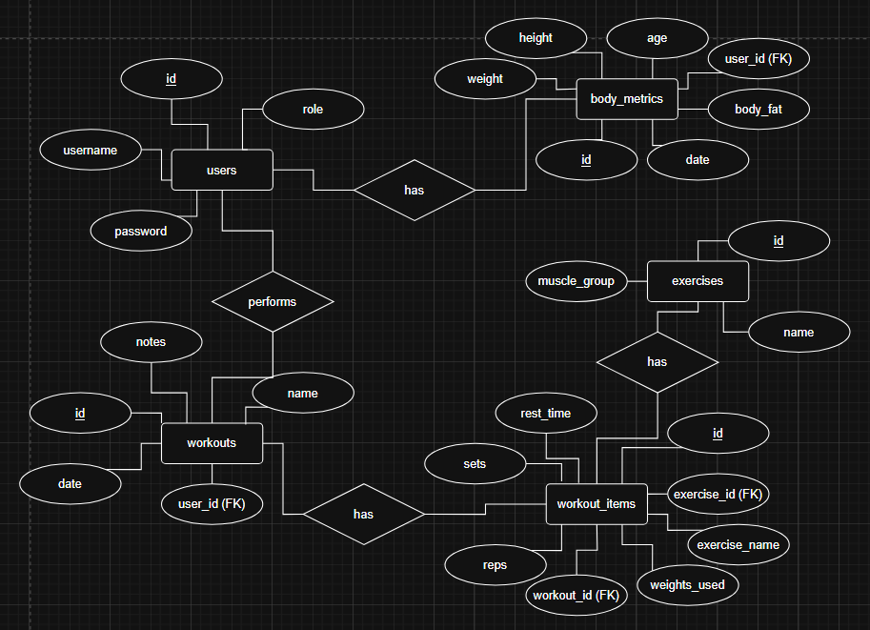

Fig: Use Case Diagram of Workout Logger System

Fig: ER Diagram of Workout Logger System

# 5. Screenshot of the Application

# 6. Conclusion

The Workout Logger System addresses the challenges of manual workout tracking by offering a centralized digital solution. Users can record exercises efficiently, maintain a history of their progress, and benefit from accurate and organized data storage. The system improves consistency in fitness tracking, reduces the likelihood of errors, and provides a foundation for further enhancements such as visualization and mobile support.  
  
Overall, the application proves to be a reliable and user-friendly tool for individuals looking to manage their workouts more effectively.

# 7. Future Implementation

Proposed future enhancements for the Workout Logger System include:

* Graphical charts for visualizing progress over time (e.g., weights lifted, calories burned).
* Mobile application integration for Android and iOS users.
* Cloud deployment for access across multiple devices.
* AI-driven personalized workout recommendations based on past performance.
* Integration with wearable fitness devices such as smartwatches and fitness trackers.
* Export and backup features to allow data portability and offline access.