2081:
Long Answer Questions: [10 marks each]
- How do you define optimal solution? Does greedy algorithm always guarantee optimal solution? Given the string “SUPER DUPER CSIT”, use a Greedy algorithm to build a Huffman tree.
- What is order statistics? Write and analyze the algorithm for randomized quick sort.
- Distinguish between dynamic programming and memorization. Parenthesize the matrices A(30 × 1), B(1 × 40), C(40 × 10) and A(10 × 15), for computing matrix multiplication using dynamic programming.
Short Answer Questions: [5 marks each]
- Solve the recurrence relation T(n) = 2T(n/2) + n using recursion tree method.
- Find the best and worst case for Bubble sort.
- Using Extended Euclidean Algorithm, find the GCD of 12 and 16.
- Find all possible subsets of the integers that sum to 21 in the array {5, 6, 10, 11, 15} using back tracking technique.
- Define class P and NP problem. Why do we need approximation algorithms? Justify.
- State the time and space complexity for sequential search. Write the rules for master theorem for finding asymptotic bounds.
- Justify the worst case for binary search. Find the edit distance from the string “RELEVANT” to “ELEPHANT” using dynamic programming approach.
- Distinguish between recursion and backtracking. Using Miller-Rabin primality test, check whether 53 is prime or not?
- How does 0/1 Knapsack problem differ from fractional one? Find the minimum vertex cover in the following graph.
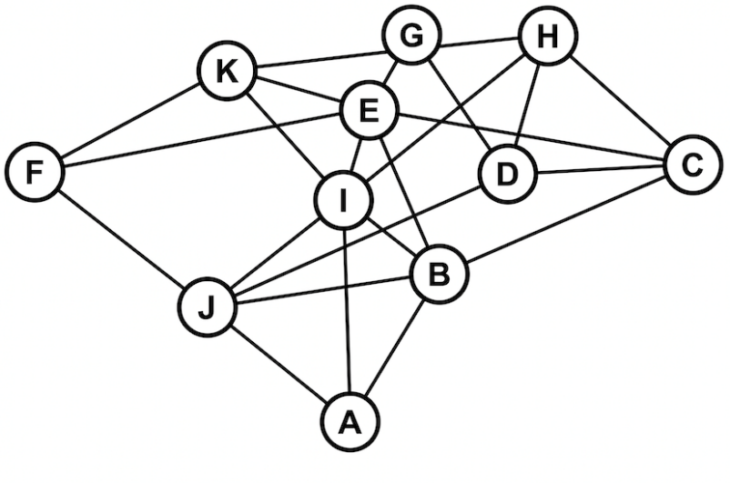
2081:
Long Answer Questions: [10 marks each]
- Differentiate between dynamic programming and memorization. Compute the shortest path between every pair in the following graphs using Floyd Warshal algorithm.
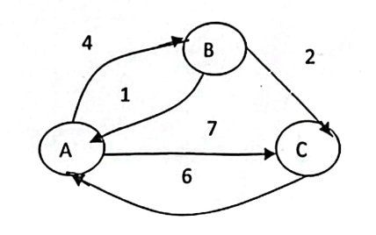
- What is the worst case of quick sort and how does randomize quick sort handle this problem? Sort the data { -2, 4, -3, 6, 12, 10, 11, 13, 9} using quick sort.
- Does greedy algorithm guarantee optimal solution? Solve the Fractional knapsack problem to find maximum loot from given information.
Item | 1 | 2 | 3 | 4 | 5 | 6 | 7
Value | 12 | 10 | 20 | 15 | 2 | 3 | 50
Weight (kgs) | 2 | 1 | 3 | 2 | 12 | 10 | 1
Short Answer Questions: [5 marks each]
- Given a set A= (5,7,10,12,15,18,20}, find the subset that sum to 35 using backtracking.
- Solve the following recurrence relations using master’s method.
- T(n)=2T(n/2) +n3, n>1
T(n)=1, n=1
- T(n)=2T(n/4) +1, n>1
T(n)=1, n=1
- Write an algorithm to find the nth Fibonacci number with its time and space complexity.
- Define order statistics problem. Find the edit distance between “cat” and “car” using dynamic programming.
- Discuss recursion and backtracking. Analyze the complexity of Miller Rabin Randomized Primality test.
- Solve the following linear equation using Chinese Remainder Theorem.
x = 1 MOD 3
x = 2 MOD 5
x = 0 MOD 7
- Explain the approximation algorithm for vertex cover of a connected graph with an example.
- State cook’s theorem. Discuss about problem reducibility.
- Write short notes on:
- Big Oh, Big Omega, Big theta
- Class P, Class NP and NP-Complete

2080:
Long Answer Questions: [10 marks each]
- What is recurrence relation? How can it be solved? Show that time complexity of the recurrence relation T(n) = 2T(n/2) + 1 is O(n) using substitution method.
- Write down the advantages of dynamic programming over greedy strategy. Find optimal bracketing to multiply 4 matrices of order 2,3,4,2,5.
- Discuss heapify operation with example. Write down its algorithm and analyze its time and space complexity.

Short Answer Questions: [5 marks each]
- Define RAM model. Write down iterative algorithm for finding factorial and provide detailed analysis.
- Write down algorithm of insertion sort and analyze its time and space complexity.
- Write down minmax algorithm and analyze its complexity.
- When does greedy strategy provide optimal solution? Write down job sequencing with deadlines algorithms and analyze its complexity.
- Suppose that a message contains alphabet frequencies as given below and find Huffman codes for each alphabet:

Symbol | Frequency
a | 30
b | 20
c | 25
d | 15
e | 35

- Does backtracking give multiple solutions? Trace subset sum algorithm for the set {3,5,2,4,1} and sum=8.
- Why extended Euclidean algorithm is used? Write down its algorithm and analyze its complexity.
- Define NP-complete problems with examples. Give brief proof of the statement “SAT is NP-complete”.
- Write short notes on:
- Aggregate Analysis
- Selection problems
Model:
Long Answer Questions: [10 marks each]
- Write down the elements of dynamic programming. Give the recursive definition of LCS problem. Find LCS between sequences S1 = “Dinesh”, S2 = “Dikshya”.
- What is heap? Sort the following data items by using heap sort A [] = {3, 5, 2, 66, 4, 11, 9, 34}.
- Given a set S = {6, 4, 5, 6, 9} and X=11. Obtain the subset sum using backtracking approach.

Short Answer Questions: [5 marks each]
- Write down algorithm of insertion sort and analyse its time and space complexity.
- Define binary search algorithms. Write down the recursive algorithm for binary search algorithm and analyze it.
- Explain the asymptotic notations used to describe the time/space complexity of any algorithm.
- What is the purpose of Euclid’s algorithm? Explain with suitable explanation.
- Solve the recurrence relation T(n) = T(n-1) + 1 when T(0) = 0.
- Define greedy algorithm. Find minimum spanning tree of the following graph by using Kruskal algorithm.
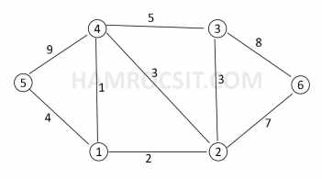
- Explain in brief about the classes P, NP, and NP complete with examples.
- Find the optimal parenthesization for the matrix chain product ABCD with size of each is given as A_{5×10}, B_{10×15}, C_{15×20}, D_{20×30.}
- Write short notes on:
- Best, Worst and average case complexity
- Backtracking strategy
2079:
Long Answer Questions: [10 marks each]
- Explain the divide and conquer strategy for problem solving. Describe the worst-case linear time selection algorithm and analyze its complexity.
- Write the dynamic programming algorithm for matrix chain multiplication. Find the optimal parenthesization for the matrix chain product ABCD with size of each is given as A_{5×10}, B_{10×15}, C_{15×20}, D_{20×30}.
- What do you mean by Backtracking? Explain the backtracking algorithm for solving 0-1
knapsack problem and find the solution for the problem given below:
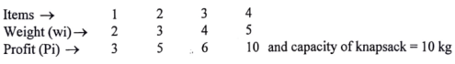

Short Answer Questions: [5 marks each]
- Explain the iterative algorithm to find the GCD of given two numbers and analyze its complexity.
- Generate the prefix code for the string ” CYBER CRIME” using Huffman algorithm and find the total number of bits required.
- Define tractable and intractable problems. Illustrate vertex cover problem with an example.
- Find the edit distance between the string ” ARTIFICIAL” and “NATURAL” Using dynamic programming.
- Write short notes on:
- Best, Worst and average case complexity
- Greedy strategy
- Solve the following recurrence relations using master’s method:
- T(n) = 2T(n/4) + kn2, n > 1
=1, n=1
- T(n) = 5T(n/4) + kn, n > 1
=1, n=1
- Solve the following linear congruences using Chinese Remainder Theorem.
X=1 (MOD 2)
X=3 (MOD 5)
X=6 (MOD 7)
- Find the MST from following graph using Kruskal’s algorithm.
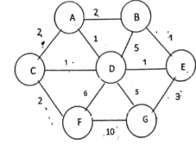
- Trace the quick sort algorithm for sorting the array A [] = {15,7,6,23, 18,34,25} and write it’s best and worst complexity.
2078:
Long Answer Questions: [10 marks each]
- What are the elementary properties of algorithm? Explain. Why do you need algorithm? Discuss about analysis of the RAM model for analysis of algorithm with suitable example.
- Explain about the divide and conquer paradigm for algorithm design with suitable example. Write the Quick sort algorithm using randomized approach and explain its time complexity.
- Explain in brief about the Dynamic Programming Approach for algorithm design. How does it differ with recursion? Explain the algorithm for solving the 0/1 Knapsack problem using the dynamic programming approach and explain its complexity.

Short Answer Questions: [5 marks each]
- Explain the recursion tree method for solving the recurrence relation. Solve following recurrence relation using this method.
T(n)=2T(n/2) +1 for n> 1, T(n) =1 for n =1
- Write an algorithm to find the maximum element of an array and analyze its time complexity.
- Write the algorithm for bubble sort and explain its time complexity.
- What do you mean by optimization problem? Explain the greedy strategy for algorithm design to solve optimization problems.
- Explain the algorithm and its complexity for solving job sequencing with deadline problem using greedy strategy.
- What do you mean by memorization strategy? Compare memorization with dynamic programing.
- Explain the concept of backtracking. How does it differ with recursion?
- Explain in brief about the complexity classes P, NP and NP Complete.
- Write short notes on:
- NP Hard Problems and NP Completeness
- Problem Reduction

2076:
Long Answer Questions: [10 marks each]
- What do you mean by the complexity of an algorithm? Explain the asymptotic notations used to describe the time/space complexity of any algorithm with their geometrical interpretation and example.
- Explain the divide and conquer paradigm from algorithm design with a suitable example. Write the Quick sort algorithm using a randomized approach and explain its time complexity.
- Explain in brief the Backtracking approach for algorithm design. How does it differ with recursion? Explain the N-Queen problem and algorithm using backtracking and analyze its time complexity.

Short Answer Questions: [5 marks each]
- Write the algorithm for selection sort and explain its time and space complexity.
- Solve the following recurrence relation using the master method.
- T(n) = 7 T(n/2) + n2
- T(n) = 4 T(n/4) + kn
- Explain the greedy algorithm for the fractional knapsack problem with its time complexity.
- Trace heap sort algorithm for the following data:
{2, 9, 3, 12, 15, 8, 11}
- What do you mean by Dynamic programming strategy? Explain the element of DP.
- Explain the approximation for solving vertex cover with a suitable example.
- Explain Prism’s algorithm for MST problem and analyze its time complexity.
- Explain in brief about the classes P, NP, and NP complete with examples.
- Write short notes on
- Backtracking strategy
- Tractable and Intractable Problem

