Assignment-1
1. What is system? Explain continuous & discrete system in detail. 1
2. Explain types of model in detail. 1
3. What is static physical model? Explain in detail about static market model. 1
4. What is dynamic physical model? Explain in detail about: 1
a. Wheel suspension system 1
b. Electrical system 1
5. What is distributed log model? Explain with suitable example. 1
6. Explain in detail about steps to be followed in simulation study with flowchart. 1
7. Write short notes on: 1
a. Advantages & disadvantages of simulation 1
b. Application of simulation 1

- What is system? Explain continuous & discrete system in detail.
A system is defined as a group of objects/entities that are joined together in regular interaction/interdependence to accomplish a specific purpose/goal. For example, a production system involves machines, workers, and component parts operating jointly to produce vehicles. A system is bounded by a system boundary and exists within a larger system environment, with which it typically exchanges information and resources. It exists and operates in time and space.

Components of System:
  - Entity: Object of interest in the system (e.g., customers in a bank).
  - Attribute: Property/characteristic of an entity (e.g., a customer's account balance).
  - Activity: Time-bound process occurring within a system and causing changes in the system’s state at a specified date & time (e.g., depositing money).
  - State Variables: A set of variables necessary to describe the system's condition currently/at any given time (e.g., number of busy tellers).
Features:
      - Descriptive: They describe the system's state at a particular point in time.
      - Dynamic: They may change as the system evolves due to activities or events.
      - Unique Representation: Together, the state variables provide a complete and unique representation of the system's state.
  - Event: Instantaneous occurrence that may change the state of system
    - Endogenous Event: Event that occurs within the system & changes the state of system (e.g., beginning of service of customer).
    - Exogenous Event: Event that occurs outside the system but affectsthe state of system (e.g., arrival of customer for service).

Example of system and their components:

Discrete vs. Continuous Systems:
Discrete System: A system in which state variables change only at a discrete set of points in time. The changes are predominantly discontinuous.
Example: In a banking system, the number of customers changes only when a customer arrives or a service is completed and they depart. 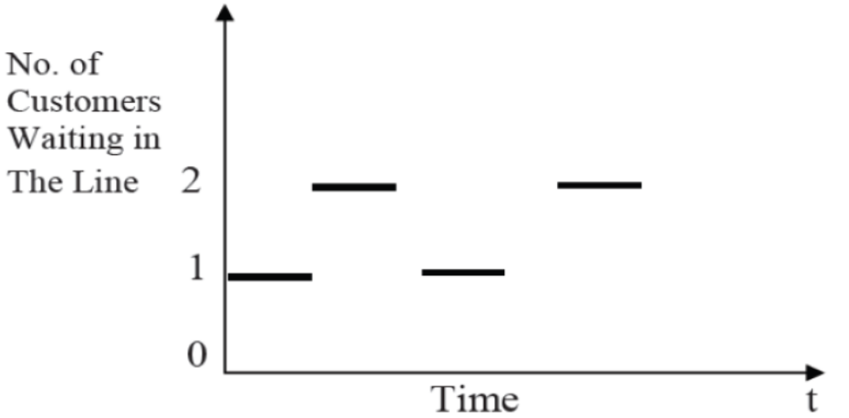

Figure: Step-graph showing the "No. of Customers Waiting in the Line" remaining constant between specific arrival/departure events.

Continuous System: A system in which state variables change continuously over time.
Example: The water level (head of water) behind a dam, which increases gradually during the rainy season and decreases gradually during winter.
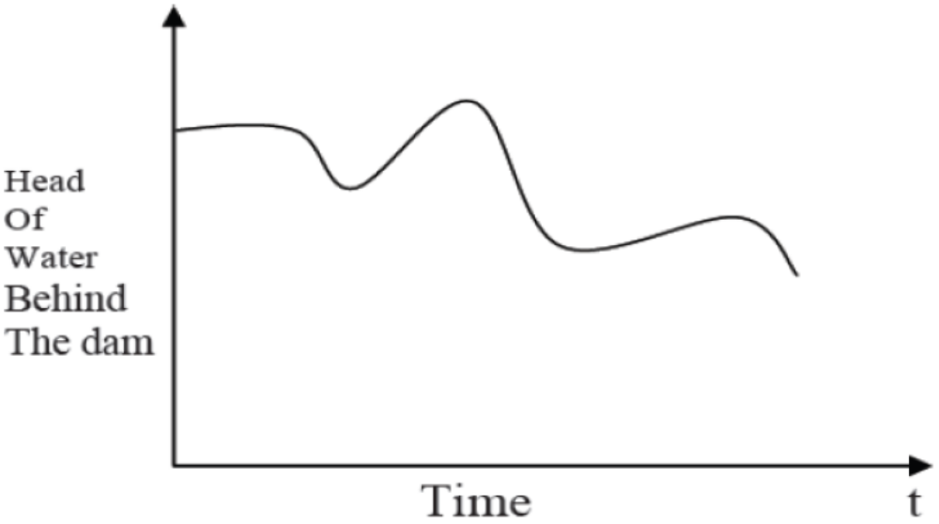
Figure: Curve showing the change of water level over time.

- Explain types of model in detail.
- What is static physical model? Explain in detail about static market model.
- What is dynamic physical model? Explain in detail about:
  - Wheel suspension system
  - Electrical system
- What is distributed log model? Explain with suitable example.
- Explain in detail about steps to be followed in simulation study with flowchart.
- Write short notes on:
  - Advantages & disadvantages of simulation
  - Application of simulation

