WHITE PAPER
Near-Infrared Prediction of Quinine in Cinchona Bark
A qualitative NIR screening tool to complement HPLC: model development, advanced-method benchmarking and deployment for 268 samples from Mangpoo, Darjeeling
Dataset: whole_Cinchona_Combine_Data_wih_Reference.xlsx (4,264 spectra, 892–1710 nm, 256 points, HPLC quinine reference)
Date: 17 September 2026

Executive summary
This paper develops and evaluates a near-infrared (NIR) method for quinine in Cinchona bark, using 268 samples from three collection campaigns (2022–2024). It positions the result as a qualitative screening tool that sorts samples into Low, Medium and High groups so laboratory effort can be prioritised. The tool does not replace HPLC, which remains the reference method for any reportable quinine value.
- Standard chemometrics (SNV + PLSR) explained about 42–50% of reference variance (RPD ≈ 1.3–1.4).
- Eleven advanced methods were benchmarked under nested cross-validation. A neural network trained on individual scans performed best: R² = 0.58, RMSECV = 1.00, RPD = 1.55. Gaussian-process regression and a stacked ensemble came close. Wavelength-selection methods gave no gain.
- As a three-class screen (Low < 3.5 ≤ Medium ≤ 5.5 < High), the model classifies 74% of samples correctly (majority-class guess: 52%) and 81% of those not flagged as borderline. It confuses Low with High in only 1.1% of samples.
- No model reaches RPD ≥ 2, and models do not transfer between campaigns, so quantitative use is not supported.
- Replicate scans agree closely (median variation 2.3%). The remaining error most likely comes from HPLC reference uncertainty and differences between campaigns.
The final model has been packaged with a web app and command-line tool (Section 6). The app reports each sample's class and flags borderline and out-of-domain samples for mandatory HPLC confirmation. The most valuable next step is verifying the HPLC reference (Section 10).

1. Data and study design
Each row of the workbook holds one NIR scan and the HPLC quinine value of its sample. The workbook has no sample-ID or date columns, so samples were identified by row position using the collection record:
Campaign | Rows | Samples × scans | Collected | Quinine range (mean)
A | 2–73 | 6 × 12 | 2022–23 | 4.60–8.07 (6.35)
B | 74–1849 | 111 × 16 | 2022–23 | 0.46–8.30 (3.79)
C | 1850–4265 | 151 × 16 | Sept 2024 | 3.06–6.60 (4.79)

All samples were sourced from Mangpoo, Darjeeling, West Bengal. The reference value is constant within every sample block, which confirms the row-based grouping. The unit of the quinine reference is not stated in the workbook and should be added.
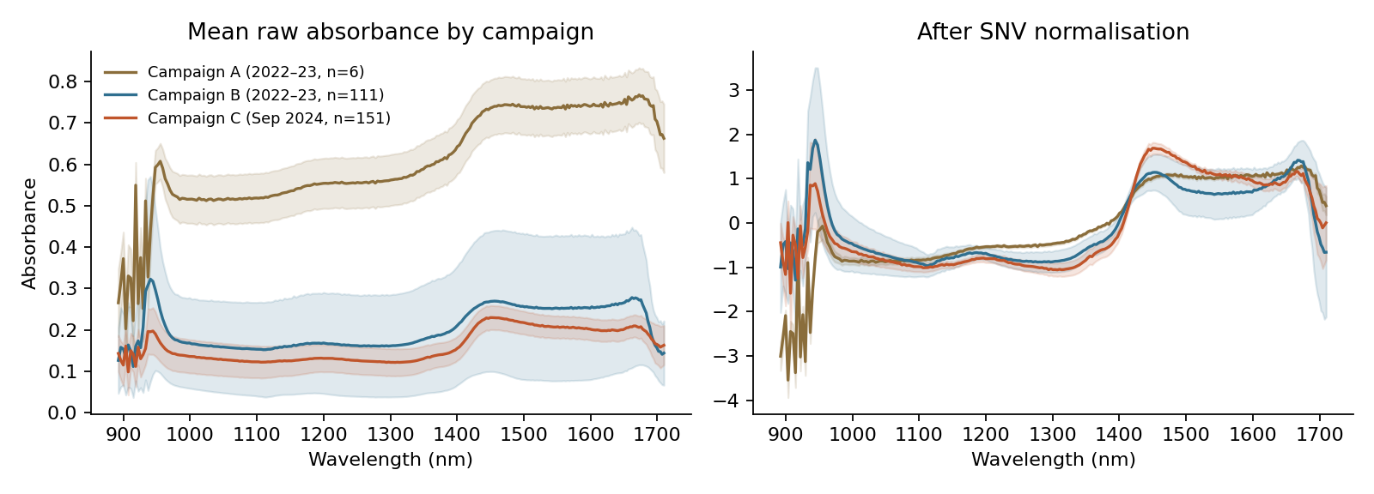
Figure 1. Mean spectra (± 1 SD) by campaign, raw (left) and after SNV (right). Campaign A absorbs about three times more strongly than B and C.
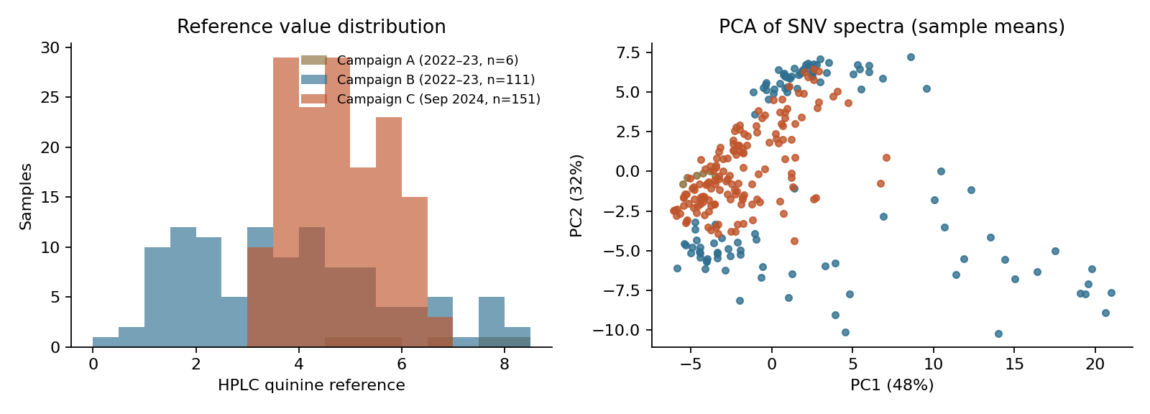
Figure 2. Left: reference distributions by campaign. Right: PCA of SNV-corrected sample means.
Two design issues stand out. First, Campaign A differs strongly in absorbance level and scan count, which points to a different measurement setup. Second, Campaign C covers a narrow concentration band, so a model trained on it cannot learn the low end of the range.

2. Methods

2.1 Preprocessing
- Scan-level outlier removal. Within each sample, a scan was removed when its SNV spectrum deviated from the sample median by a robust z-score above 3.5. This removed 186 of 4,264 scans (4.4%).
- Replicate averaging. The remaining scans were averaged to one spectrum per sample. This keeps replicates of the same sample from being split between training and test folds, which would otherwise inflate performance.
- Spectral treatments: raw absorbance; standard normal variate (SNV); and SNV followed by a Savitzky–Golay first derivative (15-point window, 2nd-order polynomial).

2.2 Algorithms
- PLSR, the chemometric standard. The number of latent variables (1–15) was chosen by lowest cross-validated error.
- Ridge regression on autoscaled spectra, with the penalty chosen by internal cross-validation.
- SVR with an RBF kernel on the first 20 principal components.
- Random forest (150 trees, minimum leaf size 3).

2.3 Validation
Performance was estimated by 10-fold cross-validation at the sample level, in four data scenarios: all campaigns pooled; Campaign B alone; Campaign C alone; and B + C without Campaign A. Reported metrics are R², RMSECV, RPD (reference SD ÷ RMSECV) and mean bias. Cross-campaign transfer was also tested by training on one of B or C and predicting the other. Because PLSR latent variables were selected on the same folds used for scoring, the PLSR figures are slightly optimistic.

3. Results

3.1 Best model per scenario
Data scenario | Preprocess | Best model | R² | RMSECV | RPD | Bias
All campaigns | SNV | PLSR (12 LV) | 0.42 | 1.19 | 1.31 | -0.01
2022-23 (n=111) | SNV | Ridge | 0.55 | 1.31 | 1.48 | 0.09
Sept 2024 (n=151) | SNV | Random Forest | 0.38 | 0.72 | 1.27 | 0.00
2022-23 + 2024 (excl. 6) | SNV | PLSR (13 LV) | 0.36 | 1.23 | 1.25 | -0.05

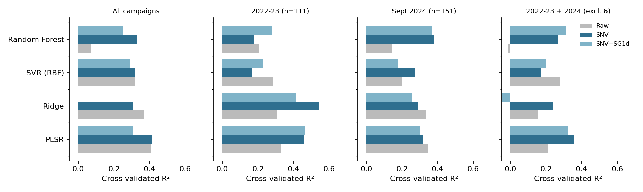
Figure 3. Cross-validated R² for every algorithm × preprocessing combination in each scenario (values below 0 are clipped).
SNV was the most useful preprocessing step in every scenario. Linear models (PLSR, Ridge) generally matched or beat the non-linear ones. Random forest was competitive only on Campaign C, where the concentration range is narrow. The derivative treatment added little and destabilised ridge regression on pooled data.

3.2 Pooled model detail
Preprocess | Model | R² | RMSECV | RPD
Raw | PLSR (11 LV) | 0.41 | 1.19 | 1.30
Raw | Ridge | 0.37 | 1.23 | 1.26
Raw | SVR (RBF) | 0.32 | 1.28 | 1.21
Raw | Random Forest | 0.07 | 1.49 | 1.04
SNV | PLSR (12 LV) | 0.42 | 1.19 | 1.31
SNV | Ridge | 0.31 | 1.29 | 1.20
SNV | SVR (RBF) | 0.32 | 1.28 | 1.21
SNV | Random Forest | 0.33 | 1.27 | 1.22
SNV+SG1d | PLSR (15 LV) | 0.31 | 1.29 | 1.20
SNV+SG1d | Ridge | 0.00 | 1.55 | 1.00
SNV+SG1d | SVR (RBF) | 0.29 | 1.31 | 1.19
SNV+SG1d | Random Forest | 0.25 | 1.34 | 1.16

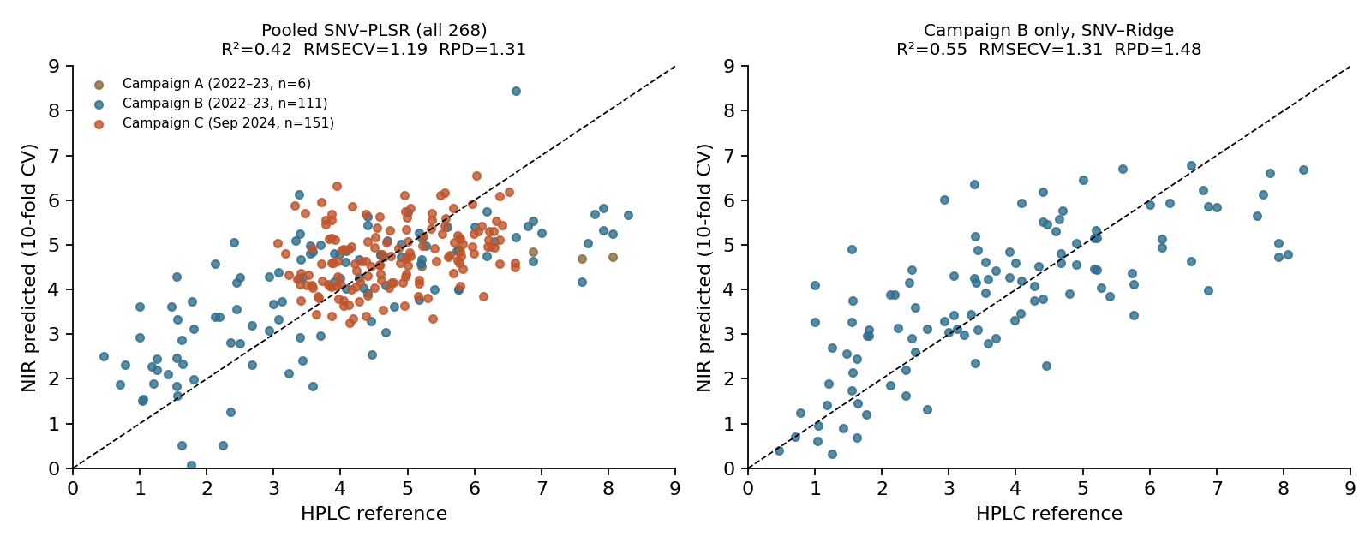
Figure 4. Cross-validated predictions against HPLC reference for the best pooled model (left) and the best Campaign B model (right).
Predictions are compressed toward the mean. High-quinine samples are under-predicted and low-quinine samples over-predicted, the typical pattern when the spectral signal explains only part of the reference variance. Campaign C points form a tight horizontal band, so within that campaign the model distinguishes samples poorly.

3.3 Cross-campaign transfer
Train on | Test on | Model | R² | RMSEP | Bias
2022–23 | Sept 2024 | PLSR | -2.44 | 1.70 | -1.02
2022–23 | Sept 2024 | Ridge | -4.90 | 2.22 | -1.70
2022–23 | Sept 2024 | SVR (RBF) | -0.72 | 1.20 | -0.52
Sept 2024 | 2022–23 | PLSR | -0.76 | 2.59 | -1.02
Sept 2024 | 2022–23 | Ridge | -1.40 | 3.02 | 2.05
Sept 2024 | 2022–23 | SVR (RBF) | -0.59 | 2.46 | 1.53

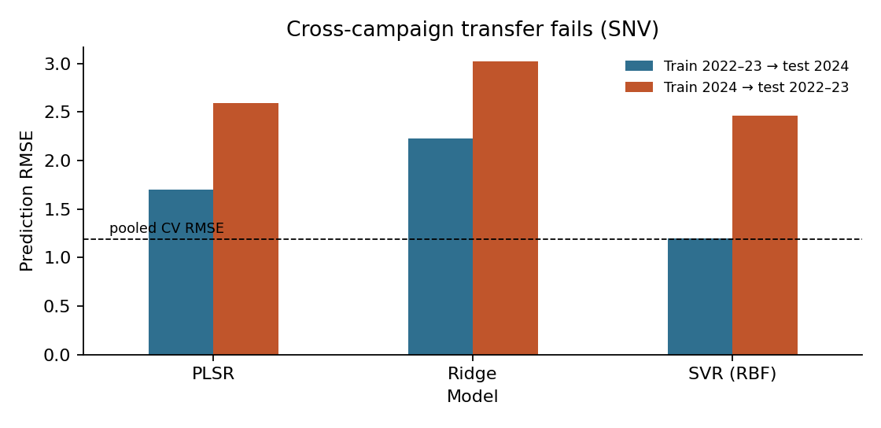
Figure 5. Prediction error when a model trained on one campaign is applied to the other (SNV spectra). The dashed line marks the pooled cross-validation error.
Every transfer test gives negative R²: the model does worse than predicting the other campaign's average. The large biases show that the spectral–reference relationship itself shifted between campaigns. Likely causes include changes in instrument or presentation, sample preparation, moisture, and HPLC calibration.

3.4 Spectral interpretation
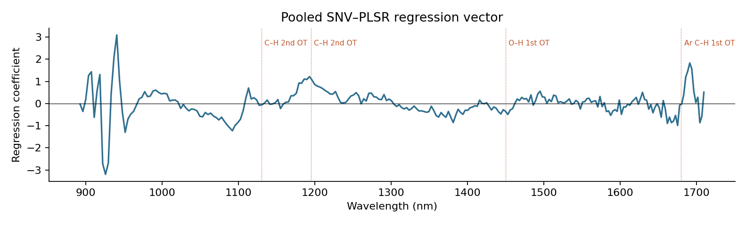
Figure 6. Regression vector of the pooled SNV–PLSR model with indicative NIR band regions.
The regression vector draws on several broad regions: C–H second-overtone bands (about 1100–1250 nm), the O–H first-overtone water band (about 1450 nm) and the aromatic C–H first-overtone region above 1650 nm. The weight on the water band suggests that moisture variation is confounding the model. The band labels are indicative assignments from general NIR literature, not confirmed for this matrix.

4. Advanced modelling
To test whether more sophisticated algorithms could overcome the limits of PLSR, eleven approaches were benchmarked. Every tuning decision (latent variables, preprocessing, variable selection, ensemble weights) was made inside the training folds only (nested cross-validation), so the scores are not inflated by selection.
Method | Idea | R² (all 268) | RPD
Scan-level neural network | MLP on PCA scores of individual SNV–derivative scans, with augmentation; sample prediction = mean of scans | 0.58 | 1.55
Stacked ensemble | Weighted blend of two PLS models, gradient boosting and SVR (non-negative weights) | 0.56 | 1.50
Gaussian process | Bayesian kernel regression on PCA scores | 0.54 | 1.47
SVR (derivative) | RBF support-vector regression on derivative spectra | 0.51 | 1.43
Local PLS | PLS fitted on the 60 nearest spectral neighbours of each sample | 0.50 | 1.41
Gradient boosting | Histogram gradient-boosted trees on PCA scores | 0.50 | 1.41
Campaign-aware PLS | Campaign-wise spectral centring plus campaign offsets | 0.49 | 1.40
PLS baseline | SNV + PLSR, latent variables chosen inside folds | 0.47 | 1.37
VIP-PLS | Wavelengths selected by VIP score | 0.47 | 1.37
PLS + auto-preprocessing | Best of six preprocessing chains chosen inside folds | 0.44 | 1.34
iPLS | Forward interval selection | 0.36 | 1.25

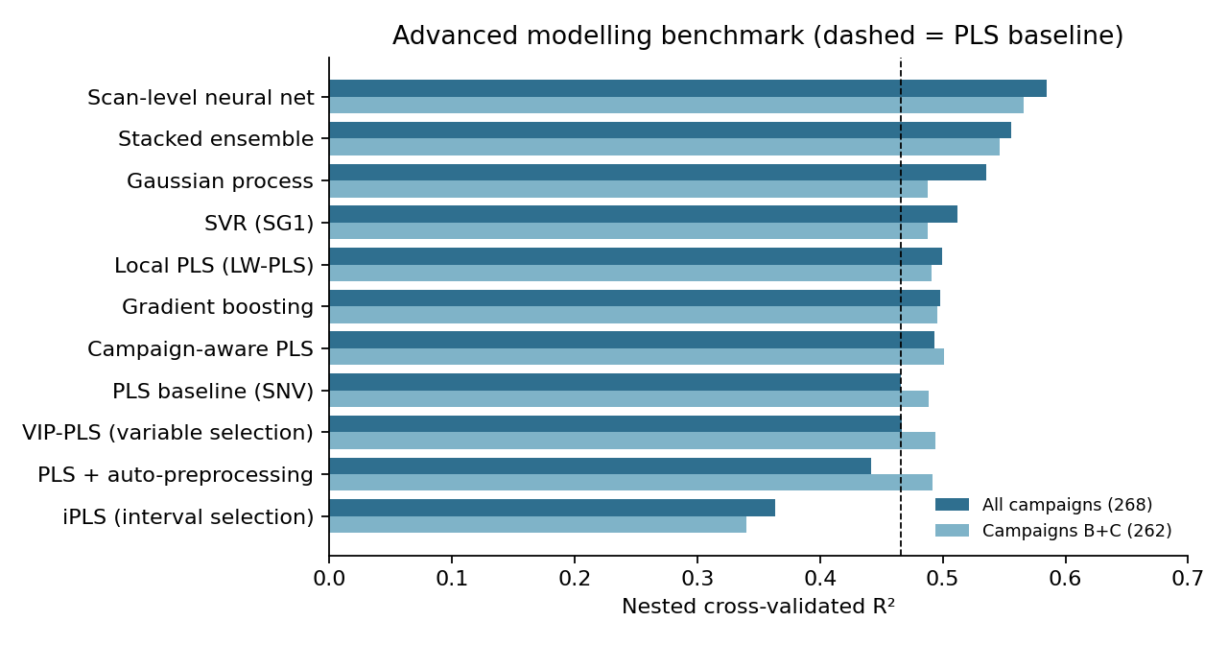
Figure 7. Nested cross-validated R² for eleven methods, with all campaigns and without Campaign A.
Three conclusions follow. First, the scan-level neural network gives the largest gain: about 10% lower error than PLS. The gain held across three different random splits (R² 0.55–0.59). Training on individual scans rather than sample averages gives the network sixteen times more examples, and the augmentation teaches it to ignore small baseline and scale shifts. Second, wavelength selection made results worse once done without peeking at test data, so there is no single clean quinine band in these spectra. Third, very different algorithms all stop at about the same accuracy. This pattern usually means the limit lies in the data, most plausibly reference uncertainty and campaign effects, and not in the algorithm.
A one-dimensional convolutional neural network, semi-supervised learning on unlabelled scans, and formal calibration transfer between instruments or campaigns (piecewise direct standardisation, external parameter orthogonalisation) remain worth testing once more data and a verified reference are available.

5. Positioning: a qualitative screening tool
Given RPD ≈ 1.5, the model is fit for ranking and grouping, not for reporting quinine content. It is therefore deployed as a qualitative screening tool that complements HPLC:
- NIR screens every sample quickly and without chemicals or sample destruction.
- Samples are assigned Low (index < 3.5), Medium (3.5–5.5) or High (> 5.5) on the HPLC reference scale. These cut-offs are working values for the laboratory to confirm.
- Samples within ±0.5 of a cut-off are flagged "Borderline – confirm by HPLC".
- Spectra that fall outside the model's training space (Hotelling T² or Q-residual beyond the 99th percentile of training scans) are flagged "Out of model domain – confirm by HPLC".
- HPLC remains mandatory for any reportable value, grading decision near a specification, or release decision.
Screening metric (10-fold CV, 268 samples) | Value
Three-class accuracy | 74% (majority-class guess 52%)
Balanced accuracy | 69%
Recall: Low / Medium / High | 65% / 86% / 58%
Samples flagged borderline | 38%
Accuracy on non-borderline samples | 81%
Low ↔ High confusion (gross error) | 1.1%
Underlying regression: R² / RMSECV / RPD | 0.58 / 1.00 / 1.55

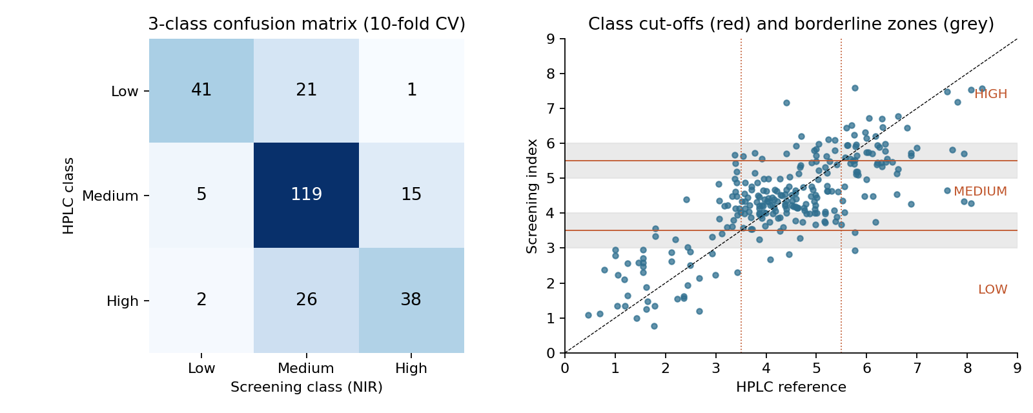
Figure 8. Left: confusion matrix of the three-class screen. Right: screening index against HPLC, with class cut-offs and borderline zones.
The main practical value is triage. A sample screened as High is very unlikely to be Low by HPLC, and the reverse also holds. The weakness is at the extremes: about a third of true Low and 40% of true High samples are pulled into Medium, because predictions are compressed toward the mean. For uses where missing high-yield bark is costly, the High cut-off can be lowered, at the cost of more false positives sent to HPLC.

6. Software and deployment
The analysis and the final model are packaged as a Python repository (cinchona-nir-quinine), intended for the Ayudyog-10 GitHub organisation.
Component | Purpose
scripts/benchmark.py | Reproduces the eleven-method nested-CV benchmark
scripts/train.py | Trains the final model; --cv reports cross-validated regression and class metrics
models/quinine_screening_model.joblib | Final model (v1.0.0) trained on all 268 samples, with a JSON model card
scripts/predict.py | Command-line screening of new spectra (CSV/Excel)
app/app.py | Streamlit web app: upload spectra, view classes and flags, download results
Dockerfile | Container deployment; the app can also be hosted on Streamlit Community Cloud

The app shows the screening-only disclaimer on every page. It averages replicate scans by sample ID, interpolates spectra on a slightly different wavelength grid, and rejects spectra that do not cover 892–1710 nm. The model file is tied to scikit-learn 1.8.0 and must be retrained if that library is upgraded. Any change of instrument, operator or sample preparation requires re-validation before use.

7. Why performance is limited
- Reference uncertainty. Spectral replicates vary by only about 2%, yet much of the reference variance stays unexplained. This is consistent with the concern that HPLC values are not fully accurate. The error of the reference method (its repeatability) caps achievable accuracy and has not been reported.
- Campaign effects. Absorbance level, scan count and the spectral–reference relationship all change between campaigns.
- Unbalanced range. Campaign C (151 samples) spans only 3.1–6.6, while the low-quinine samples come almost entirely from Campaign B.
- Moisture and physical effects. The water band contributes to the model, and particle size and moisture were not recorded.
- Small Campaign A. Six samples measured differently cannot be modelled reliably and may distort a pooled model.

8. Fitness for purpose
RPD | Typical interpretation | Current status
< 1.5 | Not reliable for prediction; rough ranking only | Classical models (1.25–1.48)
1.5–2.0 | Distinguishes high vs low | Scan-level NN (1.55): used as 3-class screen
2.0–2.5 | Approximate quantitative screening | Target for next phase
> 2.5 | Good to excellent quantitative prediction | —

The deployed model sits at the bottom of the 1.5–2.0 band. This supports its use as a High / Medium / Low screen with HPLC confirmation, and not as a replacement for HPLC in any individual-sample quantitative decision.

9. Limitations of this analysis
- Samples were identified by row position, not recorded IDs.
- No independent external test set exists; all figures are cross-validated.
- Hyperparameter search was deliberately light, so modest gains from tuning are possible but would not change the conclusions.
- Class cut-offs (3.5 / 5.5) are working values and were not optimised against a business or pharmacopoeial specification.
- Example predictions in the software use training samples and are not an independent test.

10. Recommendations and roadmap
- Verify the reference. Re-assay a stratified subset of about 30 retained samples by HPLC in duplicate, with certified quinine standards. Report repeatability (SEL). If the SEL is near 1 unit, the current models are already close to what the reference allows.
- Add metadata to the workbook: sample ID, collection date, instrument, operator, moisture and grinding/particle size, and the unit of the quinine value.
- Standardise acquisition: one instrument, one sample-presentation protocol, a fixed number of scans, and a daily reference/check-sample scan to track drift.
- Design the calibration set. Add samples below 3 and above 7 to future campaigns, and select calibration samples to cover the spectral space (e.g. Kennard–Stone).
- Handle campaign effects. Use campaign-balanced calibration, and test calibration-transfer methods (piecewise direct standardisation, or orthogonal signal correction such as EPO) using a small set of samples re-scanned under both conditions.
- Control moisture: dry to constant weight before scanning, or include moisture as a covariate.
- Re-model, then lock. Once the reference is verified, rebuild SNV + PLSR as the baseline and validate on a truly independent campaign before use.

11. Conclusion
NIR spectra carry real but partial information about quinine in Cinchona bark. A scan-level neural network improves on classical PLS and, used as a three-class screen with borderline and out-of-domain flags, reliably separates high- from low-quinine material while HPLC remains the reference method. Further gains depend less on algorithms than on data: verifying the HPLC reference, standardising acquisition across campaigns, and widening the concentration range. With those in place, the packaged tool can be retrained and re-validated, and its role reassessed.

