WHITE PAPER
Near-Infrared Screening of Paracetamol Content in Powder Blends
Consolidation of three years of METASPEQ paracetamol data, honest model validation, and a screening model with an applicability-domain check
Data: Paracetamol project folder (2024–2026): 3,343 scans, 181 physical samples, 9 collections, 892–1710 nm
Prepared for: METASPEQ / Ayudyog Private Limited, with collaboration data from Mendine Pharmaceuticals Pvt. Ltd.
Date: 17 September 2026

Executive summary
This paper brings every usable paracetamol near-infrared (NIR) scan collected by METASPEQ between January 2024 and March 2026 into one master file, and asks a simple question: how well can NIR tell how much paracetamol is in a powder blend? Two sample types were studied. The first is tablet formulations with five excipients (2024–2025). The second is paracetamol mixed with a fixed 2.00 g of talc, expressed as % label claim from 80 to 120 % (Mendine 2025 and the 2026 set).
- The earlier accuracy figures are too optimistic. The 2026 model report ranked KNN first with a test R² of 0.998. That test split individual scans at random, so scans of the same powder sat on both sides of the split. When all scans of a sample are kept together, the same models give R² 0.51–0.79 and an error of 5–8 % label claim instead of 0.5–4 %.
- The final screening model reaches R² 0.83 and RMSE 4.8 % label claim (RPD 2.5) under 5-fold sample-grouped cross-validation on 82 blend samples. On 13 re-scanned 2026 powders it gave RMSE 3.5 % label claim.
- That is good enough for screening, not for assay. A pharmacopoeial assay window of 95–105 % needs an error well under 2 %. The model is therefore released as a LOW / WITHIN RANGE / HIGH screening tool with a borderline zone that sends samples to HPLC. It never called a HIGH sample WITHIN RANGE, and called one LOW sample WITHIN RANGE out of 82.
- Models do not carry over between years. A model trained on 2026 blends predicts the 2025 Mendine blends with an error of 12–13 % label claim, and the January 2024 formulation model misses April 2024 by about 50 mg. Every new collection period needs recalibration or a calibration-transfer step.
- The Mendine Experiment-1 recovery calculation is circular. The report defined the "true value" as the mean NIR prediction. Recalculated against the weighed-in compositions, recovery is 96.4–103.5 % and the error is 0.88 % w/w (about 3.5 % label claim), which is consistent with this paper.
- An out-of-domain check works. Formulation tablets, pure paracetamol, the IPRS standard and pure talc are all flagged as outside the model, so the tool refuses to give a screening verdict for materials it was not built for.

1. Scope and material
Two excluded items should be noted. The September 2024 formulation campaign mentioned in the February 2025 status report is not in the project folder. The 25–28 March 2025 low-dose set (350–420 mg) was left out because its formulation is not documented. Its collection code (C04) is therefore skipped throughout.
The tablet formulations used 12 × dose (mg) / 1000 g of paracetamol with a fixed 1.110 g excipient mix (MCC 0.471 g, PVP 0.282 g, calcium stearate 0.188 g, talc 0.113 g, magnesium stearate 0.056 g). In the binary blends, talc is fixed at 2.00 g and paracetamol varies from 1.60 to 2.40 g. The 80–120 % label-claim range is only 44.4–54.5 % w/w, so each 1 % of label claim corresponds to about 0.25 % w/w. This is a narrow concentration window for diffuse-reflection NIR.
All reference values are gravimetric (weighed-in). No HPLC values are attached to any scan, so the errors reported here include weighing and mixing error as well as spectral error.

1.1 Collections in the master file
Code | What | Samples | Scans | Range
C01 | Formulation, Jan 2024 (raw instrument files) | 41 | 656 | 400–1200 mg
C02 | Formulation, Apr 2024, 5-min lamp rest (raw files) | 21 | 336 | 550–750 mg
C03 | Spectrafind field-test logs, 5 Mar 2025 | 3 | 520 | 550–650 mg
C05 | Mendine Exp-1: paracetamol + 2 g talc; pure API; pure talc | 23 | 454 | 80–120 % LC
C06 | Mendine Exp-2: 2 g paracetamol, talc varied | 17 | 272 | 45.5–55.6 % w/w
C07 | Mendine sub-samples 15a–d, 16a–d | 8 | 128 | 80.5–84.5 % LC
C08 | IPRS paracetamol reference standard | 1 | 4 | identity
C09 | 2026 paracetamol + talc calibration set | 57 | 912 | 80–120 % LC
C10 | Mar 2026 re-scans of C09 powders | 13 | 61 | 93–120 % LC

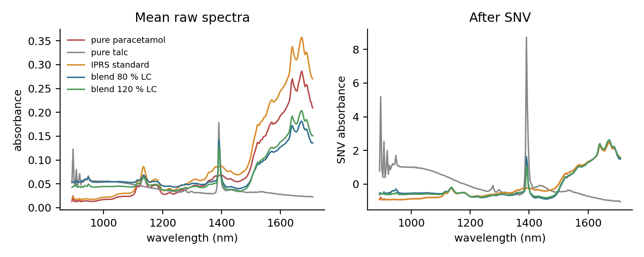
Figure 1. Mean spectra of the pure components and of 80 % and 120 % label-claim blends, before and after SNV. Talc dominates below 1300 nm and at the 1390 nm OH band; paracetamol drives the 1500–1710 nm region.

2. Data-quality findings
Building the master file required reconciling roughly 1,200 files. The absorbance calculated from the 2024 raw counts, −log10((sample − dark)/(white − dark)), matched the team's own exported absorbance exactly (maximum difference 1×10⁻¹⁶), which confirms the processing chain. The issues found are recorded in the qc_flag column of the master file.
- A pure-talc scan (11 May 2025) carried the label 101; it is stored as 0 % paracetamol.
- Mendine Experiment-2 files only held the purity value (98), so % w/w was taken from the design table by sample number.
- The C10 "test" files are re-scans of powders already in C09. They check re-scan repeatability, not new preparations. The 16 and 17 March 2026 files are subsets of the 11–12 March file.
- The 2026 samples were scanned roughly in order of label claim (correlation 0.92 between sample order and label). Instrument drift could therefore mimic a concentration signal. The three samples scanned last but labelled near 100 % (S57–S59) were predicted at 99–106 %, not near 120 %, so the model is tracking composition, but future sets should be scanned in random order.
- The 5 March 2025 field test logged predictions of about 330 mg for a 550 mg reference and 506 mg for 600 mg, showing the formulation model deployed at that time did not work on that day.
- The raw spectra show a sharp spike near 1390 nm and noise below 950 nm in every collection. These regions deserve attention when the optical path is next serviced.

3. Methods
Spectra were preprocessed with standard normal variate (SNV), alone or followed by a Savitzky–Golay first derivative (window 15, polynomial order 2). The models compared were partial least squares regression (PLSR, 4–15 latent variables), ridge regression, support-vector regression (SVR, RBF kernel), k-nearest neighbours (KNN, k = 3) and random forest (RF). Models were trained on individual scans; each sample's result is the average (benchmarks) or median (final model) of its scans.
Two validation schemes were compared. The random scheme holds out 20 % of scans at random, as in the 2026 training report. The grouped scheme uses 5-fold cross-validation in which all scans of a physical sample are held out together. Only the grouped scheme reflects how the model will meet a new powder. Transfer was tested by training on one collection and predicting another. Performance is reported as R², root-mean-square error (RMSE) and RPD (standard deviation of the reference divided by RMSE).

4. Results

4.1 The validation scheme changes the answer
Figure 2 shows the same models on the 2026 blends under both schemes. With a random scan split, SVR and KNN appear to predict within 0.7–0.8 % label claim. With sample-grouped validation their error rises to 5.0–5.6 %, and PLSR to 7.7 %. The random split mainly measures how alike repeat scans of one powder are.
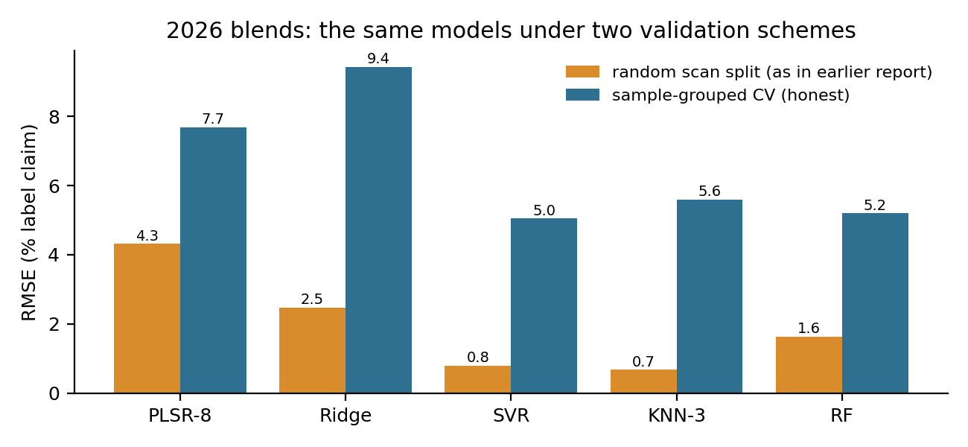
Figure 2. Sample-level RMSE for the 2026 blend set (C09, SNV) under a random scan split and under sample-grouped cross-validation.

4.2 Performance within each collection (sample-grouped CV)
Collection | Target | Best model | R² | RMSE | RPD
C09 blends 2026 (57) | % LC | SNV + SVR | 0.79 | 5.05 | 2.19
C05 Mendine blends 2025 (17) | % LC | SNV + PLSR-8 | 0.95 | 2.87 | 4.40
Pooled blends C05+C07+C09 (82) | % LC | SNV-SG1 + RF / SVR | 0.83–0.84 | 4.7–4.8 | 2.5
C01 formulation Jan 2024 (41) | mg | SNV-SG1 + SVR | 0.96 | 41.7 mg | 5.12
C02 formulation Apr 2024 (21) | mg | SNV-SG1 + RF | 0.79 | 27.9 mg | 2.22
C06 Mendine Exp-2 (17) | % w/w | SNV + RF | 0.65 | 1.84 | 1.73

The small Mendine set behaves best and is well described by a linear PLSR model. The larger 2026 set is noisier and needs non-linear models. The 2024 formulation models look reasonable relative to their wide dose range, but an error of 30–40 mg per tablet is far from assay quality. The talc-varied Experiment-2 set spans a narrow range and is only weakly predictable.

4.3 Models do not transfer between collections
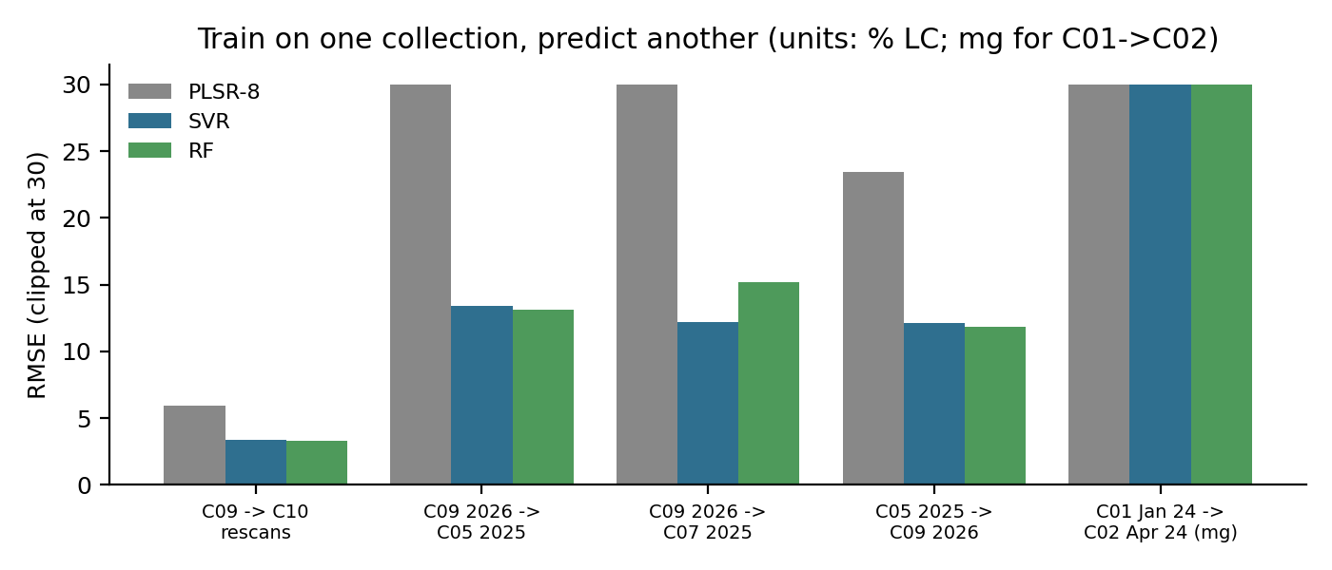
Figure 3. Error when a model trained on one collection predicts another (PLSR errors above 30 are clipped).
Within 2026, a model trained on C09 predicts the C10 re-scans with RMSE 3.3–3.4 % label claim (SVR, RF). Across years, errors jump to 12–15 % label claim with systematic bias, and the January 2024 model predicts April 2024 with an error of 49–150 mg. Instrument changes, white-reference handling, lamp condition, humidity and sample packing all shift the spectra between sessions. A pooled model that sees several sessions is more robust, which is why the final model uses all three blend collections.

4.4 Final screening model
The released model averages SVR and random forest on SNV + first-derivative spectra, trained on 1,492 scans from 82 samples (C05, C07, C09). Its 5-fold sample-grouped result is R² 0.83, RMSE 4.84 % label claim, RPD 2.48 and bias +0.24 (Figure 4). By collection, RMSE was 5.1 for C09, 3.2 for C05 and 5.9 for the narrow-range C07 set. On the 13 C10 re-scanned powders it gave RMSE 3.5 % label claim and bias +1.2; the largest miss was the 120 % sample, predicted at 112 %.
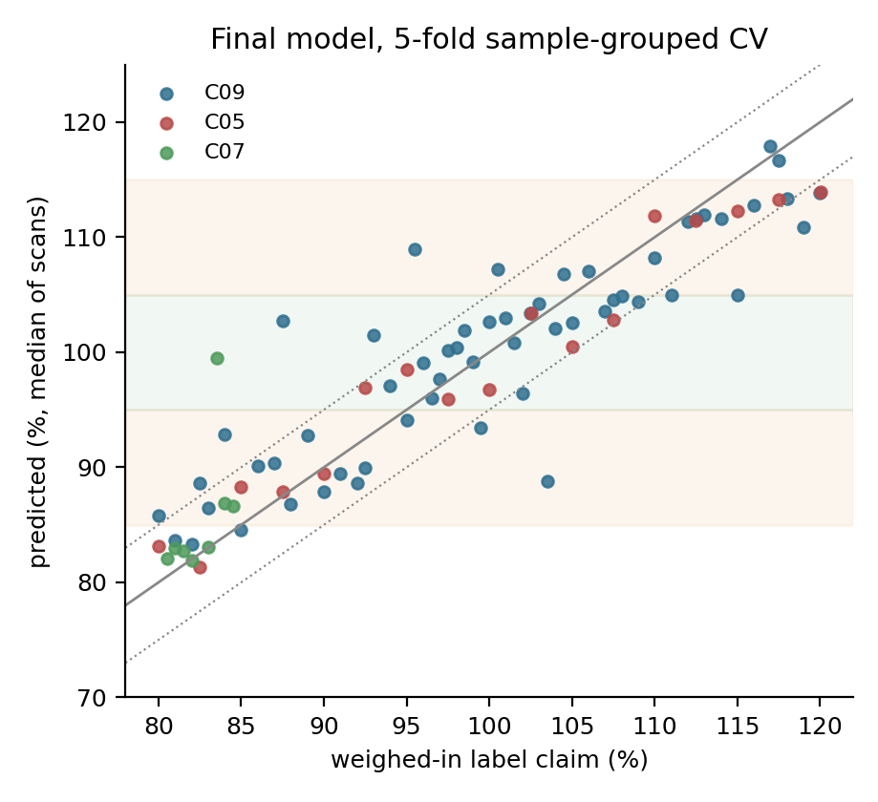
Figure 4. Predicted versus weighed-in label claim for 82 held-out samples. Green band: 95–105 %; orange bands: borderline zones; dotted lines: ±5 %.
For screening, results are placed in bands: LOW below 85 %, WITHIN RANGE 95–105 %, HIGH above 115 %, and BORDERLINE (confirm by HPLC) in between. Figure 5 shows the outcome. No HIGH sample was called WITHIN RANGE, one LOW sample was called WITHIN RANGE, and most errors fell into the BORDERLINE zone, which routes the sample to HPLC. Seven HIGH samples were called BORDERLINE, which is a safe but inefficient outcome.
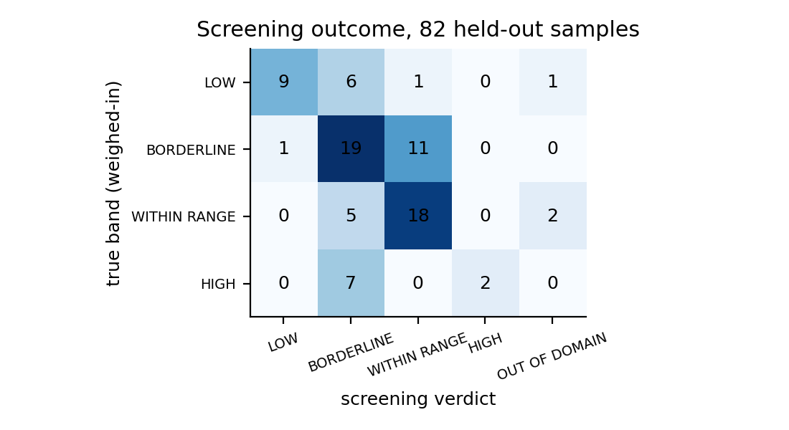
Figure 5. Screening verdict against the true band for the 82 held-out samples.

4.5 Applicability domain and identity
Each scan is compared with the calibration set using a 10-component PCA: Hotelling T² measures how unusual a scan is within the model space, and the Q residual measures what the model cannot describe. Limits are the 99th percentiles of the calibration scans. A sample receives a verdict only if at least half its scans pass and its SNV spectrum correlates at least 0.95 with the calibration mean.
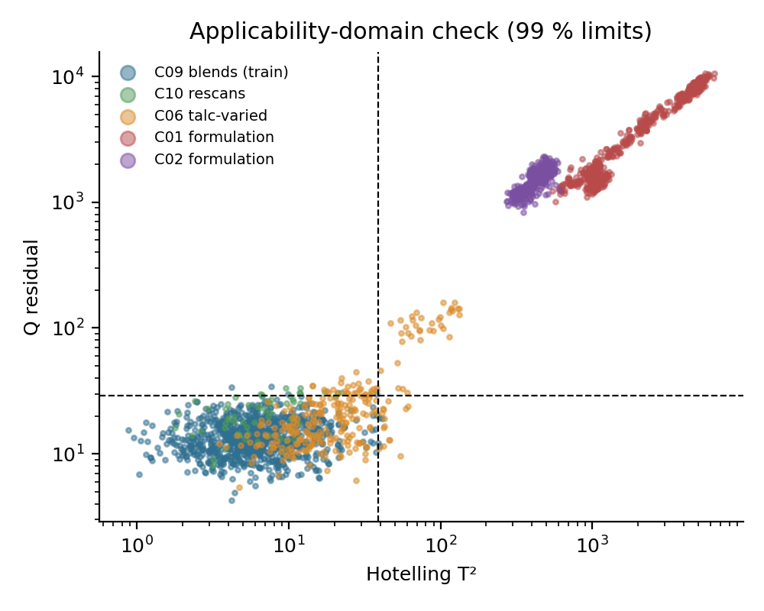
Figure 6. T² and Q for calibration scans, re-scans, the talc-varied set and the 2024 formulations. Dashed lines mark the 99 % limits.
All 62 formulation samples (C01, C02), the three field-test samples, the IPRS standard, pure paracetamol and pure talc were flagged out of domain. Pure talc was the clearest case (correlation −0.36). Most talc-varied Experiment-2 samples fell inside the domain, as expected for the same two components. A dedicated identity test (for example, correlation against the IPRS spectrum) would need its own acceptance limit, because pure paracetamol and the blends both correlate above 0.9 with the standard.

5. Re-analysis of the Mendine Experiment-1 accuracy report
The May 2025 report calculated % recovery as NIR estimate divided by spiked value, but its "true value" was itself the mean NIR prediction over 14–16 May. Using the four NIR runs in the prediction-result workbook against the weighed-in compositions gives the following:
- Recovery 96.4–103.5 % (mean 100.1 %), inside the 90–110 % limit quoted in the report.
- RMSEP 0.83–0.97 % w/w per day, 0.88 % w/w overall (about 3.5 % label claim); R² 0.94 for the four-run mean.
- Between-day RSD of the NIR result: median 0.64 %, maximum 2.44 %.
These figures support the report's conclusion but should replace its recovery column. It is not documented whether the prediction model used at Mendine was trained on the same 17 blends. If it was, these values are optimistic; the grouped cross-validation above (RMSE 2.9–3.6 % label claim for C05) suggests the true figure is similar.

6. Intended use
The model is a screening tool for paracetamol–talc blends scanned on the METASPEQ 892–1710 nm module. It sorts samples into bands and flags anything unlike its calibration set. It is not a quantitative assay, it does not replace the pharmacopoeial HPLC method, and its output must not be used for batch release. Formulations with other excipients are outside its scope.

7. Recommendations
- Adopt sample-grouped validation as the house standard. Retire the random scan split from all reports and from Spectrafind model ranking.
- Randomise scan order and record conditions. Scan samples in random order, log temperature, humidity, white-reference time and lamp warm-up, and store dark and white spectra with every scan.
- Prepare genuinely independent validation blends. Weigh 15–20 new blends on a different day (and ideally by a different analyst) and keep them out of training.
- Add HPLC on a subset. Assaying 15–20 blends would separate weighing and mixing error from NIR error.
- Plan calibration maintenance. Include a few blends and the IPRS standard in every session so that drift can be corrected (slope/bias update or piecewise direct standardisation) instead of rebuilding models.
- Restart formulation work with documented recipes. Include excipient variation and a random scan order before attempting dose prediction in tablets again.
- Service the optics. Investigate the 1390 nm spike and the noisy region below 950 nm.

8. Conclusion
NIR carries real information about paracetamol content in talc blends. A pooled model predicts new powders within about 5 % label claim and reliably flags materials it was not built for. That supports a screening role with an HPLC confirmation route, not an assay claim. The largest gains will come from better experimental design (independent validation sets, random scan order, stored reference spectra and a calibration-maintenance routine) rather than from new algorithms.

Appendix: deliverables
Item | Content
Paracetamol_NIR_Master_Raw_Spectra.xlsx | All 3,343 scans with metadata, raw detector counts, dark and white references, sample register, column dictionary
paracetamol-nir-screening (GitHub) | Master-file builder, benchmarking, training, CLI prediction, Streamlit app, model card, figures and result tables
models/paracetamol_blend_screening_model.joblib | Final SVR + RF ensemble with domain limits (scikit-learn 1.8.0, Python 3.12)

