# Main page

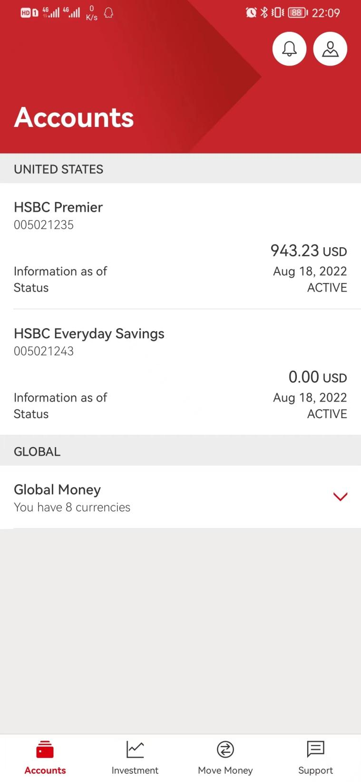

### United States:

/mobilex-us-accounts-eapi-cert-proxy/v3/accounts

### Global money:

GMA-PAPI GET /wallet/user

GVGT-PAPI GET /globalAccounts/gv

-> gvgt-sapi /linkedIdentities

-> /wallet-core-us-hbus/api/e2e/v1/wallet-customers

-> /wallet-core-us-hbus/api/e2e/v1/global-wallets/WAxxxx

-> transform to get all wallet balance

-> GMA-PAPI GET /wallet/user