Azure Resource Provisioning and Virtual Machine Deployment

Project Overview
This document summarizes hands-on experience deploying Azure resources and virtual machines using the Azure Portal.
- Created and managed core Azure resources
- Deployed and configured an Azure Virtual Machine
-----

Azure Resource Provisioning
This section documents the creation and management of core Azure resources using the Azure Portal, including subscription selection, resource group setup, and foundational configuration.
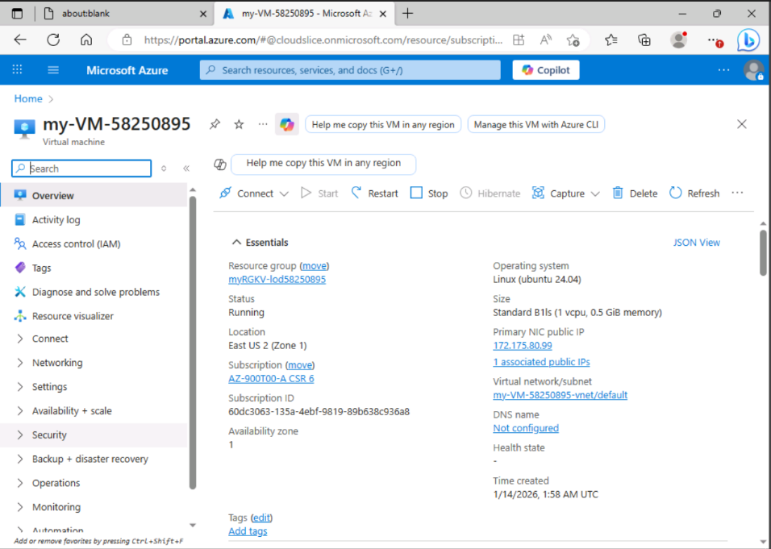

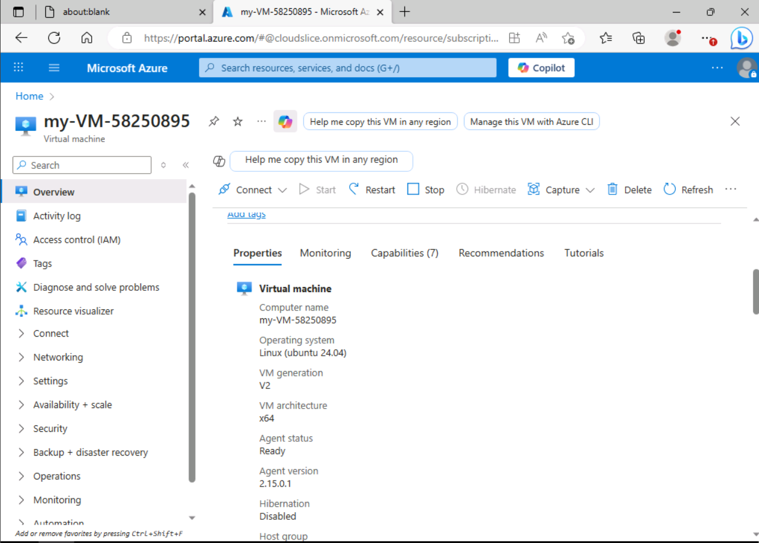

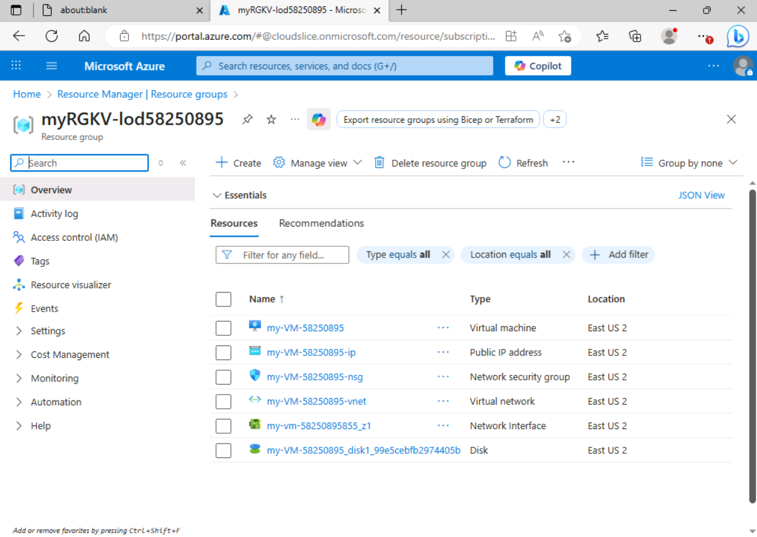

Azure Virtual Machine Deployment
This section documents the deployment and configuration of an Azure Virtual Machine using the Azure Portal, including resource selection, configuration choices, and validation steps.
