**REACT**

**WEEK 6**

**ReactJS HOL-1**

**CODE:**

**App.js**

import React from 'react';

function App() {

  return (

    <div>

      <h1>Welcome to the first session of React</h1>

    </div>

  );

}

export default App;

**OUTPUT:**

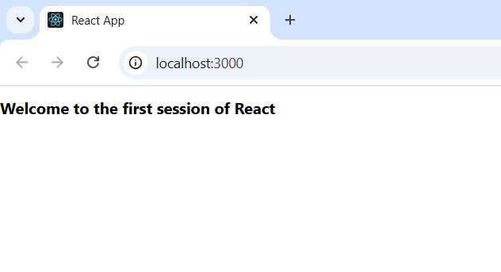

**ReactJS HOL-2**

**CODE:**

**App.js**

import React from 'react';

import Home from './Components/Home';

import About from './Components/About';

import Contact from './Components/Contact';

function App() {

  return (

    <div>

      <Home />

      <About />

      <Contact />

    </div>

  );

}

export default App;

**OUTPUT:**

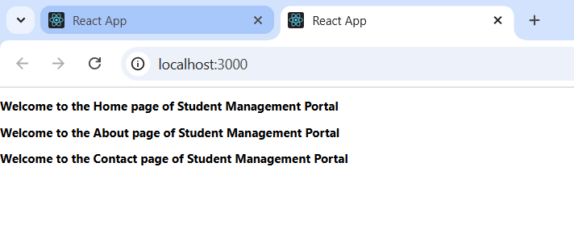

**ReactJS HOL-3**

**CODE:**

**App.js**

import React from 'react';

import CalculateScore from './Components/CalculateScore';

function App() {

  return (

    <div>

      <h1>Score Calculator</h1>

      <CalculateScore name="Aman" school="DAV Public School" total={480} goal={6} />

    </div>

  );

}

export default App;

**OUTPUT:**

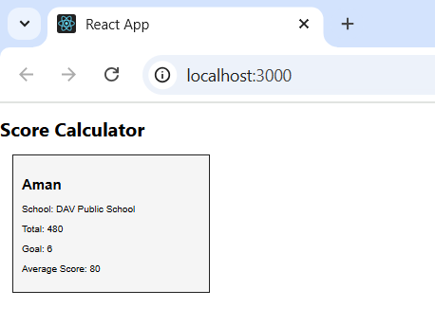

**ReactJS HOL-4**

**CODE:**

**App.js**

import React from 'react';

import Posts from './Posts';

function App() {

  return (

    <div>

      <h1>Blog App</h1>

      <Posts />

    </div>

  );

}

export default App;

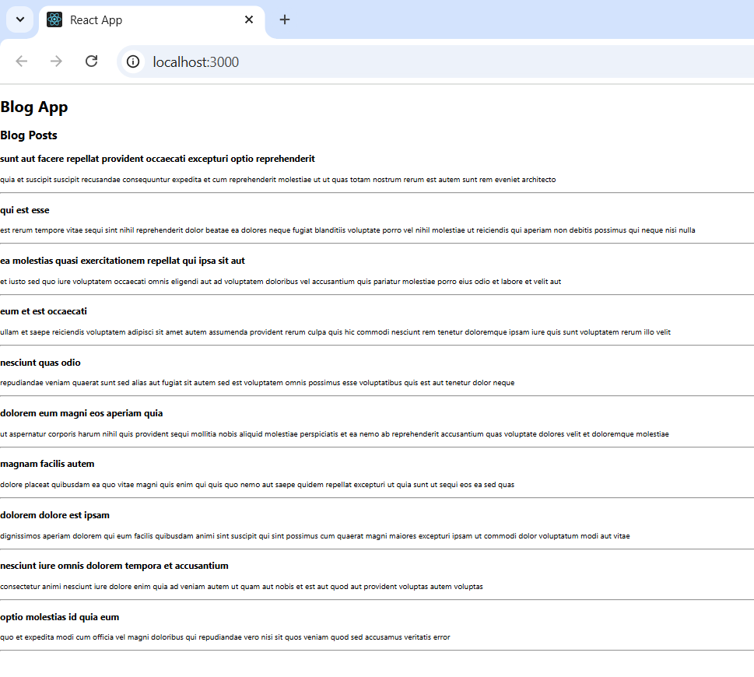**OUTPUT:**

**ReactJS HOL-5**

**CODE:**

**App.js**

import React from 'react';

import CohortDetails from './Components/CohortDetails';

function App() {

  const cohorts = [

    { name: "React Bootcamp", status: "ongoing", start: "01-Aug", end: "30-Aug" },

    { name: "NodeJS Batch", status: "completed", start: "01-Jul", end: "30-Jul" },

  ];

  return (

    <div>

      <h1>My Academy Dashboard</h1>

      {cohorts.map((cohort, index) => (

        <CohortDetails key={index} cohort={cohort} />

      ))}

    </div>

  );

}

export default App;

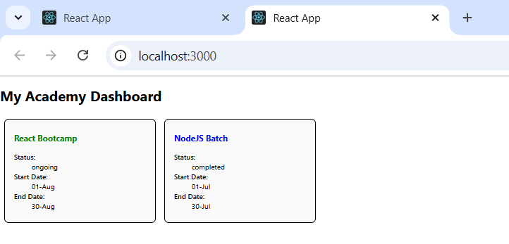**OUTPUT:**