 |  | ISSUE HISTORY
ISSUE | Description of Change |  | Status | Originator | Effective Date
1 | Initial Release |  | In progress | QA Lead | 1, May 2026
REFERENCE DOCUMENTS
DOCUMENT NUMBER | DOCUMENT TITLE

CONTENTS | Page |  | FOR DOCUMENT CONTROL USE ONLY
1 PURPOSE | 1
2 SCOPE | 1
3 PROCESS OWNER | 1
4 INVOLVED | 2
5 DEFINITIONS AND ABBREVIVTIONS | 2
6 PROCEDURES | 3
7 RECORDS | 12
8 RELATED DOCUMENTS | 12

1. PURPOSE
This SOP defines the standard QA processes, responsibilities, and workflows to ensure software quality and consistency.

2. SCOPE
Applies to requirement analysis, test planning, execution, defect management, Functional testing, regression testing, Retesting, and reporting.

3. PROCESS OWNER
QA Lead / QA Manager is responsible for implementation and monitoring of this SOP.

4. INVOLVED
QA Engineers, QA Lead, Developers, Product Owners, Business Analysts, Project Managers.

5. DEFINITIONS AND ABBREVIATIONS
QA: Quality Assurance
UAT: User Acceptance Testing
SOP: Standard Operating Procedure

6. PROCEDURES
The QA process shall follow standardized testing and defect management procedures.

  - Process Flowchart
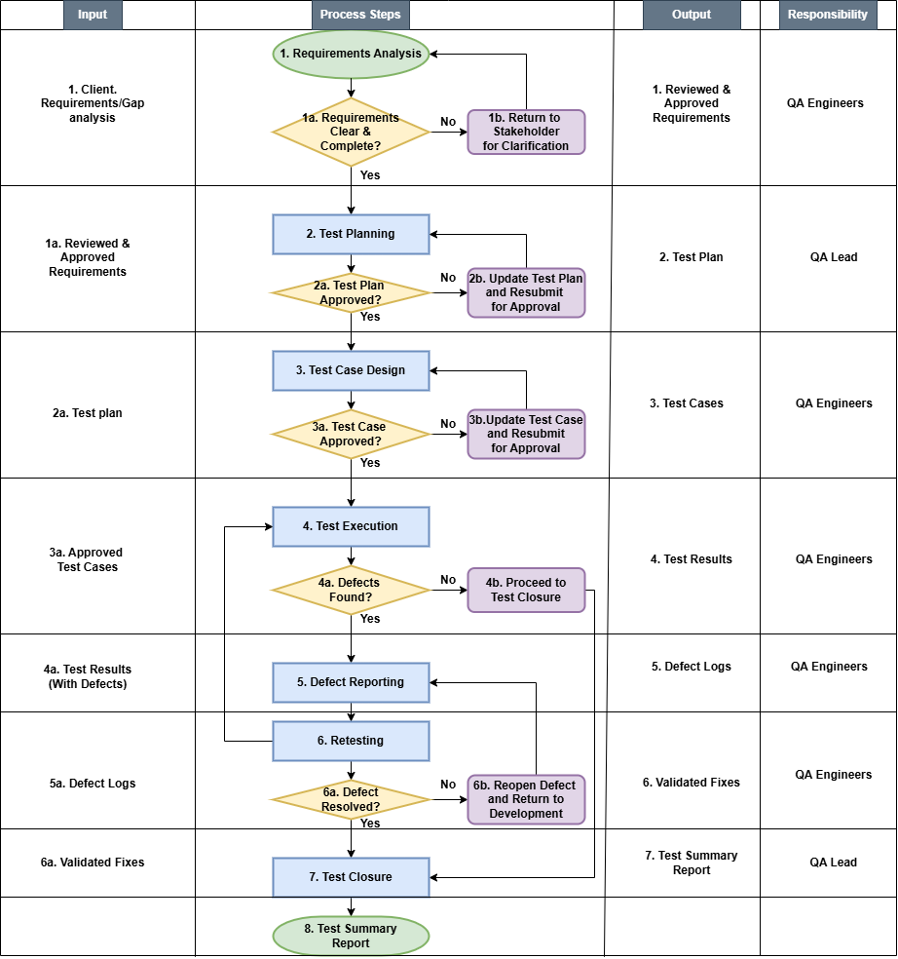

1.2 Description of Process Steps
FLW | Process Steps Description
1 | This phase begins once the requirements document is available. The QA team analyzes each requirement to determine:  - Testability: Can the requirement be verified through testing?  - Clarity: Are the requirements unambiguous?  - Completeness: Are all necessary details present?  - Consistency: Do requirements conflict with each other?  Activities:  - Requirement Review: - Read and understand each requirement  - Identify Testable Requirements: - Determine which requirements can be tested.  - Clarify Ambiguities: - Ask questions to BAs/POs to resolve unclear requirements.  - Identify Priority: - Classify requirements as High, Medium, or Low priority.
2 | This is the strategic phase where the QA Lead defines:  - What to test (scope)  - How to test (approach, techniques)  - Who will test (resources, roles)  - When testing will happen (schedule)  - What resources are needed (tools, environments)
3 | - This is the design phase where test cases are created, reviewed, and baselined.  - Create test scenarios, test cases, and test data based on requirements.  - Test cases are detailed steps that verify specific functionality.  - Ensure coverage and traceability.
4 | - This is the execution phase where test cases are run, actual results are compared to expected results, and defects are logged.  - Record actual results
5 | - Defect Reporting is the process of identifying, documenting, and communicating any deviation between actual and expected results found during test execution. It involves capturing detailed information about a defect so that developers can reproduce, analyze, and fix it, while providing stakeholders visibility into product quality.  - Log, classify, and track identified defects for resolution.  - Assign severity and priority
6 | - Retesting (also known as confirmation testing) is the process of executing test cases that previously failed, after the associated defect has been fixed by the developer, to verify that the fix correctly resolves the issue.  - Verify fixes provided by developer.  - Re-execute failed test cases.
7 | - Test Closure (also known as Test Completion) is the final phase of the Software Testing Life Cycle (STLC) where testing activities are formally concluded, all test artifacts are archived, metrics are analyzed, and a final test summary report is prepared and approved by stakeholders.  - Ensure that all test cases are executed.  - Ensure exit criteria are met.  - Finalize testing activities and prepare test summary and closure reports.  - Obtain sign-off

1.3 Additional Descriptions to Process Steps
All testing activities must follow risk-based testing practices and defect escalation procedures.

1.4 Records
- Test Plan
- Test Cases
- Defect Reports
- RTM
- Test Execution Reports
- Test Summary Reports

1.5 Related Documents
Document Number | Document Title
TCT/QA/001 | Test Case Template
OF/QA/001 | Defect Report Form
CL/QA/001 | Daily QA Workflow template
TPT/QA/001 | Test Plan Template
GL/QA/001 | Defect Severity Guideline
RTM/QA/001 | Requirement Traceability Matrix

7. RECORDS
Test Cases, Defect Reports, RTM, Test Summary Reports.

8. RELATED DOCUMENTS
Related QA templates and policies.

Approval
Name | ________________
Signature | ________________
Date | ________________

