Supporting information SI3: additional analysis
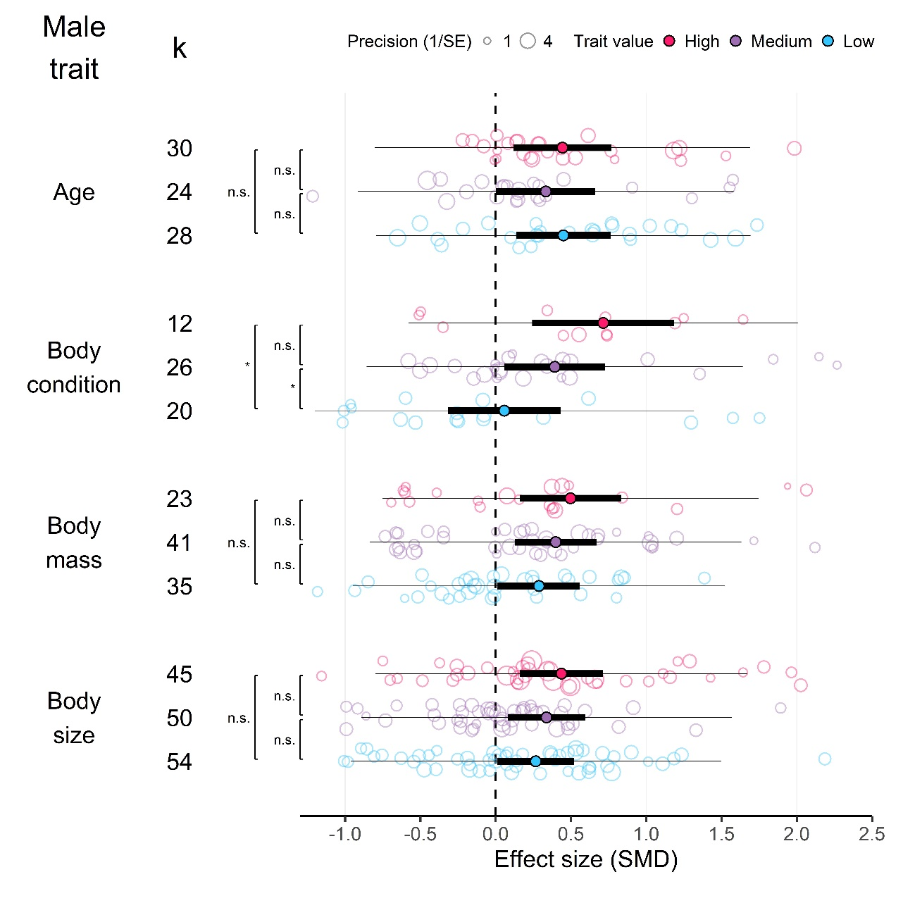
Figure S1. Mean effect sizes for male mate choice according to male phenotypes, for different male traits, using only data in which male quality could not be verified. Positive values represent that males invest more in high-quality females than in low-quality females. Thick horizontal lines represent 95% confidence interval and thin horizontal lines represent prediction interval. k is the number of effect sizes in each category. Pairwise comparisons were conducted within each male trait.

