Appendix D Methods for phylogenetic reconstruction and the resulting phylogenies used in phylogenetic meta-analyses.

Table D1: Sources used to construct phylogenies and estimate branch lengths.
Study | Abbrev. | Taxa | Phylogenetic Tree Sources | Branch Length Sources
Aerts 2006 J. Ecol. | AE06 | plants | 34 | 35
Agrawal et al. 2005 Ecology | AE05 | plants | 34 | 35
Bancroft et al. 2007 Ecol. Lett. | BE07 | animals | 1-6 | 47
Batary & Baldi 2004 Cons. Biol. | BB04 | birds | 7,33 | 47
Bolnick & Preisser 2005 Ecology | BP05 | animals | 5-6,8-10 | 47
Connor et al. 2000 Ecology | CE00 | animals | 7,10,24-25,33 | 47
Cote & Sutherland 1997 Cons. Biol. | CS97 | birds | 7,33 | 7
Harrison et al. 2009 J. Evol. Biol. | HE09 | birds | 7,33 | 7
Hoeksema et al. 2010 Ecol. Lett. | HE10 | plants | 34 | 35
Honnay et al. 2008 Oikos | HE08 | plants | 34 | 35
Huberty & Denno 2004 Ecology | HD04 | arthropods | 38,40-41 | 47
Ilisson & Chen 2009 J. Veg. Sci. | IC09 | plants | 34 | 35
Jactel& Brockerhoff 2007 Ecol. Lett. | JB07 | arthropods | 36-39 | 47
Leimu & Koricheva 2006 Am. Nat. | LK06 | plants | 34 | 35
Leimu et al. 2006 J. Ecol. | LE06 | plants | 34 | 35
Mackenzie et al. 2003 Marine Ecol. | ME03 | animals | GenBank, Table D2 | Table D2
McCall & Fordyce 2010 J. Ecol. | MF10 | plants | 34 | 35
Moller & Ninni 1998 Behav. Ecol. Socio. | MN98 | birds | 7,33 | 7
Ord & Stamps 2009 Am. Nat. | OS09 | animals | 7,11-13 | 47
Parker et al. 2005 Cons. Biol. | PaE05 | birds | 7,33 | 7
Persson et al. 2010 Oikos | PeE10 | multiple | 10,14,15,16 | 47
Poissant et al. 2010 Evolution | PoE10 | multiple | 7,10,24,26-27,33 | 47
Preisser et al. 2005 Ecology | PrE05 | multiple | 10,17-22 | 47
Robar et al. 2010 Oikos | RE10 | animals | 24,44-46 | 47
Schlossberg & King 2008 Ecol. Appl. | SK08 | birds | 7,33 | 7
Simmons 2005 AREES | Si05 | arthropods | 10 | 47
Torres-Vila & Jennions 2005 Behav. Ecol. | TE04 | arthropods | 23 | 47
Torres-Vila et al. 2004 Behav. Ecol. | TJ05 | arthropods | 23 | 47
Vanderklift & Ponsard 2003 Oecologia | VP03 | animals | 1,7,10,24,26,28-33 | 47
Vollestad et al. 1999 Heredity | VE99 | animals | 24,42-43 | 47

References for Table D1

¹ Regier, J. C., J. W. Shultz, and R. E. Kambic. 2005. Pancrustacean phylogeny: hexapods are terrestrial crustaceans and maxillopods are not monophyletic. Proceedings of the Royal Society B-Biological Sciences 272:395-401.
² Tsang, L. M., K. Y. Ma, S. T. Ahyong, T. Y. Chan, and K. H. Chu. 2008. Phylogeny of Decapoda using two nuclear protein-coding genes: Origin and evolution of the Reptantia. Molecular Phylogenetics and Evolution 48:359-368.
³ Miya, M., and M. Nishida. 2000. Use of Mitogenomic Information in Teleostean Molecular Phylogenetics: A Tree-Based Exploration under the Maximum-Parsimony Optimality Criterion. Molecular Phylogenetics and Evolution 17:437-455.
⁴ Ishiguro, N. B., M. Miya, and M. Nishida. 2003. Basal euteleostean relationships: a mitogenomic perspective on the phylogenetic reality of the "Protacanthopterygii". Molecular Phylogenetics and Evolution 27:476-488.
⁵ Frost, D. R., T. Grant, J. Faivovich, R. H. Bain, A. Haas, C. F. B. Haddad, R. O. De Sa, A. Channing, M. Wilkinson, S. C. Donnellan, C. J. Raxworthy, J. A. Campbell, B. L. Blotto, P. Moler, R. C. Drewes, R. A. Nussbaum, J. D. Lynch, D. M. Green, and W. C. Wheeler. 2006. The amphibian tree of life. Bulletin of the American Museum of Natural History:8-370.
⁶ Hillis, D. M., and T. P. Wilcox. 2005. Phylogeny of the New World true frogs (Rana). Molecular Phylogenetics and Evolution 34:299-314.
⁷ Hackett, S. J., R. T. Kimball, S. Reddy, R. C. K. Bowie, E. L. Braun, M. J. Braun, J. L. Chojnowski, W. A. Cox, K. L. Han, J. Harshman, C. J. Huddleston, B. D. Marks, K. J. Miglia, W. S. Moore, F. H. Sheldon, D. W. Steadman, C. C. Witt, and T. Yuri. 2008. A phylogenomic study of birds reveals their evolutionary history. Science 320:1763-1768.
⁸ Che, J., J. F. Pang, H. Zhao, G. F. Wu, E. M. Zhao, and Y. P. Zhang. 2007. Phylogeny of Raninae (Anura : Ranidae) inferred from mitochondrial and nuclear sequences. Molecular Phylogenetics and Evolution 43:1-13.
⁹ Marjanovic, D., and M. Laurin. 2007. Fossils, molecules, divergence times, and the origin of Lissamphibians. Systematic Biology 56:369-388.
¹⁰ Wheeler, W. C., M. Whiting, Q. D. Wheeler, and J. M. Carpenter. 2001. The phylogeny of the extant hexapod orders. Cladistics 17:113-169.
¹¹ Breden, F., M. B. Ptacek, M. Rashed, D. Taphorn, and C. A. Figueiredo. 1999. Molecular phylogeny of the live-bearing fish genus Poecilia (Cyprinodontiformes : Poeciliidae). Molecular Phylogenetics and Evolution 12:95-104.
¹² Hrbek, T., J. Seekinger, and A. Meyer. 2007. A phylogenetic and biogeographic perspective on the evolution of poeciliid fishes. Molecular Phylogenetics and Evolution 43:986-998.
¹³ Fry, B. G., N. Vidal, J. A. Norman, F. J. Vonk, H. Scheib, S. F. R. Ramjan, S. Kuruppu, K. Fung, S. B. Hedges, M. K. Richardson, W. C. Hodgson, V. Ignjatovic, R. Summerhayes, and E. Kochva. 2006. Early evolution of the venom system in lizards and snakes. Nature 439:584-588.
¹⁴ Ponder, W. F., and D. R. Lindberg. 1997. Towards a phylogeny of gastropod molluscs: Analysis using morphological characters. Zoological Journal of the Linnean Society 119:83-265.
¹⁵ Colbourne, J. K., and P. D. N. Hebert. 1996. The systematics of North American Daphnia (Crustacea: Anomopoda): A molecular phylogenetic approach. Philosophical Transactions of the Royal Society of London Series B-Biological Sciences 351:349-360.
¹⁶ Taylor, D. J., P. D. N. Hebert, and J. K. Colbourne. 1996. Phylogenetics and evolution of the Daphnia longispina group (Crustacea) based on 12S rDNA sequence and allozyme variation. Molecular Phylogenetics and Evolution 5:495-510.
¹⁷ Ball, S. L., P. D. N. Hebert, S. K. Burian, and J. M. Webb. 2005. Biological identifications of mayflies (Ephemeroptera) using DNA barcodes. Journal of the North American Benthological Society 24:508-524.
¹⁸ Ogden, T. H., and M. F. Whiting. 2005. Phylogeny of Ephemeroptera (mayflies) based on molecular evidence. Molecular Phylogenetics and Evolution 37:625-643.
¹⁹ Thomas, M. A., K. A. Walsh, M. R. Wolf, B. A. McPheron, and J. H. Marden. 2000. Molecular phylogenetic analysis of evolutionary trends in stonefly wing structure and locomotor behavior. Proceedings of the National Academy of Sciences of the United States of America 97:13178-13183.
²⁰ Koenemann, S., R. A. Jenner, M. Hoenemann, T. Stemme, and B. M. von Reumont. 2010. Arthropod phylogeny revisited, with a focus on crustacean relationships. Arthropod Structure & Development 39:88-110.
²¹ Miya, M., H. Takeshima, H. Endo, N. B. Ishiguro, J. G. Inoue, T. Mukai, T. P. Satoh, M. Yamaguchi, A. Kawaguchi, K. Mabuchi, S. M. Shirai, and M. Nishida. 2003. Major patterns of higher teleostean phylogenies: a new perspective based on 100 complete mitochondrial DNA sequences. Molecular Phylogenetics and Evolution 26:121-138.
²² Friedrich, M., and D. Tautz. 1997. Evolution and phylogeny of the diptera: A molecular phylogenetic analysis using 28S rDNA sequences. Systematic Biology 46:674-698.
²³ Mutanen, M., N. Wahlberg, and L. Kaila. 2010. Comprehensive gene and taxon coverage elucidates radiation patterns in moths and butterflies. Proceedings of the Royal Society B-Biological Sciences 277:2839-2848.
²⁴ Prasad, A. B., M. W. Allard, and E. D. Green. 2008. Confirming the phylogeny of mammals by use of large comparative sequence data sets. Molecular Biology and Evolution 25:1795-1808.
²⁵ Vondohlen, C. D., and N. A. Moran. 1995. MOLECULAR PHYLOGENY OF THE HOMOPTERA - A PARAPHYLETIC TAXON. Journal of Molecular Evolution 41:211-223.
²⁶ Bourlat, S. J., C. Nielsen, A. D. Economou, and M. J. Telford. 2008. Testing the new animal phylogeny: A phylum level molecular analysis of the animal kingdom. Molecular Phylogenetics and Evolution 49:23-31.
²⁷ Yeates, D. K., and B. M. Wiegmann. 1999. Congruence and controversy: Toward a higher-level phylogeny of diptera. Annual Review of Entomology 44:397-428.
²⁸ Giribet, G., G. D. Edgecombe, and W. C. Wheeler. 2001. Arthropod phylogeny based on eight molecular loci and morphology. Nature 413:157-161.
²⁹ Bininda-Emonds, O. R. P., J. L. Gittleman, and A. Purvis. 1999. Building large trees by combining phylogenetic information: a complete phylogeny of the extant Carnivora (Mammalia). Biological Reviews 74:143-175.
³⁰ Li, C. H., G. Orti, G. Zhang, and G. Q. Lu. 2007. A practical approach to phylogenomics: the phylogeny of ray-finned fish (Actinopterygii) as a case study. Bmc Evolutionary Biology 7:11.
³¹Koop, B. F., K. R. von Schalburg, J. Leong, N. Walker, R. Lieph, G. A. Cooper, A. Robb, M. Beetz-Sargent, R. A. Holt, R. Moore, S. Brahmbhatt, J. Rosner, C. E. Rexroad, C. R. McGowan, and W. S. Davidson. 2008. A salmonid EST genomic study: genes, duplications, phylogeny and microarrays. Bmc Genomics 9:16.
³² Richter, S., and G. Scholtz. 2001. Phylogenetic analysis of the Malacostraca (Crustacea). Journal of Zoological Systematics and Evolutionary Research 39:113-136.
³³ Maddison, D. R. and K.-S. Schulz (eds.) 2007. The Tree of Life Web Project. Internet address: http://tolweb.org
³⁴ Webb, C., and M. Donoghue. 2005. Phylomatic: tree assembly for applied phylogenetics. Molecular Ecology Notes 5:181-183.
³⁵ Wikström, N., Savolainen, V., Chase, M.W., 2001. Evolution of the angiosperms: calibrating the family tree. Proceedings of the Royal Society of London. Series B: Biological Sciences 268, 2211-2220.
³⁶ Hunt, T., et al., 2007. A comprehensive phylogeny of beetles reveals the evolutionary origins of a superradiation. Science 318, 1913-1916.
³⁷ Kristensen, N.P., Scoble, M.J., Karsholt, O., 2007. Lepidoptera phylogeny and systematics: the state of inventorying moth and butterfly diversity. Zootaxa 1668, 699-747.
³⁸ Savard, J., et al., 2006. Phylogenomic analysis reveals bees and wasps (Hymenoptera) at the base of the radiation of Holometabolous insects. Genome Research 16, 1334-1338.
³⁹ Hassanin, A., 2006. Phylogeny of Arthropoda inferred from mitochondrial sequences: strategies for limiting the misleading effects of multiple changes in pattern and rates of substitution. Molecular phylogenetics and evolution 38, 100-116.
⁴⁰ Ishiwata, K., Sasaki, G., Ogawa, J., Miyata, T., Su, Z.H., 2011. Phylogenetic relationships among insect orders based on three nuclear protein-coding gene sequences. Molecular phylogenetics and evolution 58, 169-180.
⁴¹ Wiegmann, B., et al., 2009. Single-copy nuclear genes resolve the phylogeny of the holometabolous insects. BMC biology 7, 34.
⁴² Cameron, S.L., Lambkin, C.L., Barker, S.C., Whiting, M.F., 2007. A mitochondrial genome phylogeny of Diptera: whole genome sequence data accurately resolve relationships over broad timescales with high precision. Systematic Entomology 32, 40-59.
⁴³ Miya, M., Holcroft, N.I., Satoh, T.P., Yamaguchi, M., Nishida, M., Wiley, E.O., 2007. Mitochondrial genome and a nuclear gene indicate a novel phylogenetic position of deep-sea tube-eye fish (Stylephoridae). Ichthyological Research 54, 323-332.
⁴⁴ Baldauf, S.L., Roger, A., Wenk-Siefert, I., Doolittle, W., 2000. A kingdom-level phylogeny of eukaryotes based on combined protein data. Science 290, 972-977.
⁴⁵ Asher, R., Helgen, K., 2010. Nomenclature and placental mammal phylogeny. Bmc Evolutionary Biology 10, 102.
⁴⁶ Schierwater, B., et al., 2009. Concatenated analysis sheds light on early metazoan evolution and fuels a modern ìurmetazoonî hypothesis. PLoS biology 7, e1000020.
⁴⁷ Hedges SB, Dudley J, & Kumar S. 2006. TimeTree: A public knowledge-base of divergence times among organisms. Bioinformatics 22: 2971-2972.

Table D2. Sources of data used for reconstructing the phylogeny for Mackenzie et al. (2003).
Species | GenBank Accesssion No.
Species | 12s rRNA gene | 16s rRNA gene
Alosa pseudoharengus | DQ912044.1 | DQ912079.1
Clupea harengus | EU552685.1 | DQ912078.1
Gadus morhua | AY842450.1 | AY850363.2
Merluccius bilinearis | FJ215056.1 | FJ215165.1
Merluccius merluccius | AY845392.1 | AY943309.1
Merluccius productus | DQ274012.1 | GU581262.1
Oncorhynchus gorbuscha | FJ620126.1 | EU548208.1
Oncorhynchus keta | AF113119.1 | GU018124.1
Oncorhynchus nerka | FJ620116.1 | AY800002.1
Oncorhynchus tshawytscha | HQ167665.1 | HQ167671.1
Pleuronectes platessa | AF542207.1 | GU324168.1
Pollachius virens | FJ215079.1 | GU581264.1
Salvelinus fontinalis | HQ167669.1 | HQ167675.1
Thunnus albacares | DQ874694.1 | HM071029.1
Thunnus thynnus | AY507951.1 | EU078992.1

Phylogenies used in the paper.

Aerts et al. 2006 J of Ecology

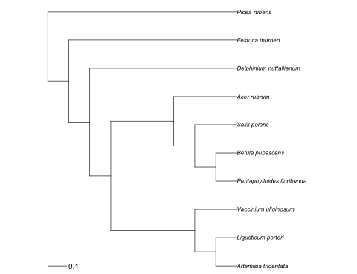

Newick: ((((((artemisia_tridentata:0.1111111111,ligusticum_porteri:0.1111111111):0.1111111111,vaccinium_uliginosum:0.2222222222):0.4444444444,(((pentaphylloides_floribunda:0.1111111111,betula_pubescens:0.1111111111):0.1111111111,salix_polaris:0.2222222222):0.1111111111,acer_rubrum:0.3333333333):0.3333333333):0.1111111111,delphinium_nuttallianum:0.7777777778):0.1111111111,festuca_thurberi:0.8888888889):0.1111111111,picea_rubens:1);

Agrawal et al. 2005 Ecology

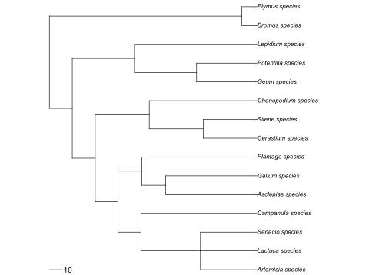

Newick: ((((((artemisia_species:44,lactuca_species:44,senecio_species:44):46,campanula_species:90):17.75,((asclepias_species:71,galium_species:71):18.375,plantago_species:89.375):18.375):17.75,((cerastium_species:41.833332,silene_species:41.833332):41.833332,chenopodium_species:83.666664):41.833336):17.75,((geum_species:47,potentilla_species:47):48.125,lepidium_species:95.125):48.125):17.75,(bromus_species:12,elymus_species:12):149);

Bancroft et al. 2007 Ecology Letters

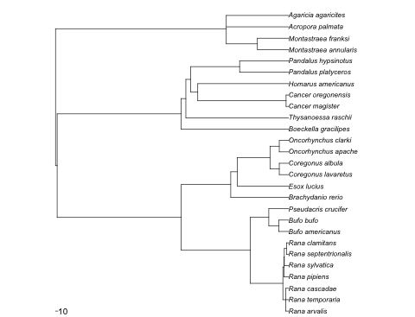

Newick: ((((((Rana_arvalis:12.1,Rana_temporaria:12.1,Rana_cascadae:12.1):12.1,(Rana_pipiens:19.799999,(Rana_sylvatica:18,(Rana_septentrionalis:9,Rana_clamitans:9):9):1.799999):4.400002):138.199997,((Bufo_americanus:41.900002,Bufo_bufo:41.900002):41.900002,Pseudacris_crucifer:83.800003):78.599991):292.5,(Brachydanio_rerio:245.100006,(Esox_lucius:217.5,((Coregonus_lavaretus:39.400002,Coregonus_albula:39.400002):39.400002,(Oncorhynchus_apache:39.400002,Oncorhynchus_clarki:39.400002):39.400002):138.699997):27.600006):209.799988):526.300049,(Boeckella_gracilipes:456,(Thysanoessa_raschii:435.5,(((Cancer_magister:10.5,Cancer_oregonensis:10.5):374.5,Homarus_americanus:385):30,(Pandalus_platyceros:207.5,Pandalus_hypsinotus:207.5):207.5):20.5):20.5):525.200012):6.899963,((Montastraea_annularis:132,Montastraea_franksi:132):132,Acropora_palmata:264,Agaricia_agaricites:264):724.099976);

Batary and Baldi 2004 Conservation Biology

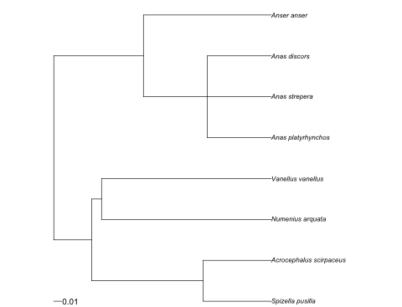

Newick: (((spizella_pusilla:0.088657,acrocephalus_scirpaceus:0.088661):0.145719,(numenius_arquata:0.221362,vanellus_vanellus:0.221362):0.013015):0.049297,((anas_platyrhynchos:0.083369,anas_strepera:0.083369,anas_discors:0.083369):0.083369,anser_anser:0.166738):0.116937);

Bolnick and Preisser 2005 Ecology

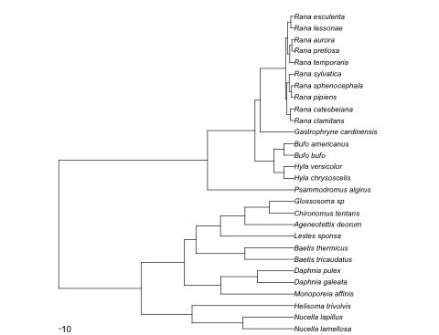

Newick: ((((Nucella_lamellosa:212.533325,Nucella_lapillus:212.533325):212.533325,Helisoma_trivolvis:425.06665):212.533325,((Monoporeia_affinis:305.399994,(Daphnia_galeata:152.699997,Daphnia_pulex:152.699997):152.699997):152.699997,((Baetis_tricaudatus:204.399994,Baetis_thermicus:204.399994):204.399994,(Lestes_sponsa:306.599976,(Ageneotettix_deorum:204.399994,(Chironomus_tentans:102.199997,Glossosoma_sp:102.199997):102.199997):102.199982):102.199997):49.300018):179.499969):343.650024,(Psammodromus_algirus:360.5,(((Hyla_chrysoscelis:41.900002,Hyla_versicolor:41.900002):41.900002,(Bufo_bufo:41.900002,Bufo_americanus:41.900002):41.900002):78.599991,(Gastrophryne_cardinensis:140.300003,(((Rana_clamitans:14.9,Rana_catesbeiana:14.9):14.9,((Rana_pipiens:9.933333,Rana_sphenocephala:9.933333):9.933333,Rana_sylvatica:19.866667):9.933333):5.100002,((Rana_temporaria:17.450001,(Rana_pretiosa:8.725,Rana_aurora:8.725):8.725):8.725,(Rana_lessonae:13.087501,Rana_esculenta:13.087501):13.087501):8.725):105.400002):22.099991):198.100006):620.75);

Connor et al. 2006 Ecology

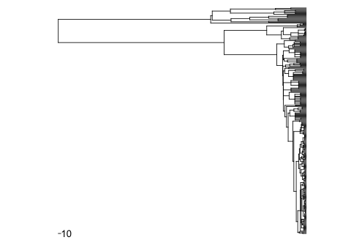
Newick: ((((((((((((((((Bombycilla_cedrorum:13.75,Bombycilla_garrulus:13.75):13.75,Regulus_regulus:27.5):5.974998,(Prunella_modularis:23.1,(((((Carduelis_chloris:9.7,Carduelis_cannabina:9.7,Carduelis_flammea:9.7,Carduelis_tristis:9.7,Carduelis_spinus:9.7,Cardeulis_barbatus:9.7,Carduelis_carduelis:9.7):9.099999,(Carpodacus_erythrinus:14.5,Carpodacus_mexicanus:14.5):4.299999,Pinicola_enucleator:18.799999,Pyrrhula_pyrrhula:18.799999,(Fringilla_coelebs:9.4,Fringilla_montifringilla:9.4):9.4,Dendroica_pensylvanica:18.799999,Loxia_curvirostra:18.799999):1.200001,(((Agelaius_phoeniceus:5.65,Curaeus_curaeus:5.65,Dolichonyx_oryzivorus:5.65,Icterus_galbula:5.65,Molothrus_ater:5.65,Quiscalus_quiscula:5.65,Sturnella_magna:5.65):5.65,((Dendroica_petechia:3.766667,Dendroica_virens:3.766667,Dendroica_dominica:3.766667,Dendroica_discolor:3.766667,Dendroica_cerulea:3.766667):3.766667,Geothlypis_trichas:7.533333,Helmitheros_vermivorus:7.533333,Icteria_virens:7.533333,Mniotilta_varia:7.533333,Oporornis_formosus:7.533333,Parula_americana:7.533333,(Seiurus_aurocapillus:3.766667,Seiurus_motacilla:3.766667):3.766667,Setophaga_ruticilla:7.533333,Vermivora_pinus:7.533333,(Wilsonia_citrina:3.766667,Wilsonia_canadensis:3.766667):3.766667):3.766667):5.400001,(Ammodramus_savannarum:11.133334,Melospiza_melodia:11.133334,Passerculus_sandwichensis:11.133334,Pipilo_erythrophthalmus:11.133334,Plectopenax_nivalis:11.133334,Pooecetes_gramineus:11.133334,(Spizella_passerina:5.566667,Spizella_pusilla:5.566667):5.566667,(Emberiza_rustica:5.566667,Emberiza_schoeniclus:5.566667,Emberiza_citrinella:5.566667):5.566667,Zonotricha_capensis:11.133334):5.566667,(Phrygilus_patagonicus:11.133334,(Cardinalis_cardinalis:5.566667,Passerina_cyanea:5.566667,Pheucticus_ludovicianus:5.566667,Piranga_olivacea:5.566667):5.566667):5.566667):3.299999):1.033333,((Anthus_pratensis:7.011111,Anthus_trivialis:7.011111):7.011111,(Motacilla_flava:7.011111,Motacilla_alba:7.011111):7.011111):7.011111):1.033335,(Passer_montanus:11.033334,Passer_domesticus:11.033334):11.033334):1.033333):10.374998):5.975002,((((((Hirundo_rustica:5,Tachycineta_leucopyga:5,Delichon_urbica:5):5,(Phylloscopus_trochilus:5,Phylloscopus_collybita:5,Phylloscopus_sibilatrix:5):5):5,((Acrocephalus_palustris:5,Acrocephalus_scirpaceus:5):5,Hippolais_icterina:10):5,(Zosterops_conspicillatus:10,(Sylvia_communis:5,Sylvia_nisoria:5,Sylvia_curruca:5,Sylvia_atricapilla:5,Sylvia_borin:5):5):5):5,Alauda_arvensis:20):5,((Parus_major:8.333333,Parus_cristatus:8.333333,Parus_ater:8.333333,Parus_caeruleas:8.333333,Parus_cinctus:8.333333,Parus_palusons:8.333333,Parus_montanus:8.333333):8.333333,Baeolophus_bicolor:16.666666,Poecile_atricapillus:16.666666):8.333334):5,(((Sitta_canadensis:11.3125,Sitta_carolinensis:11.3125):11.3125,(((Thryothorus_ludovicianus:9.05,(Troglodytes_aedon:4.525,Troglodytes_troglodytes:4.525):4.525):4.525001,Polioptila_caerulea:13.575001):4.525,(Certhia_familiaris:9.05,Certhia_americana:9.05):9.05):4.525):4.525,(((Sturnus_vulgaris:10.599999,(Aplonis_tabuensis:5.3,Aplonis_atrifusca:5.3,Aplonis_opacus:5.3):5.3):5.3,(Dumetella_carolinensis:13.8,Mimus_polyglottos:13.8,Toxostoma_rufum:13.8):2.099999):8.4,(((Luscinia_luscinia:6.433333,Luscinia_svecica:6.433333):6.433333,Muscicapa_striata:12.866666,Phoenicurus_phoenicurus:12.866666,Saxicola_rubetra:12.866666,Erithacus_rubecula:12.866666,Ficedula_hypoleuca:12.866666):6.433333,((Catharus_fuscescens:6.433333,Catharus_guttatus:6.433333):6.433333,Hylocichla_mustelina:12.866666,Oenanthe_oenanthe:12.866666,Sialia_sialis:12.866666,(Turdus_pilaris:6.433333,Turdus_philomelos:6.433333,Turdus_falcklandii:6.433333,Turdus_iliacus:6.433333,Turdus_merula:6.433333,Turdus_viscivorus:6.433333,Turdus_tadorna:6.433333,Turdus_migratorius:6.433333):6.433333):6.433333):5):2.85):2.85):9.450001):9.450001,((Vireo_griseus:12.25,Vireo_flavifrons:12.25,Vireo_olivaceus:12.25):12.25,(Rhipidura_rufifrons:22,((Lanius_collurio:9.75,Lanius_excubitor:9.75):9.75,((Corvus_brachyrhynchos:8.5,Corvus_ossifragus:8.5,Corvus_corax:8.5,Corvus_monedula:8.5,Corvus_corone:8.5):8.5,Garrulus_glandarius:17,Perisoreus_infaustus:17,Nucifraga_caryocatactes:17,Cyanocitta_cristata:17,Pica_pica:17):2.5):2.5):2.5):24.400002):4.099998,(Foulehaio_carunculata:26.5,Myzomela_cardinalis:26.5):26.5):18.416664,((Contopus_virens:43.333332,(Empidonax_virescens:21.666666,Empidonax_minimus:21.666666):21.666666,Myiarchus_crinitus:43.333332,Sayornis_phoebe:43.333332,Elaenia_albiceps:43.333332,Colorhamphus_parvirostris:43.333332,Pyrope_pyrope:43.333332,Anairetes_parulus:43.333332,Tyrannus_tyrannus:43.333332):21.666666,((Pteroptochos_tarnii:24.375,Scelorchilus_rubecula:24.375,Eugralla_paradoxa:24.375):24.375,(Scytalopus_magellanicus:32.5,(Aphrastura_spinicauda:16.25,Sylviorthorhynchus_desmursii:16.25,Pygarrhichas_albogularis:16.25):16.25):16.25):16.25):6.416664):6.416664,Enicognathus_leptorhynchus:77.833328):6.416672,(Milvago_chimango:42.125,Falco_columbarius:42.125):42.125):6.416664,(((((Colaptes_auratus:22.549999,Colaptes_pitius:22.549999):22.549999,(Dryocopus_martius:22.549999,Dryocopus_pileatus:22.549999):22.549999,Campephilus_magellanicus:45.099998,(Melanerpes_erythrocephalus:22.549999,Melanerpes_carolinus:22.549999):22.549999,(Dendrocopos_major:22.549999,Dendrocopus_minor:22.549999):22.549999,Picus_canus:45.099998,Jynx_torquilla:45.099998,(Picoides_lignarius:22.549999,Picoides_tridactylus:22.549999,Picoides_pubescens:22.549999,Picoides_villosus:22.549999):22.549999):22.549995,Halcyon_chloris:67.649994):22.549999,(Aegolius_funereus:60.133331,Asio_flammeus:60.133331,Bubo_virginianus:60.133331,Otus_asio:60.133331,(Strix_uralensis:30.066666,Strix_varia:30.066666):30.066666):30.066666):0.233337,((Buteo_lineatus:30.144445,Buteo_platypterus:30.144445,Buteo_buteo:30.144445,Buteo_lagopus:30.144445,Buteo_jamaicensis:30.144445):30.144445,(Accipiter_nisus:30.144445,Accipiter_cooperii:30.144445,Accipiter_gentilis:30.144445):30.144445,Haliaeetus_albicilla:60.288891):30.144444):0.23333):0.233335,(((Actitis_hypoleucos:50.900002,Bartramia_longicauda:50.900002,Calidris_temminckii:50.900002,Numenius_phaeopus:50.900002,Philomachus_pugnax:50.900002,Gallinago_gallinago:50.900002,Lymnocryptes_minimus:50.900002,Scolopax_rusticola:50.900002,(Tringa_glareola:14,Tringa_ochropus:14,Tringa_nebularia:14):36.900002):18.699997,(Gygis_alba:43.5,(Anous_stolidus:10,Anous_minutus:10):33.5):26.099998):15,(Pluvialis_apricaria:69,Vanellus_vanellus:69):15.599998):6.300003):1.25,(Ixobrychus_sinensis:81.400002,((Porphyrio_porphyrio:21.799999,Rallus_philippensis:21.799999):43.399998,(Cuculus_canorus:49,(Coccyzus_americannus:24.5,Coccyzus_erythropthalmus:24.5):24.5):16.199997):16.200001):10.75):1.25,((((Archilochus_colubris:37.099998,Sephanoides_galeritus:37.099998):37.099998,(Collocalia_spodiopygia:37.099998,Aerodramus_vanikorensis:37.099998,Apus_apus:37.099998):37.099998):13.200005,Caprimulgus_vociferus:87.400002):3,(((Columba_araucana:22.6,Columba_oenas:22.6,Columba_palumbus:22.6):22.6,(Ptilinopus_roseicapilla:22.6,Ptilinopus_perousii:22.6,Ptilinopus_porphyraceus:22.6):22.6,(Ducula_oceanica:22.6,Ducula_pacifica:22.6):22.6,Gallicolumbia_xanthonura:45.200001,Streptopelia_bitorquata:45.200001,Zenaida_macroura:45.200001):22.600002,Phaethon_lepturus:67.800003):22.599998):3):22.900002,((Megapodius_laperouse:69.649994,(Colinus_virginianus:52.599998,(Gallus_gallus:47.799999,(Tetrao_urogallus:23.9,Tetrao_tetrix:23.9):23.9,Lagopus_lagopus:47.799999,Lyrurus_tetrix:47.799999,(Bonasa_bonasia:23.9,Bonasa_umbellus:23.9):23.9):4.799999):17.049995):17.049999,(Anas_platyrhynchos:43.349998,Aix_sponsa:43.349998):43.349998):29.600006):208.499985,(((Blarina_brevicauda:65.466667,(Sorex_araneus:32.733334,Sorex_minutus:32.733334,Sorex_caecutiens:32.733334):32.733334):32.733334,((Tamais_striatus:60.650002,((Sigmodon_hispidus:10,Oryzomys_palustris:10):21.200001,(Clethrionomys_glareolus:6.1,(Microtus_pennsylvanicus:3.05,Microtus_agrestis:3.05,Microtus_ochrogaster:3.05):3.05):25.1,(Reithrodontomys_megalotis:7.1,(Peromyscus_maniculatus:3.55,Peromyscus_gossypinus:3.55,Peromyscus_leucopus:3.55):3.55):24.1):29.450001):29.449999,Ochotona_princeps:90.099998):8.099998):58,(Trichosurus_vulpecula:35.799999,Dendrolagus_lumhotzi:35.799999,(Hemibelideus_lemuroides:23.866667,(Pseudocheirus_archeri:11.933333,Pseudocheirus_herbertensis:11.933333):11.933333):11.933333):120.399994):168.599991):656.400024,(Metrioptera_bicolor:378,(((Odonaspis_sp.:148.759995,Eriococcus_sp.:148.759995):148.759995,((Destria_bisignata:111.569992,Amphicephalus_simplex:111.569992,Aphelonema_simplex:111.569992):111.569992,(Tytthus_sp.:148.759995,(Tumidagena_minuta:74.379997,Neomegamelanus_dorsalis:74.379997,Delphacodes_detecta:74.379997,Megamelus_lobatus:74.379997):74.379997):74.37999):74.380005):74.379997,((Tetraopes_tetraophthalmus:128.399994,((Diabrotica_undecimpunctata:42.799999,Diabrotica_virgifera:42.799999):42.799999,Acalymma_vittatum:85.599998,(Phyllotreta_cruciferae:42.799999,Phyllotreta_striolata:42.799999):42.799999):42.799999):171.600006,(Plutella_xylostella:121.5,(Anticarsia_gemmatalis:60.75,Pieris_rapae:60.75):60.75):178.5):71.899994):6.100006):603.200012);

Cote and Sutherland 1997 Conservation Biology

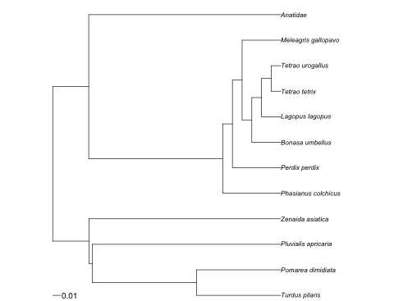
Newick:
((((Turdus_pilaris:0.104769,Pomarea_dimidiata:0.104769):0.129609,Pluvialis_apricaria:0.234378):0.004232,Zenaida_asiatica:0.23861):0.045065,((Phasianus_colchicus:0.07228,(Perdix_perdix:0.060234,((Bonasa_umbellus:0.03614,(Lagopus_lagopus:0.024093,(Tetrao_tetrix:0.012047,Tetrao_urogallus:0.012047):0.012047):0.012047):0.012047,Meleagris_gallopavo:0.048187):0.012047):0.012047):0.166616,Anatidae:0.238896):0.044779);
Harrison et al. 2009 J of Evolutionary Biology

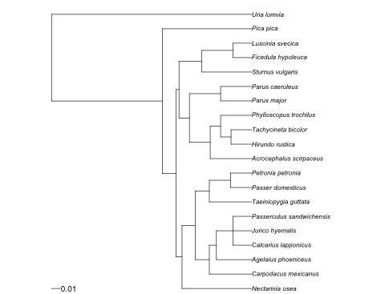
Newick:
((((Nectarinia_osea:0.081676,((Carpodacus_mexicanus:0.049749,(Agelaius_phoeniceus:0.041456,(Calcarius_lapponicus:0.02211,Junco_hyemalis:0.02211,Passerculus_sandwichensis:0.02211):0.019346):0.008291):0.016582,(Taeiniopygia_guttata:0.049748,(Passer_domesticus:0.024874,Petronia_petronia:0.024874):0.024874):0.016583):0.015345):0.006983,(((Acrocephalus_scirpaceus:0.048696,((Hirundo_rustica:0.024347,Tachycineta_bicolor:0.024348):0.012174,Phylloscopus_trochilus:0.036522):0.012174):0.024348,(Parus_major:0.036521,Parus_caeruleus:0.036521):0.036521):0.012174,(Sturnus_vulgaris:0.058433,(Ficedula_hypoleuca:0.0219125,Luscinia_svecica:0.0219125):0.0365205):0.026782):0.003443):0.01611,Pica_pica:0.10477):0.129609,Uria_lomvia:0.234379);
Hoeksema et al. 2010 Ecology Letters

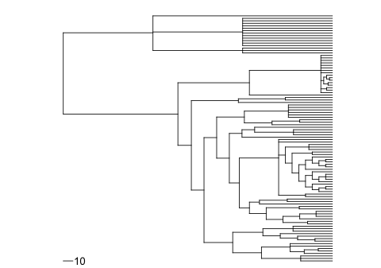

Newick:
(((((((anethum_graveolens:33,apium_graveolens:33,trachyspermum_ammi:33)107:40.933334,((berkheya_coddii:29.333334,(chrysanthemum_cinerariefolium:14.666667,solidago_sempervirens:14.666667)110:14.666667)109:14.666667,callistephus_chinensis:44,lactuca_sativa:44)108:29.933334)106:29.933334,((((lavandula_spica:18.108334,prunella_vulgaris:18.108334)114:18.108334,tectona_grandis:36.216667)113:18.108334,olea_europaea:54.325001)112:18.108334,(capsicum_annuum:41,lycopersicon_esculentum:41,nicotiana_tabacum:41)115:31.433334)111:31.433334)105:29.933334,(((((((alnus_acuminata:25.744444,alnus_tenuifolia:25.744444)122:25.744444,(fagus_sylvatica:34,(quercus_alba:17,quercus_robur:17,quercus_velutina:17)124:17)123:17.488888)121:17.488888,(coriaria_nepalensis:34.488888,cucumis_sativus:34.488888)125:34.488888)120:17.488892,(morus_alba:76,(fragaria_sp:47,prunus_maritima:47)127:29)126:10.466667)119:10.466667,((afzelia_africana:28,afzelia_bella:28)129:28,((((((anthyllis_cytisoides:14,(dorycnium_pentaphyllum:7,lotus_corniculatus:7)136:7)135:7,gliricidia_sepium:21)134:7,((lens_culinaris:14,(trifolium_pratense:7,trifolium_repens:7,trifolium_subterraneum:7)139:7)138:7,medicago_sativa:21)137:7)133:7,(cajanus_cajan:28,(((calopogonium_caeruleum:7,glycine_max:7)143:7,(vigna_radiata:7,vigna_unguiculata:7)144:7)142:7,erythrina_berteriana:21)141:7)140:7)132:7,(arachis_hypogaea:21,stylosanthes_guyanensis:21)145:21)131:7,(cassia_reticulata:24.5,cassia_siamea:24.5,cassia_spectabilis:24.5)146:24.5)130:7,cryptosepalum_tetraphyllum:56,paramacrolobium_coeruleum:56)128:40.933334)118:10.466667,(ceratopetalum_apetalum:94.199997,((hevea_brasiliensis:40.5,manihot_esculenta:40.5,uapaca_somon:40.5)149:40.5,populus_trichocarpa:81)148:13.199997)147:13.200005)117:13.199997,((shorea_pinanga:62.866665,(gossypium_arboreum:34,theobroma_cacao:34)152:28.866665)151:28.866665,(eucalyptus_diversicolor:45.866665,eucalyptus_europhylla:45.866665,eucalyptus_globulus:45.866665,eucalyptus_grandis:45.866665,eucalyptus_pilularis:45.866665,eucalyptus_urophylla:45.866665)153:45.866665)150:28.866669)116:13.200005)104:13.2,(podophyllum_peltatum:98,(pulsatilla_patens:49,pulsatilla_pratensis:49)155:49)154:49)103:14,(syngonium_podophyllum:86.5,(andropogon_gerardii:12,(bouteloua_eriopoda:6,bouteloua_gracilis:6)158:6,((brachypodium_pinnatum:4.5,triticum_aestivum:4.5)160:4.5,((panicum_amarum:3,zea_mays:3)162:3,uniola_paniculata:6)161:3)159:3,elymus_elymoides:12,festuca_arundinacea:12,homolepsis_aturensis:12,hordeum_vulgare:12,leymus_arenarius:12,lolium_perenne:12,paspalum_conjugatum:12,sorghum_sudanese:12)157:74.5)156:74.5)102:119.5,((picea_abies:93.5,picea_glauca:93.5,picea_mariana:93.5)164:93.5,(pinus_banksiana:93.5,pinus_contorta:93.5,pinus_halepensis:93.5,pinus_lambertiana:93.5,pinus_pinaster:93.5,pinus_pinea:93.5,pinus_radiata:93.5,pinus_resinosa:93.5,pinus_rigida:93.5,pinus_strobus:93.5,pinus_sylvestris:93.5,pinus_taeda:93.5)165:93.5,pseudotsuga_menziesii:187)163:93.5)101;
Honnay et al. 2008 Oikos

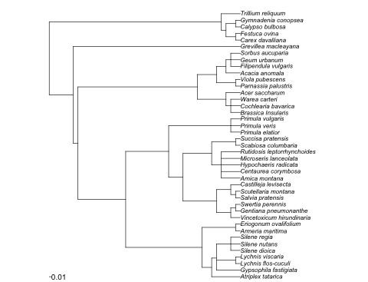
Newick:
((((((atriplex_tatarica:0.15,(gypsophila_fastigiata:0.125,(lychnis_flos-cuculi:0.025,lychnis_viscaria:0.025):0.1,(silene_dioica:0.05,silene_nutans:0.05,silene_regia:0.05):0.075):0.025):0.05,(armeria_maritima:0.025,eriogonum_ovalifolium:0.025):0.175):0.4,((((vincetoxicum_hirundinaria:0.05,(gentiana_pneumonanthe:0.025,swertia_perennis:0.025):0.025):0.075,((salvia_pratensis:0.025,scutellaria_montana:0.025):0.025,castilleja_levisecta:0.05):0.075):0.175,((arnica_montana:0.1,centaurea_corymbosa:0.1,hypochaeris_radicata:0.1,microseris_lanceolata:0.1,rutidosis_leptorrhynchoides:0.1):0.05,(scabiosa_columbaria:0.025,succisa_pratensis:0.025):0.125):0.15):0.075,(primula_elatior:0.05,primula_veris:0.05,primula_vulgaris:0.05):0.325):0.225):0.25,(((brassica_Insularis:0.05,cochlearia_bavarica:0.05,warea_carteri:0.05):0.025,acer_saccharum:0.075):0.15,((parnassia_palustris:0.025,viola_pubescens:0.025):0.1,(acacia_anomala:0.075,(filipendula_vulgaris:0.05,geum_urbanum:0.05,sorbus_aucuparia:0.05):0.025):0.05):0.1):0.625):0.025,grevillea_macleayana:0.875):0.125,(((carex_davalliana:0.025,festuca_ovina:0.025):0.05,(calypso_bulbosa:0.025,gymnadenia_conopsea:0.025):0.05):0.025,trillium_reliquum:0.1):0.9);
Huberty and Denno 2004 Ecology

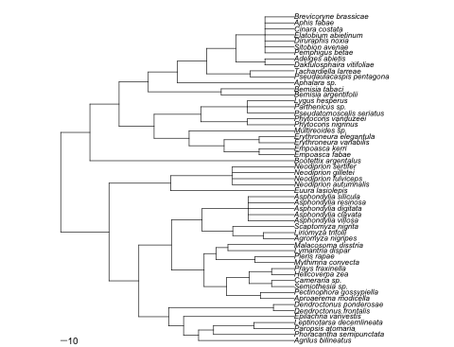
Newick:
((((((Agrilus_bilineatus:152.266663,(Phoracantha_semipunctata:128.399994,(Paropsis_atomaria:64.199997,Leptinotarsa_decemlineata:64.199997):64.199997):23.866669):23.866669,Epilachna_varivestis:176.133331):23.866669,(Dendroctonus_frontalis:33,Dendroctonus_ponderosae:33):167):47.5,((((Aproaerema_modicella:53.8125,Pectinophora_gossypiella:53.8125):53.8125,((Semiothesia_sp.:35.875,Cameraria_sp.:35.875):35.875,(Helicoverpa_zea:35.875,Prays_fraxinella:35.875):35.875):35.875):35.875,((Mythimna_convecta:62.25,Pieris_rapae:62.25):62.25,(Lymantria_dispar:105.5,Malacosoma_disstria:105.5):19):19):52,(((Agromyza_nigripes:48.875,Liriomyza_trifolii:48.875):48.875,Scaptomyza_nigrita:97.75):48.875,(Asphondylia_villosa:73.3125,Asphondylia_clavata:73.3125,Asphondylia_digitata:73.3125,Asphondylia_resinosa:73.3125,Asphondylia_silicula:73.3125):73.3125):48.875):52):47.5,(Euura_lasiolepis:196.666672,(Neodiprion_autumnalis:98.333336,Neodiprion_fulviceps:98.333336,Neodiprion_gilletei:98.333336,Neodiprion_sertifer:98.333336):98.333336):98.333336):76.899994,(Bootettix_argentalus:325.412506,(((((Empoasca_fabae:55.784996,Empoasca_kerri:55.784996):55.784996,(Erythroneura_variabilis:55.784996,Erythroneura_elegantula:55.784996):55.784996):55.784988,Multireoides_sp.:167.35498):55.785004,((Phytocoris_nigrinus:74.379997,Phytocoris_vanduzeei:74.379997):74.379997,(Pseudatomoscelis_seriatus:74.379997,Parthenicus_sp.:74.379997,Lygus_hesperus:74.379997):74.379997):74.37999):55.785004,((Bemisia_argentifolii:116.21875,Bemisia_tabaci:116.21875):116.21875,(Aphalara_sp.:185.949997,((Pseudaulacaspis_pentagona:69.731247,Tachardiella_larreae:69.731247):69.731247,((Daktulosphaira_vitifoliae:46.487499,Adelges_abietis:46.487499):46.487499,(Pemphigus_betae:46.487499,Sitobion_avenae:46.487499,Diruraphis_noxia:46.487499,Elatobium_abietinum:46.487499,Cinara_costata:46.487499,Aphis_fabae:46.487499,Brevicoryne_brassicae:46.487499):46.487499):46.487495):46.487503):46.487503):46.487488):46.487518):46.487499);

Illisson and Chen 2009 J of Vegetation Science

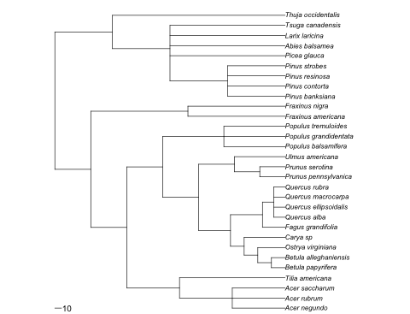
Newick:
(((((acer_negundo:79.333336,acer_rubrum:79.333336,acer_saccharum:79.333336):79.333336,tilia_americana:158.666672):79.333328,((((((betula_papyrifera:20.5,betula_alleghaniensis:20.5):20.5,ostrya_virginiana:41):20.5,carya_sp:61.5):20.5,(fagus_grandifolia:34,(quercus_alba:17,quercus_ellipsoidalis:17,quercus_macrocarpa:17,quercus_rubra:17):17):48):48,((prunus_pennsylvanica:38,prunus_serotina:38):38,ulmus_americana:76):54):54,(populus_balsamifera:92,populus_grandidentata:92,populus_tremuloides:92):92):54):54,(fraxinus_americana:146,fraxinus_nigra:146):146):54,(((pinus_banksiana:86.5,pinus_contorta:86.5,pinus_resinosa:86.5,pinus_strobes:86.5):86.5,picea_glauca:173,abies_balsamea:173,larix_laricina:173,tsuga_canadensis:173):86.5,thuja_occidentalis:259.5):86.5);
Jactel and Brockerhoff 2007 Ecology Letters

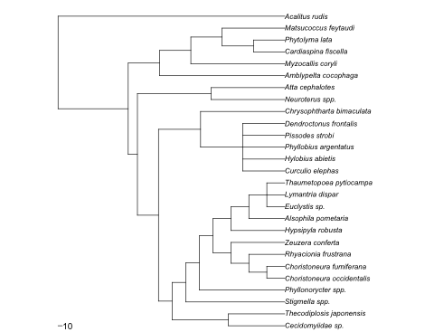
Newick:
((((((cecidomyiidae_sp.:133.824997,thecodiplosis_japonensis:133.824997):133.824997,(stigmella_spp.:235.300003,(phyllonorycter_spp.:202.950012,((((choristoneura_occidentalis:42.650002,choristoneura_fumiferana:42.650002):42.650002,rhyacionia_frustrana:85.300003):42.650002,zeuzera_conferta:127.950005):42.650002,(hypsipyla_robusta:127.950005,(alsophila_pometaria:85.300003,(euclystis_sp.:42.650002,lymantria_dispar:42.650002,thaumetopoea_pytiocampa:42.650002):42.650002):42.650002):42.650002):32.350006):32.349991):32.349991):32.349998,((curculio_elephas:100,hylobius_abietis:100,phyllobius_argentatus:100,pissodes_strobi:100,dendroctonus_frontalis:100):100,chrysophtharta_bimaculata:200):100):50,(neuroterus_spp.:175,atta_cephalotes:175):175):21.899994,(amblypelta_cocophaga:297.519989,(myzocallis_coryli:223.139984,((cardiaspina_fiscella:74.379997,phytolyma_lata:74.379997):74.379997,matsucoccus_feytaudi:148.759995):74.37999):74.380005):74.379997):166.600006,acalitus_rudis:538.5);
Leimu et al. 2006 J of Ecology

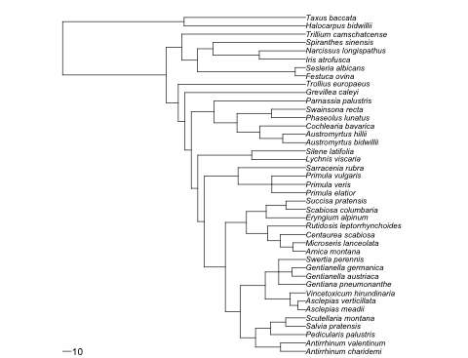
Newick:
(((((((((((antirrhinum_charidemi:28.916666,antirrhinum_valentinum:28.916666):28.916666,(pedicularis_palustris:40.416664,(salvia_pratensis:23,scutellaria_montana:23):17.416664):17.416668):17.416668,(((asclepias_meadii:9,asclepias_verticillata:9):9,vincetoxicum_hirundinaria:18):28.625,(gentiana_pneumonanthe:31.083334,(gentianella_austriaca:15.541667,gentianella_germanica:15.541667):15.541667,swertia_perennis:31.083334):15.541666):28.625):17.416664,((((arnica_montana:14.666667,microseris_lanceolata:14.666667):14.666667,centaurea_scabiosa:29.333334):14.666667,rutidosis_leptorrhynchoides:44):24.333336,(eryngium_alpinum:45.555557,(scabiosa_columbaria:22.777779,succisa_pratensis:22.777779):22.777779):22.777779):24.333328):24.333334,((primula_elatior:39,primula_veris:39,primula_vulgaris:39):39,sarracenia_rubra:78):39):7.5,(lychnis_viscaria:62.25,silene_latifolia:62.25):62.25):7.5,((((austromyrtus_bidwillii:26.4,austromyrtus_hillii:26.4):26.4,cochlearia_bavarica:52.799999):26.399998,(phaseolus_lunatus:39.599998,swainsona_recta:39.599998):39.599998):26.400002,parnassia_palustris:105.599998):26.400002):7.5,grevillea_caleyi:139.5):7.5,trollius_europaeus:147):14,(((festuca_ovina:12,sesleria_albicans:12):113,((iris_atrofusca:53.5,narcissus_longispathus:53.5):53.5,spiranthes_sinensis:107):18):18,trillium_camschatcense:143):18):119.5,(halocarpus_bidwillii:140.25,taxus_baccata:140.25):140.25);
Leimu and Koricheva 2006 American Naturalist

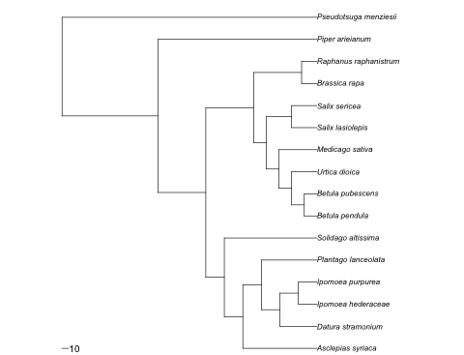
Newick:
(((((asclepias_syriaca:116.266663,((datura_stramonium:58.133331,(ipomoea_hederaceae:29.066666,ipomoea_purpurea:29.066666):29.066666):29.066666,plantago_lanceolata:87.199997):29.066666):29.066666,solidago_altissima:145.333328):29.066666,(((((betula_pendula:19.84,betula_pubescens:19.84):19.84,urtica_dioica:39.68):19.839996,medicago_sativa:59.519997):19.840004,(salix_lasiolepis:39.68,salix_sericea:39.68):39.68):19.839996,(brassica_rapa:24,raphanus_raphanistrum:24):75.199997):75.199997):75.200012,piper_arieianum:249.600006):150.399979,pseudotsuga_menziesii:399.999985);
Mackenzie et al. 2003 Marine Ecology Progress Series

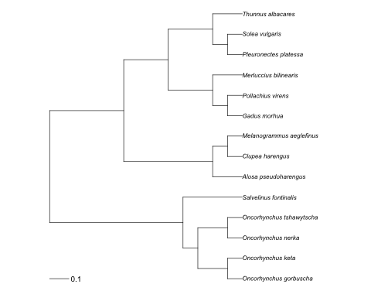
Newick:
((((Oncorhynchus_gorbuscha:0.07692307692,Oncorhynchus_keta:0.07692307692):0.1538461538,(Oncorhynchus_nerka:0.07692307692,Oncorhynchus_tshawytscha:0.07692307692):0.1538461538):0.07692307692,Salvelinus_fontinalis:0.3076923077):0.6923076923,((Alosa_pseudoharengus:0.1538461538,(Clupea_harengus:0.07692307692,Melanogrammus_aeglefinus:0.07692307692):0.07692307692):0.4615384615,(((Gadus_morhua:0.07692307692,Pollachius_virens:0.07692307692):0.07692307692,Merluccius_bilinearis:0.1538461538):0.2307692308,((Pleuronectes_platessa:0.07692307692,Solea_vulgaris:0.07692307692):0.07692307692,Thunnus_albacares:0.1538461538):0.2307692308):0.2307692308):0.3846153846);
McCall and Fordyce 2010 J of Ecology

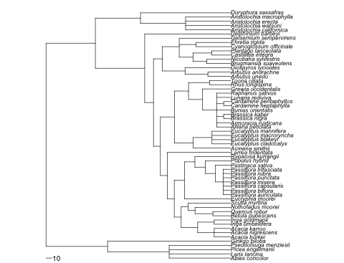
Newick:
(((abies_concolor:105.222221,larix_laricina:105.222221,picea_engelmanii:105.222221,pseudotsuga_menziesii:105.222221):105.222221,ginkgo_biloba:210.444443):105.222214,(((((((((acacia_burkei:28.222221,acacia_nigrescens:28.222221,acacia_karroo:28.222221):28.222221,(inga_umbellifera:28.222221,inga_goldmanii:28.222221):28.222221):28.222221,(((betula_pubescens:30.5,quercus_robur:30.5):30.5,nothofagus_moorei:61):11.833336,scutia_myrtina:72.833336):11.833328):11.833336,(eucryphia_moorei:78.875,((((passiflora_auriculata:13,passiflora_biflora:13,passiflora_capsularis:13,passiflora_misera:13,passiflora_punctata:13,passiflora_rubra:13,passiflora_trifasciata:13):13,pastinaca_sativa:26):17.625,populus_hybrid:43.625):17.625,ryparosa_kurrangii:61.25):17.625):17.625):11.833336,larrea_tridentata:108.333336):11.833328,((acmena_smithii:64.083336,(eucalyptus_cladocalyx:32.041668,eucalyptus_blakeyi:32.041668,eucalyptus_macroryncha:32.041668,eucalyptus_mannifera:32.041668):32.041668):32.041664,(((alliaria_petiolata:24,armoracia_rusticana:24,(brassica_nigra:12,brassica_kaber:12):12,bunias_orientalis:24,(cardamine_heptaphylla:12,cardamine_pentaphyllos:12):12,lunaria_rediviva:24,raphanus_sativus:24):24.041664,grewia_occidentalis:48.041664):24.041664,(rhus_longispina:36.041664,toona_ciliata:36.041664):36.041664):24.041672):24.041664):11.833336,(((arbutus_unedo:39,arbutus_andrachne:39):39,diospyros_lycioides:78):39,(((brugmansia_suaveolens:41,nicotiana_sylvestris:41):23.5,(castilleja_integra:32.25,plantago_lanceolata:32.25):32.25):23.5,(cyanoglossum_officinale:59,ehretia_rigida:59):29,gelsemium_sempervirens:88):29):15):15,delphinium_barbeyi:147):84.333328,((aristolochia_californica:77.111107,aristolochia_watsoni:77.111107,aristolochia_erecta:77.111107,aristolochia_macrophylla:77.111107):77.111107,doryphora_sassafras:154.222214):77.111115):84.333328);

Moller and Ninni 1998 Behavioral Ecology and Sociobiology

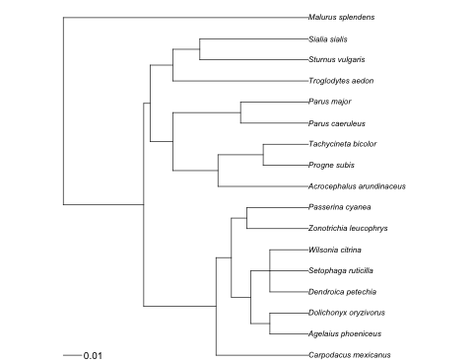
Newick:
(((Carpodacus_mexicanus:0.049749,(((Agelaius_phoeniceus:0.020728,Dolichonyx_oryzivorus:0.020728):0.010364,(Dendroica_petechia:0.020728,Setophaga_ruticilla:0.020728,Wilsonia_citrina:0.020728):0.010364):0.010364,(Zonotrichia_leucophrys:0.033165,Passerina_cyanea:0.033164):0.008291):0.008291):0.03891,(((Acrocephalus_arundinaceus:0.048696,(Progne_subis:0.024348,Tachycineta_bicolor:0.024348):0.024348):0.024348,(Parus_caeruleus:0.036521,Parus_major:0.036521):0.036521):0.012174,(Troglodytes_aedon:0.073044,(Sturnus_vulgaris:0.058433,Sialia_sialis:0.058432):0.014608):0.012174):0.003443):0.043322,Malurus_splendens:0.131983);
Ord and Stamps 2009 American Naturalist

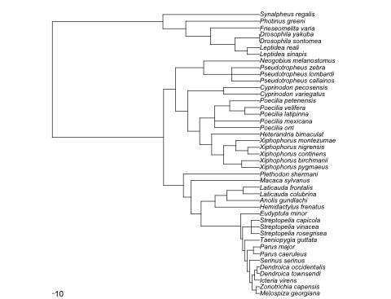
Newick:
((((((((((((Melospiza_georgiana:18,Zonotrichia_capensis:18):18,(Icteria_virens:24,(Dendroica_townsendi:12,Dendroica_occidentalis:12):12):12):12,Serinus_serinus:48):12,(Parus_caeruleus:30,Parus_major:30):30):12,Taeniopygia_guttata:72):9.125,(Streptopelia_rosegrisea:40.5625,Streptopelia_vinacea:40.5625,Streptopelia_capicola:40.5625):40.5625):9.125,Eudyptula_minor:90.25):187.25,(Hemidactylus_frenatus:211.5,(Anolis_gundlachi:156.399994,(Laticauda_colubrina:78.199997,Laticauda_frontalis:78.199997):78.199997):55.100006):66):47.299988,Macaca_sylvanus:324.799988):36.400024,Plethodon_shermani:361.200012):93.699982,((((((Xiphophorus_pygmaeus:85.293747,Xiphophorus_birchmanii:85.293747):85.293747,((Xiphophorus_continens:56.862499,Xiphophorus_nigrensis:56.862499):56.862499,Xiphophorus_montezumae:113.724998):56.862495):56.862503,Heterandria_bimaculat:227.449997):56.862503,(Poecilia_orri:213.234375,Poecilia_mexicana:213.234375,((Poecilia_latipinna:71.078125,Poecilia_velifera:71.078125):71.078125,Poecilia_petenensis:142.15625):71.078125):71.078125):56.862488,(Cyprinodon_variegatus:170.587494,Cyprinodon_pecosensis:170.587494):170.587494):56.862518,((Pseudotropheus_callainos:132.679169,Pseudotropheus_lombardi:132.679169,Pseudotropheus_zebra:132.679169):132.679169,Neogobius_melanostomus:265.358337):132.679169):56.862499):526.300049,(((((Leptidea_sinapis:58.5,Leptidea_reali:58.5):58.5,(Drosophila_sontomea:0.5,Drosophila_yakuba:0.5):116.5):116.5,Frieseomelita_varia:233.5):116.5,Photinus_greeni:350):108.100006,Synalpheus_regalis:458.100006):523.099976);
Parker et al. 2005 Conservation Biology

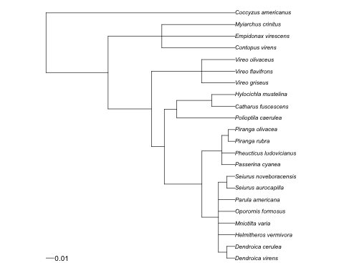
Newick:
(((((((Dendroica_virens:0.010364,Dendroica_cerulea:0.010364):0.010364,Helmitheros_vermivora:0.020728,Mniotilta_varia:0.020728,Oporornis_formosus:0.020728,Parula_americana:0.020728,(Seiurus_aurocapilla:0.010364,Seiurus_noveboracensis:0.010364):0.010364):0.020728,(Passerina_cyanea:0.016582,Pheucticus_ludovicianus:0.016582,(Piranga_rubra:0.008291,Piranga_olivacea:0.008291):0.008291):0.024873):0.047201,(Polioptila_caerulea:0.073043,(Catharus_fuscescens:0.029216,Hylocichla_mustelina:0.029217):0.043824):0.015617):0.01611,(Vireo_griseus:0.041908,Vireo_flavifrons:0.041908,Vireo_olivaceus:0.041908):0.062862):0.054424,(Contopus_virens:0.091762,Empidonax_virescens:0.091762,Myiarchus_crinitus:0.091762):0.067431):0.077924,Coccyzus_americanus:0.237117);

Persson et al. 2010 Oikos

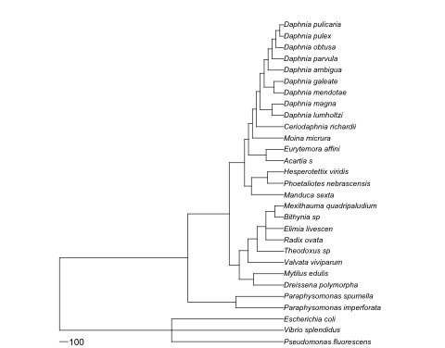
Newick:
((Pseudomonas_fluorescens:1311,Vibrio_splendidus:1311,Escherichia_coli:1311):1311,((Paraphysomonas_imperforata:560.450012,Paraphysomonas_spumella:560.450012):560.450012,(((Dreissena_polymorpha:355,Mytilus_edulis:355):165.400024,(Valvata_viviparum:416.320007,(Theodoxus_sp:312.23999,(Radix_ovata:208.160004,Elimia_livescen:208.160004,(Bithynia_sp:104.080002,Mexithauma_quadripaludium:104.080002):104.080002):104.079987):104.080017):104.080002):117.199951,((Manduca_sexta:378,(Phoetaliotes_nebrascensis:189,Hesperotettix_viridis:189):189):80.100006,((Acartia_s:206.145004,Eurytemora_affini:206.145004):206.145004,(Moina_micrura:366.480011,(Ceriodaphnia_richardii:320.670013,((Daphnia_lumholtzi:137.430008,Daphnia_magna:137.430008):137.430008,((Daphnia_mendotae:114.525002,Daphnia_galeate:114.525002):114.525002,(Daphnia_ambigua:183.240005,(Daphnia_parvula:137.430008,(Daphnia_obtusa:91.620003,(Daphnia_pulex:45.810001,Daphnia_pulicaria:45.810001):45.810001):45.810005):45.809998):45.809998):45.810013):45.809998):45.809998):45.809998):45.810001):179.499969):483.300049):1501.099976);
Poissant et al. 2010 Evolution

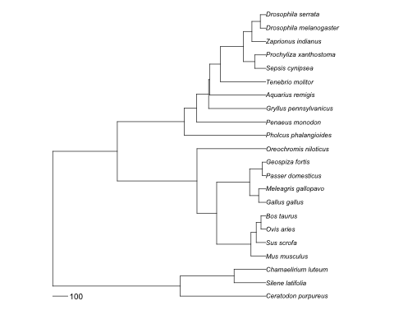
Newick:
((ceratodon_purpureus:565.200012,(silene_latifolia:209.699997,chamaelirium_luteum:209.699997):355.5):842.600037,((((mus_musculus:98.199997,(sus_scrofa:63.5,(ovis_aries:31.9,bos_taurus:31.9):31.6):34.699997):226.599991,((gallus_gallus:47.299999,meleagris_gallopavo:47.299999):59.600002,(passer_domesticus:23.1,geospiza_fortis:23.1):83.800003):217.899994):130.100006,oreochromis_niloticus_:454.899994):526.300049,(pholcus_phalangioides:538.5,(penaeus_monodon:458.100006,(gryllus_pennsylvanicus:378,(aquarius_remigis:371.899994,(tenebrio_molitor:300,((sepsis_cynipsea:73.75,prochyliza_xanthostoma:73.75):73.75,(zaprionus_indianus:92,(drosophila_melanogaster:36.5,drosophila_serrata:36.5):55.5):55.5):152.5):71.899994):6.100006):80.100006):80.399994):442.700012):426.600037);
Preisser et al. 2005 Ecology

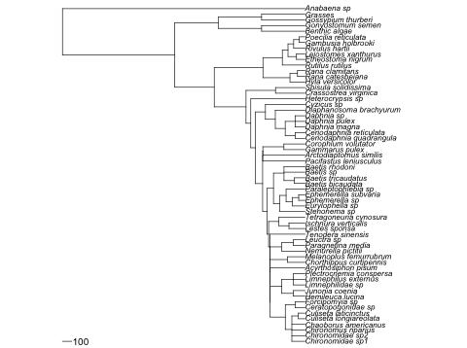
Newick:
((((((((((((((((Chironomidae_sp1:142,Chironomidae_sp2:142,Chironomus_riparius:142,Chaoborus_americanus:142,(Culiseta_longiareolata:71,Culiseta_laticinctus:71):71):71,(Ceratopogonidae_sp:106.5,Forcipomyia_sp:106.5):106.5):163.799988,((Hemileuca_lucina:125.599998,Junonia_coenia:125.599998):125.599998,(Limnephilidae_sp:125.599998,Limnephilus_externus:125.599998,Plectrocnemia_conspersa:125.599998):125.599998):125.599998):0.299988,Acyrthosiphon_pisum:377.099976):0.300018,(Chorthippus_curtipennis:188.699997,Melanoplus_femurrubrum:188.699997):188.699997):0.300018,(Nemurella_pictitii:251.800003,(Paragnetina_media:125.900002,Leuctra_sp:125.900002):125.900002):125.900009):0.300003,Tenodera_sinensis:378):15.399994,((Lestes_sponsa:173.300003,Ischnura_verticalis:173.300003):110.050003,Tetragoneuria_cynosura:283.350006):110.049988):15.399994,((Stenonema_sp:272.533325,((Eurylophella_sp:136.266663,(Ephemerella_sp:68.133331,Ephemerella_subvaria:68.133331):68.133331):68.133331,Paraleptophlebia_sp:204.399994):68.133331):68.133331,((Baetis_bicaudata:113.55555,Baetis_tricaudatus:113.55555):113.55555,Baetis_sp:227.111099,Baetis_rhodoni:227.111099):113.555557):68.133331):49.300018,(Pacifastus_leniusculus:457.049988,(Arctodiaptomus_similis:456,(Gammarus_pulex:228,Corophium_volutator:228):228):1.049988):1.050003):76.600006,((((Ceriodaphnia_quadrangula:106.940002,Ceriodaphnia_reticulata:106.940002):106.940002,(Daphnia_magna:106.940002,Daphnia_pulex:106.940002,Daphnia_sp:106.940002):106.940002):106.940002,Diaphanosoma_brachyurum:320.820007):106.940002,Cyzicus_sp:427.76001):106.940002):51.450012,Heterocrypsis_sp:586.150024):51.449982,(Crassostrea_virginica:318.799988,Spisula_solidissima:318.799988):318.799988):343.600037,((Hyla_versicolor:162.399994,(Rana_catesbeiana:81.199997,Rana_clamitans:81.199997):81.199997):292.5,(Rutilus_rutilus:245.100006,((Etheostoma_nigrum:91.912506,Leiostomes_xanthurus:91.912506):91.912506,(Rivulus_hartii:122.550003,(Gambusia_holbrooki:61.275002,Poecilia_reticulata:61.275002):61.275002):61.275009):61.275002):209.799988):526.300049):426.600037,((benthic_algae:469.266693,Gonyostomum_semen:469.266693):469.266693,(Gossypium_thurberi:469.266693,grasses:469.266693):469.266693):469.266693):1214.399902,Anabaena_sp:2622.199951);
Robar et al. 2010 Oikos

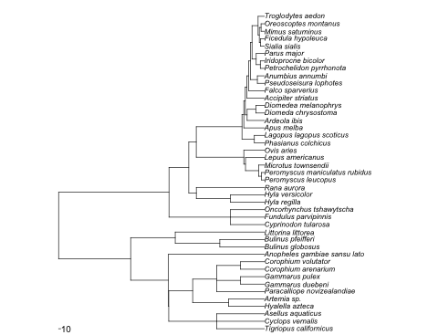
Newick:
(((((Tigriopus_californicus:228,Cyclops_vernalis:228,Asellus_aquaticus:228):228,((Hyalella_azteca:171,Artemia_sp.:171):171,(Paracalliope_novizealandiae:228,(Gammarus_duebeni:114,Gammarus_pulex:114):114,(Corophium_arenarium:114,Corophium_volutator:114):114):114):114):2.100006,Anopheles_gambiae_sansu_lato:458.100006):179.499969,((Bulinus_globosus:212.533325,Bulinus_pfeifferi:212.533325):212.533325,Littorina_littorea:425.06665):212.533325):343.600037,((Cyprinodon_tularosa:162.399994,Fundulus_parvipinnis:162.399994,Oncorhynchus_tshawytscha:162.399994):292.5,(((Hyla_regilla:162.25,Hyla_versicolor:162.25):162.25,Rana_aurora:324.5):36,(((((Peromyscus_leucopus:14,Peromyscus_maniculatus_rubidus:14):14,Microtus_townsendii:28):62.099998,Lepus_americanus:90.099998):8.099998,Ovis_aries:98.199997):226.599991,((Phasianus_colchicus:47.799999,Lagopus_lagopus_scoticus:47.799999):59.100002,(Apus_melba:98.199997,((Ardeola_ibis:82.199997,(Diomeda_chrysostoma:41.099998,Diomedea_melanophrys:41.099998):41.099998):8.800003,(Accipiter_striatus:83,(Falco_sparverius:75,((Pseudoseisura_lophotes:33.5,Anumbius_annumbi:33.5):33.5,(((Petrochelidon_pyrrhonota:19.5,Iridoprocne_bicolor:19.5):19.5,Parus_major:39):20,(((Sialia_sialis:19.299999,Ficedula_hypoleuca:19.299999):5,(Mimus_saturninus:15.9,Oreoscoptes_montanus:15.9):8.4):5.700001,Troglodytes_aedon:30):29):8):8):8):8):7.199997):8.700005):217.899994):35.700012):94.399994):526.300049);
Schlossberg and King 2008 Ecological Applications

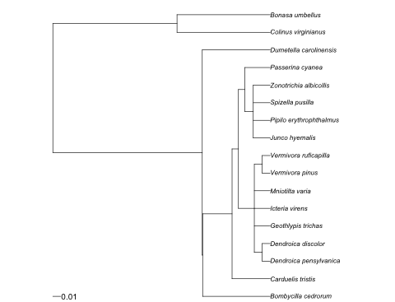
Newick:
(((Bombycilla_cedrorum:0.088173,(Carduelis_tristis:0.049749,(((Dendroica_pensylvanica:0.010364,Dendroica_discolor:0.010364):0.010364,Geothlypis_trichas:0.020728,Icteria_virens:0.020728,Mniotilta_varia:0.020728,(Vermivora_pinus:0.010364,Vermivora_ruficapilla:0.010364):0.010364):0.020728,((Junco_hyemalis:0.02211,Pipilo_erythrophthalmus:0.02211,Spizella_pusilla:0.02211,Zonotrichia_albicollis:0.02211):0.011055,Passerina_cyanea:0.033164):0.008291):0.008291):0.038423):0.000487,Dumetella_carolinensis:0.088658):0.195016,(Colinus_virginianus:0.121602,Bonasa_umbellus:0.121602):0.162073);

Simmons 2005 Annu Rev Ecol Evol Syst

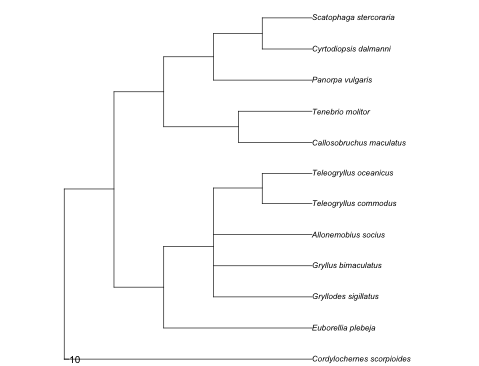
Newick:
(cordylochernes_scorpioides:538.5,((euborellia_plebeja:323.099976,(gryllodes_sigillatus:215.399994,gryllus_bimaculatus:215.399994,allonemobius_socius:215.399994,(teleogryllus_commodus:107.699997,teleogryllus_oceanicus:107.699997):107.699997):107.699982):107.700012,((callosobruchus_maculatus:161.549988,tenebrio_molitor:161.549988):161.549988,(panorpa_vulgaris:215.399994,(cyrtodiopsis_dalmanni:107.699997,scatophaga_stercoraria:107.699997):107.699997):107.699982):107.700012):107.699997);

Torres-Villa et al. 2004 Behavioral Ecology and Sociobiology

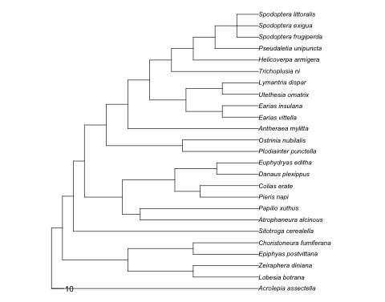
Newick:
(Acrolepia_assectella:170.600006,(((Lobesia_botrana:53.855556,Zeiraphera_diniana:53.855556):53.855556,(Epiphyas_postvittana:53.855556,Choristoneura_fumiferana:53.855556):53.855556):53.855553,(Sitotroga_cerealella:152.53334,(((Atrophaneura_alcinous:97.5,Papilio_xuthus:97.5):14.699997,((Pieris_napi:48.299999,Colias_erate:48.299999):20.700001,(Danaus_plexippus:34.5,Euphydryas_editha:34.5):34.5):43.199997):31.300003,((Plodiainter_punctella:62.78125,Ostrinia_nubilalis:62.78125):62.78125,(Antheraea_mylitta:107.625,(((Earias_vittella:29.895834,Earias_insulana:29.895834):29.895834,(Utethesia_ornatrix:29.895834,Lymantria_dispar:29.895834):29.895834):29.895832,(Trichoplusia_ni:71.75,(Helicoverpa_armigera:53.8125,(Pseudaletia_unipuncta:35.875,(Spodoptera_frugiperda:17.9375,Spodoptera_exigua:17.9375,Spodoptera_littoralis:17.9375):17.9375):17.9375):17.9375):17.9375):17.9375):17.9375):17.9375):9.03334):9.033325):9.033336);
Torres-Villa and Jennions 2005 Behavioral Ecology and Sociobiology

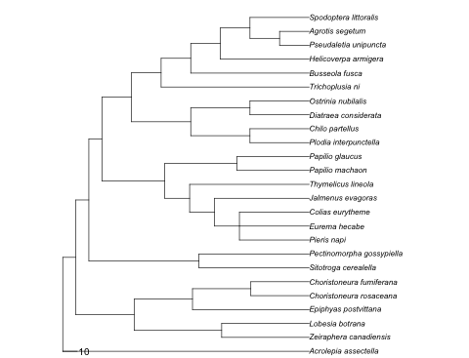
Newick:
(Acrolepia_assectella:170.600006,(((Zeiraphera_canadiensis:60.587502,Lobesia_botrana:60.587502):60.587502,(Epiphyas_postvittana:80.783333,(Choristoneura_rosaceana:40.391666,Choristoneura_fumiferana:40.391666):40.391666):40.39167):40.391663,((Sitotroga_cerealella:76.26667,Pectinomorpha_gossypiella:76.26667):76.26667,(((((Pieris_napi:48.299999,Eurema_hecabe:48.299999,Colias_eurytheme:48.299999):17.233334,Jalmenus_evagoras:65.533333):17.23333,Thymelicus_lineola:82.766663):17.233334,(Papilio_machaon:50,Papilio_glaucus:50):50):43.5,(((Plodia_interpunctella:41,Chilo_partellus:41):41,(Diatraea_considerata:41,Ostrinia_nubilalis:41):41):41,(Trichoplusia_ni:102.5,(Busseola_fusca:82,(Helicoverpa_armigera:61.5,((Pseudaletia_unipuncta:20.5,Agrotis_segetum:20.5):20.5,Spodoptera_littoralis:41):20.5):20.5):20.5):20.5):20.5):9.03334):9.033325):9.033336);
Vanderklift and Ponsard 2003 Oecologia

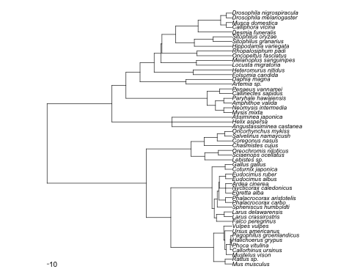
Newick:
(((((mus_musculus:36.799999,rattus_sp.:36.799999):61.399998,(((mustelus_vison:31.6,(callorhinus_ursinus:9.2,((phoca_vitulina:3.066667,halichoerus_grypus:3.066667):3.066667,pagophilus_groenlandicus:6.133333):3.066667):22.400002):6.199999,ursus_americanus:37.799999):6.2,vulpes_vulpes:44):54.199997):226.599991,(((falco_peregrinus:82.699997,(larus_crassirostris:41.349998,larus_delawarensis:41.349998):41.349998):11.850006,(spheniscus_humboldti:78.699997,((phalacrocorax_carbo:34.700001,phalacrocorax_aristotelis:34.700001):34.700001,((egretta_alba:33.700001,nycticorax_caledonicus:33.700001,ardea_cinerea:33.700001):33.700001,(eudocimus_albus:33.700001,eudocimus_ruber:33.700001):33.700001):2):9.299995):15.850006):11.850002,(coturnix_japonica:36.599998,gallus_gallus:36.599998):69.800003):218.399994):130.100006,((lebistes_sp.:145,(sciaenops_ocellatus:72.5,oreochromis_niloticus:72.5):72.5):72.5,(chasmistes_cujus:148.149994,(coregonus_nasus:78.800003,(salvelinus_namaycush:39.400002,oncorhynchus_mykiss:39.400002):39.400002):69.349991):69.349998):237.399994):526.300049,((angustassiminea_castanea:318.799988,helix_aspersa:318.799988,assiminea_japonica:318.799988):318.799988,((((mysis_mixta:44,neomysis_intermedia:44):44,(amphithoe_valida:44,paryhale_hawaiensis:44):44):44,(callinectes_sapidus:66,penaeus_vannamei:66):66):430.833313,((artemia_sp.:244.033325,daphia_magna:244.033325):244.033325,((folsomia_candida:206.649994,heteromurus_nitidus:206.649994):206.649994,((locusta_migratoria:189,melanoplus_sanguinipes:189):189,((oncopeltus_fasciatus:185.949997,rhopalosiphum_padi:185.949997):185.949997,((hippodamia_variegata:200,(sitophilus_granarius:100,sitophilus_oryzae:100):100):100,(desmia_funeralis:180.149994,((calliphora_vicina:30.15,musca_domestica:30.15):30.15,(drosophila_melanogaster:30.15,drosophila_nigrospiracula:30.15):30.15):119.849991):119.849998):71.899994):6.100006):35.299988):74.766663):74.766663):74.766663):343.600037);
Vollestad et al. 1999 Heredity

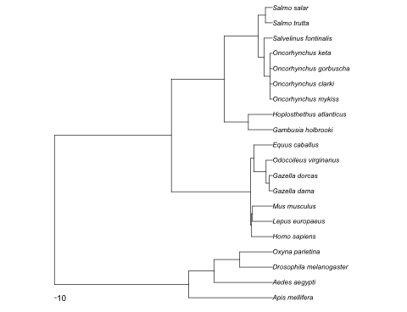
Newick:
((Apis_mellifera:377,(Aedes_aegypti:262.25,(Drosophila_melanogaster:147.5,Oxyna_parietina:147.5):114.75):114.75):604.200012,(((Homo_sapiens:94.149994,(Lepus_europaeus:90.099998,Mus_musculus:90.099998):4.049995):4.049999,(((Gazella_dama:14.45,Gazella_dorcas:14.45):14.45,Odocoileus_virginanus:28.9):55.299995,Equus_caballus:84.199997):14):356.700012,((Gambusia_holbrooki:108.75,Hoplosthethus_atlanticus:108.75):108.75,(((Oncorhynchus_mykiss:10.7,Oncorhynchus_clarki:10.7,Oncorhynchus_gorbuscha:10.7,Oncorhynchus_keta:10.7):26.549999,Salvelinus_fontinalis:37.25):26.549999,(Salmo_trutta:31.9,Salmo_salar:31.9):31.9):153.699997):237.399994):526.300049);

