RESEARCH PAPER
Concise and informative article title in sentence case
[First Author]ª, [Second Author]^{b} and [Corresponding Author]ª,*
a [Department, Institution, City, Country]
b [Department, Institution, City, Country]
* Corresponding author: [name], [email address] | ORCID: [0000-0000-0000-0000]

ABSTRACT
Provide a self-contained abstract of approximately 150–250 words. Briefly state the context, objective, methods, principal quantitative findings, and main conclusion. Avoid citations, undefined abbreviations, equations, and overly general claims.
KEYWORDS
Fresh water; Environment; Hydraulics; Sustainability; Mongolia

1. Introduction
Establish the scientific or engineering context, identify the knowledge gap, and state the study objective and contribution. Cite relevant literature using the journal’s APA author–date style, for example (Author, 2025) or Author and Author (2025).
End the Introduction with a clear statement of the research questions, hypotheses, or practical objectives. Avoid presenting detailed methods or results here.

2. Materials and methods

2.1. Study area, data, or experimental setup
Describe the study setting, data sources, instrumentation, sampling period, spatial and temporal resolution, and quality-control procedures sufficiently for replication. Define all variables and abbreviations at first use.

2.2. Analytical or modelling methods
Explain governing equations, assumptions, boundary and initial conditions, calibration and validation, uncertainty treatment, and software versions where relevant. Use italic symbols for scalar variables and roman type for units.
Q = A V (1)
where Q is discharge (m³/s), A is flow area (m²), and V is mean velocity (m/s).
For figures, use figure caption tool. Do not change style of caption.
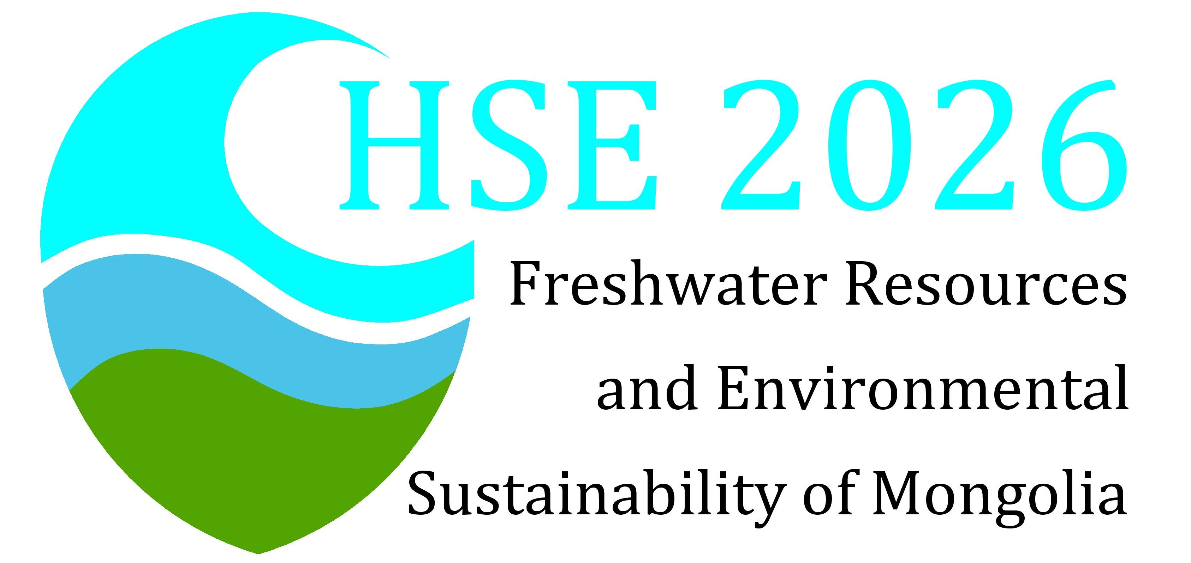
Figure 1. Concise description of the study area, experimental arrangement, model domain, or conceptual framework. Define symbols and abbreviations in the caption

3. Results
Present findings in a logical sequence. Report effect sizes, uncertainty, goodness-of-fit, or other appropriate quantitative evidence. Do not repeat every value from tables and figures in the text.
Table 1. Descriptive table title placed above the table.
Variable | Value / range
[Parameter 1] | [value]
[Parameter 2] | [value]
[Parameter 3] | [value]
Note: Define abbreviations, symbols, statistical tests, and sources. Use SI units and consistent decimal precision.

4. Discussion
Interpret the results in relation to the research objective and previous studies. Explain mechanisms, practical implications, unexpected findings, uncertainty, and the limits of generalization. Avoid repeating the Results section.

4.1. Limitations
State the main methodological, data, scale, or transferability limitations and explain how they affect interpretation.

5. Conclusions
Summarize the principal findings and their scientific or engineering significance in a short, evidence-based conclusion. Do not introduce new results or citations. Add actionable recommendations only when supported by the study.

Acknowledgements
Acknowledge non-author contributions, facilities, field assistance, or institutional support. Remove this section if not applicable.

Disclosure statement
The authors report [no competing interests / the following competing interests: …].

Funding
This work was supported by Funder Name under Grant No. XXXX. If there was no specific funding, state this explicitly.

Author contributions
Use the CRediT taxonomy, e.g. Conceptualization; Methodology; Investigation; Formal analysis; Writing – original draft; Writing – review and editing; Visualization; Supervision; Funding acquisition.

Data availability statement
State where the data and code supporting the findings can be accessed, including a repository name and persistent identifier, or explain any justified restrictions.

Ethics statement
Provide approval and consent information when human participants, animals, sensitive locations, or Indigenous/local knowledge are involved. Otherwise state ‘Not applicable.’

References
Journal article: Author, A. A., & Author, B. B. (2025). Title of article in sentence case. Journal Title, 12(3), 100–115. https://doi.org/10.xxxx/xxxxx
Book: Author, A. A. (2024). Title of book in sentence case (2nd ed.). Publisher.
Report: Organization Name. (2025). Title of report (Report No. 10). Publisher. https://doi.org/10.xxxx/xxxxx
Dataset: Author, A. A. (2025). Title of dataset (Version 2) [Data set]. Repository. https://doi.org/10.xxxx/xxxxx

Submission checks
☐ All bracketed guidance and template notes have been removed.
☐ The manuscript is anonymized if the journal uses double-anonymous review.
☐ Every figure and table is cited in numerical order and supplied at publication quality.
☐ References are complete, include DOIs where available, and match all in-text citations.
☐ Permissions have been obtained for reused copyrighted material.
☐ Language, units, equations, declarations, and data availability have been checked.

